Document: FCILekha Supplementary User Guide | Version:13.55



User Guide Supplementary


Jan 2026

CONTENTS
1.1 CR 180 - Addition of DFF column in AP Module - Dummy cheque 32
1.2 Auto Reconciliation for Electronics Payment (CM module) 33
1.3 CR-227, Gunny Bag Solution (GL module) 34
1.4 Auto Creation of Invoices 34
1.4.1 AP to AR 34
1.5 Restriction on Product entry in Non-Sale transaction source(AR Module) 35
1.6 CR-225 Partially Paid and Unpaid Invoice Report 35
2 Deployments - November 2012 37
2.1 Automatic rounding off feature in AR 37
2.2 FCI Purchase Day Book : (CR no. 248 Conversion of Report to Excel format ) 37
2.3 FCI Transaction Available For Reconciliation : (CR no. 248 Conversion of Report to Excel format ) 40
2.4 FCI Check Printing: 42
2.5 FCI India Cash/Bank Book Report 45
2.6 FCI Transfer in Transfer Out Report : (CR no. 248 Conversion of Report to Excel format ) 47
3 Deployments - December 2012 51
3.1 FCI Prepayments Status Report 51
3.2 FCI Purchase Day Book : Available in both Notepad and excel format now. 52
3.3 Restrictions during the Interco IOR Creation:- 52
3.4 Inclusion of Bank Details in Discoverer Report :Supplier Master Details 54
3.5 Print Invoice Notice 59
3.6 CR 221: Supplier Data Validation 61
Checks for Supplier and Supplier Sites. 61
3.7 CR 248: FCI Transfer in against Stock received. 61
4 Deployments - January 2013 64
4.1 FCI Sales Day Book 64
4.2 Addition to CR 221 67
4.3 FCI Trial Balance Summary 1 68
4.4 Security Check : 72
4.5 FCI Trial Balance Detail Report: 76
4.6 FCI AR Receipts 81
4.7 Separate Period Closure 83
4.8 Automatic Deactivation of Corresponding User in Apps : 84
4.9 FCI DEBTOR TB 85
4.10 Intercompany Checks added: 86
4.11 Intercompany Personalizations: 87
4.12 Intercompany Reports: 87
4.13 FCI Journal Approval Report 88
5 Deployments Feb -2013 90
5.1 FCI India Creditors Trial Balance Report 90
6 Deployments – March 2013 91
6.1 FCI prepayments Status Report 91
7 Deployments – April 2013 93
7.1 Receipt Write Off in AR 93
7.2 FCI Final Payment Register 94
7.3 Auto import,auto validation of Auto created invoices and Payment hold on EMD and SD 95
7.4 FCI Payables Invoice Register 95
7.5 Rounding Off line 96
7.6 FCI Prepayment Status Schedule Report 97
8 Deployments – May 2013 98
8.1 Nominee Payment 98
8.2 Print Invoice Notice 99
8.3 Bank Detail Updation 100
9 Deployments Jun -2013 101
9.1 FCI AR Receipts 101
9.2 FCI Journal Batch Approval Status Correction Program 102
9.3 Aging – 4 Bucket Report 103
9.4 Separate Period Closure for RO Level 106
9.5 FCI DEBTOR TB 107
9.6 FCI_Sales_Day_Book 107
9.7 FCI Receivables Invoice Register 108
9.8 FCI India cash/Bank Book Report 109
9.9 Receipt Summary form 110
9.10 IOM Within Same Unit 110
9.11 Consolidated Trial Balance 110
10 Deployments Jul -2013 110
10.1 AP Intercompany Restrictions added: 110
10.2 FCI Interco IOM Voucher 112
10.3 CR 161 116
11 Deployments Aug -2013 120
11.1 Budget Module: 120
12 Deployments Sep-2013 120
12.1 CR 300 120
12.2 CR 288 120
12.3 CR 291 120
13 Deployments – Oct- 2013 122
13.1 CR 299 122
13.2 CR 304 122
13.3 AP-AR, AR-AP, REFUND Process Change pertaining to Period Closure 123
14 Deployments – Nov-2013 125
14.1 CR-311 125
14.2 CR-318 125
14.3 CR-317 125
14.4 CR-305 126
14.5 CR-312 127
15 Deployments - Dec-2013 129
15.1 CR -331 129
16 Deployments – Jan- 2014 129
16.1 CR – 335 129
16.2 CR-319 131
16.3 CR-321 131
16.4 CR-320 132
16.5 CR -324 Custom Period Closure 132
16.6 CR- 310 FCI Intercompany Reconciliation report 133
17 Deployments – Feb- 2014 134
17.1 FCI Asset Addition Report : 134
17.2 Setup to coinsider Satrday as working day in Treasury : 137
17.3 CR-351 138
18 Deployments – Mar- 2014 138
18.1 CR 337 FCI Asset Period Status Report 138
18.2 CR 353 Account Head 4534 is allowed with internal bank accounts 139
18.3 FCI InterCo IOM Voucher 139
18.4 CR -352 Restrictions to be applied in the system 140
18.5 CR 354 FCI Journal Status Report. 140
19 Deployments – Apr- 2014 142
19.1 CR 365 AR-Receipt Date 142
19.2 CR 343 Creation of new unit HQ11 142
19.3 CR 346 Stock entry should not be allowed with nil amount (Revised) 143
19.4 CR 368 Depots under unit ND12 to be prefixed with ND11 143
19.5 CR 355 Auto Generation of Service Tax Invoices 143
19.6 CR- 370 Creation of Account Head 0972. 144
19.7 Mantis Issue 2821 (SLS Report and Personalization on AP). 144
20 Deployments – May- 2014 144
20.1 CR 357 Incorporation of fixed Asset Module in Custom Period Closure 144
20.2 CR 379 Change in the description for A/c head 2191 and updation in the depreciation rates 146
20.3 CR 378 -FCI GL balance reconciliation Summary report 147
20.4 CR 378-FCI GL Balance Reconciliation Detail 148
20.5 CR 334- Modifications in Print Invoice Notice 149
20.6 Changes in Retirement Gain/Loss 150
20.7 CR 382- Creation of new a/c heads 3794 against existing account head 29.100 And 5402 against existing account heads 13.111, 13.112 and 13.113 155
21 Deployments – Jun- 2014 157
21.1 CR 388- Addition of Asset Category and updating Existing Vs Final 157
21.2 CR 391- Distribution parameter from FCI India cash/Bank Book Report 157
21.3 CR 366- DM-REFUND Functionality 157
21.4 CR 390- FCI India - Debtors Ledger Report 158
21.5 CR 393- Creation of new STL Depreciation methods 158
21.6 CR 397- Personalisation applied on DFF on goods purchse invoice 158
22 Deployments – JUN 2014 159
22.1 CR 396- Removal of "Post in summary/Summarize Journal Entries" Parameter 159
22.2 CR 369- InterCo IOCPF has to be automated in the system 159
23 Deployments – JUL 2014 161
23.1 CR - 399 Requirement of Document Sequence in Trial balance report & debit / credit total in Trial balance Detail report. 161
23.2 CR - 363 FCI Consolidated Trial Balance 161
23.3 CR – 402 CR 402 Closing balance parameter in FCI - Bank Reconciliation Statement 162
24 Deployments – AUG 2014 163
24.1 CR- 323 FCI SLS For Stores And spares 163
24.2 CR 363 - FCI Profit & Loss Statements Report 164
25 Deployments – SEP 2014 166
25.1 CR 403 – Period Opening Rights in Apps 166
25.2 CR 406 - FCI Asset Adjustment Report 166
25.3 CR 423 - Updation of Account/Unit/Product/Scheme segment values 167
26 Deployments – DEC 2014 171
26.1 CR 409 – Validations in AR 171
26.2 CR 444 – Changes for Asset Module 171
26.3 CR 445 – Changes in FCI Profit & Loss Statements 171
27 Deployments – Jan 2015 172
27.1 CR 426 – Asset Transfer Reconciliation Report 172
27.2 CR 443 – Changes in FCI Asset Addition Report and personalizations in FA module 173
27.3 CR 416 – Changes in Payment form for discount field 173
27.4 CR 394 – FCI A2S Report: Statement A to S 173
27.5 CR 412 – Limit on Quantity in AR Forms 174
27.6 CR 453 – Allowing pass/approve JE to the user of HQ11 GL having cat. HQ11_Others by taking Unit Code of Other units at line level 174
27.7 CR 371 – Disabled code combination handling 175
28 Deployments – Feb 2015 178
28.1 CR 451 – Addition of Banks in Valid Bank List 178
28.2 CR-429: Automation of flow of bank details from apps to payroll 180
29 Deployments – Mar 2015 181
29.1 CR-437 FCI India Creditor Trial Balance Report 181
29.2 CR -456 Checks in Asset Module : 181
29.3 CR-464 , No changes allowed in invoice flowing from payroll to Apps module. 184
29.4 CR-455 Modification in chart of accounts and grouping 184
29.5 CR-419 Creation of new Report 186
29.6 CR- 420 Changes In FA Module: 188
30 Deployments – Apr 2015 191
30.1 CR 428- APP Change in calculation of TDS and WCT: 191
30.2 CR 471: Addition of Banks in Valid Bank List 192
30.3 CR 477: Addition of Banks in Valid Bank List 192
30.4 CR 468 : Changes in Asset Category and creation of new ones 193
30.5 CR 481 :Run Depreciation form and incorporation of Depreciation check 193
30.6 CR 478 : Creation of 2 Units(District Office)under Jharkhand region in Payroll & Apps 194
30.7 CR 476: Creation of a new report ‘FCI Unplanned Depreciation’ 196
1. A new report ‘FCI Unplanned Depreciation’ has been created. 196
31 Deployments – MAY 2015 199
31.1 CR-484: Restriction on Distribution lines of prepayment 199
31.2 CR 494 : Addition of Bank in Valid Bank List 199
31.3 CR 480 : Changes in FCI Asset Book report 199
32 Deployments – JUN 2015 200
32.1 CR-467: Changes in FCI Debtor Trial Balance 200
33 Deployments – JUL 2015 201
33.1 CR-496:Restriction of double posting of JEs from FA to GL 201
33.2 CR-503 :Withdrawl of period closure of MAR period in FA from FCI Support User 201
33.3 CR-434: Requirement of New Report in GL module- FCI Account Head Balance Report 201
33.4 CR 499 : Restriction of unbalanced JEs from FA to GL 203
34 Deployments – AUG 2015 205
34.1 CR- 519: Asset Deletion not allowed after JE sent to General Ledger 205
34.2 CR- 482: Creation of New Report - FCI Depot Detail Report 205
34.3 CR- 414: FCI Stock Ledger Summary Report – Addition of Parameters 205
34.4 CR 529 : Creation of a new scheme 436 for LAN/ WAN Restructuring 209
34.5 CR 505 : Check On Invoice Number 209
34.6 CR 483 : FCI Part I & Part II Account Variance Master (Request Set) 210
34.7 CR 446 : Modifications in FCI Asset Schedule As per Company’s Act Report. 211
35 Deployments – SEP 2015 212
36 Deployments – OCT 2015 213
36.1 CR-491: Addition of India Income Tax Report for Fixed Asset March Period Closure 213
37 Deployments – Nov 2015 214
37.1 CR-497: Creation of New report FCI Sales/Purchase Summary Report (FCI Stock Detail Report) 214
37.2 CR-521: CR-497- Modifications in Purchase Day Book report 216
38 Deployments – Dec 2015 218
38.1 CR-473: Changes in FCI Prepayment Status Schedule Report and withdrawal of Unpaid and Partially Paid Invoices Report 218
38.2 CR-553: Output Format of FCI Payment Batch Report to be modified 219
38.3 CR 518: With-drawl of FA from period closure and check on salary initialize 222
38.4 CR 557 : Addition of Bank in Valid Bank List 223
38.5 CR 552: Creation on new product codes for pulses & new account heads, updation of CVR and updation of A to S report. 223
39Deployments –Jan 2016 232
39.1 CR-542: Inclusion of additional fields in FCI Asset Status Report & FCI closed period Status Report Output 232
40Deployments – MAR2016 235
40.1 (CR-564) Addition of value in input parameters of SLS report and DFF of Depot Creation Form 235
40.2 (CR-568) Check on rate/section selection (for auto TDS and WCT deduction from payment) in DFF of invoice distribution form. 235
40.3 (CR-571)Creation of new schemes for NFSA & Updating of CVR 235
40.4 (CR- 559) Check on Assets Major-Minor Category Combination and Asset Block 237
41Deployments – APR 2016 238
41.1 (CR-573) "ALL" value is required in LOV of input parameter unit code of FCI Intercompany Reconciliation Report 238
41.2 (CR-560) Restriction on receivable line at the distribution form while creating Manual Transaction in AR 238
41.3 (CR-582) Inclusion of Account head-1806 in receivable of transaction 238
42Deployments – MAY2016 239
42.1 (CR-430)Creation of two new reports (Balance Sheet and Profit and Loss Report) 239
42.2 (CR-583) Incorporation of Run Depreciation Form and Checks 239
43Deployments – JUNE2016 240
43.1 CR 584 : Bank Name to be Added In Valid List 240
43.2 CR 588 : Bank Name to be Added In Valid List 240
43.3 CR 591: Creation of New Account Heads 240
43.3 CI 9684: India Income Tax Report in FA 241
43.4 CR 592: Incorporation of customization in FA module 241
43.5 CR 599 :Creation Of BANDHAN BANK 242
44Deployments – JULY2016 243
44.1 CR 602 : Bank Name to be Added In the Valid Bank List 243
45Deployments – OCT2016 244
45.1 CR-567 :No Change should be allowed in the CCID of internal bank 244
45.2 CR-565 : Creation of New Account Heads, Updation of CVR and updation of all relevant reports. 244
45.3 CR-612 : Bank Name to be Added In the Valid Bank List 244
45.4 (CR-581) Bank name to be modified in valid bank list 245
46Deployments- NOV2016 246
46.1 (CR 575) Creation of new account head, scheme 246
46.2 (CR 606) Creation Of New Scheme 249
47Deployments- JAN2017 251
47.1 (CR 631) Conversion of FCI Consolidated Report to FCI. 251
47.2 (CR- 587) Custom Period Closure Fixed Assets: 252
47.3 CR-622 : Creation of New Account Heads, Updation of CVR and updation of all relevant reports. 253
47.4 Supplier Bank as selection criteria in PPR. 253
48Deployments- APR2017 255
48.1 CR-617 : Updation of Name of block of assets/depreciation rate 255
49Deployments- MAR2017 256
49.1 CR-673 : Bank Name to be Added In the Valid Bank List 256
49.2 CR-656: Creation Of new account heads and modification in certain existing account heads 256
49.3 CR- 659: Asset Period Closure Form at FCI Support Level 256
49.4 CR-662: Creation Of new account heads and change in the nomenclature of account heads 3157 and 3158 257
49.5 CR- 660 Tax Setup at FCI Support User Responsibility 257
49.6 CR-658: Creation of new account head, updating of CVR and updating of A to S statement 257
49.7 CR-595: Modification in Purchase Day book 258
49.8 CR-676: Creation of new product codes for non issuable pulses and oil seeds viz. 1451,1454,1457,1460 and 1463 258
49.9 CR-680: Change of Address-Zonal Office 259
49.10 CR-630: Creation of Pay groups for New Units 260
Pay Groups for units NH27 and EE12 260
49.11 CR-675: Creation of Pay groups for New Units 260
Pay Groups for units NH32, SB13 and SB19 261
50Deployments- APR2017 262
50.1 CR-684: Creation of new account head 5220, updating of CVR and updating of A to S statement 262
50.2 CR-650: Goods Purchase Invoice with zero quantity. 262
51Deployments- MAY2017 263
51.1 CR-686: Creation of new account heads 1308, 3576 and 1906 for National Small Saving fund loan to FCI and modification in nomenclature of existing account head 3720 263
51.2 CR-625: Enhancement In Oracle’s Account Analysis Report 263
51.3 CR- 624: 264
Phase 1: Creation of FCI Receipts and Payment Summary Report. 264
Phase 2: Creation of FCI Receipts and Payment Detail Report 265
52 Deployments-JUNE2017 267
52.1 CR 634: Rectification of Bug identified in Debtors TB 267
52.2 CR-701: Creation of Pay groups for New Units 268
Pay Groups for unit WD15 268
52.3 CR-704 : Bank Name to be Added In the Valid Bank List 268
52.4 CR-702: Creation of new account heads for GST Implemenation 269
53Deployments- JUL2017 270
53.1 CR-654 : Editing in FCI Intercompany Reconciliation Report 270
53.2 CR-694: Rectification in Existing reports "FCI SLS for Stores and Spares" & "FCI Stock Ledger Summary Report" 271
53.3 CR-664: Creation of a new Programme “FCI Stock Ledger Summary Programme” and change in output of “FCI SLS for Stores and Spares” 272
53.5 CR-698: Creation Of new account head 4762 viz. sundry debtors against CPF Trust 274
53.6 CR-596: Disable the Discount Field In Payment Batch Form 274
53.8 CR-706: Change of Address-Regional Office 275
54Deployments- AUG2017 276
54.1 CR-618: Restriction on change of type while creating a credit memo through Credit Transaction 276
54.2 CR-682: DPIS as GL Date of AP Invoice and Check on Control Total on Split of Asset 276
54.3 CR- 648: New Field in DFF as actual date of installation &Changes in FCI Asset Book Report 276
54.4 CR- 697: Modification in the invoice after accounting 277
55 Deployments- SEP 2017 278
55.1 CR-714: Changes in A to S grouping of existing account heads 278
55.2 CR-716: Changes in A to S grouping of existing account heads 278
55.3 CR-724: Changes in A to S grouping of existing account heads 278
55.4 CR-721: Creation of new account head 3577 279
55.5 CR-663: Restriction on taking Receivable activity of other units while creating the transaction from C.M Module 279
56 Deployments- SEP 2017 280
56.1 CR-610: Creation of new account head 5731 280
57 Deployments- OCT 2017 281
57.1 CR-726: Creation of new A/c head for Usage Charges for packaging of procured paddy (5281) 281
57.2 CR-727: Changes in existing grouping of account heads 281
58 Deployments- NOV 2017 282
58.1 CR-646: FCI Journal Voucher Detail Report 282
58.2 CR-674: Transfer Asset SB to SF Region 283
58.3 CR-730: Creation of new A/C head for Trade Receivable-DCP Trust (4763) 284
58.4 CR-723: Creation of new account heads 284
58.5 CR-738: Creation of new account head 284
59 Deployments- DEC 2017 285
59.1 CR-572: Changes in Profit and Loss Statement Report 285
59.2 CR-GST: FCI GST Job Work Register 285
60 Deployments- JAN 2018 289
60.1 CR-740: Creation of New account heads, change in PNL grouping of existing account head, change in Organizations’ name 289
60.2 CR-623: Changes in Asset Adjustment Report. 289
H2>Failure of server APACHE bridge:</H2><P><h 290
60.4 CR- 729: Rounding off should be on invoice level instead of line level. 290
60.5 CR- 746: Creation of new Account heads 291
61 Deployments- FEB 2018 292
61.1 CR- 737: Asset Period Closure Form At FCI Support level 292
61.2 CR- 707: Addition of new classification for supplier and changes in reports "FCI Receipt and Payment Detail Report" and "FCI Receipt and Payment Summary Report" 292
61.3 CR- 641: Modification in FCI Trial Balance Detail With Document Sequence Report to introduce A to S, Balance Sheet, P&L and P&L statement Grouping. 293
62 Deployments- MAR 2018 294
62.1 CR- 753: Creation Of new Account Head 294
62.2 CR- 745: Regarding Supplier Type 294
62.3 Personalization on supplier form for GST 294
62.4 CR-756, GSTIN 14TH character as Alphanumeric 294
62.5 CR-758, Creating New Items, HSN-SAC mapping & New Report Development detailing the FCI Item List 294
63 Deployments- APR 2018 296
63.1 CR- 671: Pending invoices against inactive suppliers 296
63.2 CR- 754: Changes in existing mapping in A to S statement 296
63.3 CR 752 : Email ID and Contact Number of Supplier’s Site inclusion in FCI Supplier Master Report 297
64 Deployments- MAY 2018 298
64.1 CR 763: Opening of DFF at transaction form in AR Module 298
64.2 CR 743: Closure of two units of EF region 298
64.3 CR 739: Creation of 2 units (District offices) under Bihar region (Patna) in Payroll & Apps & change in Unit Office Name 299
64.4 CR- 769: Creation of new Account heads 299
65 Deployments- JUN 2018 300
65.1 CR- 759: Addition of scheme code 3422 in account codes 2149, 2249, 2349 300
65.2 CR 734: Amortization Mandatory in Fixed Assets 300
65.3 CR 774: Check on Manual entry of Account Head-4206 in AR distributions 300
65.4 CR 780: Creation/ Updation of HSN Codes 301
65.5 CR 761: To Cater In Transit Assets in Custom Period Closure 301
66 Deployments- JUL 2018 302
66.1 CR- 511: Replacement of Account Heads 302
66.2 CR- 749: Creation of New account Heads and opening of new pay code. 303
66.2 CR- 788: Creation of New account Head. 303
66.3 CR-785: Uploading of expenditure for period from 01.04.2017 to 30.09.2017 on PFMS portal 304
66.4 CR-589: Activation of account heads, creation of new journal category and updating of SLS Report 304
67 Deployments- AUG 2018 306
67.1 CR- 792: Period Closure rights of SF region 306
67.2 CR- 640: Automatic updating of Bank Account on Employees Present Site 306
67.3 CR- 750: Updation of CVR for Account Head 5281 & 5171 307
67.4 CR- 793: Creation of new account head and product codes 307
67.5 CR- 790: Creation of new report FCI Payment Batch Output Report – Excel 307
68 Deployments- SEP 2018 309
68.1 CR- 795: Modification to be made in 1740, 1741 and 5232 309
68.2 CR- 757: Creation of New account Heads 309
68.3 CR- 802: Creation of New account Head 5403(Freight Container- Operations) 310
68.4 CR- 794: Creation of New HSN Codes 310
68.5 CR- 791: Modifications in format of GL GST Delivery Challan 311
68.6 CR- 712: Reflection of void payment and receipt reversal in FCI BRS report 311
68.7 CR- 804: Changes in CVR w.r.t account codes 1723, 1727, 6206 311
68.8 CR-805: Creation of new account heads 312
69 Deployments- OCT 2018 313
69.1 CR-678: Creation of new report FCI Purchase Tally Report 313
70 Deployments- NOV 2018 315
70.1 CR-781: Restrict the transaction completion if product at line and distribution are different. 315
71 Deployments- NOV 2018 316
71.1 CR-811: Bank Name to be added in the Valid List 316
71.2 CR-787: Modification in Transfer Functionality 316
71.3 CR-807: Modification in the DFF in Paddy out category and UOM field in IOM category 317
71.4 CR-6 Creation of New Account Heads 317
Account code 1442 317
Account code 6136 319
71.5 CR-4 Disable the check so that FCI Custom Period Closure Report – Auto invoice& Interface 320
71.6 CR-8 Asset period closure from at Fci Support User for Mar17-18 321
72 Deployments- FEB 2019 322
72.1 CR-20 (MID: 86342), Creation of account codes, product codes and modification in product codes’ nomenclature & grouping of account codes 5274 322
72.2 CR-24 (MID: 86477), Modification to be made in account codes 1908 & 5279 322
72.3 CR-3 (MID: 82178), Change Existing SLS Mapping of account head 5231 323
73 Deployments- APR 2019 325
73.1 CR-43 (MID: 88118), Exclusion of Inactive Bank Account of WB15 District Office Adipur viz. WB15_10316662384 from PFMS reporting. 325
73.2 (MID- 86258), Exclusion of Old 11i Paid Invoices from Trial Balance reporting. 326
73.3 CR-22 (MID: 88066), Modifications to be made in “FCI Payment Batch Output Report for CMP - Excel” Report. 327
73.4 CR-45 (MID: 88328), New Account Code 2827 & Modification in Account Code 5731 328
74 Deployments - MAY 2019 329
74.1 CR-23(MID: 89036), Modification in Nomenclature of account code-4302 329
74.2 CR-14 (MID: 82433), Modifications to be made in CVR for account codes 2121, 2221, 2321, 2122, 2222 & 2322 329
74.3 CR-19 (MID: 86270), Creating New Items, HSN-SAC mapping 329
75 Deployments - JUN 2019 331
75.1 CR-32(MID: 89035), Bank Name to be added in The Valid List 331
75.2 CR-66(MID: 0089814), Generation of Bill of supply in respect of Non GST transactions 331
75.3 CR-61(MID: 89583), Inclusion of segment code for PFMS crop year (2019-20 RMS and 2019-20 KMS) 332
76 Deployments - JUL 2019 333
76.1 CR-62 (MID: 89645), AR INTERCO-Responsibility creation for unit ED14 and ED15 333
76.2 CR-71 (MID: 90443), Removal of additional items from LOV of transaction type (input parameter) of Report FCI GST AR Tax invoice/Bill of supply. 334
76.3 CR-29 (MID: 90240), Creation of new HSN Code 334
76.4 CR-40(MID: 89303), Creation for new account head, Creation of new scheme codes & Change in CVR of existing A/C head. 335
76.5 CR-68(MID: 90309), Improvement in the logic of Reverse charge register. 336
76.6 CR-52(MID: 90228), Change in CVR & PFMS mapping of existing AC heads 336
77 Deployments - AUG 2019 338
77.1 CR-41(MID: 89304),:-Organization & location field should be made mandatory during filling of "India Tax Details " at ITD Form in AP & AR. 338
77.2 CR-67(MID: 90306) :- Distribution's CCID field should be freezed after completion of the transactions in AR Module. 338
77.3 CR-25(MID: 87216), Creation of new functionality for bulk supplier creation 338
77.4 CR-46 (MID: 89306) :- Check should be applied to ensure TAX category, HSN should only be applied where item code is there for transaction in AR module. 342
77.5 CR-92(MID: 91618), Adding name in valid bank look up 342
77.6 CR-53(MID: 90230), Change in the name of Regional Offices, SB11 & SF11 343
77.7 CR-17(MID:89301)Restriction in payable responsibility w.r.t to supplier & bank & creation new report "FCI SUPPLIER BANK DETAIL UPDATION REPORT” 344
78 Deployments - SEP 2019 344
78.1 CR-90 (MID: 0091412) Creation of new account codes 3175 & 3176 and corrections in dependent scheme codes for account code 6070 344
78.2 CR-93 (MID: 0091778) Modifications to be made in account code 5233 347
78.3 CR-95(MID: 0092016) Moving of the GST reports to General Ledger user responsibility. 348
78.4 CR-99(MID: 0092317) Modification in logic for the quantity to be shown under PU (Purchases) in FCI Stock Detail Report. 349
78.5 CR-73(MID:0090445) GST details reflected in the "PRINT INVOICE NOTICE REPORT" and report generate output only for validated invoices. 349
79 Deployments - OCT 2019 349
79.1 CR-84(MID: 91063) Creation of new report supplier payment history report-Excel and addition of new field at AP invoice header 349
79.2 CR-74(MID: 90540) Modification in the logic of FCI Asset addition report & FCI Asset Register report 350
79.2 CR-102(MID: 92526), Adding name in valid bank look up 351
79.3 CR-100 (MID: 92459), Creation of new HSN Codes 352
79.4 CR-103 (MID:92594) Rounding off line should be grey out in AR Transactions. 354
79.5 CR-69 (MID:91336) Creation of new scheme code 3482 & new minor category 482 and modifications in nomenclature of scheme code 3481. 355
80 Deployments - NOV 2019 357
80.1 CR 91 (MID: 91411) Development of New report ‘FCI Comparative Analysis Report’ 357
80.2 CR: 105 Modification in dependent scheme for account head (6121 to 6135) to be allowed scheme 211 to 2226 358
80.3 CR-112 (MID: 0095440) Creation of new account code 1909 and nomenclature change for account head 7132, 7212, 1908 364
80.4 CR-110 (MID: 0095076): Creation of new account code 4557 367
81 Deployments - DEC 2019 367
81.1 CR-109 (MID: 94884): Modification in CVR, Nomenclature and A to S grouping of existing A/C head 5201 367
82 Deployments - JAN 2020 368
82.1 CR-5 (MID: 82757): Disabling of check for addition & retirement of assets 368
82.2 CR-117(MID: 97448), Adding name in valid bank look up 369
83 Deployments - FEB 2020: 370
83.1 CR-121 (MID: 98328): Creation of new scheme code 429 & addition of scheme 429 in dependent scheme for account code 5701 370
83.2 CR-106 (MID: 94400): Creation of new account code 3799 & new minor categories 505 to 514 and 515, 516, 522, 523 371
83.3 CR-118 (MID: 97592): Creation of new account codes 2728 & 7195 and modifications in nomenclature & dependent scheme codes for account codes 372
83.4 CR-124 (MID: 99225): Modification in nomenclature of acct. code 4219 and deactivation of acct. code 4220 374
83.5 CR-128 (MID: 100594): Creation of HSN Codes 375
83.5 CR-127 (MID: 0099642): New banks name should be added in the valid bank look up. 376
83.6 CR-123 (MID: 0098991): New banks name should be added in the valid bank look up. 378
84 Deployments - APR 2020: 379
84.1 CR-59 (MID: 90233): Tax Category should be default and non editable for exempted items in ITD form for AR Sales type transactions. 379
84.2 CR-129 (MID: 100616): Creation new report "FCI Bank Account Assignment Detail Report 380
84.3 CR-131 (MID: 101445): Creation of new scheme code 430 & addition of scheme 430 in dependent scheme for account code 5701 and 5731 380
84.4 CR-72 (MID: 90444): Creation of new Receipt Register Report 382
85 Deployments - MAY 2020: 383
85.1 CR-134 (MID: 101741): Creation of acct. heads 3116 to 3123 383
85.2 CR-135 (MID: 102053): Creation of acct. head 4626 and scheme codes 431, 432 and 433 386
85.3 CR- 139(MID: 102890): Creation of new scheme code 706 & addition of scheme 706 in dependent scheme for account code 1308 391
85.4 CR-136(MID: 0102716): Changes in the TDS Rate Regarding 391
86 Deployments - JUN 2020: 392
86.1 CR- 143(MID: 103150): Creation of HSN Codes 392
86.2 CR- 144(MID: 103325): Creation of new scheme code 434 & addition of scheme 434 in dependent scheme for account code 5701 392
86.3 CR-142 (MID: 0103141): CR-142 New banks name should be added in the valid bank look up. 393
86.4 CR-16 (MID: 0089914): Unit Code (Hierarchy) as mandatory input parameter should be created in the report named "FCI Bank Statement summary report". 393
86.5 CR- 140(MID: 0102901): Freeze Journal Source 'Financials India' 394
86.6 CR- 96(MID: 0092171): Provision to enter Physical balance of Fixed Assets in FAP & development of Reconciliation Report. 394
87 Deployments - JUL 2020: 395
87.1 CR-115 (MID: 96786): Requirement of asset period closure form at FCI Support User for Mar 18-19 395
88 Deployments – AUG 2020: 395
88.1 CR- 155(MID: 104047): Creation of HSN Codes 395
88.2 CR- 156(MID: 104627): Addition of scheme code 2301 in dependent scheme of account heads 6091, 6092 and 6095 396
88.3 CR- 150(MID: 103706): Creation of new scheme code 3423 and minor category 423 397
88.4 CR- 137(MID: 102806): Creation of new acct. heads 3287, 1811 and 6309 and modification in nomenclature of acct. head 3156 399
89 Deployments – SEP 2020: 401
89.1 CR- 154(MID: 103724): Updates in Creditor TB and Debtor TB 401
89.2 CR- 63 (MID: 89617): Reflection of Updated GSTIN in GST reports 401
89.3 CR- 116 (MID: 97135): Addition of three new columns in Asset Book Report & applying restriction on selection of depreciation limit type. 402
89.4 CR- 149(MID: 103492): Creation of new acct. head 6080 and addition of scheme code 707 402
89.5 CR- 163(MID: 106376): Creation of account head 1636 404
90 Deployments – OCT 2020: 404
90.1 CR- 161(MID: 106043): Development of Cash Flow Statement report 404
90.2 CR- 166(MID: 107144): Creation of account heads 3224, 3225 and 3226 406
91 Deployments – DEC 2020: 407
91.1 CR- 175(MID: 108567): Creation of account head 2936 and modification in nomenclature of acct. heads 1636, 3105, 3221, 3981 and 3993 408
91.2 CR- 172(MID: 107575): Deactivation of account heads 3881, 3883, 3884, 3885, 2951, 4771, 2751 and 2851 410
91.3 CR- 138(MID: 102862): Inclusion of MSME Categories in the LOV of Supplier Type 411
91.4 CR- 177(MID: 109263): Modification in S.No. for T.B. of acct. heads 1908 and 1909 412
91.5 CR- 178(MID: 110033): Creation of new scheme code 209 & addition of scheme 209 in dependent scheme for account code 5701 414
91.6 CR- 179(MID: 110556): Creation of account head 2828 414
91.7 CR- 185(MID: 111555): Creation of account head 6081 415
92 Deployments – JAN 2021: 417
92.1 CR- 182(MID: 111583): Redesign of FCI PFMS chart of account mapping report 417
92.2 CR-157(MID: 104573), Adding name in valid bank look up 417
93 Deployments - MAR 2021: 418
93.1 CR- 195(MID: 114082): Creation of HSN Codes 418
94 Deployments - APR 2021: 419
94.1 CR- 193(MID: 113889): Change in CVR of AC head 1554, 1555, 1560 & 1561 419
94.2 CR – 201 (MID: 116003): Creation of acct. head 3675 419
94.3 CR-146 (MID: 103377): Creation of RO Manipur and DO Imphal 420
95 Deployments MAY-2021: 421
95.1 CR-194 (MID: 114083): Creation of new acct. head 1812 421
95.2 CR-203 (MID: 116922): Creation of new acct. head 1434 and scheme code 3424 and minor category 424 421
95.3 CR-200 (MID: 115646): Creation of HSN Codes 423
95.4 CR-181 (MID: 111330): Requirement of asset period closure tick box on FCI Support User responsibility for Mar 19-20 FA closure 423
96 Deployments JUN-2021: 424
96.1 CR-197 (MID: 117926): Addition of Column in FCI Debtor/Creditor age-wise report 424
96.2 CR-202 (MID: 116467): Creation of new acct. head 5234, 0957 425
96.3 CR-133 (MID: 101570) Creation of new account codes 5422, 5423 and 5283 and addition of schemes 111 and 112 427
97 Deployments JUL-2021: 434
97.1 CR-214 (MID: 118371): Creation of new JE category 'Interco IOPS New' 434
97. 2 CR-210 (117853):FCI Purchase Dashboard Creation 435
97. 3 CR-209 (0117753): Provision for uploading of bulk Invoices in FAP 435
97. 4 CR-222 (120973): Mantis Bug Tracker application migration to new cloud space 436
98 Deployments June-2022: 438
98.1 - CR-204 (MID: 117240): Creation of DO Aurangabad and 438
98.2 CR-213 (MID: 118067): Closure of D.O. Jalpaiguri (EF22) in FAP 439
98.3 CR-224 (MID: 122448): Creation of New Account Head- 5235 440
98.4 - CR-228 (MID: 124420): Change in Nomenclature of certain HOA & Scheme in FAP 441
98.5 CR-246 (MID: 127426): Change in Dependent Unit under A/c Head 3577 444
98.6 CR-247 (MID: 127642): To change NA11 for ZCC Account (40637198512) of Zonal Office(NA!!) instead of existing practice i.e. HA11. 445
98.7 CR-256 (MID: 131013): To allow Product Codes of fortified rice i.e. 206 to 209 in J.E. Category "Paddy Mill - Rice in" 445
98.8 CR-250 (MID: 132228): Modify the nomenclature of HOA -4536 446
98.9 CR-253 (MID: 132546): addition of new Product code 1206 - 1209 446
99.1 CR-242 (MID-0126869) DEACTIVATION OF HOA 5171 AND MODIFICATION IN NOMENCLAURE 449
99.2 CR-267 (MID-0138415) -Change of Nomenclature of Product code 1103 450
99.3 CR 240 (MID-126214) Generation of QTD (Quarter-to-Date) Balance Report 450
99.4 CR 274 (MID-142676) To create a new SAC 998311- Honorarium 451
99.5 CR 234 (MID-125333) Creation of HSN Code for transfer of mobile phone to employee 451
99.6 CR 275 (MID-148489) For Modification in nomenclature of HOA and scheme 452
99.7 CR 258 (MID-0131964)- Addition of new scheme code 3439 and 3440 and minor category 439 & 440 (Circ 1329) 452
100.1 CR 227 (MID-0124308)- Account heads to be Mapped in Profit and Loss Grouping for year 2020-21 & Cost Statement 454
100.2 CR 265 (MID-0138412)- To create new HOA 0935-Inter Office TDS/TCS Claim 454
100.3 CR 276 (MID-0148575)- For Addition of new Scheme under HOA 5701 and for creation of new HOA 4665 and new scheme code 435. 454
100.4 CR 268 (MID-0138698)- Creation of new HOA-2104-Provision for Audit Fee 455
101.1 CR-263 (138028) - Modify the nomenclature of HOA -3719, 3467 & 2604 and inactivate HOA 2907, 3569, 3570, 3708, 3735, 5751, 3734, 3736. 456
101.2 CR-266 (0138414: )-To create new HOA for NPS 456
101.3 CR-272 (0141743)- For mapping of Product code 1206 – 1209 457
101.4 - 0152803: CR-282-Addition/Modification in existing FCI Debtor/Creditor Age-Wise Report 457
101.5 - 0160769: CR-292-To change in mapping of NPS HOA (1643 to 1649, 1698, 6257 to 6259) 458
101.6 - 0160771: CR-293- For Modification in nomenclature of HOA 7192 459
101.7 - 0163949: CR-300-Change in CVR- Depot Segment 459
101.8 - 0165363: CR-303-To allow Product Code 0206 to 0209 in existing HOA 5231 & 5403 459
101.9 - 168613: CR-306-For Modification in nomenclature of HOA and scheme 460
102.1- 0120697: CR-229:- Revision in mapping of group in Balance Sheet and Profit & Loss 460
102.2. - 0156717: CR-285-To update revised mapping of existing HOA 3766, 3767 & 3997 461
102.3 - 0180485: CR-314-De-activation of Scheme Code 3421- Office Equipment - Depot On Line System-UPS 461
102.4 - 0170765: CR-308-De-activation of Scheme Code 604 - Direct by FCI under levyProcured under Levy 462
102.5 - 0179129: CR-312-Creation of new HOA-4627-Sundry Debtors for food Subsidy claims for distribution of food grains to Non-NFSA beneficiaries 462
102.6 - 0181355: CR-316-Change in CVR- Depot Segment- AH 3710 and 3763 462
102.7 - 0169825: CR-307-Creation of new HOA-2729-"Travel Advance against Emp. for ticket arranged through Travel Agency". 463
102.8 - 0123155: CR-225 Updation of 6/8 digit HSN Codes of different items (Outwards supply) 463
103.1 - CR-280-To assign "FCI Period Closure Tool" to Compilation Division 464
103.2 - CR-324-To update revised mapping of existing HOA 4627. 464
103.3 - CR-321-Creation of new HOA i.e 0936-Inter Office TDS and TCS Claim w.e.t. 01.04.2024 and Deactivation of existing HOA 0935- Int 464
103.4 - CR-320-Creation of new HOA i.e 2829, 4628 465
103.5 - CR-319 -Change in Dependent Scheme for AH 1554 465
103.6 - CR-317-To create a new HSN/SAC i.e. 999794 - "Penalty levied on late submission of BG". 465
103.7 - CR-325-For mapping of Dependent Product code 0201 to 0209 with HOA 4005-Recoveries from Millers on Other Account. 466
103.8 - CR-326To update revised mapping of existing HOA 3170, 3171, 3172, 3173, 3174, 3175 & 3176. 466
104.1 - CR 327(MID-0190891)- Updating the 8 digit HSN codes of different items (Outward supply). 467
104.2 - CR-296 (MID-0162493) -To close Unit Code SB12- District Office GUNTUR 467
104.3 - CR305(MID-0167325): update mapping of existing HOA 2711, 4762, 4763, 3206, 3463, 3799, 6067, 6104, 6112, 1442, 1552, 1554, 1636, 1903 468
104.4 - CR-322(MID-0187162)-To Change in Dependent Scheme under HOA 1643, 1644, 1645, 1646, 1647, 1648, 1649, 1650, 1698, 6257, 6258 & 6259 in Group. 468
104.5 - CR-338(MID-0200113)- For creation of new Sale Schemes i.e. 210- Bharat Brand under OMSS(D) and 211- Community Kitchen under OMSS(D) w.e.f. 01.04.2024. 469
104.6 - CR-334(MID - 0194689)-Linking of AH 7321 & 7331 with Product code 0501. 469
104.7 - CR-332(MID -0193954): Creation of new HOA i.e. 4104, 4105, 4106 and 4629 w.e.f. 01.04.2023. 469
104.8 - CR-323 (MID-0187163)-Deactivation of HOAs- w.r.t. circular no 1215 (Year 2017) of A/cs Div- AH 1691, 1692, 1693 and 1694 etc. (total 21 AH). 470
105.1 - CR-340- To update Dependent Unit code of Existing Account Head i. 4629. 470
105.2 - CR-331- Addition of new scheme code 3357 and minor category 357. 471
105.3 - CR-339-For creation of new HOA 2914- Deposit with utility service provider (other than Electricity Board) w.e.f. 01.04.2024. 471
105.4 - CR-344-Linking of Product code 0201 to 0209 with existing HOA 5233 & creation of new HOA 5236- Farmer Welfare Charge w.e.f. 01.04. 472
105.5 - CR-345- For Creation of new HOA 4764- Sundry debtors against CPF Trust for Higher Pension w.e.f. 01.04.2024. 472
105.6 - CR-346-For Creation of new HSN 71069290 – For transfer of Silver Coins w.e.f. 01.04.2024. 472
105.7 - CR-347- Creation of new HOA 4107-4109, change in Nomenclature of HOA 4105, 4106 and de-activation of HOA 4104 w.e.f. 01.04.2024. 473
105.8 - CR-333-For opening of new HOA 0945, 1405 and 1406. 473
105.9 - CR-343- To create a new HSN/SAC i.e. 999799 - "Other Services". 474
106.1 - CR-352- For creation of new HOA 1562- Liability for Contribution to EPS 1995 additional 1.16% increased contribution w.e.f. 01.04.25. 474
106.2 -CR-348 - For creation of new SAC codes i.e 998221 to 998224. 474
106.3 -CR-342- Addition of new scheme code 3213 and minor category 213. 475
106.4 -CR 355 Addition of new scheme code 3358 and minor category 358. 475
106.5 -CR 356 For creation of new HOA 5522- Ocean Freight – Movement to Lakshadweep w.e.f. 01.04.2025. 476
106.6 -CR 357 For creation of new HOA 3161 - Fee for Independent Engineer & Auditor (IE&A) at Silo w.e.f. 01.04.2025. 476
106.7-CR 358 For creation of new HOA 7114, 7124, 7125, 7207, 7208, 7169, 7170, 7178, 7232 and 7233 w.e.f. 01.04.2025. 477
106.8-CR-363- For creation of new Scheme Code 0210 to 0227 and 1210 to 1227 and link same with existing HOA 2819, 4005, 5232, 5233, 5. 477
106.9-CR-361- For linking of Scheme Code 2301 with HOA- Towel, Soap & Workman's Compensation. 478
107.1-CR-362-Creation of new scheme code 801, 802, 803 and 804 and linking under existing HOA 3303. 478
107.2-CR-364-Change in T.B. Group of HOA 6091 and Change in P&L Grouping of HOA 3997, 4551, 4553 & 4557. 478
107.3-CR-365- For creation of new HOA 3227-Charges under PMS Model and 3228 -Charges under Non-PMS Model. 479

CR 180 - Addition of DFF column in AP Module - Dummy cheque

- In case of any bank issues cheque book of the series whose any cheque number falls in the dummy cheque series that already created in the system, the system does not allow user to create original cheque book document. Hence following functionalities are included.

- Two New fields are provided in payable Payment form named ‘Is RTGS/NEFT?’ and ‘Original Document Number’. These fields are mandatory column under the DFF context ‘Check Payment’.
- Enter the first field as ‘No’ as it is not a RTGS or NEFT payment.
- In the second field enter the actual cheque that user want to issue.
- Bank reconciliation will be done based on the ‘Original Document Number’ column.
- If units are issuing cheque along with RTGS/NEFT payment.
- Two New fields are provided in payable Payment form named ‘Is RTGS/NEFT?’ and ‘Original Document Number’. These fields are mandatory column under the DFF context ‘Check Payment’.
- Enter the first field as ‘yes’ as it is a RTGS or NEFT payment.
- In the second field enter the payable document number that user want to issue.
- If the payable document number is unused, system will skip the payable document number.
- Bank reconciliation will be done based on the ‘Original Document Number’ column.
- Some validation methods are added to validate the value entered in the two new fields and message will be displayed accordingly.
- Cheque is not required in Wire type payment. : If user has chosen payment medium as wire and trying to enter the cheque number in new fields.
- Use Electronics method for RTGS payment. : If user has chosen payment method as cheque or wire but entering the value ‘Yes’ in field ‘Is RTGS/NEFT?’.
- Payable document is not created for this cheque number. : If user is entering a cheque no in ‘Original Document Number’ that actually not created in system.
- Cheque is not used. You can use the payable document. : If user is entering a cheque no in ‘Original Document Number’ that actually not used. User can make payment with the cheque number, no need to use this functionality.

Auto Reconciliation for Electronics Payment (CM module)
For ECS, RTGS, NEFT type payment user uses electronic medium. In FAP user uses electronics payable document to make the payment. But bank does not provide the reference number in bank statement based on which the reconciliation can be done. Hence following functionalities are included.

- Two programs are created.
- FCI Bank Statement Line Update: program is getting called from ‘FCI BANK STATEMENT MASTER’ request set.
- FCI EFT Bank Statement Update: program is getting called from ‘FCI AutoReconciliation’ request set.
- The programs populate bank statement transaction number as electronic payable document number for single payment and reference number for payment batch. The searching and populating of the transaction number will be based on the following criteria.
- For Single payment: The Electronic Document Number will be populated in the bank statement, on the basis of bank, branch, amount, and date for electronic payments. The program will search the electronics type payment whose payment date falls in the date range, 0 to 4 days prior to the bank statement transaction date.

- For Batch Payment: The value of the Reference given for each payment batch will be populated in the bank statement based on bank, branch, electronic, date and amount. The program will search the electronics type payment batch whose settlement date falls in the date range, 0 to 4 days prior to the bank statement transaction date.
- The first program populates transaction number at the time of bank statement upload.
- The second program populates transaction number after bank statement upload and before auto reconciliation run.
- If User wants to reconcile electronics type bank statement (for which bank does not provide any cheque number) automatically, use the request set ‘FCI AutoReconciliation’ in Oracle Cash Management.

CR-227, Gunny Bag Solution (GL module)
- Data entry in the Line Level DFF (Descriptive Flex field) of Journal entry form: In case of intercompany transaction (IOM) with in same unit or other units user can capture the gunny bag number in line level of the transaction. In IOM type journal form click on line DFF, fields will appear to capture the Gunny bag number. Field value should be a whole number only. The DFF will be enabled only for food grains product. For other product like chemical and gunnies the DFF will be disabled.
- The field size of Railway receipt number quantity fields that available in header DFF, has been increased 25 digits (including precision of 5 digits).

Auto Creation of Invoices

AP to AR
- Restriction on Manual Entry of Negative Amount for AP to AR Accounts in Payables: A restriction has been applied in Account Payables Invoice window .so , user will not be able to enter negative amount in case user selects standard invoice as Invoice Type and select any account among following accounts. In such case user will get a message “Negative amount cannot be entered for following accounts:
2714
2901
4512
4513”
These accounts are the accounts which have been mapped in system for automatic creation of transaction from AP to AR. For detail please refer user guide.

- Handling of other than manual entry: No negative transaction entry will flow from AP to AR.

Restriction on Product entry in Non-Sale transaction source(AR Module)
- A validation has been applied that in case of NON SALES transaction the item field will not be displayed in transaction line form. For SALES source user can enter the item details.
- In transaction distribution form user can only enter the product as default for Non Sales transaction. If any product other than default will be entered the system will display an error message. For SALES source user can enter the product details.

CR-225 Partially Paid and Unpaid Invoice Report

- Three additional optional parameters have been added in the report Partially Paid and Unpaid Invoice report. Parameters are:
      - Vendor Name
      - Vendor Number
      - Vendor Site Code.

- Three additional fields would also get displayed in Unpaid Invoice Report. Those fields are:

- Vendor Name
- Vendor Number
- Vendor Site Code

- Four additional fields would also get displayed in Partially paid Invoice Report. Those fields are:

- Vendor Name
- Vendor Number
- Vendor Site Code
- Amount Paid

Deployments - November 2012

Automatic rounding off feature in AR

Earlier user has to enter rounding off amount manually in the system, now system will create rounding automatically in the system. This rounding is applicable on the gross amount only.
For this if you recheck the line Items after once entering the data you will get one rounding off line in the system. This is applicable only for new entered transactions.

FCI Purchase Day Book : (CR no. 248 Conversion of Report to Excel format )

- FCI Purchase Day book report has been converted to Excel.

Please follow the document attached below to run the Excel reports. You can run the excel reports by following the same process.

To run Purchase Day Book in Perform:
1. While running this request click on OPTIONS as red marked in the given screenshot.

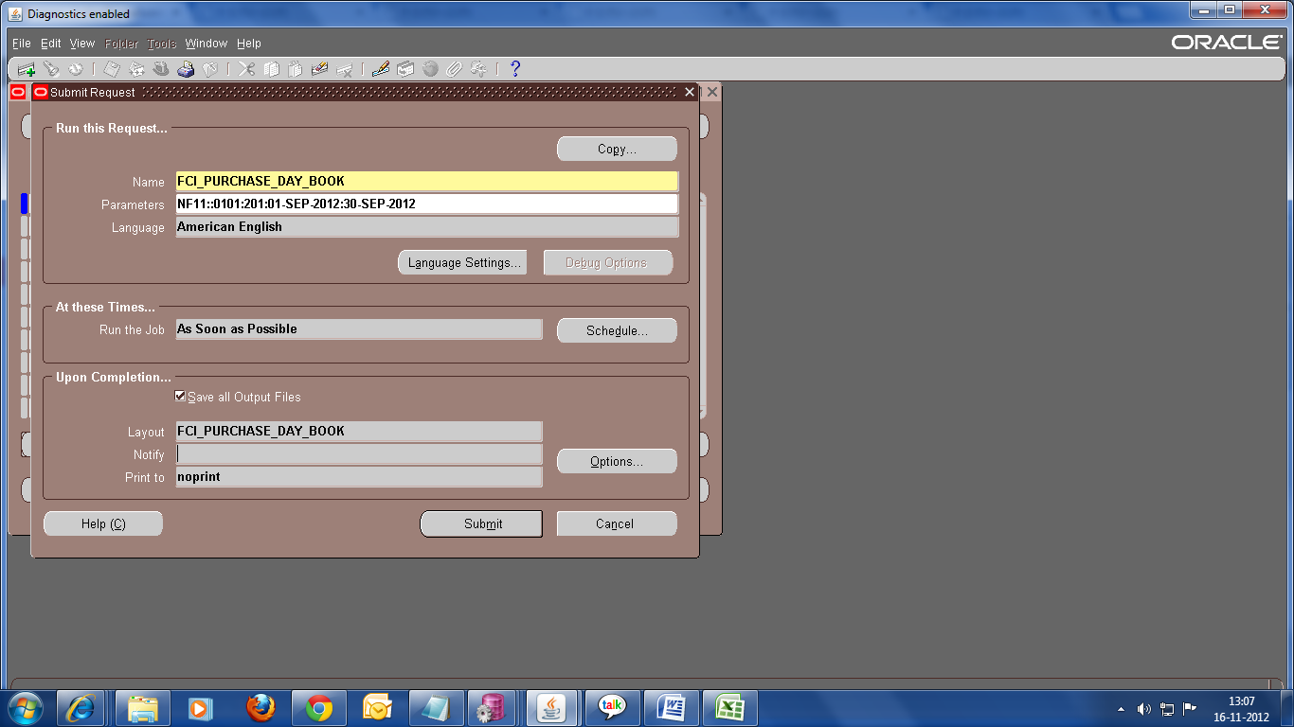7

2. Choose format as EXCEL, as shown in the screenshot below:

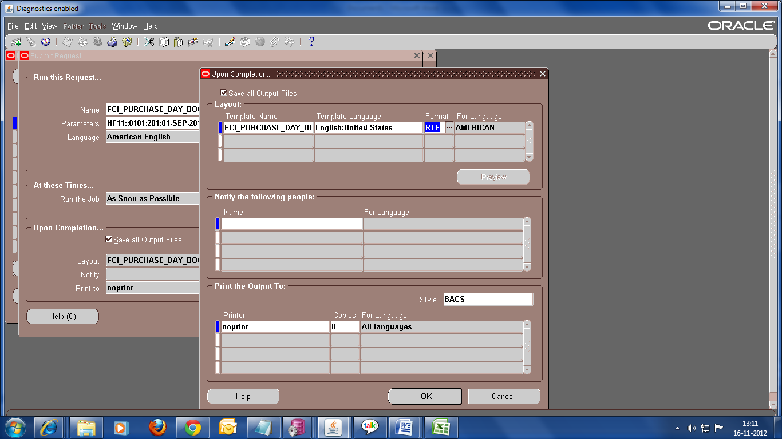

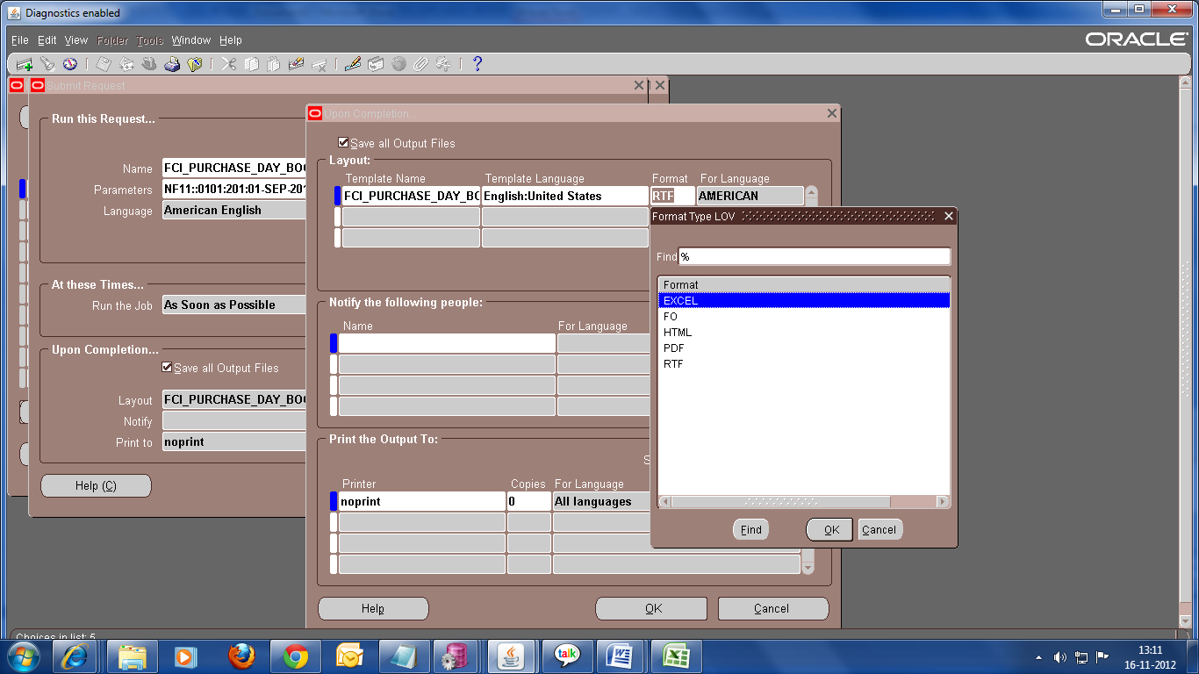

Click Ok and run the report.
You will get the output of the report in Excel form.

Sample output in excel format is attached below.
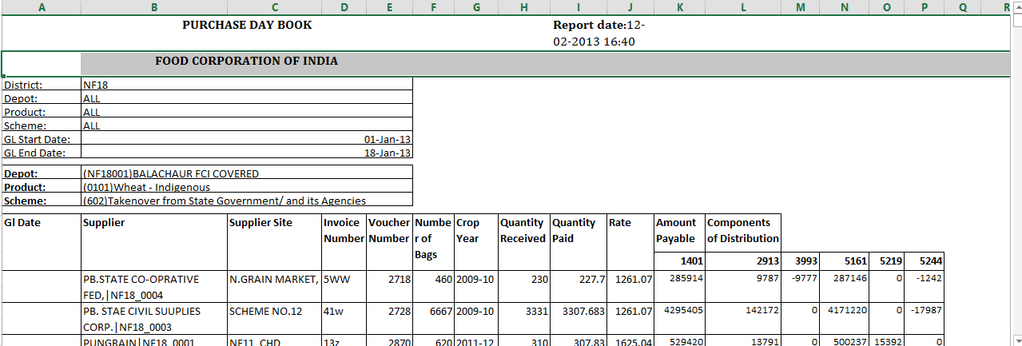

FCI Transaction Available For Reconciliation : (CR no. 248 Conversion of Report to Excel format )

- Transaction Available For Reconciliation has been customized, converted to excel and renamed as FCI Transactions Available For Reconciliation.

Please follow the document attached below to run the Excel reports. It is just a sample showing how to run FCI Debtor TB report which again is an Excel format report. You can run FCI TRANSACTION AVAILABLE FOR RECINCILIATION report by following the same process selecting for this report.

1. While running this request click on OPTIONS as red marked in the given screenshot.
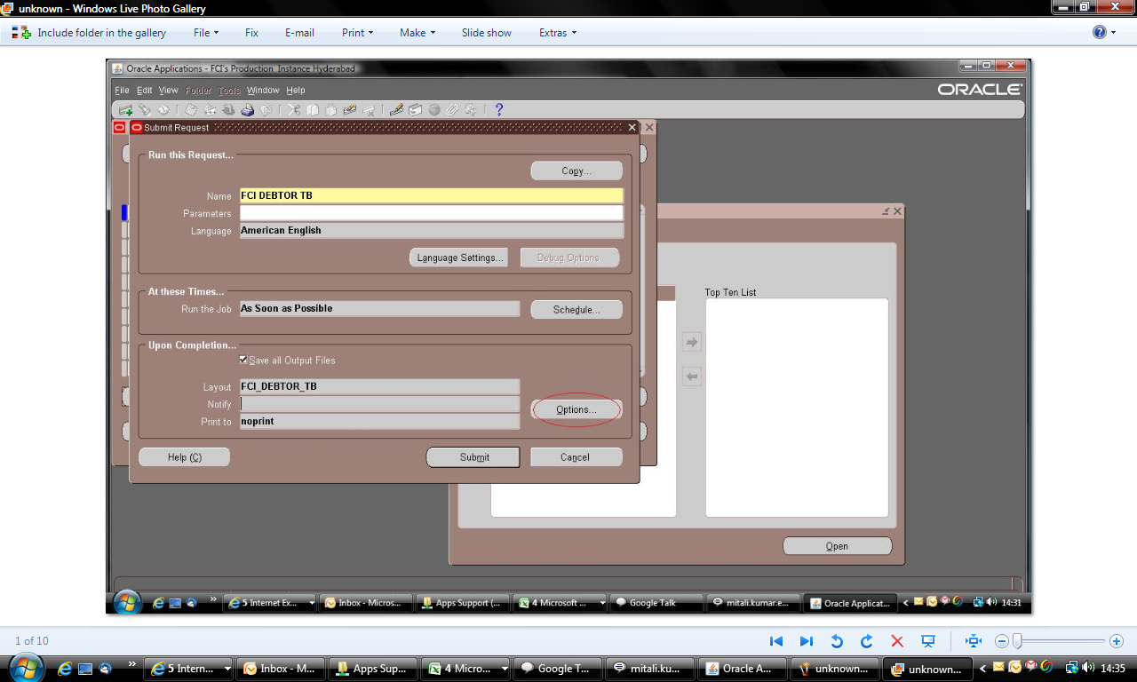
2.Choose format as EXCEL, as shown in the screenshot below:
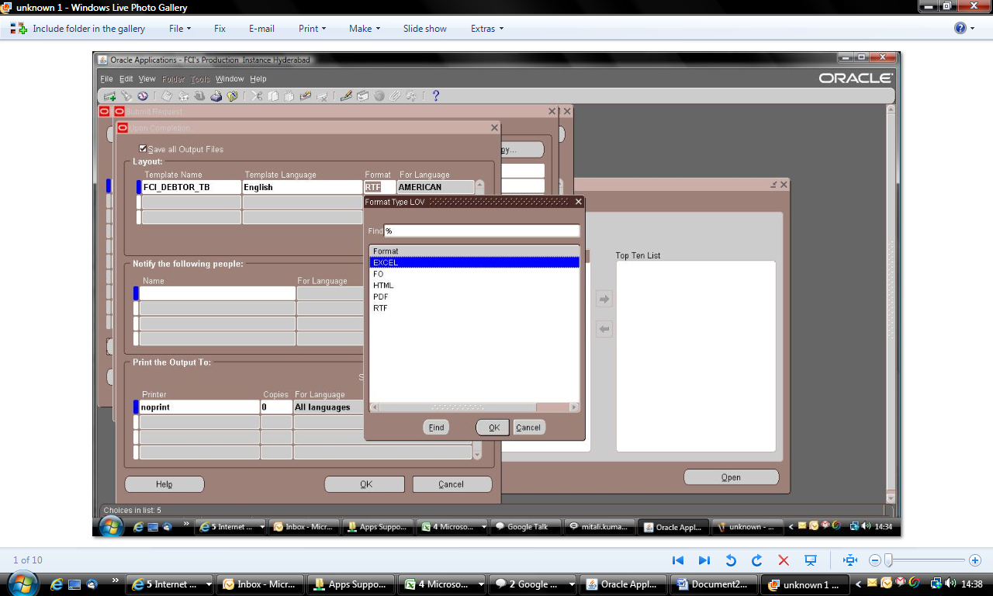.

Sample output in excel format is attached below:

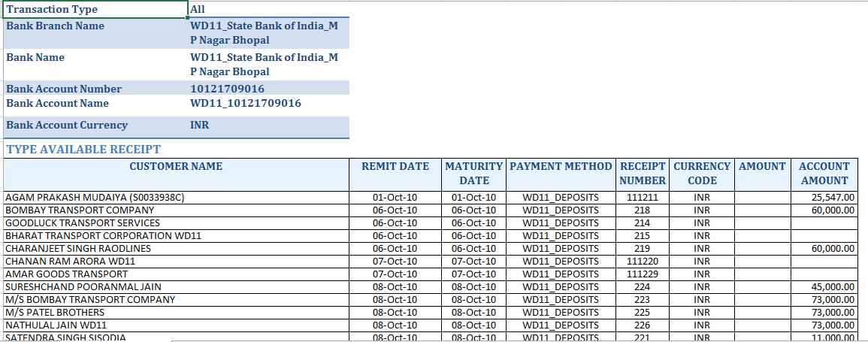

FCI Check Printing:

- FCI check printing has been converted to PDF.

The following changes were made in the rdf of fci_check_printing1.
- The address field has been concatenated to show address line1,address line2,city and state.
- The check number field displays the actual check number which is used to make payment.
- Name has been split into two fields
- Amount in words has been split into two fields

Please follow the document attached below to run the PDF reports. You can run the PDF reports by following the same process.

To run FCI Check Printing in PDF format
1. While running this request click on OPTIONS as red marked in the given screenshot.

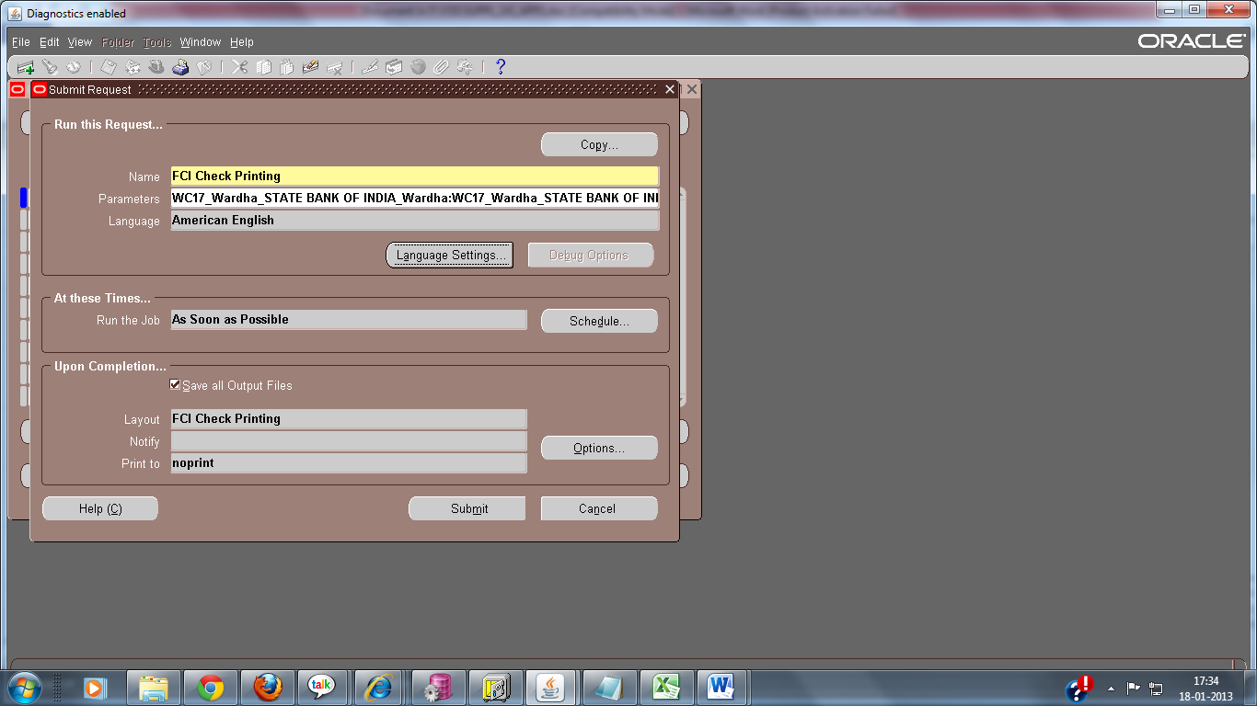

2.Choose format as PDF , as shown in the screenshot below:

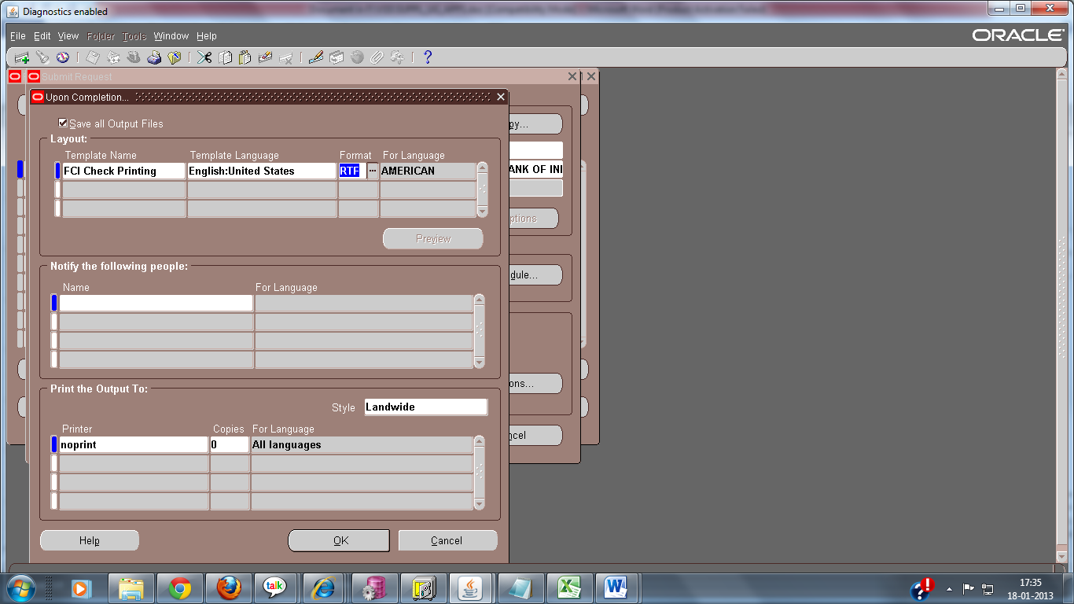

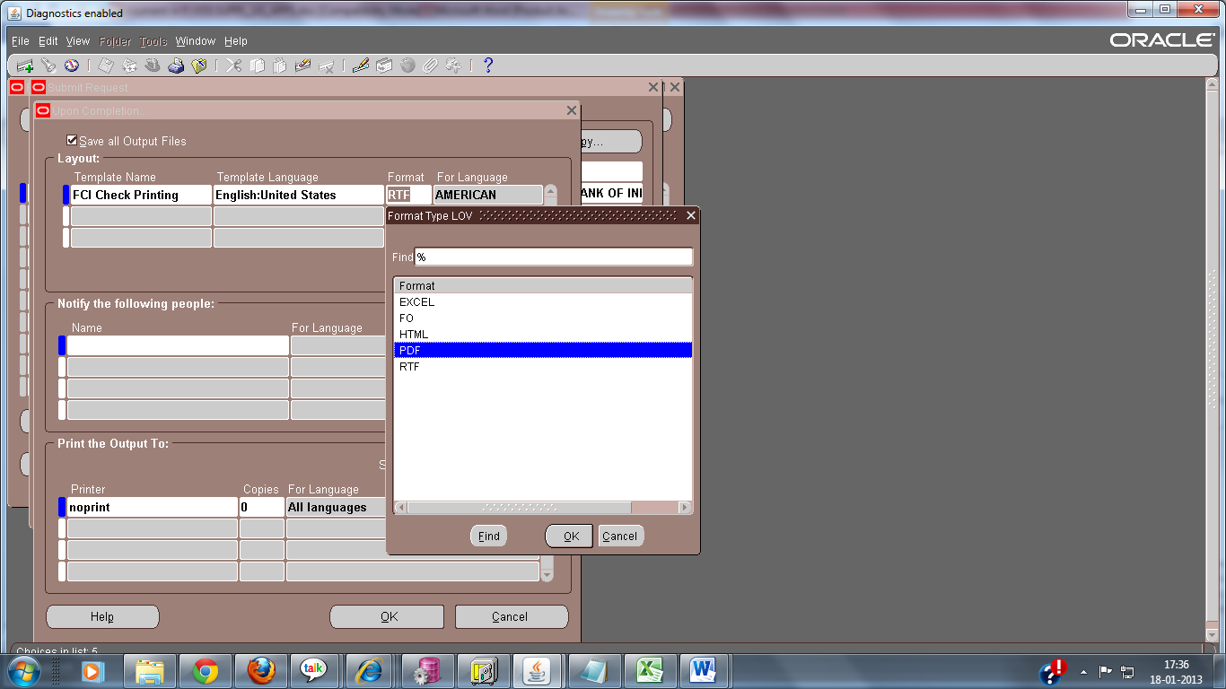

Click Ok and run the report.
You will get the output of the report in PDF form.

Sample output in PDF format is attached below.
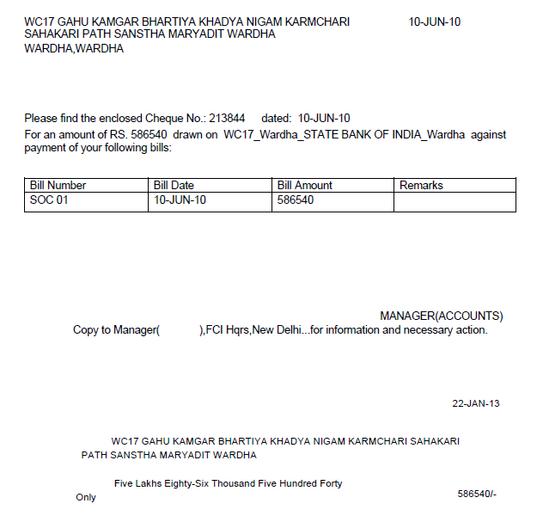
Note: Kindly check that the paper size while taking print out is A4.

FCI India Cash/Bank Book Report

- FCI India Cash/Bank Book report has been converted to Excel.

Please refer to the document attached in section 2.2: FCI Purchase Day book report to run the report in excel format.
Also FCI India Cash/Bank Book report with Distribution has been revoked from Production instance.

- The following changes have been made:

- The report now shows the distribution also.
- Report output can be run with Distribution or without Distribution by providing Yes/No in the parameter while running the report.
- Void payments in AP:

  - Void entry of the voided Payments will be displayed as Type ‘Void’ and this entry will not show Distribution.
  - Amount corresponding to a payment entry will be shown in Payment column and amount corresponding to void entry(which previously used to come as 0.00 ) against the payment will be shown in Receipt column .
  - Void date will be appended to description column in case of payment and Payment date will be appended to description column in case of Void Payment.

- Reversed Receipt in AR:
  - Reverse entry of the reversed receipts will be displayed as Type 'Rev' and this entry will not show Distribution.
  - Amount corresponding to a Receipt entry will be shown in Receipt column and the amount corresponding to reversed entry (which previously used to come as 0.00 ) will be shown in Payment column.
  - Reversed date will be appended to description column in case of Receipt and Receipt date will be appended to description column in case of Reversed Receipt.

- Last effective Revenue details will be available in case of apply and Unapply of receipt on transactions.
- In case of Partial Payments, distribution will be shown only for the first payment and no distribution will be shown for rest of the payments on the corresponding invoice. Similarly for Receipt Application, distribution will be shown once for the first entry.

Sample output is attached below:

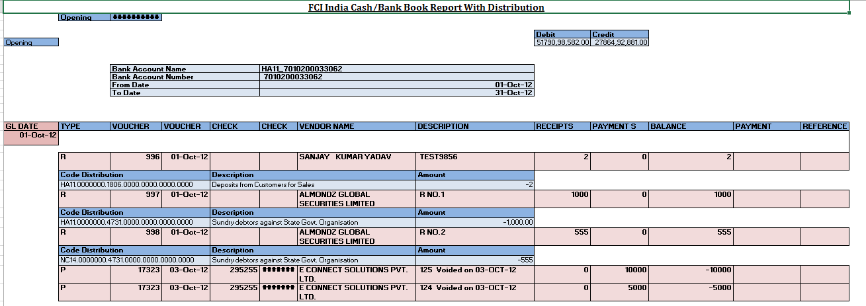

FCI Transfer in Transfer Out Report : (CR no. 248 Conversion of Report to Excel format )

- FCI Transfer In Transfer Out report has been converted to Excel.

Please follow the document attached below to run the Excel reports. You can run the excel reports by following the same process.

To run FCI Transfer in transfer Out in Excel format
1. While running this request click on OPTIONS as red marked in the given screenshot.

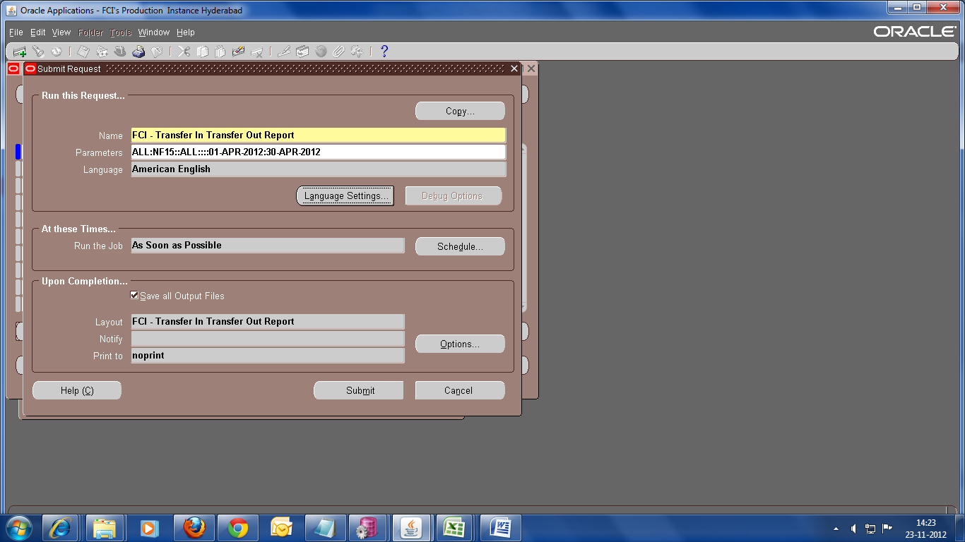

2.Choose format as EXCEL, as shown in the screenshot below:

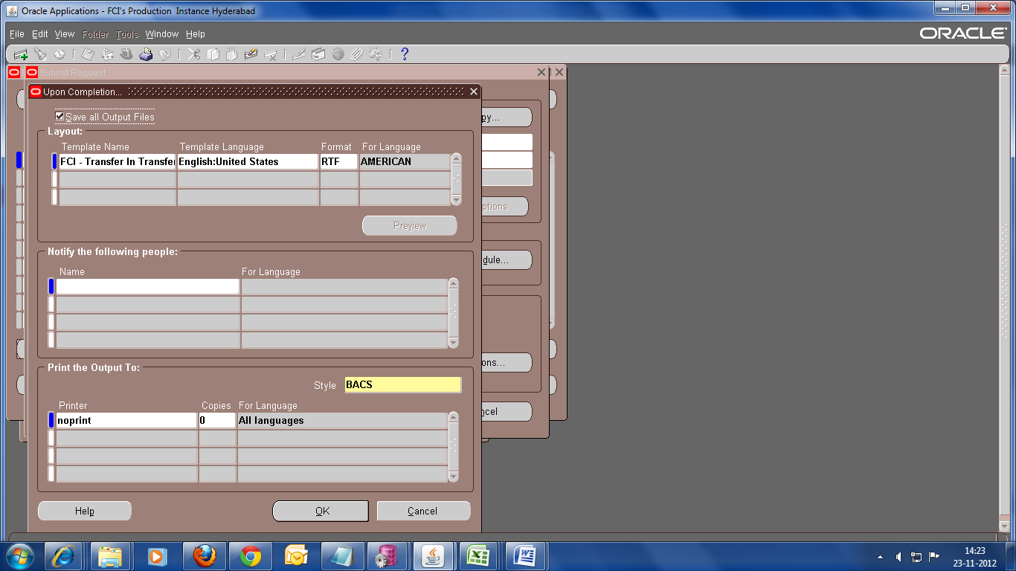

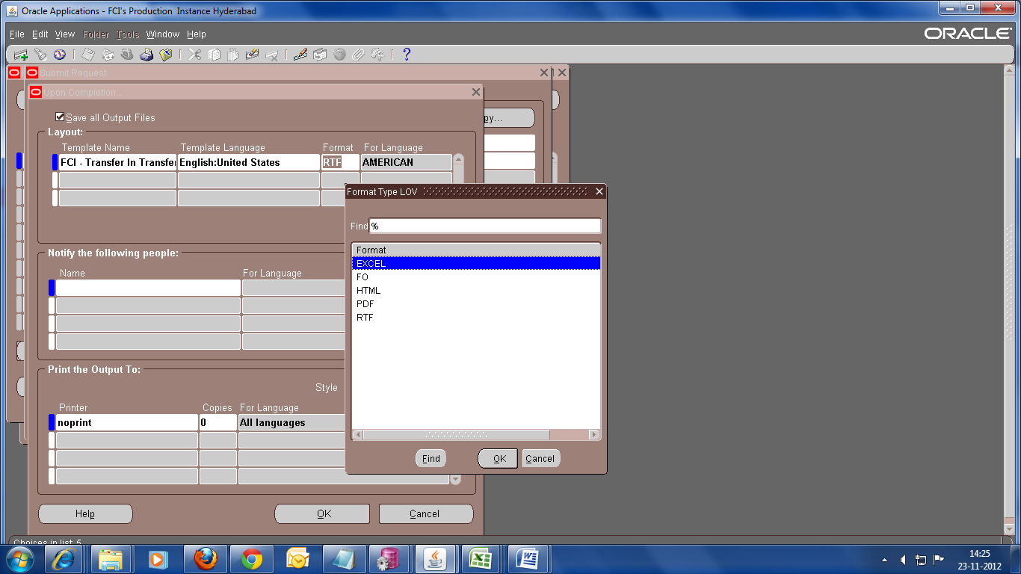

Sample output in excel format is attached below:

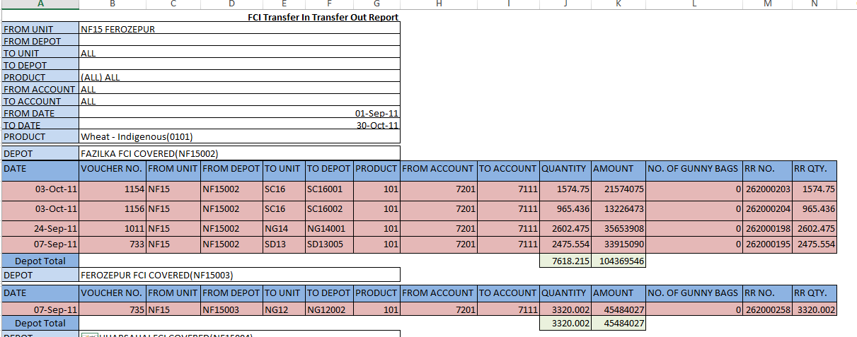

Deployments - December 2012

FCI Prepayments Status Report

FCI Prepayments Status Report is available on production. One mandatory parameter, named Unit is added in the report. The report can only be run for a particular Unit.

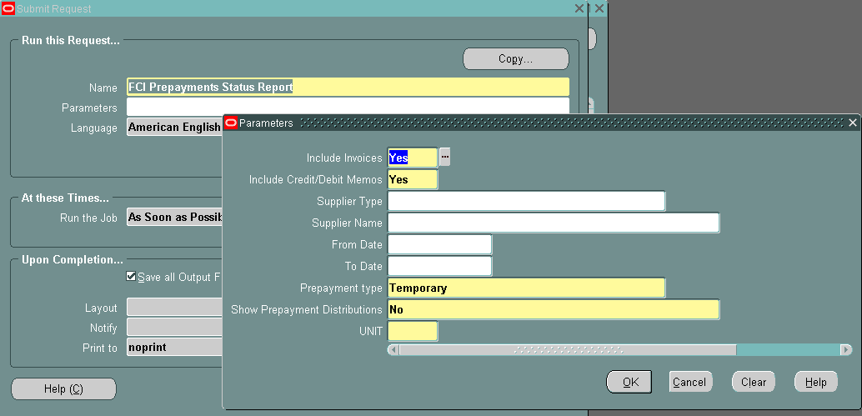

Sample output of the report is attached below:

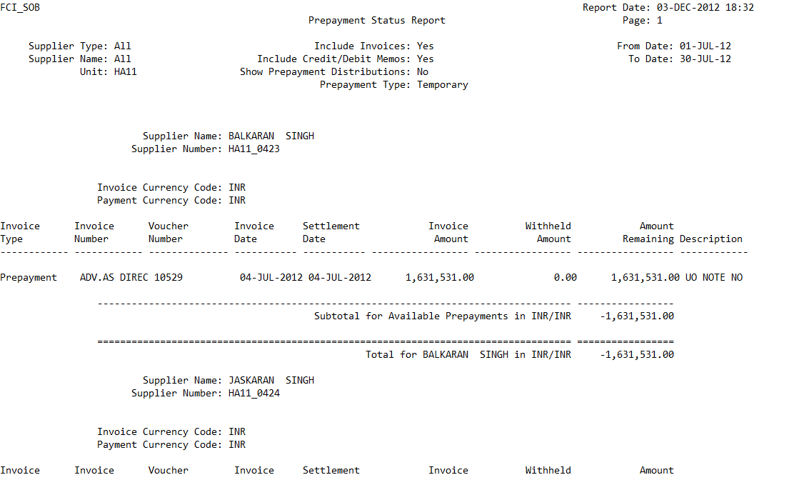

FCI Purchase Day Book : Available in both Notepad and excel format now.

- FCI_PURCHASE_DAY_BOOK report provides data in notepad format .

- FCI_PURCHASE_DAY_BOOK EXCEL provides output in Excel format.

To run the FCI_PURCHASE_DAY_BOOK EXCEL please follow the instructions given in the file attached(How to run Purchase Day Book in Excel format ) in Section 2.2 of this document.

Restrictions during the Interco IOR Creation:-
- one line entered, should be of the UNIT for which category has been chosen.
- Restriction’s for Other unit line are listed below
  - All DO’s can send IOR to their respective ZO’s (North Region can send its IOR to HQ or Rajasthan RO or Punjab RO)
  - ZO can send IOR to HQ and DO’s.
  - HQR can send IOR to all north region (unit code starting with N and H) and ZO’s in other regions.
  - RO Punjab and RO Rajasthan can send IOR’s to the units starting from ‘N’ and HQs (HA11).
  - IOR can be send on above criteria or vice versa.
  - Account numbers are provided by FCI for the same are listed below.
SR. NO | ZONES/HQRS | Bank A/c No.
1 | HQs /North Zone | 30009447399
2 | RO Punjab | 55023970098
3 | West Zone | 30156609067
4 | South Zone | 10640630597
5 | South Zone | 62007252020
6 | North East Zone | 10824154519
7 | East Zone | 1104390666
8 | RO Rajasthan | 51091726718
9 | R.O.CHANDIGARH(HR) | 55023970101

Inclusion of Bank Details in Discoverer Report :Supplier Master Details
As per Headquarter Requirement (CR 256. Inclusion of Bank Details in Discoverer Report Supplier Master Details ) the columns for bank details for the supplier have been added to the report.
The report contains the following Bank Details for the supplier:
- Bank Account Name
- Bank Account Number
- Bank Name
- Bank Branch Name
- Start Date (Start Date of bank account assignment to the supplier)
- Acct. Inactive Date ( Inactive date of bank account assignment to the supplier)

Note : The report will show only the bank details for the primary bank attached to the supplier only.
The suppliers to which no bank account has been attached, the bank details fields will display ‘NULL’. Also if inactive date is null, that i.e the primary bank account attached to the supplier is active. The acct. Inactive date field displays ‘NULL’..

A sample output in excel has been attached for reference:
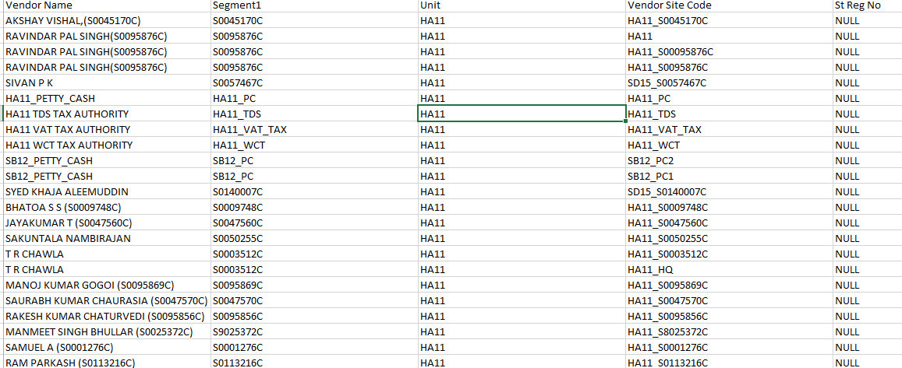f

3.5 Unapplied And Unresolved Receipt Register

Use the Unapplied and Unresolved Receipts Register to review detailed information about your customers' on-account and unapplied payments for the date range that you specify. Having an understanding of a customer's on-account and unapplied payments more accurately indicates how much a customer actually owes you.
This report includes all receipts that are not fully applied to customer transactions. This includes receipts with unapplied cash, in addition to receipts with applications that require resolution, such as applications to:
- On Account
- Claim Investigation (for users of Oracle Trade Management only)
- Prepayment
This report excludes receipts applied to activities that do not affect the customer balance, such as receipt write-offs, short-term debt, and credit card refunds. For example, when you create a credit card refund, it is the credit memo associated with the refund that affects the customer balance (and is reported in the Transaction Register).
This report also excludes miscellaneous receipts.
When reconciling, the Unapplied and Unresolved Receipts Register's total should match the Unapplied Receipts Journal.

Report Parameters

Format Option: Choose the format to use to print your report. You can choose from the following:

Detailed: This option includes customer name, customer number and the GL date for this line as well as the payment balance information.

Summarize : This option includes customer name and customer number as well as the payment balance
information.

Batch Name: Print report information for the receipt batch range that you specify.

Batch Source: Print report information for the receipt batch source range that you specify.

Entered Currency: Print report information for the currency code that you specify. If you do not enter a currency, Receivables prints all amounts in your functional currency.

Customer Name: Prints report information for the customer name range that you specify.

Customer Number: Print report information for the customer number range that you specify.

GL Date: Prints your report information for the general ledger date or general ledger date range that you specify. Specify a complete GL date range to display all unapplied and unresolved receipts for that period. Or, to display all unapplied and unresolved receipts as of a particular date, enter a date for the GL Date To parameter only.

Receipt Number: Print report information for the receipt number range that you specify.

Report Headings

Company Segment: The balancing segment from the Accounting Flexfield.

Currency: The currency code you specified for this report in the report parameters.

Format: The format you selected for this report in the report parameters.

GL Date (Date) to (Date): The GL date range you specified for this report in the report parameters.

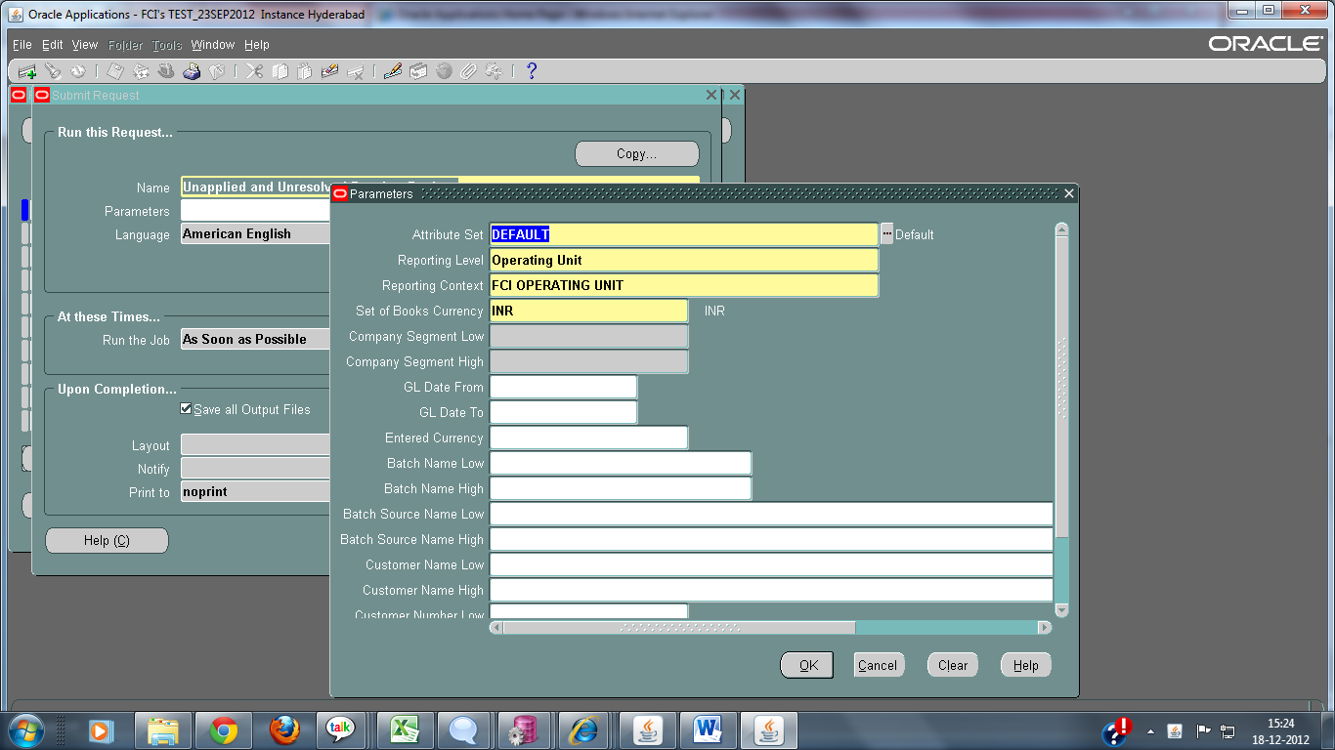

A sample output is attached:
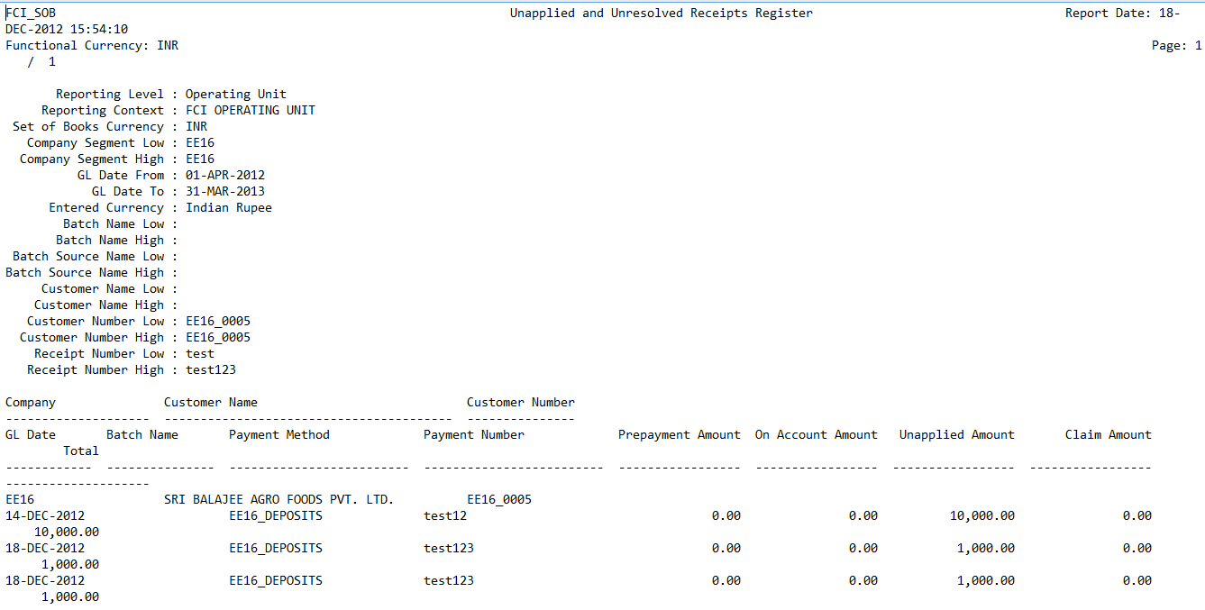

Print Invoice Notice

This report generates a standard invoice notice to send to a supplier to inform them about one or more invoices you have entered. For credit/debit memos, the notice informs the supplier of outstanding credit or debit memos that you will apply to future invoices.
Print Invoice Report is used to print multiple invoice notices for invoices that match selection criteria you specify in the Report parameters.

Report Parameters

Enter any of the following parameters to limit the number of invoice notices Payables creates. If you enter no parameters, Payables will create invoice notices for each invoice you have entered in Payables. The input parameters are:
- Supplier Type.
- Supplier Name.
- Pay Group.
- Invoice Type.
- Invoice Number.
- From: Start date for a range of invoice dates.
- To: End date for a range of invoice dates.
To customize the signature block on the invoice notice:
- Name of Sender.
- Title of Sender.
- Phone of Sender.

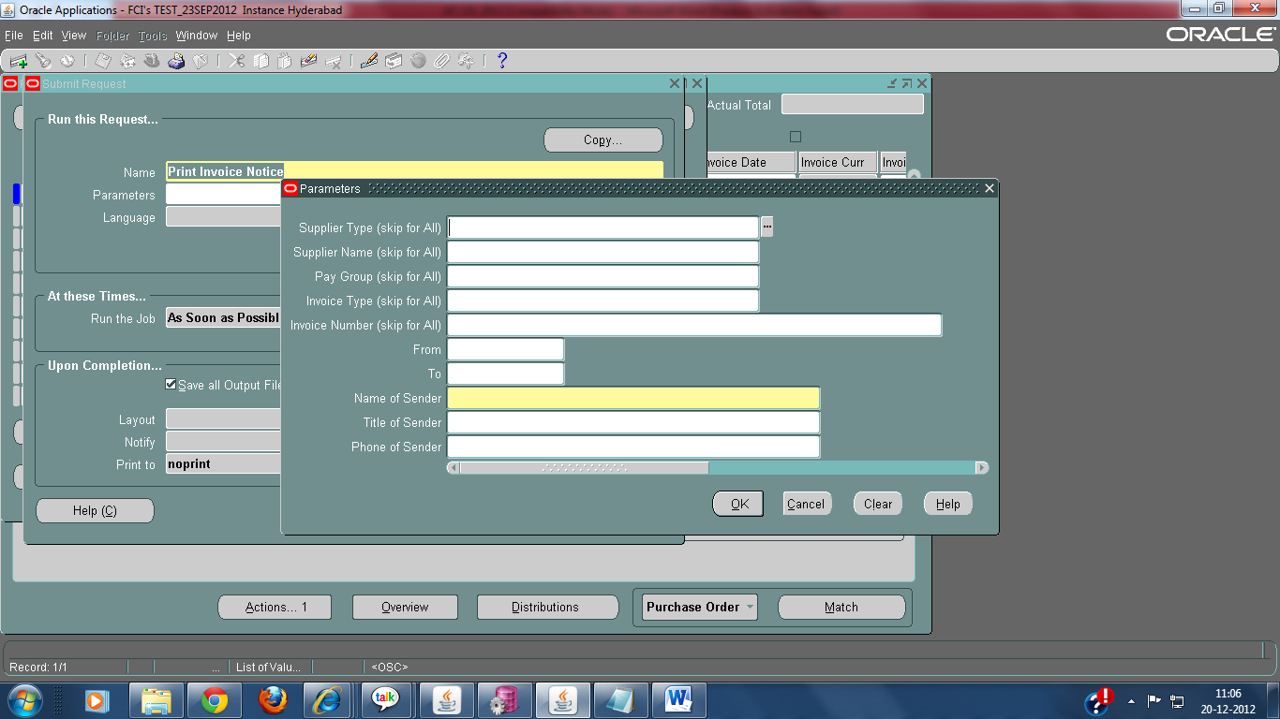

The output fields of the report are as follows:
- Unit Code
- Invoice Num.
- Voucher Num.
- Supplier Num.
- Supplier Name
- Supplier Address
- Account Description
- Payments
- Deductions

CR 221: Supplier Data Validation

Checks for Supplier and Supplier Sites.
User cannot make changes in supplier master details of suppliers of other units.He would be able to make changes in suppliers of his unit only. For ex: If a supplier belongs to HA11,supplier master details will get updated only from HA11 Payables responsibility.
The supplier number field would be grayed out(non-editable) once saved. User will not be able to make any changes in supplier number once it is entered and saved.
User will not be able to make changes in supplier sites of other units. For ex: A supplier of HA11 cannot make any changes in sites of WA11.
First four characters of liability account should match either supplier number or site code for creating a new supplier.

CR 248: FCI Transfer in against Stock received.

- FCI Transfer against Stock Received has been converted to Excel.

Please follow the document attached below to run the Excel reports. You can run the excel reports by following the same process.

To run FCI Transfer in transfer Out in Excel format
1. While running this request click on OPTIONS as red marked in the given screenshot.

2.Choose format as EXCEL, as shown in the screenshot below:

Sample output in excel format is attached below:

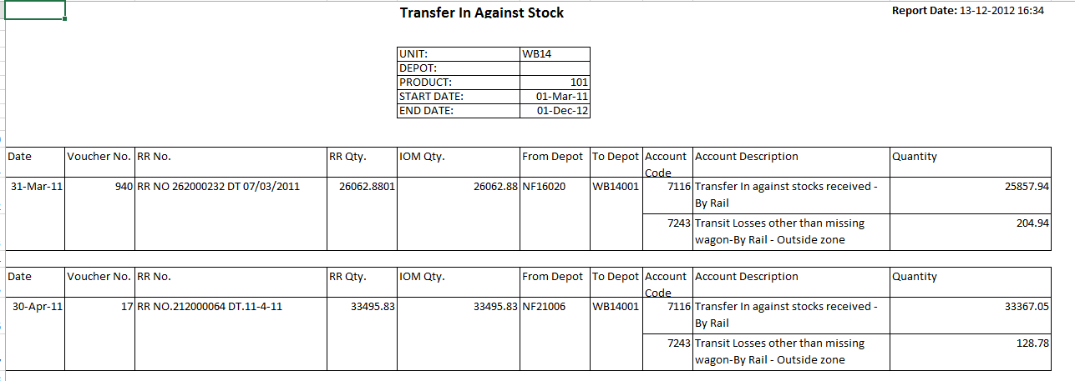

Deployments - January 2013

FCI Sales Day Book
- FCI Sales Day Book report has been converted to Excel.

Please follow the document attached below to run the Excel reports. You can run the excel reports by following the same process.

To run FCI Sales Day Book in Excel format
1. While running this request click on OPTIONS as red marked in the given screenshot.
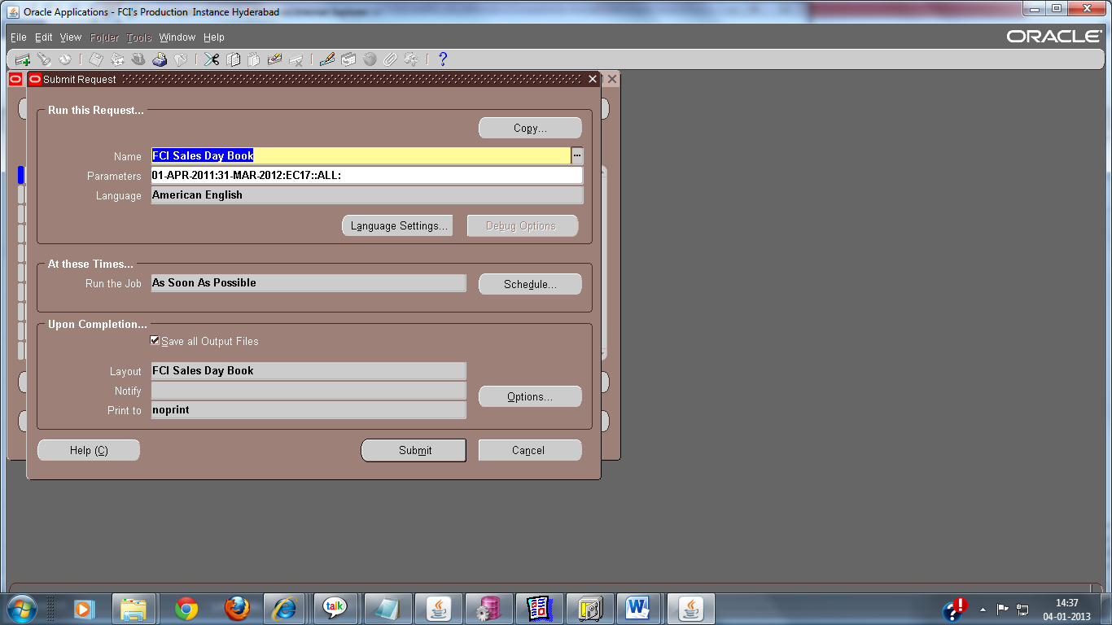

2.Choose format as EXCEL, as shown in the screenshot below:

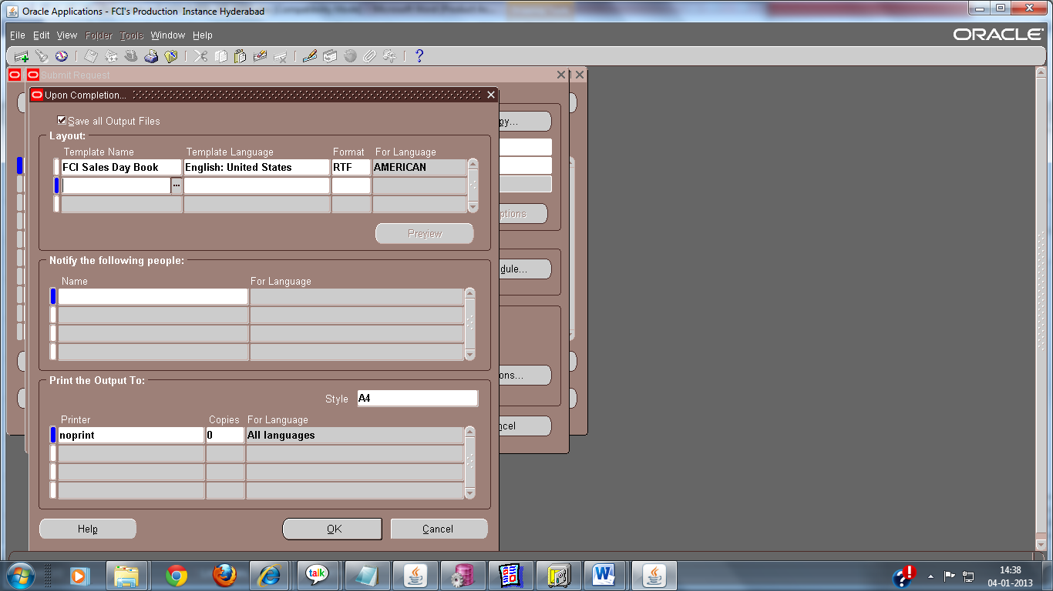

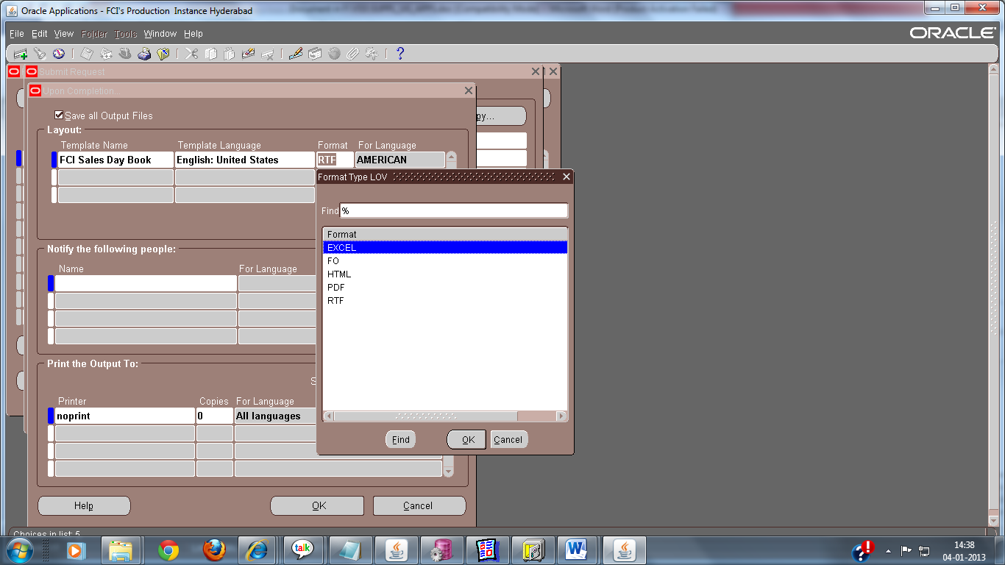

Report will follow these points:

- Transactions with “UNIT_SALES” as Source only will be reflected in report.
- Voided transactions will be not included in the report.
- Transaction line details will be shown as “Sales” header in report.
- Tax name shown is taken from the account code of tax applied.
- Following note will be displayed at the top of the report.
*Tax Rates are in Percentage (%)
Sales Rates are in Rupees (Rs.)
- Quantity field in tax column will be shown as “-“.
- Credit memo with positive quantity will be shown as “-” in the report.
- Negative quantity in credit memo will be reflected in the report.
- Lines other than Sales and tax applied to them will be not shown in the report.
- Sorting will be done on the order Depot, Product, scheme, gl_date and Trx_number.
- Gl_date will be first and Trx_number will be next for transaction details.
- Comments Column in more tab of transaction will be shown as Particulars in report.
- Totals will be shown for the combinations of Depot, Product and scheme.
- Report totals also shown at the end of report.
Sample output in excel format is attached below:

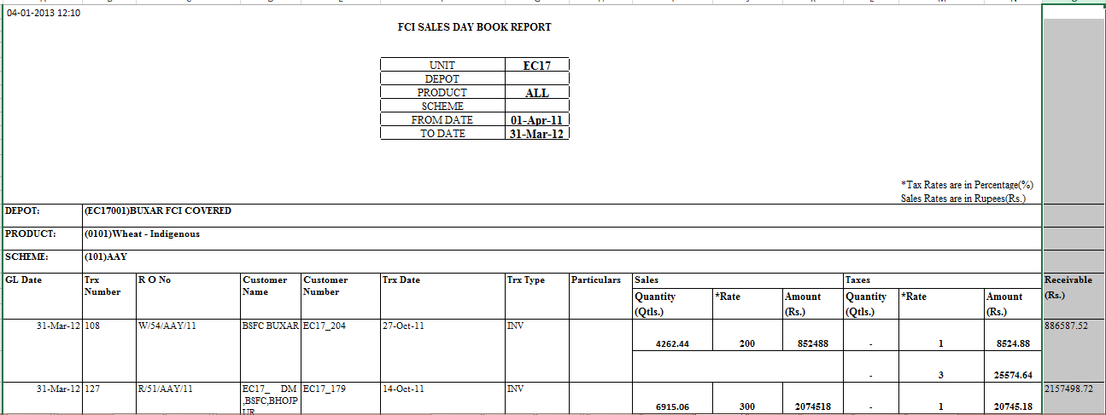

Addition to CR 221

Supplier master details for suppliers created from payroll starting from (S….C (Employee), D…C (Departmental), L….C (Labor)) will be entirely non-editable for users.No changes could be made in master form for such suppliers.

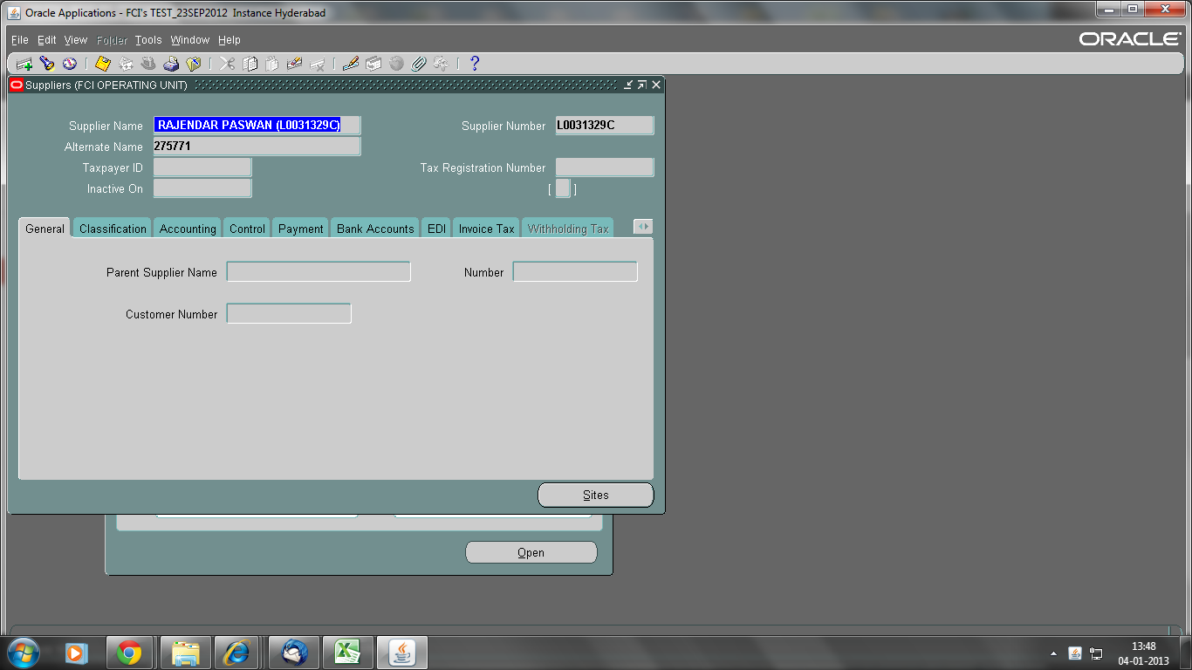

FCI Trial Balance Summary 1
The Trial Balance Summary1 report has been converted to excel format. The required parameters are same as text report.

The snapshot of reports are given below:
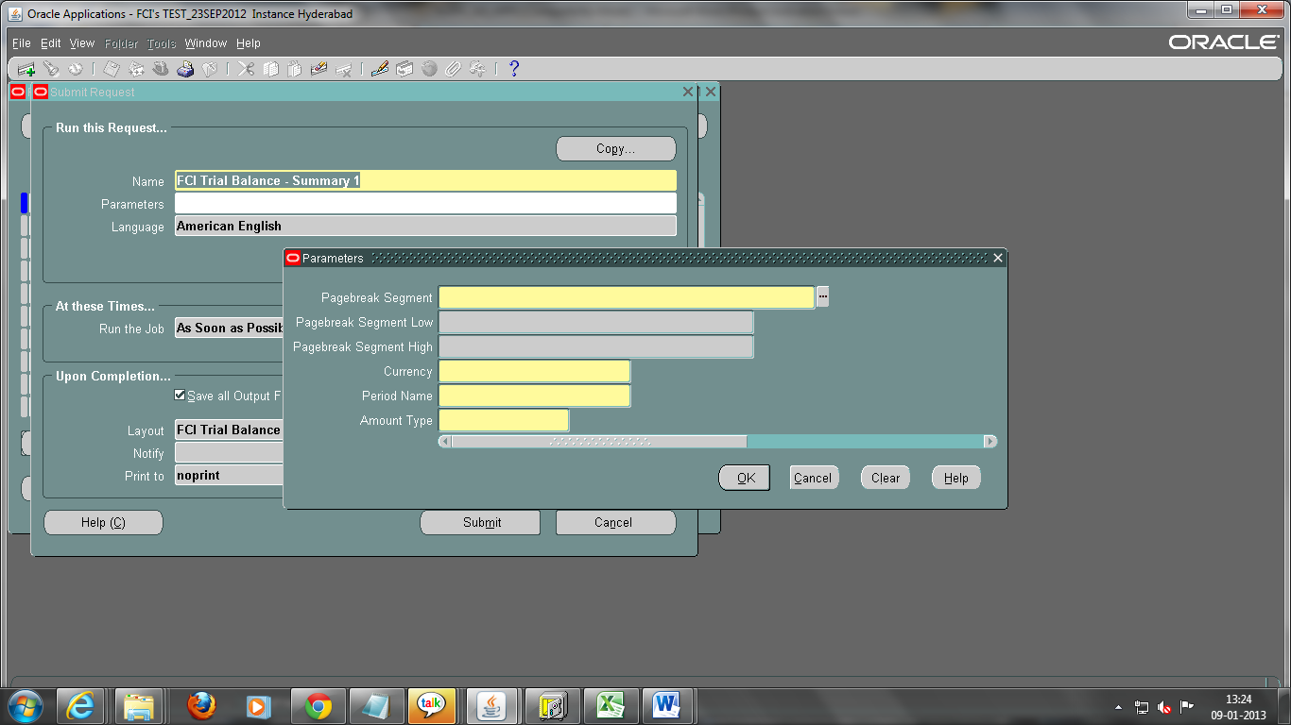

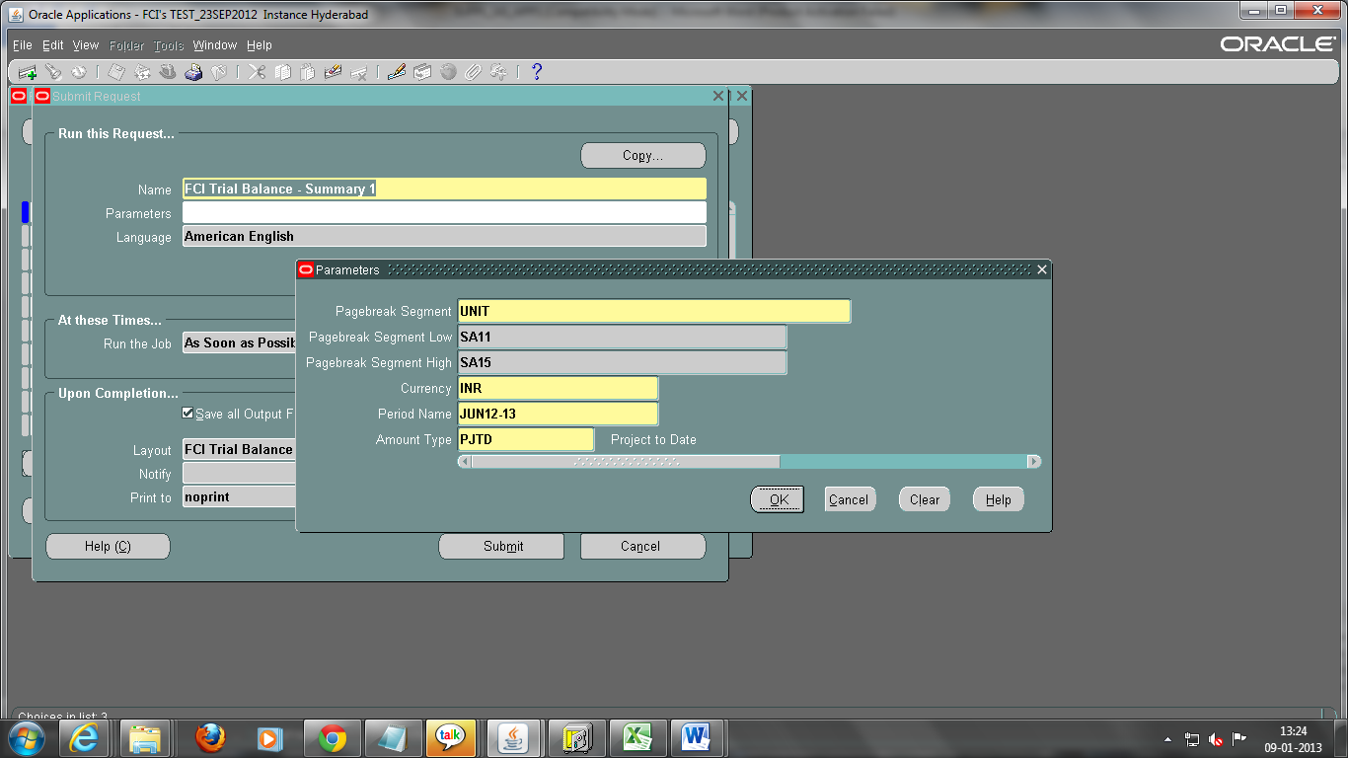

The procedure to execute an xml report is given in below document:
1. While running this request click on OPTIONS as red marked in the given screenshot.
2.Choose format as EXCEL, as shown in the screenshot below:
.
You will get the output of the report in Excel form.

The sample output of this report is attached below:
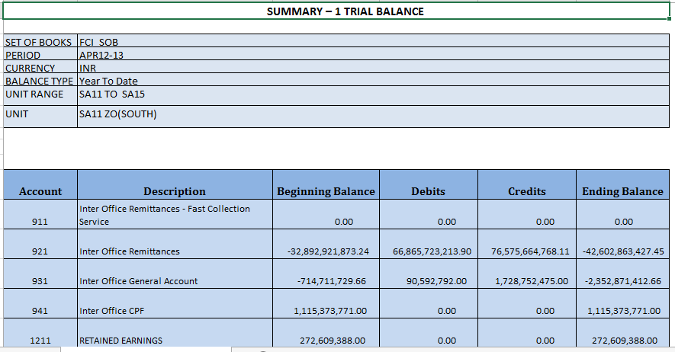

Security Check :

- Accounts Payables :

- Security rules assigned to all the custom responsibilities(Except InterCo Payables responsibilities) that are assigned to the users. This will prevent the usage of liability account / Distribution accounts of unit other than the User’s own unit.

- For all payables responsibilties(Including InterCo Payables responsibilities): Restriction on Payment form is applied so that a user can’t make payment of any invoice that has the Liability Account of some other unit. On Payment Batch form, from normal responsibility , invoices having the first four characters of the pay group same as the first four characters of the responsibility being used can be picked in the payment batch. It will not check the liability account of the invoice as it is seeded oracle feature.

- For all payables InterCo responsibilties: Payment Batch form will be removed. In case a user needs to make payment of an InterCo Invoice(Having paygroup of the user’s unit) , he can do it only by Quick Payments method.

- For all payables responsibilties(Except InterCo Payables responsibilities): Restriction is applied so that a user will not be able to query/view the payments and payment batches beloging to another unit (The first four characters of the Bank Account should be same as the first four characters of the responsibility that the user is using , to get to view the payments/payment batches).

- For all payables responsibilties : At the time of creation of a payment batch , the pay group selected should be belonging to the user’s unit only. Payment Batch form is revoked from Payables InterCo Responsibilitites.

- For all payables responsibilties(Except InterCo): The user can only view the invoices that has the pay group AND Liability Account AND Document Category (either belonging to the user’s unit OR Standard Invoice OR Credit Memo Invoices (For TDS invoices) ) . This will prevent the user of another unit from validating / Approving /putting hold / cancelling any invoice of other unit.

- For all payables InterCo responsibilties: Restriction on Invoice Entry form is applied which will prevent the user of another unit from validating / Approving /putting hold / cancelling any invoice that doesn’t have the pay group OR Liability Account OR Document Category belonging to the user’s unit . The user will only be able to view the invoices that has the pay group OR Liability Account OR Document Category belonging to the user’s own unit .

- For all payables InterCo responsibilties: A check is added in system which makes sure that at the time of creation of an invoice , Pay group and the liability account both should belong to a single unit. (For normal responsibility as the security check is applied , the user will not be able to pick the liability account of another unit , also there is a personalization which prevents the user from picking the pay group of some other unit.)

- Earlier the TDS invoices use to get generated with blank pay group , provisions are made to add pay group same as that of the original invoice, in TDS invoice. Also Data fix is applied to populate pay group in existing TDS invoices , same as that of the original invoice , to which the TDS invoice belongs.

- For all payables InterCo responsibilties: A check is applied which makes sure that while creation of a new invoice , either liability account OR the first line of the distribution Line should belong to the user’s unit.

- For all payables responsibilties(Except InterCo): A restriction is applied on Invoice entry form which will prevent the user from selecting the supplier of another unit. The personalization checks whether the first four characters of the responsibility in use (ex HA11 in case we are using ‘HA11 Payable User’) are same as the first four characters of the selected Supplier site’s Liability account.
(There is already a personalization on Supplier Entry form which makes sure that either Supplier number or the supplier site name has the unit code appended to it , and the liability account used for the supplier belongs to the supplier’s unit only.)

- Accounts Receivables :

- Security rules assigned to all the custom responsibilities(Except InterCo Receivables responsibilities) that are assigned to the users. This will prevent the usage Distribution accounts of unit other than the User’s own unit , while creation of a new transaction.

- For all Receivables Responsibility (Except InterCo Receivables responsibilities): In Accounts Receivables , personalization is added on Receipts,Receipt Summary, Transaction and Transaction Summary form which will prevent the user from selecting customer belonging to another unit . The personalization will check whether the first four characters of the responsibility in use (ex HA11 in case one is using ‘HA11 Receivable User’) are same as the first four characters of Customer number or Customer bill to location selected in the invoice.

- For all Receivables Responsibility (Except InterCo Receivables responsibilities): There is restriction applied on the forms Transaction and Transaction summary which will prevent deletion / completion / incompletion/ changes in line items by another unit’s user. The check will compare first four characters of the Source of the Transaction and first four characters of the responsibility being used and only allow the change in case both are same. The user will not be able to view the transaction otherwise.

- For all Receivables Responsibility(Except InterCo Receivables responsibilities) : While creating a new transaction the transaction source and transaction type should be User’s unit‘s only.

- For all Receivables Responsibility(Except InterCo Receivables responsibilities): Customer /Customer Site has been made non updatable after the receipt is transferred to GL unless the Customer is NULL . In case the customer is NULL , only customer could be added after posting of the receipt.

- On Application of the receipt and transaction , the user is allowed to apply the transaction to the receipt only if the Payment method of Receipt and the receivable account of the transaction to which the receipt is being applied belongs to same unit , otherwise the user will get an error. In case the error occurs the user will have to close the main form and reopen it .

- For all Receivables Responsibility : There is a customization added on Receipt and Receipt Summary form which will prevent changes and reversal of receipt which doesn’t belong to the user’s unit. The check will compare first four characters of the Payment Method of the Receipt and first four characters of the responsibility being used and only allow the change in case both are same. The user will not be able to view the receipt otherwise.

- On Credit Transaction form , for normal responsibility : While creating a new transaction ,transaction type and transaction source should be of user’s unit.(According to the responsibility being used)

- Manual Customer creation option is removed from custom responsibilities and it will be an automated process . Please refer section Customer And Supplier of the document.

3. Customer And Supplier :

- The customer creation form is revoked from all the custom receivables responsibilities, so now the customer creation/updation cannot be done manually.

- Any Updation/Creation of a supplier in AP will be reflected in the corresponding customer in AR .

- If supplier site is present but the corresponding customer site is not present, in case any update is made in the supplier site form, a new customer site (location) will be created to the corresponding customer.
Note : If in this case the update made to the supplier site is de-activation of the supplier site the new customer site (location) will not be created.

- From now on , Supplier can only be deactivated on present date , future and past date as deactivation date is not allowed .

4. General Ledger :

- Security rules assigned to all the custom responsibilities(Except InterCo General Ledger responsibilities) that are assigned to the users. This will prevent the usage Distribution accounts of unit other than the User’s own unit , while creation of a new journal through these responsibilities.
- Another cutomization is added on Journal entry form which will prevent Approval / Reserve funds and posting of another unit’s Journals. The check will compare first four characters of the Category of the Journal and first four characters of the responsibility being used and only allow the change in case both are same otherwise it will not let the user view the journal.
The above mentioned check will not be for the journals having category any of the ones mentioned below :
1 Purchase Invoices
2 Balance Sheet Close
3 Credit Memo Applications
4 Credit Memos
5 Debit Memos
6 Misc Receipts
7 Payments
8 Sales Invoices
9 Trade Receipts
10 Transfer
- Budget
5. Folder Creation/Updation : Standard folders are assigned to all the custom responsibilities , no new folders can be created or any updation in the existing folders is not allowed now onwards .

FCI Trial Balance Detail Report:
Trial Balance - Detail has been converted to Excel format and instead of period activity, two columns debits and credits are added in the new report which shows the amount debit and credit in that period.
The new report is available as FCI Trial Balance Detail Report.

The report parameter is same as the text report(Trial Balance – Detail).

The snapshot of the new report is given below:

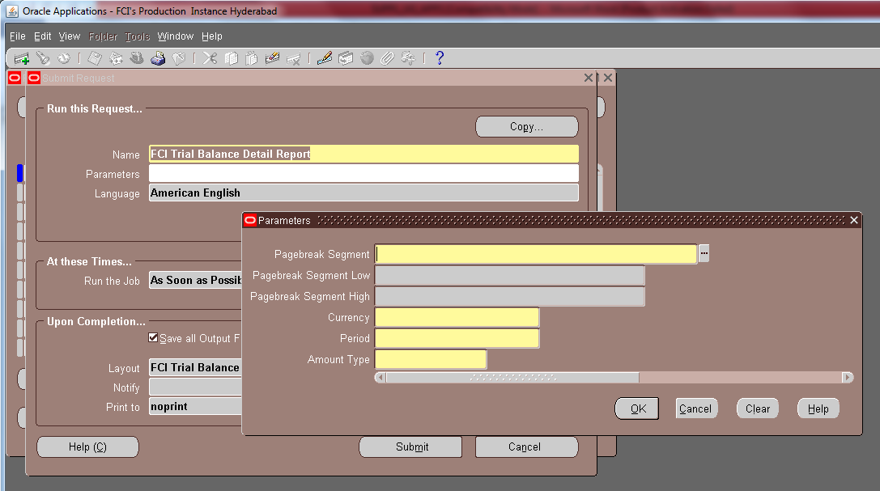
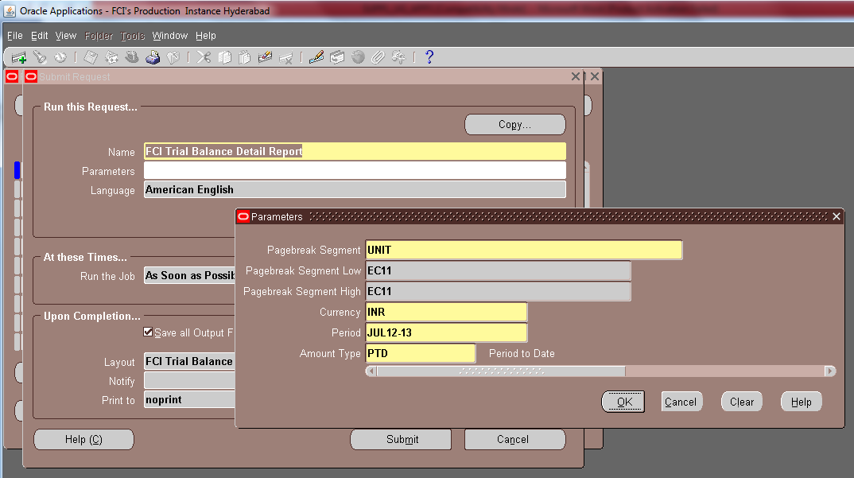

The procedure to execute excel report in given in the attached document:

Click on Ok button
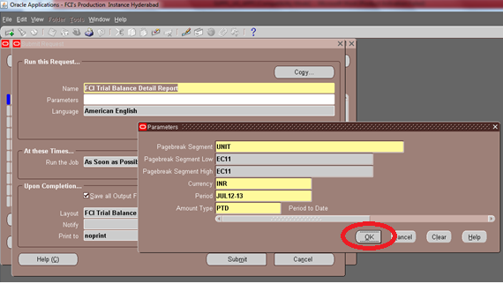

Click on Option Button:
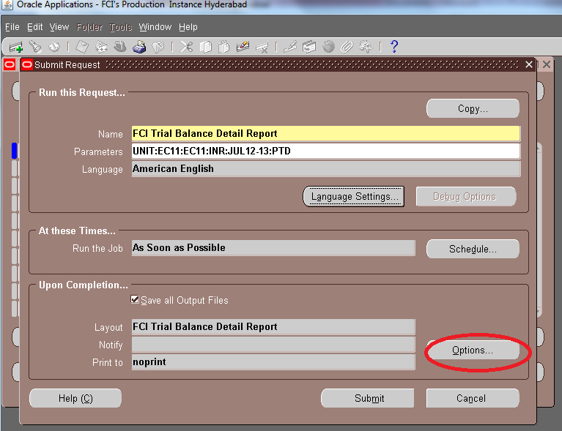
Click on Format and select Excel:
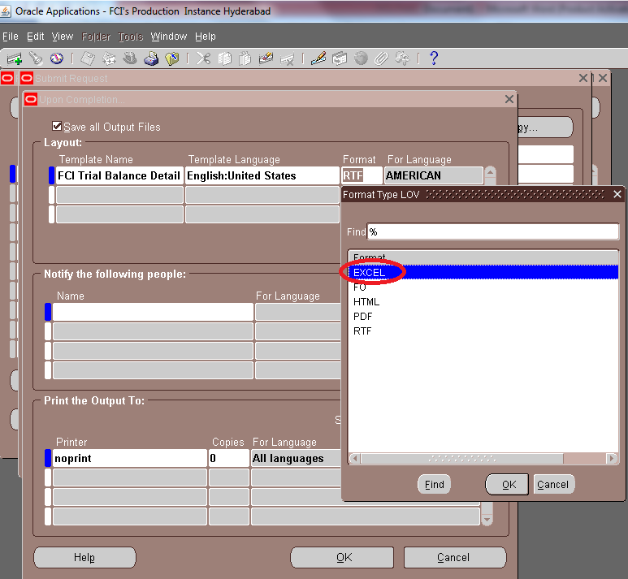

Click OK and submit the request.

The sample output of this report is attached below:

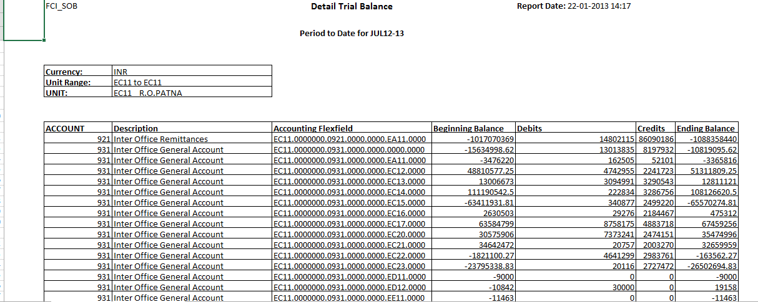

FCI AR Receipts

The have the following parameters:
- Unit (mandatory)
- Cheque No. (Optional)
- From Date (Mandatory)
- To Date (Mandatory)
- Document Number From (Optional)
- Document Number To (Optional)

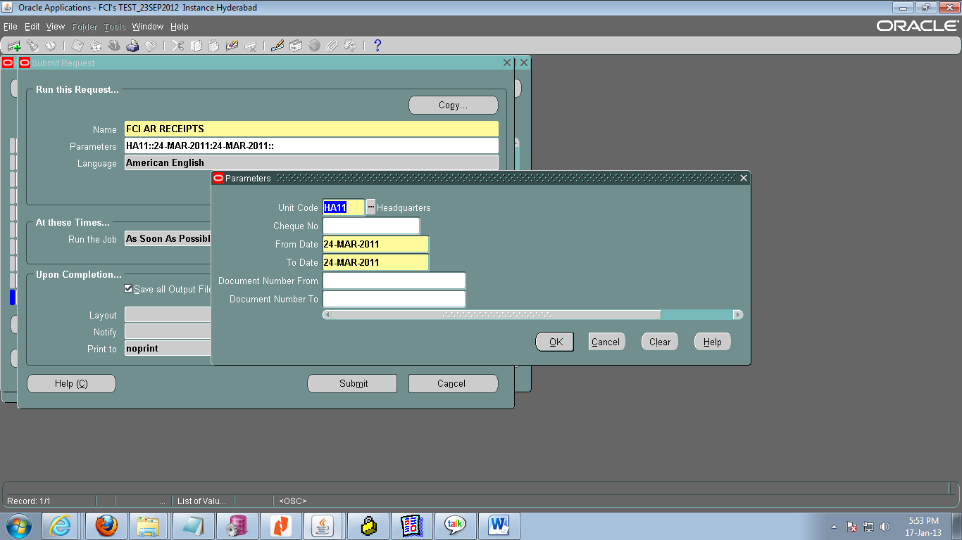

Output of this report is a test file.
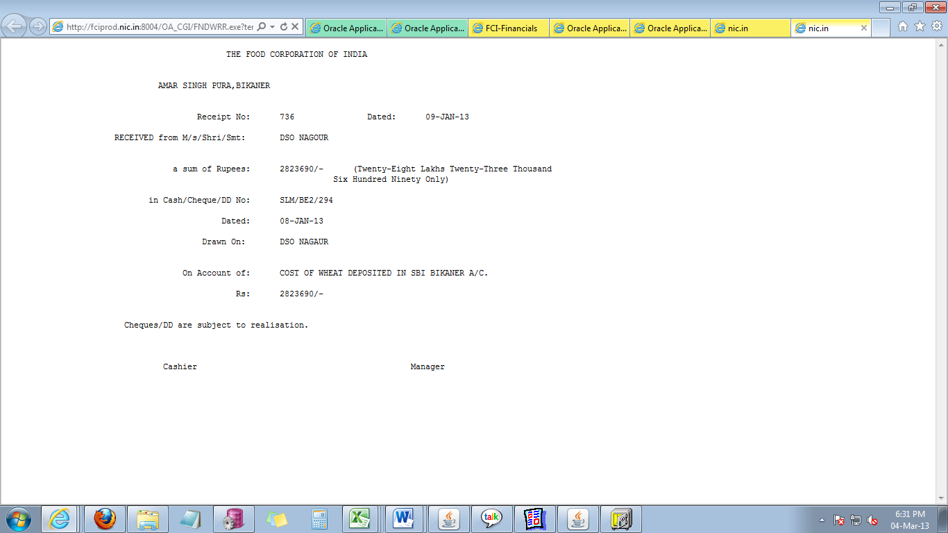

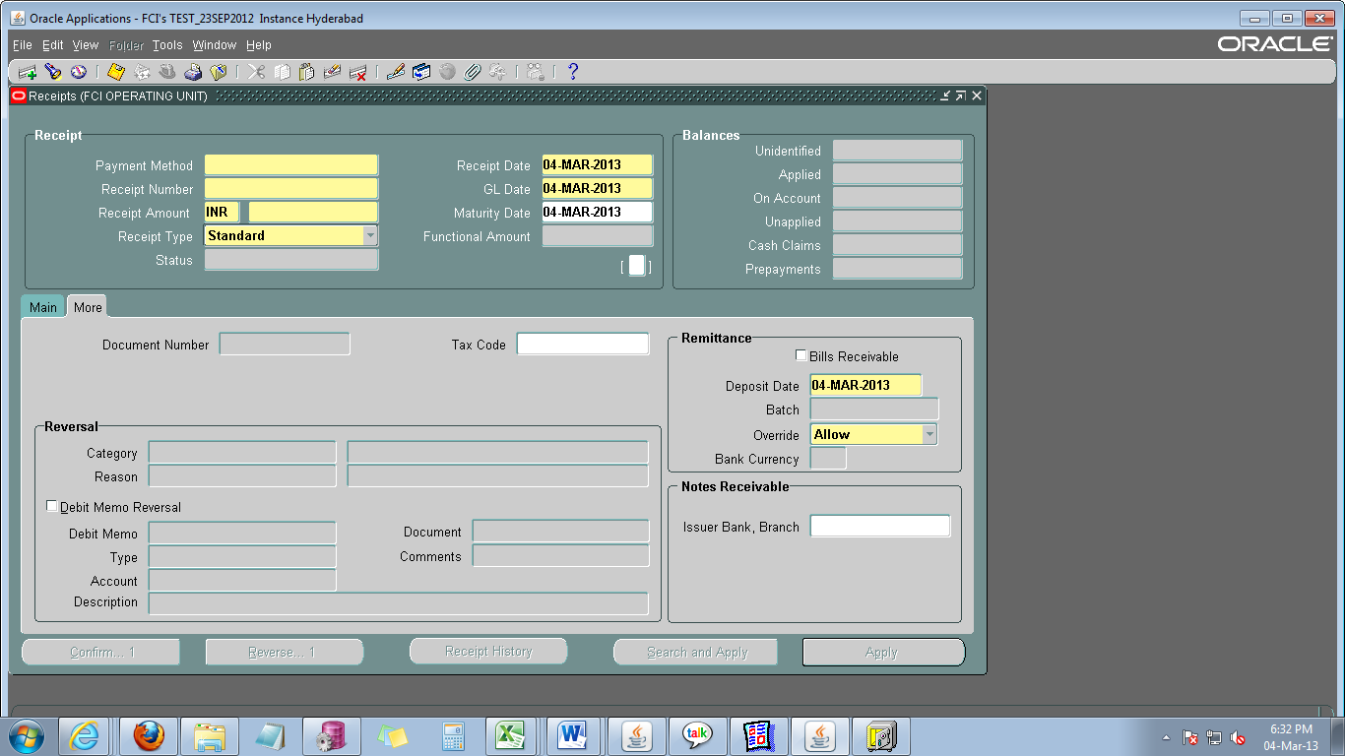

Separate Period Closure

Customization has been done in the system, for opening and closing of periods in AR, AP and GL. Period will be closed separately for individual units .

HQ will handle opening and closing of periods. Units will have to contact HQ for getting the period open or closed.The Units will have to make sure that all the transactions , related to a month in AP , AR and GL are posted before the period get closed for that month.

The period will not be closed until and unless all the entries are posted. Once a period is closed users will neither be able to perform any operation on the transactions of closed period, nor they will be able to create any transaction in closed period.Only the following could be done in closed period:

- AP: After the closure of period, users will only be able to void the payments on the date of opened period.
For Example: If a payment of March 2012 is to be voided, and period for March has been closed, the user will be able to void it on date of April (April as open period.)
- AR : After the closure of period, users will only be able to reverse the receipts, on the date of opening period.A receipt of a closed period can be applied to a transaction on the date which is in open period.
For Example: A receipt of closed period(say March 2012) can be reversed on the date of April 2012 (April as open period), and can be applied to a transaction on the date of April(April as open period).
- GL: After the closure of period, users will only be able to reverse the journal entries, on the date of open period.
For Example: A journal entry of closed period (say March 2012) can be reversed on the date of April (April as open period.)
In case a custom closed period needs to be opened, the provision has been provided to HQ. Units will have to contact HQ for the same.

Automatic Deactivation of Corresponding User in Apps :
Whenever an employee is Retired/Transferred in Payroll :-
Customization is made in system so that now onwards whenever an employee is retired or transferred in payroll , the corresponsing user id will be deactivated in Apps .
Also in case the above mentioned employee is a superuser, all the end users linked with this user will also get deactivated automatically.
The end users will have to contact Support team to get the superuser changed and get their respective user ids activated.
In case the user id is deactivated manually from Apps , even if the the user is a superuser the end users will not get deactivated by itself . The support team will have to deactivate the end users manually.

FCI DEBTOR TB

In the report FCI DEBTOR TB three extra parameters :
- As of Date (Mandatory)
- Customer Number (Optional)
- Customer Name(Optional)
Have been added, Sorting of the report has been done as per Customer Number and then as per GL Date.Two additional details of GL_Date and Invoice Amount has been added in the output.
The screenshot of parameter screen is given below:

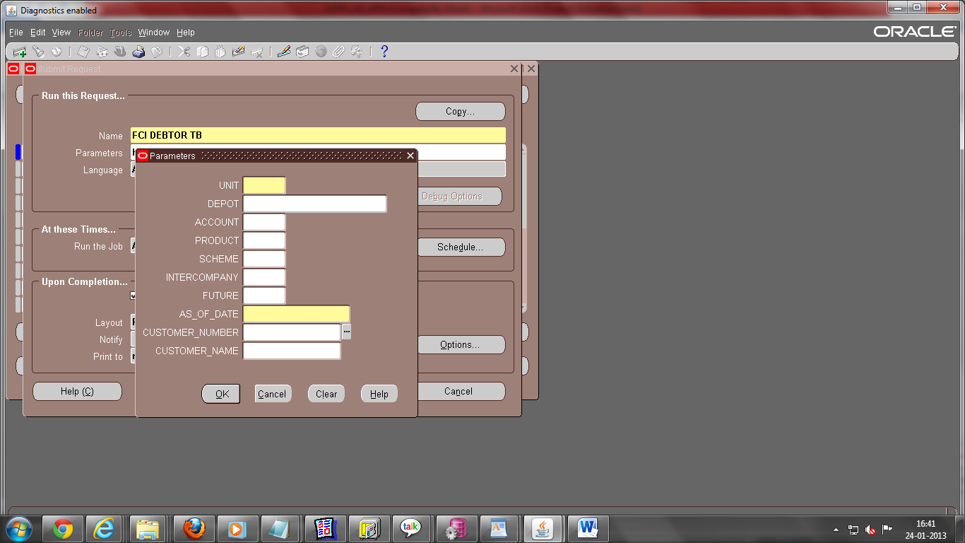

The output is attached below:

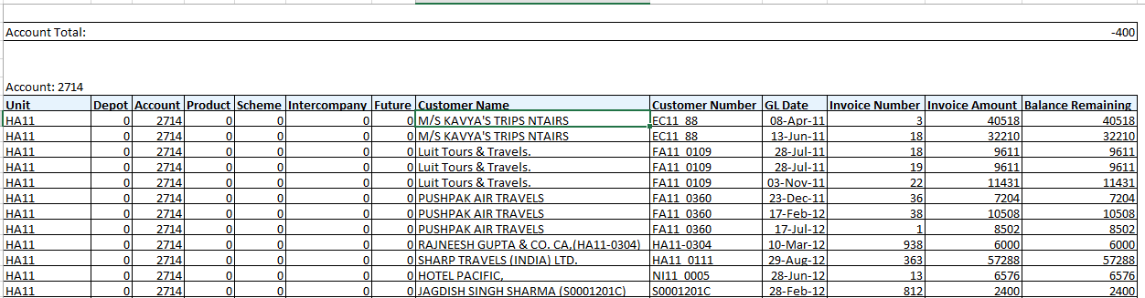

Intercompany Checks added:
- DFF for InterCo IOM Rail Road has been changed with two new mandatory fields, i.e To Account and To Depot.
- DFF for Trf in Stock Recvd has been changed with two new mandatory fields i.e From account and from Depot.
- The Category LOV for General Ledger Inter Co Responsiblity will show options for IOR and Fast Collection only.
- In Distribution , IOM Transfer Out category allows only account codes from 7201 to 7210,7701,7702,7703,7709,7710,0981.
- For interco IOM Rail Road,Transfer in stock received category following checks have been added.
- Same product for all lines.
- Same depot for all or default depot (for account head 0981)can be used.
- Exactly 1 line with account head 0981.
- Intercompany segment cannot be default for line with account head ‘0981’.
- Intercompany segment provided in line with account head 0981 should match with either ‘To Depot ‘ segment of descriptive field in case of interco IOM Rail Road, and ‘From Depot’ segment of descriptive field in case of Transfer in stock received.
Note : RECEIVABLES INTER-CO USER responsibility has been de-activated for all the users.Also no inter-company transactions could be entered in the system from 29-Jan-2013 onwards.

Intercompany Personalizations:
- With account head 0981 default Product could not be taken, whereas default depot can be taken.

Intercompany Reports:

- A new report FCI- Transfer In Transfer Out report New have been added , for new IOM journals entered in the system from 29-Jan-2013 , as shown below :

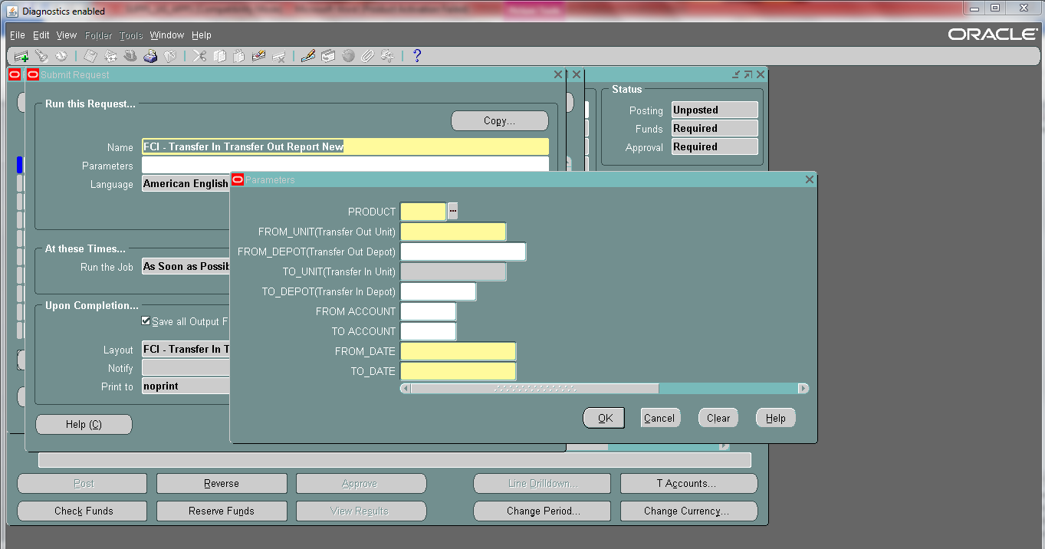

For IOM within same unit , and other journals, old reports of Transfer in Transfer Out and transfer in Against Stock received Report will do.

- A new report ‘FCI Transfer In Against Stocks Received New’ have been made for new Intercompany Transfer In against Stocks Received Journals which are entered in the system from 29-Jan-2013 It is available in Excel format.

The screenshot of the report is shown below:

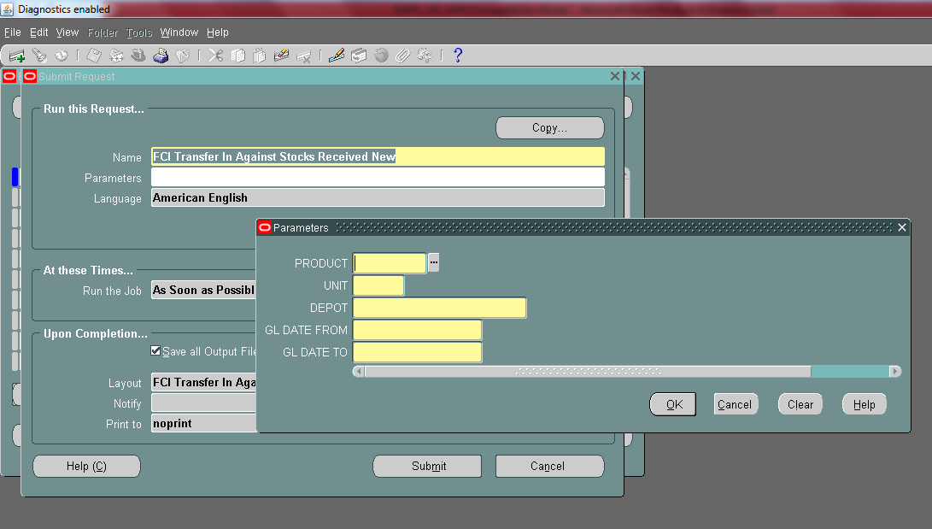

FCI Journal Approval Report
A customized report have been added in GL module named as, FCI Journal Approval Report, which will show the final approver of any journal. The parameters are :

- Unit (Mandatory)
- Category (Optional)
- Batch Name (Optional)
- Journal Name (Optional)
- Document Number (Optional)
- From Date (Mandatory)
- To Date (Mandatory)

The screenshot is attached here:

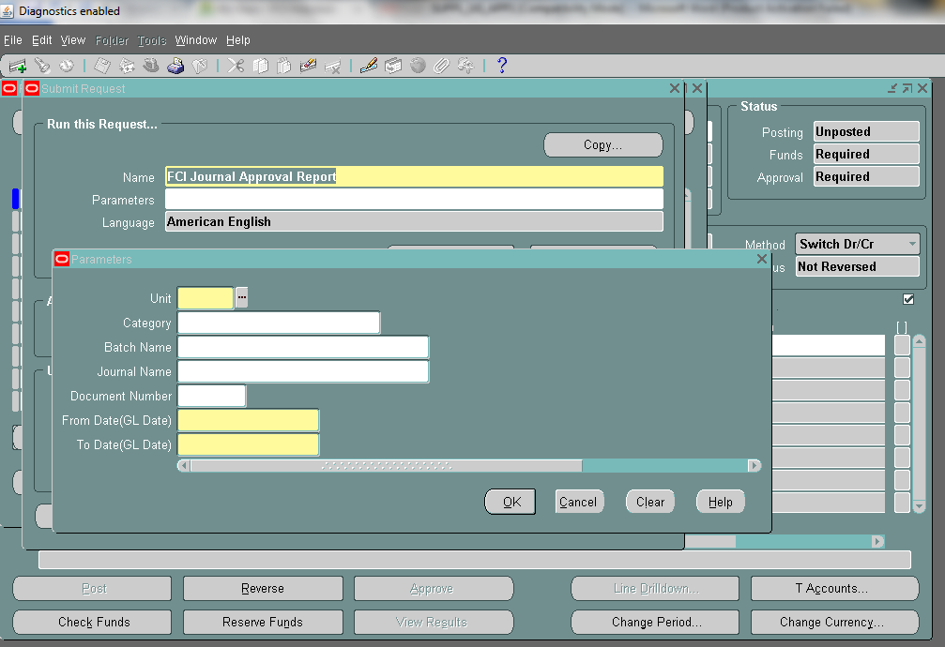

Deployments Feb -2013

FCI India Creditors Trial Balance Report

The report has been converted to excel. Also, as per CR 265 the suppliers having nil outstanding liability have been removed from the output of the report.

Lists the closing balance of suppliers as on date. This report runs unit wise.

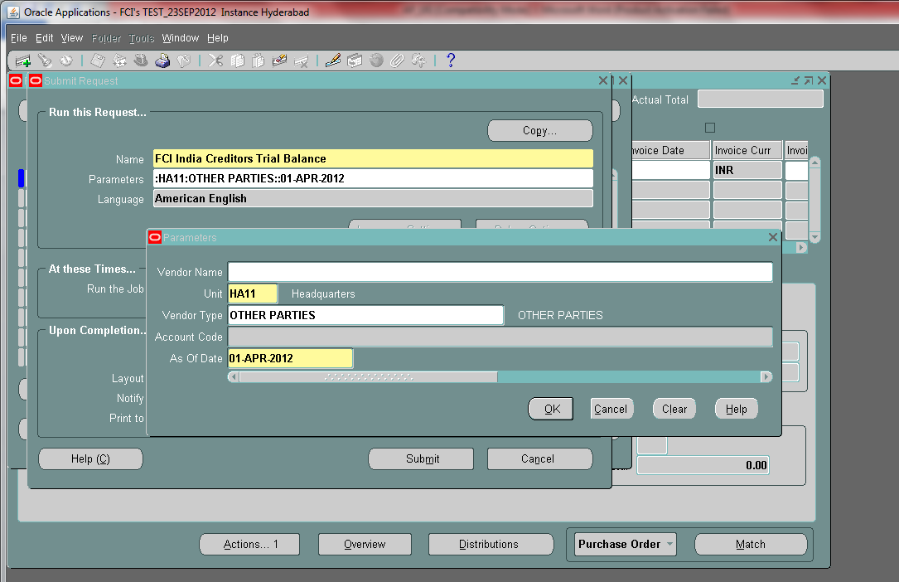

This report will not fetch data for suppliers having nil outstanding liability.Also the report has been converted to excel.

The ouput of this excel report has been attached below.
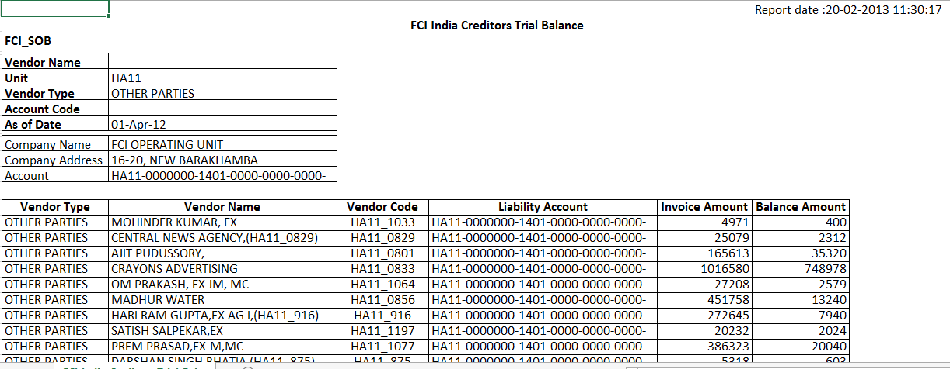

Deployments – March 2013

FCI prepayments Status Report

The report has been added with an extra optional parameter of Account. That implies report can be executed account wise for a particular unit. When the inculde invoice flag would be switched to No , it would not fetch data for invoices, but only for prepayments for that account head.

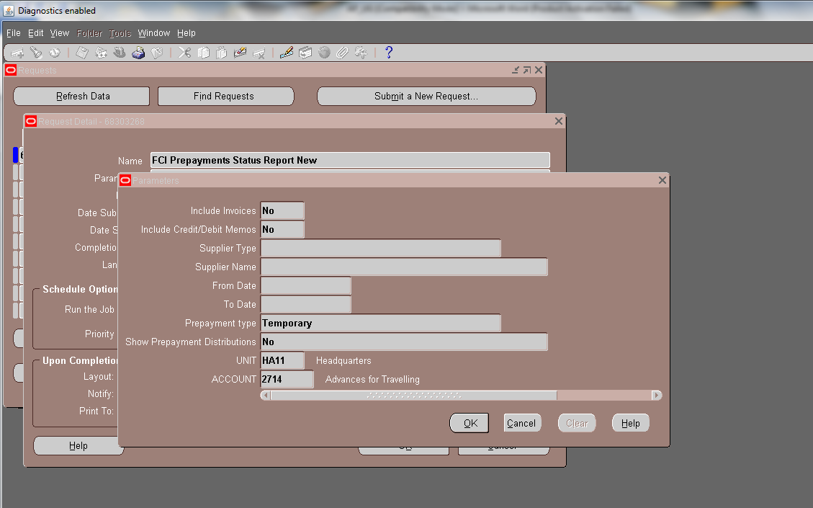

Sample output of the report is attached below:

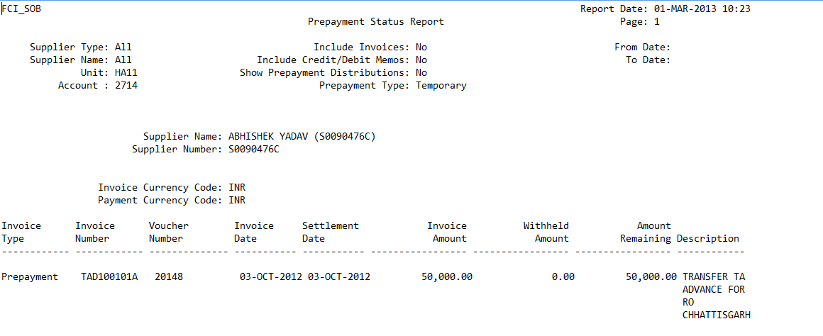

A personalization also has been added for prepaymnet type of invoice, that user cannot enter more than one line in distributions.

Deployments – April 2013

Receipt Write Off in AR
Receipt Write Off setup has been implemented in Accounts Receivable Module. Also the Write Off limits has been set for all the active users to Rs. 500 , as per instructed by FCI HQ.
For all the Users that will be created in Future by support Team , the write Off approval limit will have to be set separately.
The user ,if required , can write off an amount upto Rs. 500 on a receipt. One needs to select Receipt Write Off in Apply to column and FCI Receipt Write Off in Activity column

Related Screenshots are attached below:

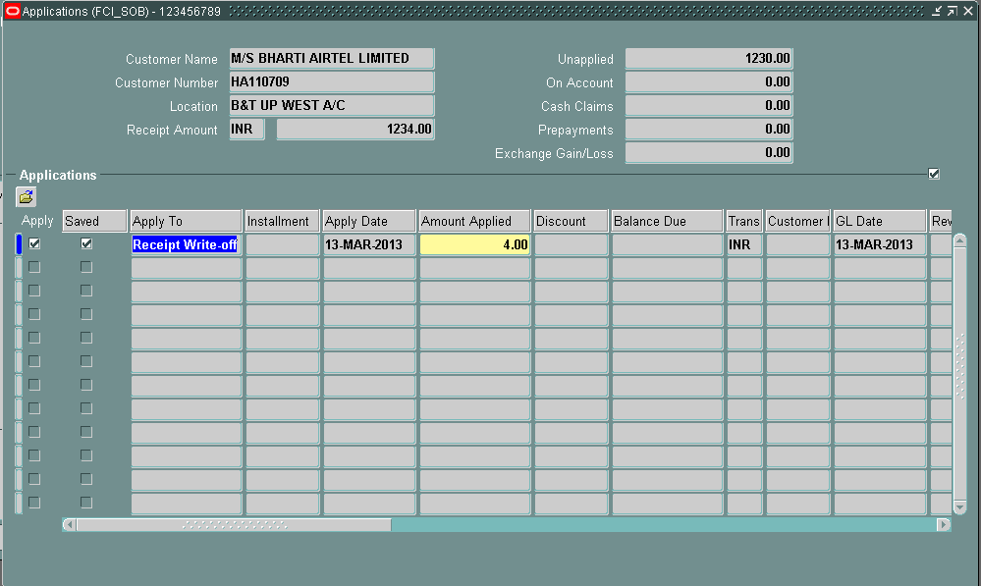

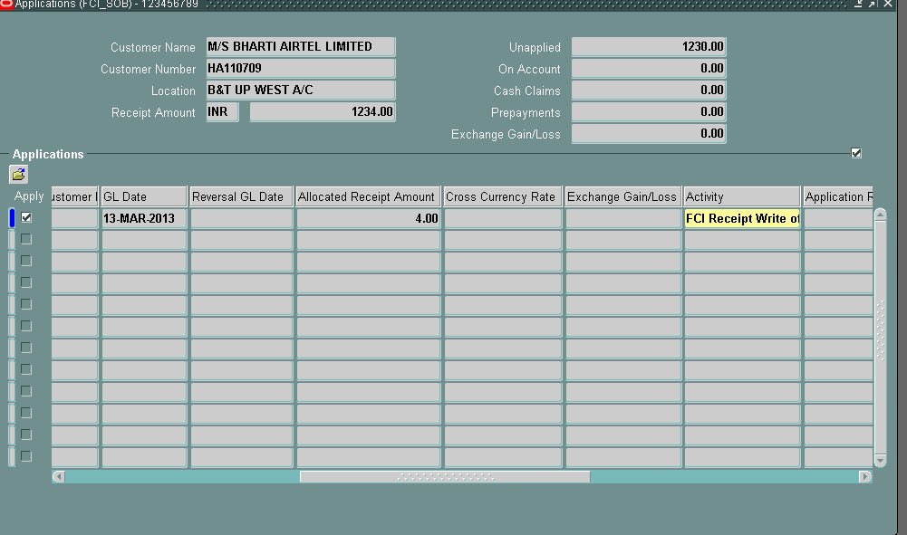

FCI Final Payment Register

FCI Final Payment Register report which lists payments from a specific payment batch .
The input parameter to generate the report is:
1. Payment Batch :- Mandatory.

Columns bearing Supplier bank MICR code, Supplier bank IFSC code, Supplier bank name and Supplier bank branch name of the corresponding payment has been added to the output of the report.

The output of the report is in excel.

Auto import,auto validation of Auto created invoices and Payment hold on EMD and SD

The auto created invoices EMD,SD and Refund will be automatically imported to payables and automatically validated.

Payment hold will be applied on EMD and SD. User has to remove the hold manually in order to make payment.

FCI Payables Invoice Register

This report picks all the invoices and their respective distributions based on the given parameters.
The input parameters are as given below:
- Unit (mandatory)
- PayGroup - User can pick pay groups pertaining to the Unit that he has selected in Unit parameter only.
- Supplier Name – If left blank , the report will fetch all the invoices irrespective of the supplier against whom the invoice is . In case it is populated , report will fetch the invoices that are against the specific supplier.
- Invoice Type - If left blank , will fetch all invoices irrespective of the invoice type.
- Entered By - If left blank , will fetch all invoices irrespective of the user name who has entered the invoice.
- From Gl Date(mandatory)
- To GL Date(mandatory)
- Accounting Period
- Cancelled Invoices Only? - If the user enters ‘Yes ‘ in this parameter , the report will pick only cancelled invoices.
- Unapproved Invoices Only ? - If the user enters ‘Yes ‘ in this parameter , the report will pick only unapproved invoices.
- From Account
- To Account
User can use From Account and To Account parameters to fetch the invoices having distributions lines with in the given Account Range.
Four input parameters are made invisible as they get populated by the system itself . They are :
- Trace Switch
- Org Id
- Set of Books Id
- Chart Of Accounts

The output of the report is in excel format.
Depending on the given parameters the report will fetch the data . Unit parameter is mandatory and pay group is non mandatory .

In case one runs the report for a specific unit (say ‘HA11’ ) with pay group as blank. The report will show all the invoices pertaining to that unit ( HA11 in this case ) , irrespective of the pay group , for the time period given in the input parameters, that is if unit is present in either document category or pay group or in distribution line then that invoice will be fetched in the output.
If user gives UNIT as well as Pay group in the input parameter then,the invoice which has the same pay group as given in input parameter and unit either in document category or in distribution then only the invoice will be fetched in the output.

Note: There was another report ‘FCI Payables Invoice Register With PayGroup’ which was creating confusion, hence this report ‘FCI Payables Invoice Register With PayGroup’ has been removed on confirmation from HQ.

Rounding Off line
For transactions, rounding off line will be shown at tax level and will grouped by the items selected .The account head used is:4206
For Sales transaction, item is mandatory at Line of item and default item cannot be used.
At distribution level, for revenue line product code will be automatically populated depending on the item selected for sales transaction at Line of item level.

FCI Prepayment Status Schedule Report

‘FCI Prepayment Status Schedule Report’ fetches the status of prepayment based on the specific date parameter.This report does not fetch any standard invoice.The parameters for this report are:

S.No | Parameter | Required/Optional | Description
1 | Supplier Type | Optional(leave blank to execute the report for all supplier types) | Selection of Type of supplier
2 | Supplier Name | Optional(leave blank to execute the report for all suppliers) | For a particular supplier
3 | As Of Date | Optional(leave blank to execute the report till date) | To Gl date
4 | Prepayment Type | Required | Yes/No(For prepayment type)
5 | Show Prepayment Distributions | Required | Yes/No (To show distributions)
6 | Unit | Required | Selection of Unit
7 | Account | Optional(leave blank to execute the report for all unspecified accounts) | Selection of Account

Deployments – May 2013

Nominee Payment
If User wants to make payment to the nominee then follow the steps mentioned in section 32 Make Payments – Using Invoice Workbench(Accounts Payable User Guide) upto step 9 and then click on []
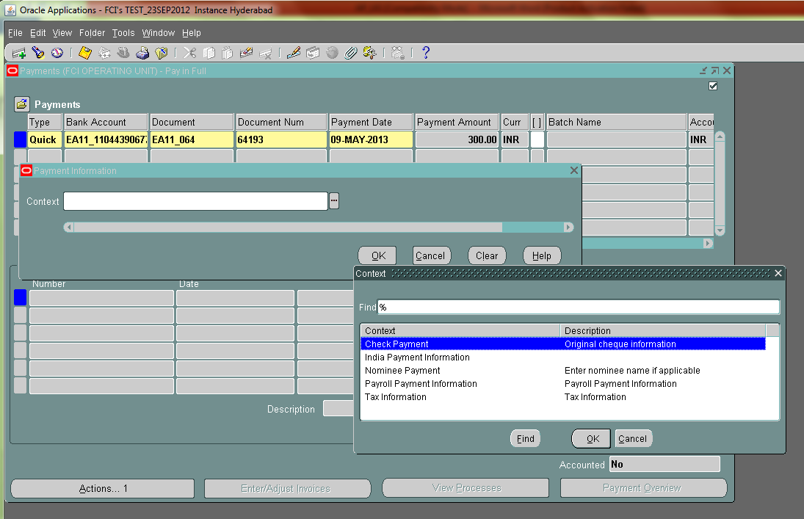
Then user can enter the nominee name in either Check payment(if payment is made through check, then select check payment) or in Nominee payment.
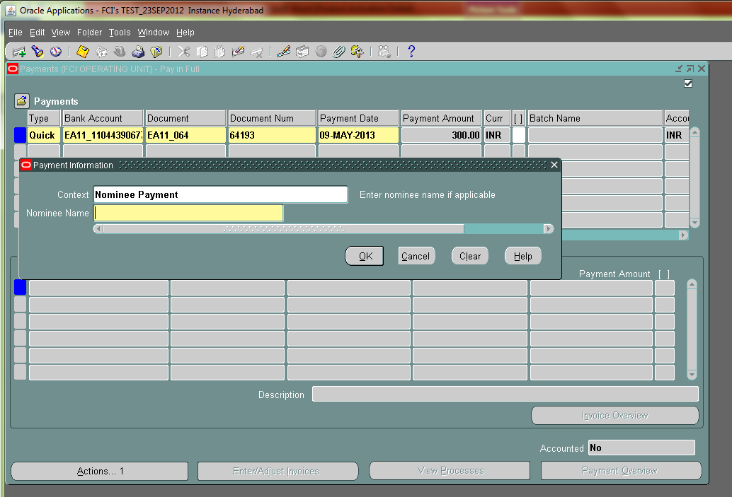
Enter Nominee name and click Ok and save. And then again follow the remaining steps mentioned in section 32 Make Payments – Using Invoice Workbench (Accounts Payable User Guide)
Note: Once the accounting for the payment is created, user cannot change the name of the nominee if payment is made to the nominee.
If payment is to be made to multiple nominee, then split the payment in schedule payments tab in the invoice form(distribute the invoice amount accordingly) and then make the payment to each of the nominee accordingly.
This functionality is not available for payment batch.

Print Invoice Notice

- Document Category name added as an optional parameter in the report. If user selects a document category, then voucher number range will become enabled and mandatory. If user skips document category name, voucher number range will remain disabled.
- Hold amount, if applicable, will be displayed in a separate section Hold Payments.
- For goods purchased entries, depot code and name will also get displayed in report output.
- amount payable will come in words also.
- In the report header, Food Corporation of India along with the site address will get displayed.
- At the end of report, a line showing total amount received is displayed as
Received a sum of Rs.________________________________
This amount will get displayed in numeric and words both followed by signature and date.

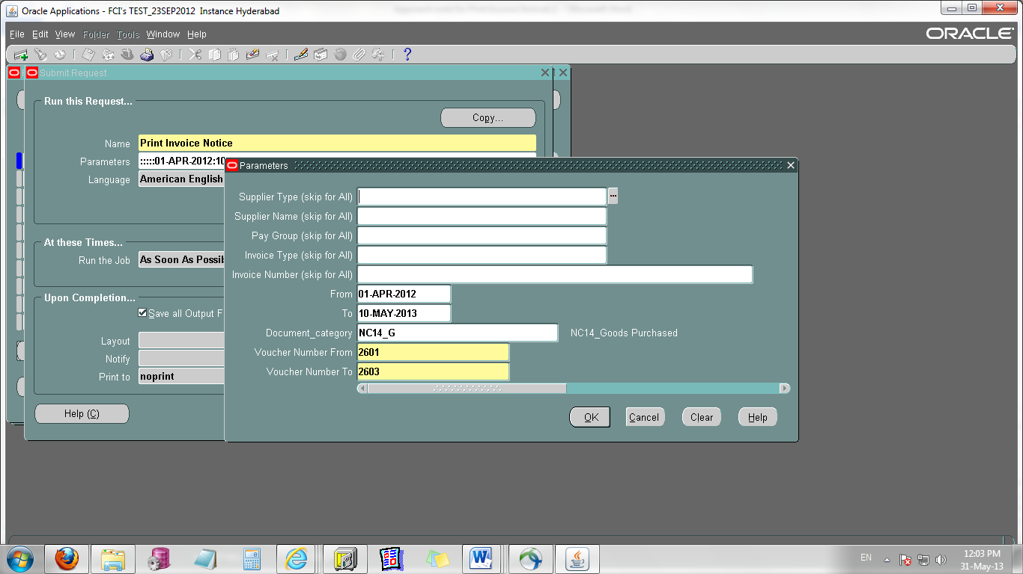

Bank Detail Updation

- BIC is made mandatory for all the banks. If an internal/external bank do not have IFS Code, then user have to enter FCIDUMMYBIC in BIC Field. Also for Petty Cash banks, user have to enter FCIPETTYBIC in case they don’t have IFS Code.

- A proper format for entering IFSC code has to be followed. It should always be of 11 characters. Also, other than FCIDUMMYBIC and FCIPETTYBIC , first four characters should be non-numeric and rest should be numeric i.e. ABCD1234567.
- Checks are implemented so that a bank account cannot be updated till it is attached to any active supplier site. If user tries to update such accounts, an error message will popup.

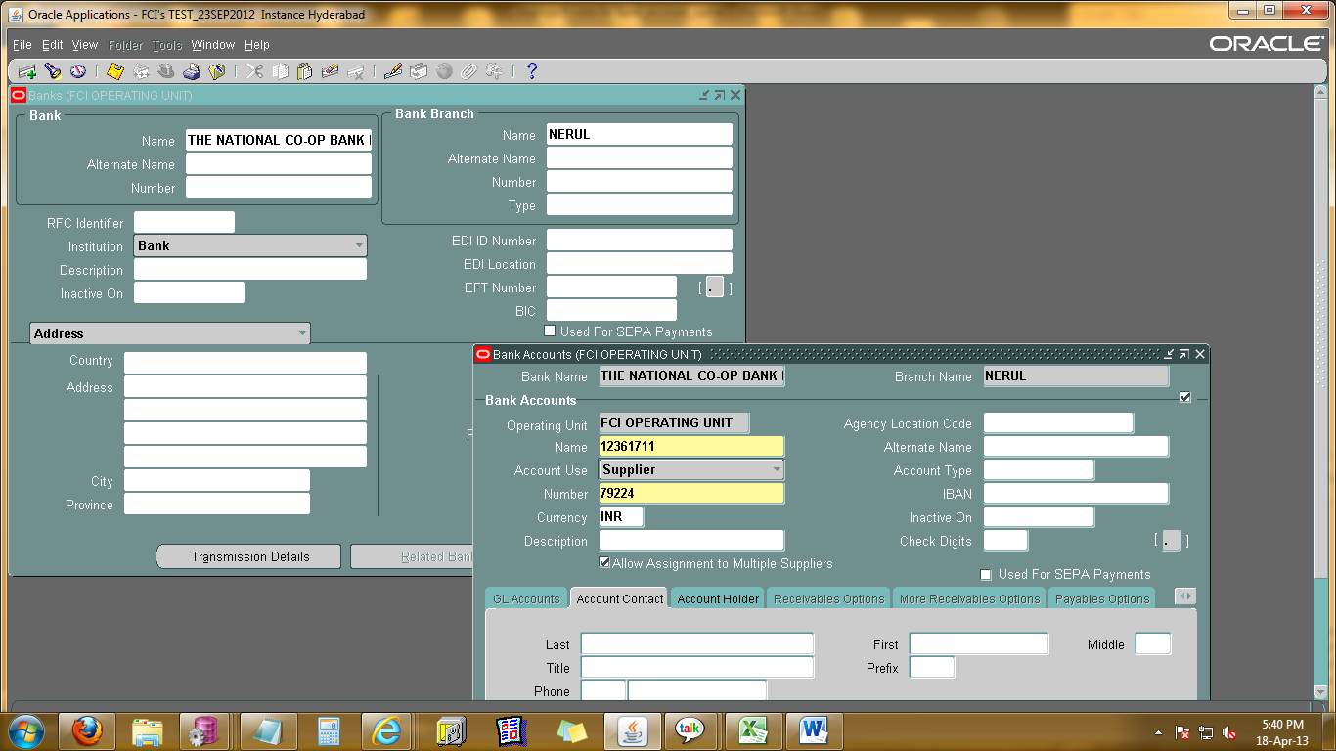

Deployments Jun -2013

FCI AR Receipts

FCI AR RECEIPTS Report previously used to print all the receipts that comes in the date range given in parameters pertaining to the unit mentioned in parameters. Some modifications in the report were asked by FCI, which are as follows:

- Address of FCI given besides the Logo should be in Bold letters.
- Page break after every receipt.
- In case the Customer Name is not available for a receipt (Generally Miscellaneous Type reciepts) , the Customer Name field itself should not be shown in the report output.
The changes are made as per the given requirement. Sample output of the report is given below for further reference.

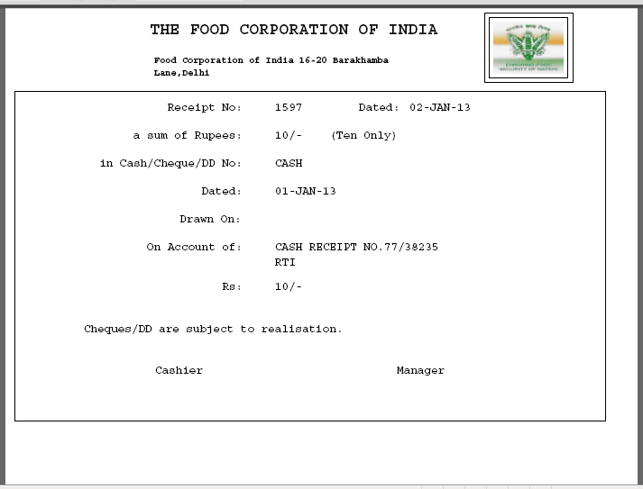

FCI Journal Batch Approval Status Correction Program

A new program is created through which the support team can set the workflow approval status of journals having workflow Approval State ‘In Process’ to ‘Required’ and so further delete or initiate the approval for the journal again.

- The user will have to provide the Batch Name in parameter for the request. The program will pick the Batch by name provided that is having Approval State ‘In Process’ and set its status to ‘Required’.
- In case there are more than one jounal Batch with same name and more than one of them has Approval State ‘In Process’ , the program will pick one of the journal Batch and set its status to ‘Required’.
- User will have to run the program again to set the status of another Journal Batch with same name to ‘Required’.
- The Fund Status of the journal will remain the same as it was before running the program.
- Also the request will only pick the Journals having source ‘Manual’.
This request will only be accessible to the FCI Support Team through FCI Support Team Responsibility . The Screenshot is given below:

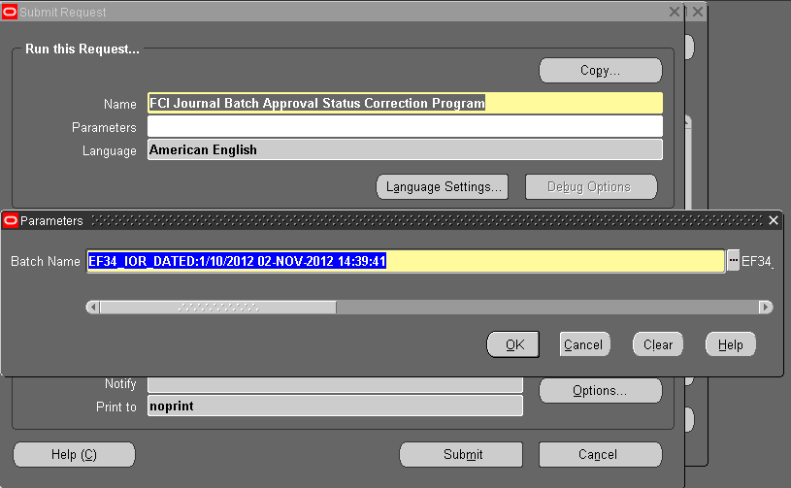

Aging – 4 Bucket Report

Use the Receivables Aging - 4 to review information about your open items within either four or seven aging buckets . These reports can print both detail and summary information about your customer's current and past due invoices, debit memos, and chargebacks. Receivables also gives you the option to see credit memos, on-account credits, unidentified payments, and on-account and unapplied cash amounts.
Aging reports show detail and summary information about open items. The aging reports will be sorted by company with each item allocated to a company. Here in this case , it is unit, and site can execute this report at site level to view the due invoices, debit memos, and charge backs for all the customers.
The report can be executed unit wise,and customer wise also.The default parameter for parameter Aging Bucket name is ‘Standard’.

Screenshots attached below to execute the report:
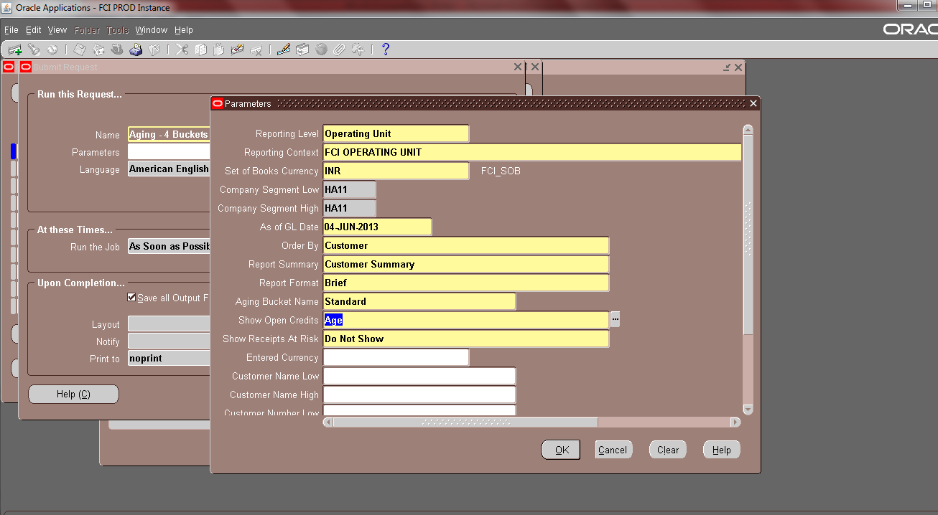

A sample output is attached:

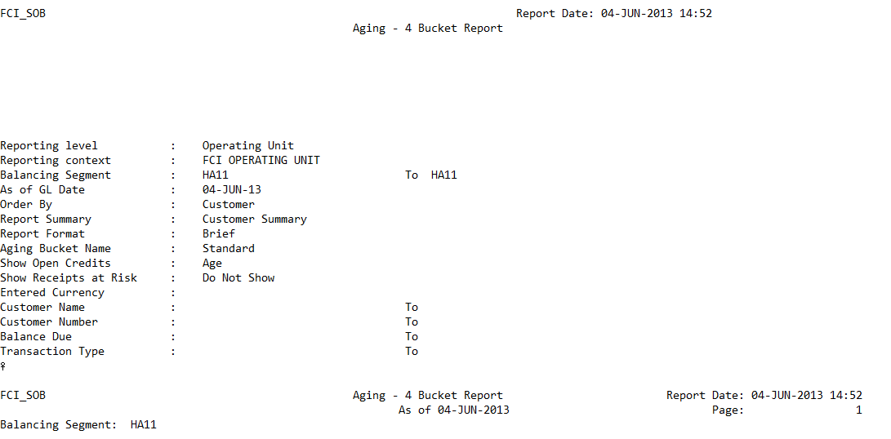

Report Parameters

Name | Optional/Required/Defaulted | Description
Reporting Level | Required | This field will get value automatically
Reporting Context | Required | This field will get value automatically
Set of Books Currency | Optional | This field will get value automatically
Company Segment Low | Optional | Enter Unit name
Company Segment High | Optional | Enter Unit name
As of GL Date | Required | Receivables includes all open items whose GL date is before or the same as the date you enter
Order By | Required | Sort Option available, By customer or by
Report Summary | Required | The Invoice Summary option prints information on all customers' debit items. The Customer Summary option prints customers' names with their total debit item balances.
Report Format | Required | Format parameters include 'Brief' and 'Detailed'.
Aging Bucket name | Required | Receivables prints your report information from the bucket set you specify.
Show open credits | Required | It will show the amount of credit items for each customer
Show Receipts at Risk | Required | Receipts at Risk are receipts that have either not been cleared or factored receipts that have not been risk eliminated
Entered Currency | Optional | INR in this case.
Customer Name Low | Optional | Enter Customer Name(Lower limit)
Customer Name High | Optional | Enter Customer Name(Upper Limit)
Customer Number Low | Optional | Enter Customer Number(Lower limit)
Customer Number High | Optional | Enter Customer Number(Upper Limit)
Balance Due Low | Optional | Balance Due(Lower Limit)
Balance Due High | Optional | Balance Due(Upper Limit)
Transaction Type Low | Optional | Type of transaction for which the report has to be executed(Lower Limit)
Transaction type High | Optional | Type of transaction for which the report has to be executed(Upper Limit)

Separate Period Closure for RO Level

- RO can close its accounting periods (AP,AR,GL) as well as the accounting periods of their concerning DO’s.
- Once a period is closed, RO can’t open it and only HQ have the privilege to open that closed period.
- A responsibility FCI Period Closure Tool will be assigned to concerned person at RO level by HQ using which user can close the accounting periods.
- Once a period is closed for a specific module say AP, AR or GL, user can’t make any entry or update the existing ones in the system.
- Before closing the period, user has to clear all the pendency from the system. User can see the details of pending data using the following reports available in the responsibility:

- FCI AP Custom Period Close Execution Report
- FCI GL Period Closure Execution Report
- FCI AR Period Closure Exception Report
- FCI Custom Period Closure Report - Autoinvoice & Interface

- Once the pendency is cleared, user have to run FCI Custom Period Close Program
- Status of all the closed/open units can be reviewed through report FCI Closed Period Status Report
- For all the interface stuck entries, user have to contact HQ.
- For opening a particular unit’s period, FCI Custom Period Open Program should be run through FCI Support Tool.

FCI DEBTOR TB
The output of the report will be sorted on customer number and fully applied receipt and transaction that is customers whose outstanding balance is zero will not be shown.

FCI_Sales_Day_Book
Additional column, Reference has been added, which will fetch the line level reference of the transaction.

FCI Receivables Invoice Register
The following report parameters have been made invisible because these parameters get automatically populated and user cannot change these values:
- Reporting Level
- Reporting Context
- Set of Books Currency
- Chart of Account Id
Two more parameters also have been made invisible.
- Exclude Rounding equals zero because FCI does not use the seeded rounding off functionality.
- Entered Currency parameter as FCI deals only with INR.
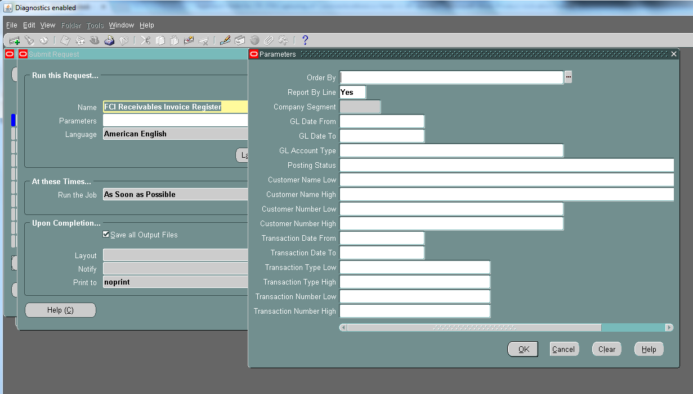

Changes in the report:
Two additional columns, namely, Reference and Comments have been added which fetches the line level reference (more tab) and header level comments(more tab) of the transaction.
The fields will be blank in case user has not provided any data in those fields.
Report will fetch line level reference if report is executed for all GL account Type or for Revenue type. For all other accounts, report will not fetch any data.
The report has been converted in excel format.
Sample excel format:
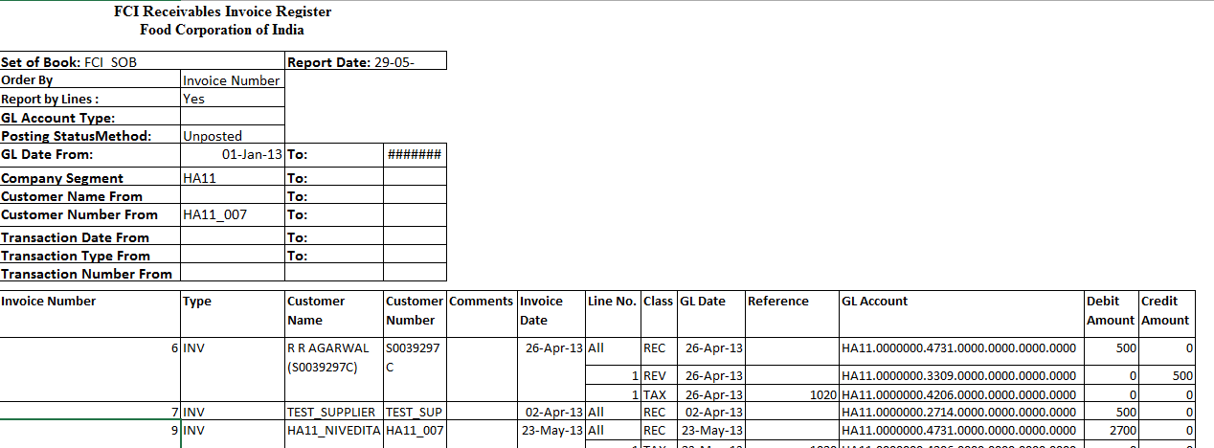

FCI India cash/Bank Book Report
Additional column Comments has been added in the report which will fetch Reference field and Comments field from receipt form in concatenated manner (Reference#Comments).
If reference field in receipt form is blank then in the output comments will be displayed as ‘#comments’ and if comments field is blank in receipt form then output will be ‘Reference#’
And if both are blank then comments in the output will be blank.
For receipts, the description will fetch the receipt number even if comments field is not blank.
For Receivable transaction, line level reference field will be displayed under comments in the output.
Payment Batch Name header has been renamed as Payment Batch Name/Receipt Batch Number and the receipt batch number will be displayed under this header in the report.

Receipt Summary form
Comments field and Customer Receipt Reference has been displayed in the form so that user can capture additional information.

IOM Within Same Unit
The category ‘IOM Within Same Unit’ has been revoked from Journal form in General Ledger responsibility. User cannot enter new journals with this category now onwards but user can query old journals with the same category.

Consolidated Trial Balance
If the report is executed for East Zone (E000) then the report will fetch data for Head quarter along with data of the East Zone.
Note: this sequence will be fetched only when the report is executed for the child unit and not at any parent level.
As per CR 454, following modifications are done:
    - There will be two divisions introduced in the report namely Part I Trial Balance and Part II Trial Balance.
    - Part I TB will be containing all those accounts under grouping 1 to 195 and 300. Sub Total should come for this part before Part II starts.
    - Part II TB will be containing all those accounts under grouping 196 to 299. Sub Total of this part should also come.
    - Report Total will be provided at the end of report i.e. total of Part I TB and Part II TB.
    - Account Head 0981 from group 1 will be in Part II TB as refer to CR 455.

Deployments Jul -2013

AP Intercompany Restrictions added:

- User will not be able to create any (Standard Invoices, Credit Memos) invoices with distributions lines having account pertaining to some other unit from InterCo responsibility also.
- Though user can use Intercompany accounts using intercompany natural account head and the unit code of other unit in intercompany segment in Accounting Flex field of a distribution line.
- For Standard Invoice User is allowed to enter his own unit only in Accounting flex field , but he is allowed to use intercompany account ( for example 0931 , 0911 etc.) and enter the other unit’s unit code in Intercompany segment.
- Liability account of other unit and distribution of own unit can be chosen while making interco transaction in AP.

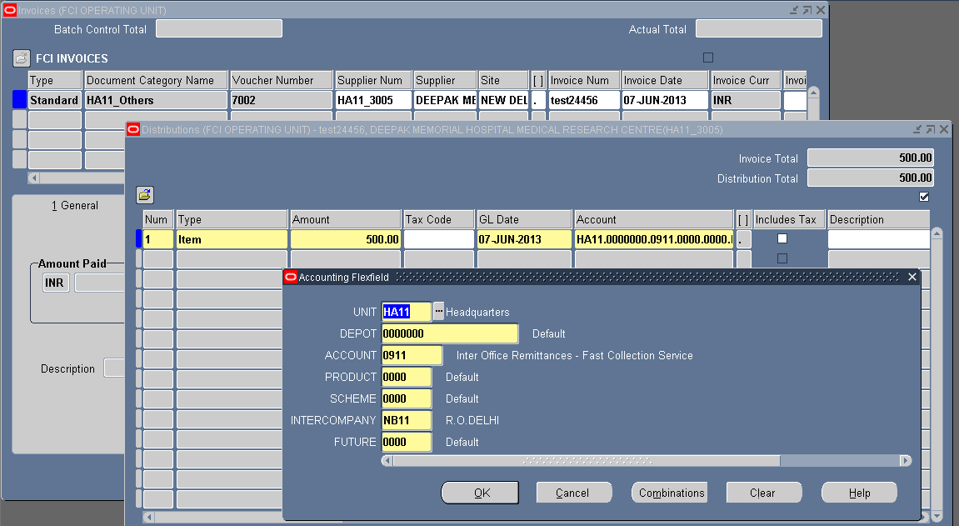

From InterCo responsibility, user is allowed to create intercompany type “Prepayment” invoices with distribution lines having account pertaining to some other unit.

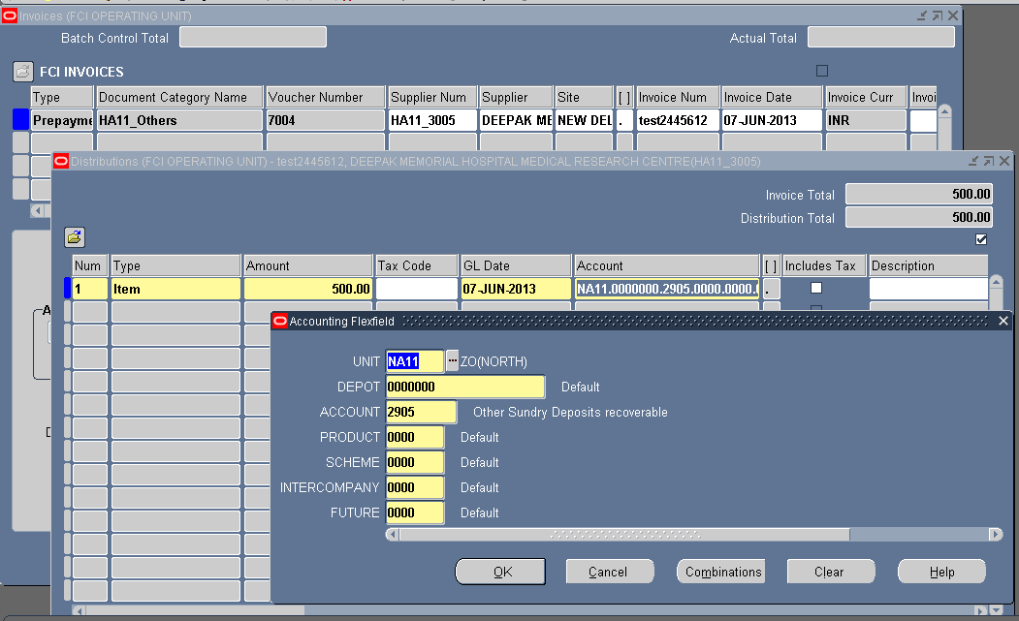

FCI Interco IOM Voucher

A new report ‘FCI Interco IOM Voucher’ has been created which fetches the detail of the ‘InterCo IOM RailRoad’ journal.
The input parameters for the report are:

Sl.No. | Parameter | Required/Optional | Description
1 | Document Category | Required | User has to select the IOM category from the LOV for which the report is to be executed.
2 | Start Document Number | Optional | User has to give the range of document number of the journal which is to be fetched
3 | End Document Number | Optional | User has to give the range of document number of the journal which is to be fetched
4 | Start Date | Required | User has to give the starting range of default effective date of the journal.
5 | End Date | Required | User has to give the end of default effective date of the journal.
The output of the report is in pdf format.
Kindly follow the steps mentioned in the document below to run a pdf report
- While running this request click on OPTIONS as red marked in the given screenshot.

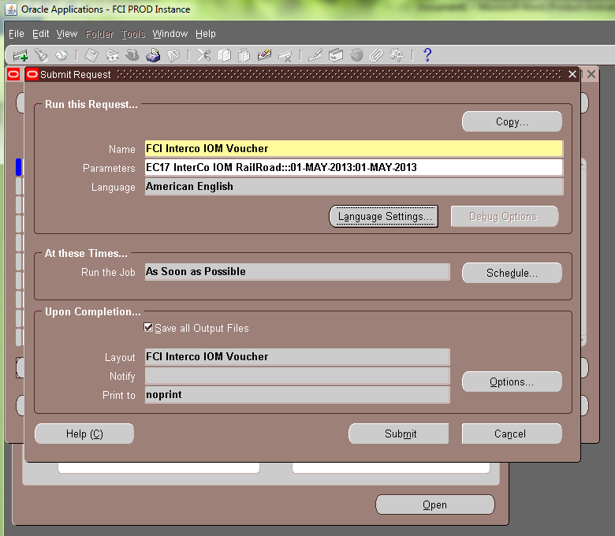
2.Choose format as EXCEL, as shown in the screenshot below:
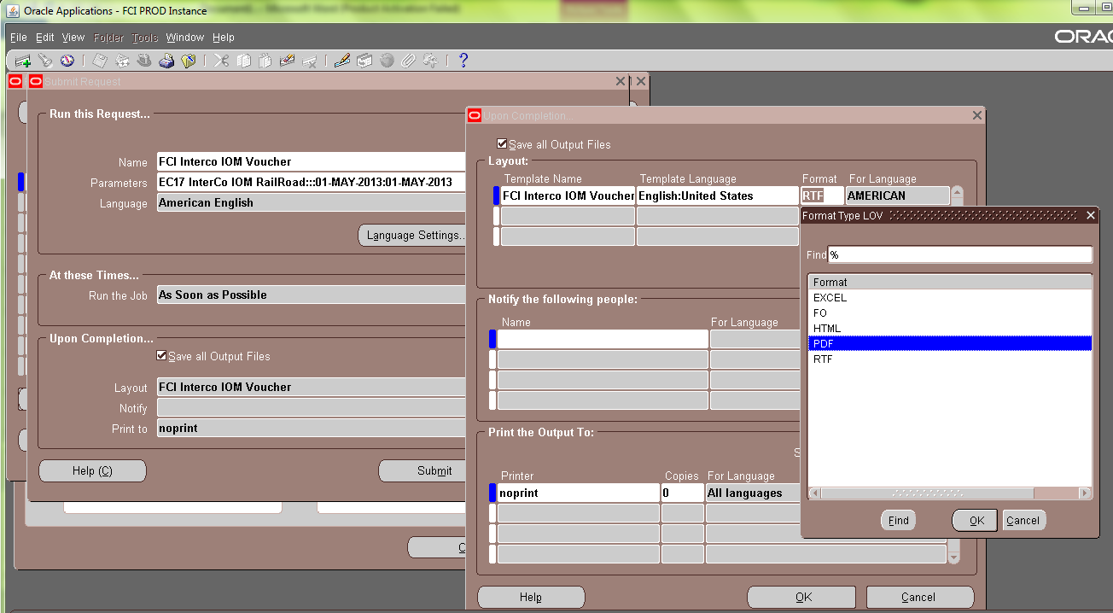
You will get the output of the report in PDF form.

The sample output is attached below,
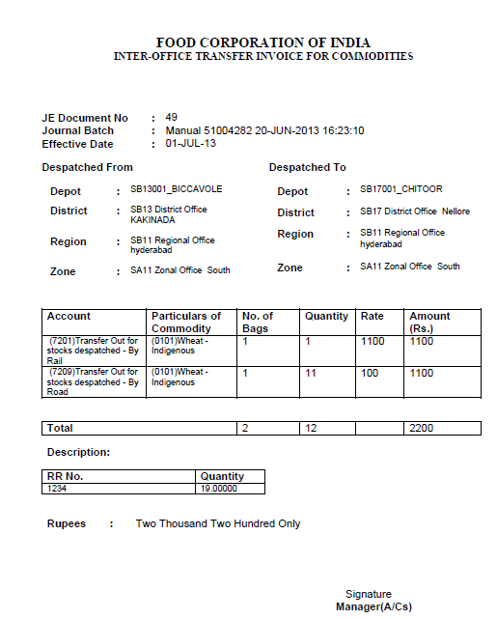
Note: The report will not fetch detail of 0981 account head.

CR 161
For suppliers created from payroll:
1. Supplier will be created automatically , whenver any active employee is created in Payroll.
2. Any changes done in active employees in Payroll , will automatically get reflected in Supplier also.
3. If any employee is inactive in payroll, and user activates it in payroll, corresponding supplier will be created in APPS (if no corresponding supplier exists).
4. If any active employee is inactivated in payroll, the classification of corresponding supplier in APPS, will change to FCI Retired Employee, and if it is again activated in payroll, the classification in APPS will change to FCI Employee.
5. No manual craetion of supplier with supplier number as staff code and classification as FCI Employee or FCI Retired Employee is permitted in APPS.

6. Supplier master form will remain freezed for suppliers created from payroll (with classification FCI Employee).

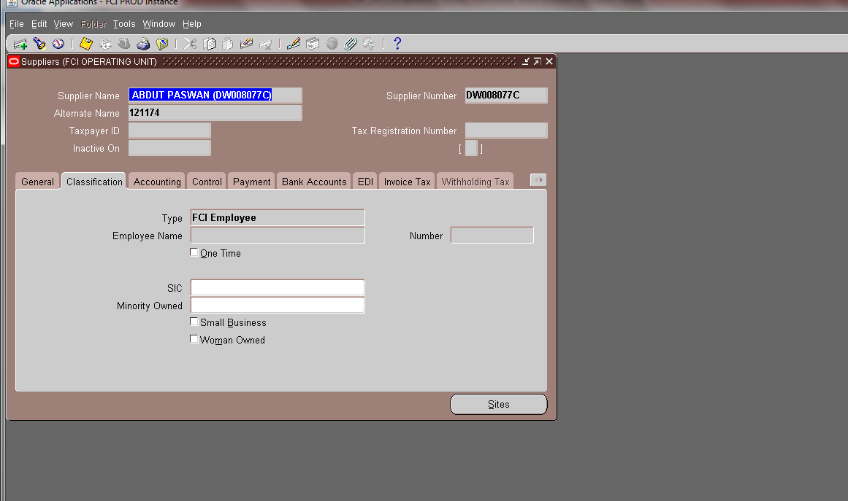

7. Once the employee gets retired in Payroll, its classification in APPS will be changed to FCI Retired Employee and the field of inactive date will become editable.

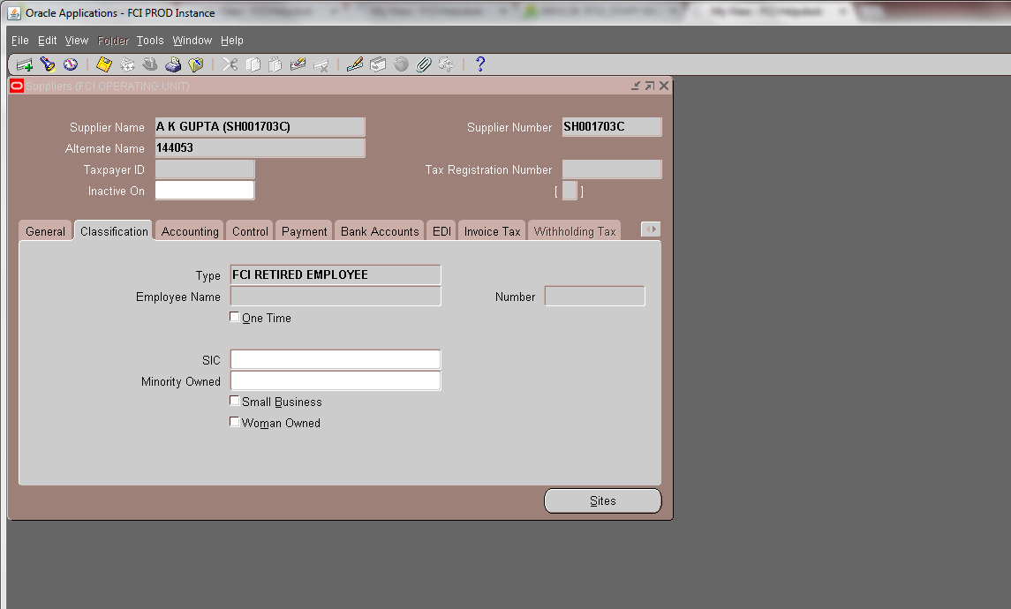

8. Customer for suppliers created from payroll will also be created automatically. There is no need for executing any concurrent program. For any active employee created in payroll , supplier and customer will be created automatically. Also, if further changes are made in employee details in payroll, they will automatically flow to supplier as well as customer.

Creation of Sites for suppliers created from payroll:

1 As any employee gets created in payroll, his corresponding supplier with present location as his site will be created . In this site , the primary flag will be checked. Same site will also get created in Customer.
2 Also, when the employee gets transferred in payroll, his new site will be created automatically in Supplier as well as Customer.
3 There is a check on supplier site form, that user cannot de-activate his site which is his present location in Payroll.
4 For any supplier created from payroll, with classification FCI Employee, no sites can be created manually.
5. If any employee is transferred from site A to Site B a new site B will be created in APPS (both in supplier and customer), and if the employee again gets transferred to Site A, new site will not be created but the old site A will get activated again(if inactive) in supplier as well as customer.
6. Whenever any changes are made in Payroll, corresponding changes will also flow to the user-ids created in APPS.In case of transfer cases , the user id with previous location will get updated with new location code and will get de-activated. It will have to be activated manually then.

For Customers/Suppliers created from Payroll :

- As any active employee will get created in payroll, corresponding supplier and customer will get created automatically, with present loaction as its site .
- Any changes done in employee in payroll , will automatically flow to supplier as well as customer.
- Also, if any employee in payroll gets transferred from one location to another, corresponding site will get automatically created in AP and AR.
- If any site in AP is in-activated , corresponding site will also get inactive in AR.
- Whenever any changes are made in Payroll, corresponding changes will also flow to the user-ids created in APPS.

Deployments Aug -2013

Budget Module:
Budget Module has been deployed in Production Instance.
A new report ‘FCI Budget Variance Report’ is also deployed which can be used to check the variance in the budget allotted.
The output of the report is in excel format.

Deployments Sep-2013

CR 300
- FCI Transfer In Transfer Out Report re-named to FCI Transfer Out Report.
- FCI transfer In transfer Out Report – New re-named to FCI Transfer Out Report New.
- Nomenclature of unit ED12 changed from HAZARIBAGH to DHANBAD.
- A replica report of Aging -4 Bucket Report created in the name of FCI Debtors Aging report, with same parameters as Aging -4 Report.

CR 288
The field Tax Registration Number in supplier form has been changed to Tax Identification Number , in which supplier can provide TIN number . This is an optional field.

Also, this information will get reflected in FCI Purchase Day Book , for those suppliers who have inserted it.

CR 291
- In the distribution of Goods purchase invoice, user can enter either default value or same value for depot in all the distribution lines, abiding by the cross validation rules. Similar validation is applied for product and scheme.
- For account only one of the purchase accounts (5161, 5171, 5181 ) can be used. In addition to purchase account, user can enter any other natural account in the distribution. Exactly one line with purchase account will be allowed.

Deployments – Oct- 2013

CR 299
- New adjustment activity is created in the system in Receivable for all kind of transactions.
- User wise limit for the activity has to be setup so that adjustment can be made.
- The activity GL account will be UNIT.0000000.4206.0000.0000.0000.0000 e.g for EA11 it would be EA11.0000000.4206.0000.0000.0000.0000
- User from a particular unit can only select adjustment activity pertaining to his own unit.
- Select adjust from actions tab,select the activity name for your unit,and enter the amount .Now save the procedings.
- Amount entered should be with opposite sign as that of the transaction amount.Eg if transaction amount is 100Rs,then you have to enter -100 in adjustment.

CR 304
FCI india Creditors trial Balance Report has been sorted on Supplier Name, in order to increase the readability of the report. The report parameters are

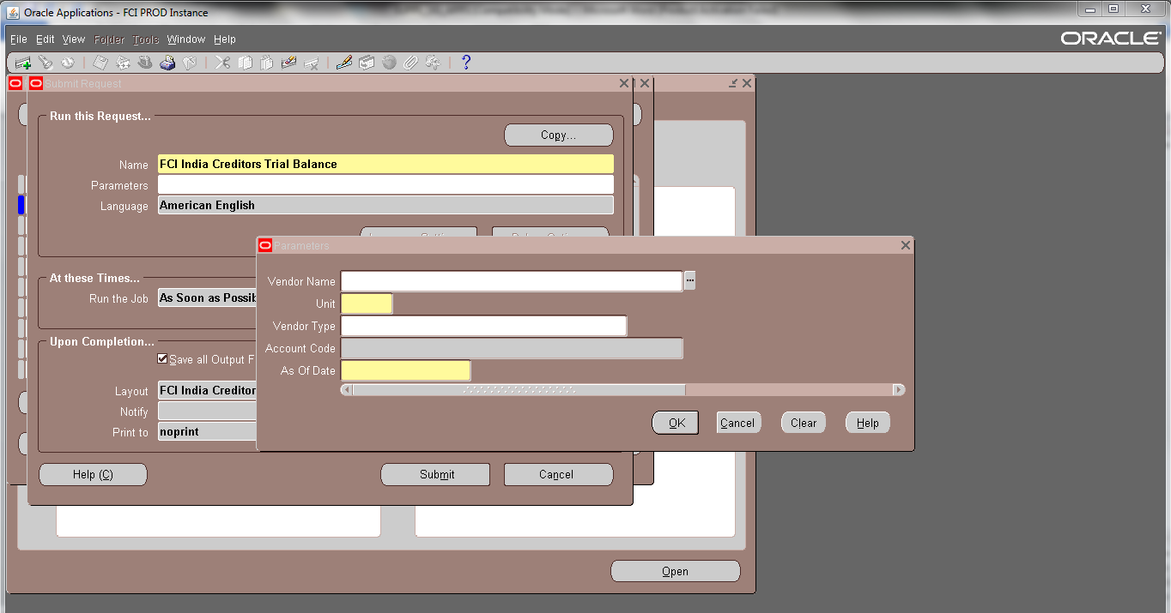
The output is attached below for reference:

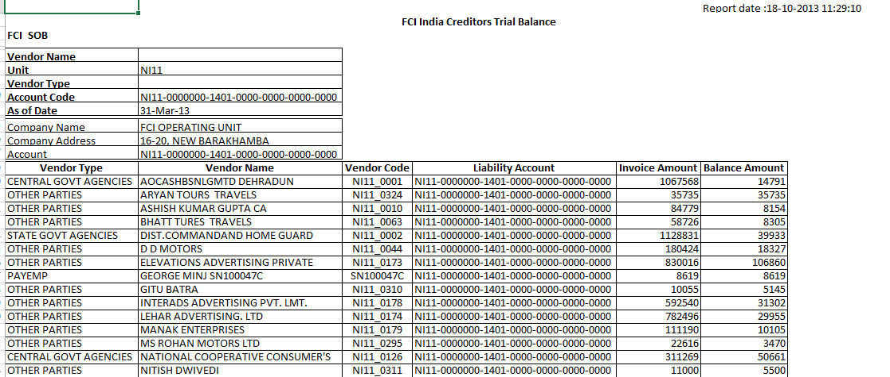

AP-AR, AR-AP, REFUND Process Change pertaining to Period Closure

Pertaining to Mantis Issue id 3772, the changes has been made in AP-AR Autoinvoice , AR-AP Autoinvoice , REFUND Autoinvoice creation processes.
After this change:

- The AP to AR process will create a transaction in AR with transaction date and GL date same as the maximum of prepayment application date/ payment date of the related AP invoice. Previously the process used to create transaction in AR with transaction date and GL date same as the GL Date of the related AP invoice .

- The AR to AP process will create the invoice with invoice date and gl date same as the maximum transaction and receipt application date of the related AR transaction. Previously the process used to create invoice in AP with invoice date and GL date same as the GL Date of the related AR transaction.

- The REFUND process will create the invoice in AP with invoice date and gl date same as the maximum transaction and receipt application date of the related AR transaction. Previously the process used to create invoice in AP with invoice date and GL date same as the GL Date of the related AR transaction.

- Also the related errors will be shown in the respective output files.

- Also the related changes has been made in FCI Custom Period Closure Report - Autoinvoice & Interface . Now the report will fetch the records whose application/ payment date falls in the given date range, instead of the gl date of the invoice/transaction.

Deployments – Nov-2013

CR-311

- A check has been applied on Supplier master form, so that user cannot enter special charaters in supplier name field (except . , ( _ ) numbers 0-9 charaters A-Z and spaces)

- If the user enters any special charaters , other than these mentioned above, an error prompt will be displayed showing the message that special charaters could not be entered in Supplier Name.

CR-318

- A check will be applied, that will prevent user to change the values entered in the field of EFT number and BIC (MICR number and IFSC code respectively).

- User can enter values in these field only once ,i.e at the time of creation of bank. Once the record is saved, user will not be able to make any changes in the above fields, as they will get grayed out.

- In case user requires some changes, in MICR number and IFSC code , he will have to contact FCI Helpdesk to get them done.

- FCI Helpdesk will be able to make changes in the above fields through FCI Support User responsibility .

CR-317

  - While entering assignment in Global HRMS form, the value of Group field (FCI in this scenario) , will always be in Capital Case.

  - Functionality of Account Analysis, Account analysis and Drill Down provided in FCI Audit User responsibility.

  - While querying the journals in GL, user will be able to view the approval status of the batch on main query form itself. This has been done for all the responsibilities including FCI Audit User.

CR-305

New WCT taxes are created in system for 3 units : NB11, NB12, NB13 , two for each unit keeping HA11 WCT @ 4 % REG. and HA11 WCT @ 6 % UNREG. as reference.
Details are as follows :
VAT from Registered Contractor – 4%
VAT from Un-Registered Contractor – 6%

The newly created WCT taxes are named as follows:
- NB11 WCT @ 4 % REG.
- NB11 WCT @ 6 % UNREG.
- NB12 WCT @ 4 % REG.
- NB12 WCT @ 6 % UNREG.
- NB13 WCT @ 4 % REG.
- NB13 WCT @ 6 % UNREG.

CR-312

At present, in AR transactions, entering tax is not mandatory. If in case tax is entered and the accounting segments are not changed explicitly , the tax line takes default account head 7903.

As per the requirement of CR 312 , in case the user enters tax code in a transaction line, he will have to enter the correct tax account head explicitly. System will not enter default account head. The GL Account field for Tax line will look as shown in the screenshot given below.

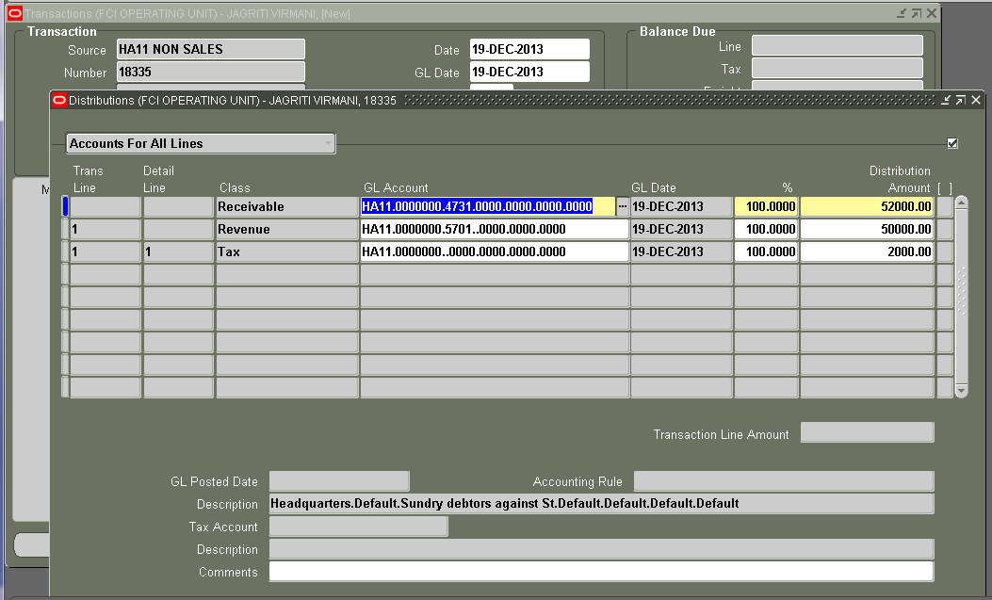

If in case the user doesn’t enter the account and tries to complete the transaction, he will get the error shown in the screenshot given below:
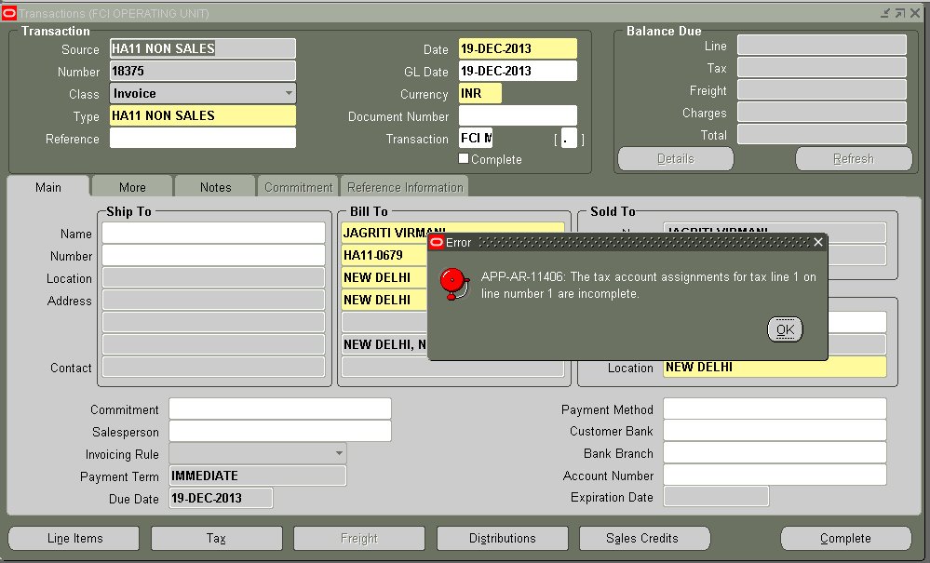

Also 7903 account is end dated so that in future if the user tries to create a transaction with 7903 account in distribution, system will throw an error saying the Account has been expired. Screenshot is given below:

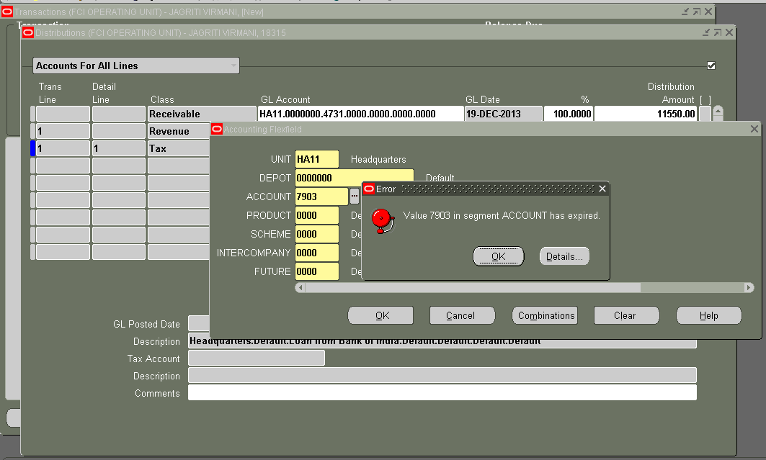

Deployments - Dec-2013

CR -331

- Reversal GL date will be non updateable.
- Reversal GL date will get automatically updated by Reversal Date, entered by the user, of the receipt.
- Datafix will be applied on prod that reversal date will be updated as per reversal gl date.

Deployments – Jan- 2014

CR – 335
- For Interco – IOM Rail Road category , 7216 account has been allowed at line level entry.
- IOM Transfer Out category allows only account codes 7111, 7112 and from 7201 to 7210,7216,7611,7612,7616,7617,7621,7701,7702,7703,7709,7710.
- For Transfer In against Stock received category , 7709 account head is been allowed in the DFF.
- Accounts allowed in the DFF for IOM Rail road category are shown as below:

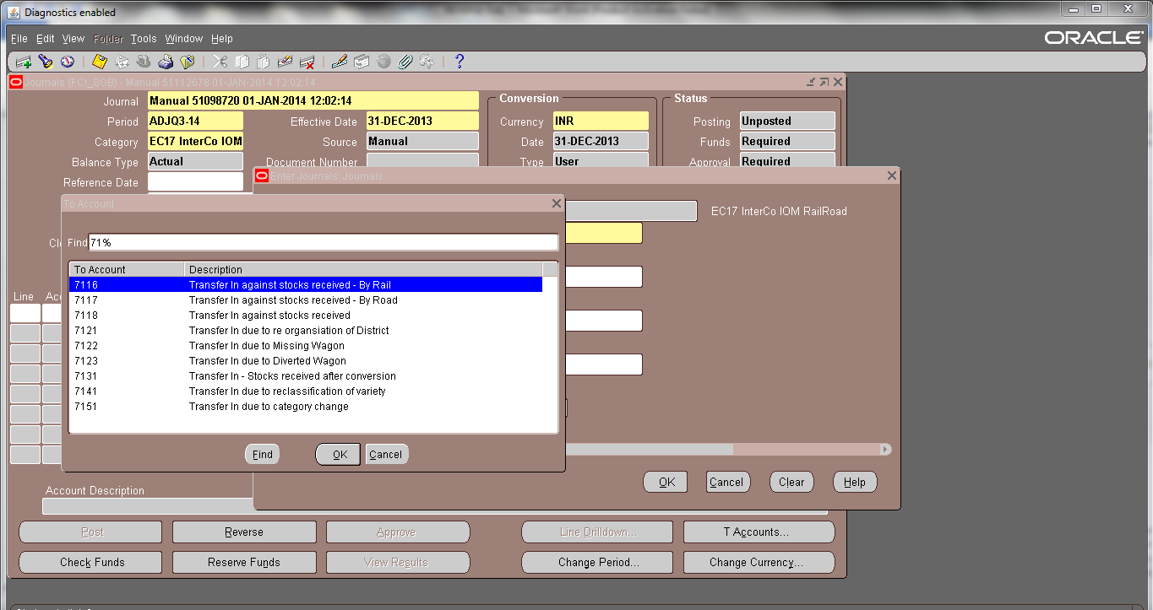

- Accounts allowed in DFF for Transfer in against stock received category are :
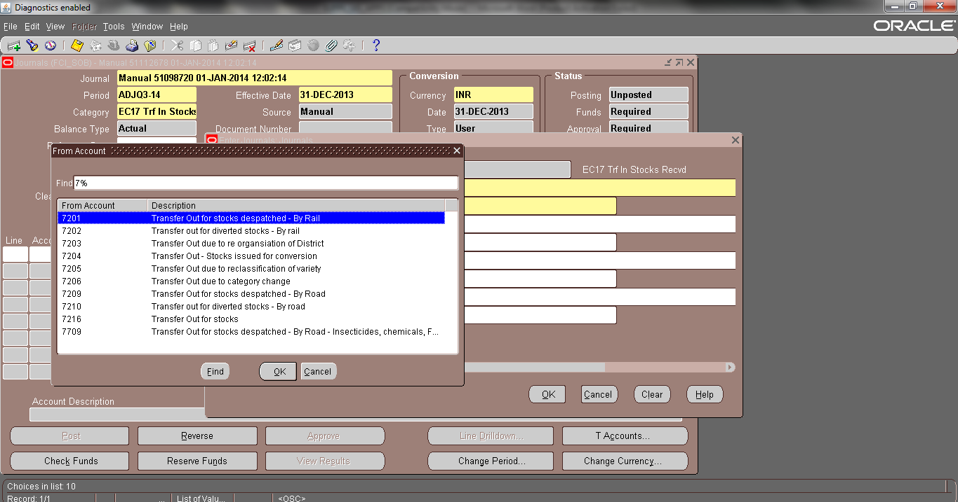

CR-319
The prepayment can be applied to a standard invoice which contains the unit taken in pre-payment distribution in its liability as well as distribution. That implies while application of a prepayment and Standard Invoice, either of the cannot be inter-co.
For instance : If unit A is taken in distribution of prepayment, then it can be applied with an invoice in which Unit A exists in distribution as well as liability .

CR-321
A check has been implemented to prevent user from cancelling the invoice if all the periods of the FY of the invoice is closed.
If the period to which the invoice belongs and or any of the periods after that is open for that FY then user will be able to cancel the invoice .
For eg: Invoice belongs to period JAN12-13 and if the period JAN12-13 or Feb12-13 or Mar12-13 is open then user will be able to cancel the invoice in FY 13-14 and the accounting date for cancellation will be in the last open period of FY12-13 but the cancel date will be the current date.

If the FY12-13 is closed till Mar12-13 then system will prevent user to cancel the invoice.

System will not allow user to create invoice with different GL Dates at header level and distribution level. Once the invoice is saved and invoice has been accounted, user will not be able to change the GL Date both at header level and distribution level.
System will not allow user to change the gl date of the line corresponding to cancellation of the cancelled invoices.
For Interco Invoices , the above mention solution approach will be followed for Unit at header level and distribution level.
For example ,if liability of the invoice is booked for WD11 and expense is booked for WD16 and gl date of the invoice is 30-Mar-2013 and FY12-13 for WD11 is closed and WD16 is closed till 28-Feb-2013.
The system will check for the open period of WD11 and WD16 as well,though WD16 Mar12-13 is open but system will not allow to cancel the invoice as FY12-13 is closed for WD11.

CR-320

The report ‘FCI Users Detail’ has been modified so as to fetch below mentioned three columns, along with existing columns(SR No. ,User Name ,Full Name ,Last Logon Date, Date Of Birth, Supervisor Name ,Status).
- Journals: Allow Preparer Approval
- Authorization Limit
- Gender

CR -324 Custom Period Closure

- 5 Adjustment period will be provided in custom close 4 are quarter Adjustments and 1 is year adjustment period.
- Period names will be added to Status of custom period closure.
- Custom closure functionality will be provided to zones (SA11,EA11,FA11,NA11,WA11,HA11) also for their own period closure, Currently Regions have access to close their own units and undelaying Districts , Support team have the access to close any unit in FCI.
- Adjustment period closure process have to submit same as main periods sequentially with other periods.

CR- 310 FCI Intercompany Reconciliation report

FCI Intercompany Reconciliation Report picks all the intercompany accounts that are used in Unit’s transactions ( Unit-Like “HA11’ in balancing segment) and its totals (Debit - Credit). The report also shows the account and the amount corresponding to the given accounts booked in transactions of the other unit involved ( Unit-Like “HA11’ in intercompany segment).
Differential amount between the amounts booked by both the units and quantity will also be shown in the report. Report picks data on as of date basis. For ex if the report is ran with As of Date 31-DEC-2013, it will pick records falling between 01-APR-2013 – 31-DEC-2013.

The report can be run from the General Ledger Responsibility. It can be run for all units from HA11 responsibility by selecting ‘ALL’ in report unit’s LOV.
The input parameter :Unit will fetch the first four characters of the responsibility with which user is executing the report, it will fetch, ‘WB12’ if user is executing the report from ‘WB12 General Ledger User Responsibility’.
All three parameters i,e; Unit , Natural Account , As of Date (eg – 31-DEC-2013) are mandatory. The screenshot is given below :

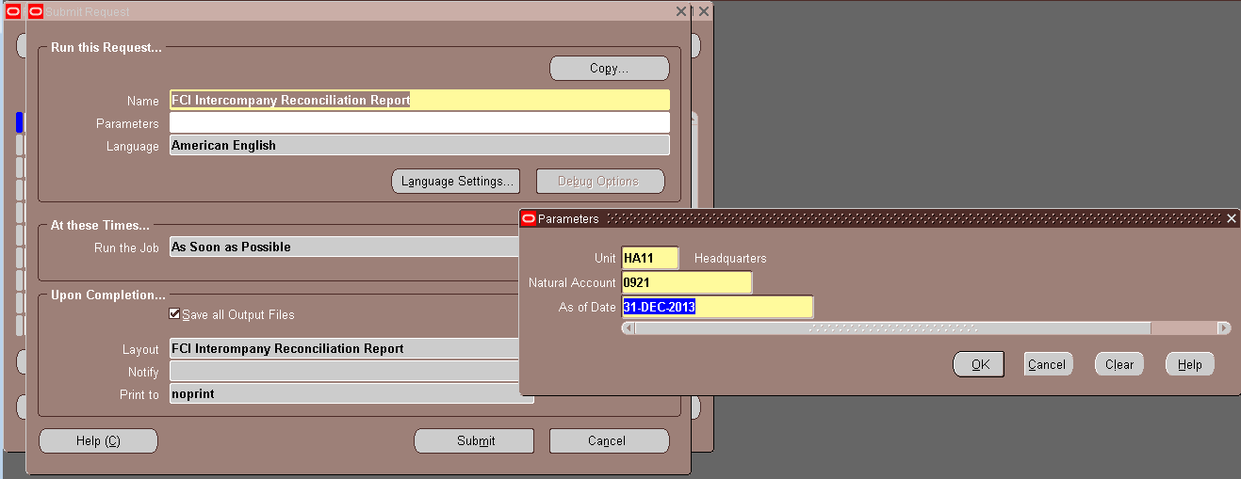

Sample output is attached herewith.
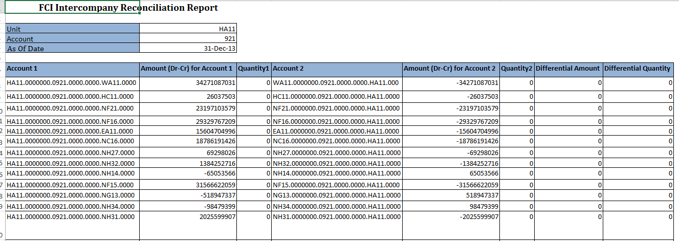

Deployments – Feb- 2014

FCI Asset Addition Report :

The report will fetch the details of asset added in a given period. This will be an excel report with the following input parameters:

S.No | Parameter Name | Optional/Mandatory | Description
1 | Unit | Mandatory | The unit for which report has to be executed
2 | Date From | Mandatory | Staring Period for report
3 | Date To | Mandatory | Ending period for report
4 | Asset Addition Type | Optional /If blank ALL | Whether it is OB/New/Transferred
5 | Asset Account | Optional /If blank ALL | For a particular asset account
6 | Minor Category | Optional /If blank ALL | For a particular minor category
7 | Location | Optional /If blank ALL | For a specific location(i.e Depot)
8 | Asset Type | Optional /If blank ALL | Whether it is Capitalised / CIP
9 | IT Block of Assets | Optional /If blank ALL | For a specified block type.

Output Fields :

- Asset Book : The asset book for which report was executed (taken in input parameter).

- Asset Account : The asset cost account of assets added in that period.

- Minor category : Minor category of all assets added in that period.

- IT Block of Assets : The block of assets to which the assets added in this period belong.

- Asset addition Type : The type (OB / New / Transferred) of added asset will be fetched in this column.

- Transferred From Unit : If the Asset addition type above is Transferred then only this column will get populated . The asset has got transferred from which unit will be fetched in this column.For asset addition type new and OB, this will be nul.

- Date of Addition : The date on which asset was created in the system .

- Asset Number : Asset Number of the added assets will be fetched here .

- Description : Description of added assets will be shown here.

- Date Placed in Service : Date placed in service given at the time of asset addition.

- Quantity : The number of units for that particular asset updated.

- Cost : The original cost of the asset, when it was added.

- Depreciation Reserve : The depreciation reserve for that particular asset of the period for which the report is executed.

- WDV : The net book value – salvage value .

- Salvage Value : Salvage value of the assets added in the given period for which the report is executed.
- Supplier Number : Will be populated with supplier number of invoices, only when the source of asset is Accounts Payable.For all other assets it will be null.

- Supplier Name : Will be populated with supplier name of invoices, only when the source of asset is Accounts Payable. For all other assets it will be null.

- Voucher Number : Will be populated with voucher number of invoices , only when the source of asset is Accounts Payable. For all other assets it will be null.

- GL Date : Will be populated with GL Date of invoices , only when the source of asset is Accounts Payable. For all other assets it will be null.

- Invoice Number : Will be populated with invoice number of invoices , only when the source of asset is Accounts Payable. For all other assets it will be null.

- Invoice Date : Will be populated with invoice date of invoices , only when the source of asset is Accounts Payable. For all other assets it will be null.

- WDV for DPIS < 180 Days : Cost of asset added in less than 180 days.(Difference between DPIS and end date of financial year of DPIS is less than 180 Days ,then this column will be populated with WDV, otherwise it will null ).

- WDV for DPIS > 180 Days : Cost of asset added in more than 180 days. (Difference between DPIS and end date of financial year of DPIS is greater than 180 Days ,then this column will be populated with WDV, otherwise it will null ).
Note :
- Depreciation reserve for any asset will be calculated for the month which is given in From and To date .
- Cost of the asset will be original cost , as it was when the asset was added.
Sample output is attached for your reference:
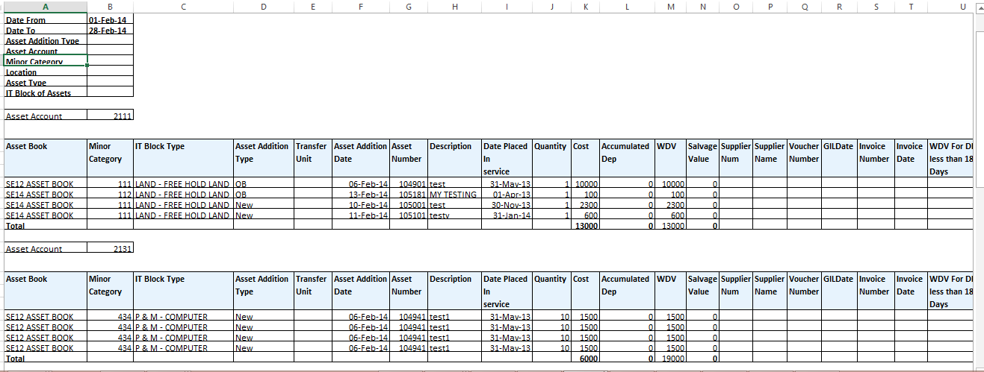

Setup to coinsider Satrday as working day in Treasury :

Sunday is considered as holiday in treasury setup. Any coupon fall on Sunday will be reflected on Monday in respect of accounting. Deals will be not entered on Saturday and should be taken care by users manually

CR-351
As per CR 351 the nomenclature of the following account heads have been changed:
Account head | Old Name | New Name
3759 | Transit shortages in missing wagons | Transit shortages in missing wagons/Withdrawal of claims for missing wagon
4215 | Transit gains in missing wagons | Transit gains in missing wagons/Withdrawal of liabilities for Unconnected wagons

18 Deployments – Mar- 2014

18.1 CR 337 FCI Asset Period Status Report

A new report that shows the Assets period status report asset book wise .This will be an excel report with no input parameter.
Output Fields :
- An Asset Book will be added to the report, so that the report can be generated.
- Period Name will show the open period.
- Fiscal Year shows the current fiscal year.
- Start Date shows the open date of the Asset Book.
- End Date shows the closed date of the Asset Book.
- Run Depreciation flag shows whether depreciation has been initiated for the asset

Sample output is attached for your reference:
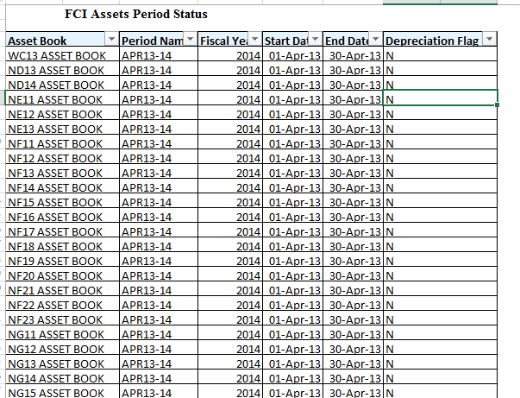
This report can be run from all Asset responsibility.

18.2 CR 353 Account Head 4534 is allowed with internal bank accounts

    - Account Head 4534 is allowed with internal bank accounts.
    - Default depot is not allowed with account head 4534.

18.3 FCI InterCo IOM Voucher

There has been a change to the report i.e. if the quantity entered is zero then the rate displayed on the report will be zero.

18.4 CR -352 Restrictions to be applied in the system

- A check is applied in the system so that the payment date cannot not be earlier than invoices GL Date.
For instance, if the invoice GL date is 01-APR-2013, then user cannot take any payment date prior to 01-APR-2013.
- For preventing this scenario to occur through payment form, a check is applied which will check the GL date of invoices selected in that payment , and will not allow user to take payment date earlier than invoice GL Date.
- For preventing the above scenario to occur in a payment batch, a check is applied on invoice form, so that payment schedule date on invoice form should be equal to or greater than invoice GL Date.
- An additional check is applied on payment batch form , so that pay through date cannot be more than the payment date, so that future GL dated invoices do not get selected in the batch which has lesser payment date.
For instance, if the payment date is 01-Mar-2013, then pay through date cannot be more than 01-Mar-2013, so that invoices with GL Date 02-Mar-2013 does not get paid on payment date 01-Mar-2013.
- If the user tries to pay the invoice from invoice form by selecting the option of ‘Pay in Full’, then also, he will not be able to take the payment date earlier than the invoice GL Date.
- A check is applied on the system, so that the type in invoice distribution could not be taken as ‘Miscellaneous’ , if the user does so, he will be prompted with an error message.

18.5 CR 354 FCI Journal Status Report.

A new report ‘FCI Journal Status Report’ is created and provided in FCI Support User responsibility, through which journals posted on a specific date , with a specific account head can be viewed.

This report will only fetch the journals which are posted .
Screen shot of this report is attached below:
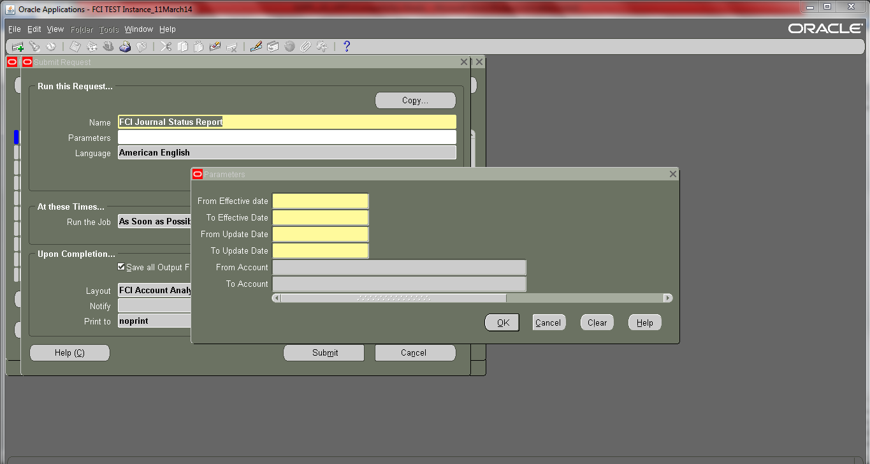
- The input parameter for the report will be:

Sl No. | Parameter | Mandatory/Non Mandatory
1 | From GL Date | Mandatory- Effective date of the journal for a particular accounting flex at line level
2 | To GL Date | Mandatory- Effective date of the journal for a particular accounting flex at line level
3 | From Update Date | Mandatory-Last update date of the account flex field at line level
4 | To Update Date | Mandatory-Last update date of the account flex field at line level
5 | From Account | Mandatory- Accounting flex field for which report is to be executed
6 | To Account | Mandatory- Accounting flex field for which report is to be executed

Sample output is attached for reference :
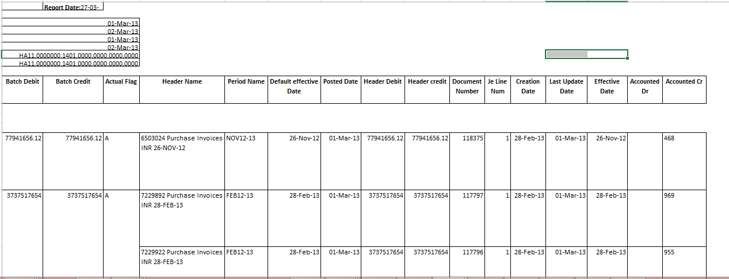

19 Deployments – Apr- 2014

19.1 CR 365 AR-Receipt Date
- Validation has been added that receipt date should be less than or equal to the receipt gl date.
- An error message will be displayed if user enters receipt date greater than receipt GL and receipt will not be saved. User has to enter receipt date as same as gl date or less than gl date

19.2 CR 343 Creation of new unit HQ11

- The new unit HQ11 will be created in the system.
- For the new unit, new responsibility for GL module ‘HQ11 General Ledger User’, for AP module ‘HQ11 Payables Super User’, for AR ‘HQ11 Receivables Super User’ will be created.
Interco responsibility for the above mentioned three modules will not be created.
- For other modules- XTR, FA, CM, Budget no responsibility will be created.
- Security rule as per the present system will be applicable to the new responsibilities ‘HQ11 General Ledger User’, ‘HQ11 Payables Super User’, ‘HQ11 Receivables Super User’.
- User will be allowed to use the new unit HQ11 as balancing unit in any accounting flex field as per the existing security rule in the system.
- ‘HQ11 Others’ category will be created for HQ11 in GL module
- ‘HQ11_Others’ document category will be created in AP module.
- ‘HQ11 SALES’ and ‘HQ11 NON SALES’ source will be created for transactions in AR module.
- For other modules (FA, XTR, Budget, CM) no category will be created.
- For AP module only ‘HQ11_APPS’ pay group will be created.
- Since no bank is available for HQ11, bank account will not be created in AP module. Thus, no payments can be made for the invoices of HQ11.
- Since no bank is available for HQ11, payment method for Receipts in AR module will not be created. Thus, receipts cannot be created for HQ11 in AR.
- No depot will be created for HQ11.
- HQ11 as intercompany segment will not be created.
- ‘H000’ will be the parent for the new unit HQ11.
- The new unit ‘HQ11’ will be custom closed till ADJQ3-14.

19.3 CR 346 Stock entry should not be allowed with nil amount (Revised)
- A new check has been implemented on the journal entry form which prevent user to input nil (0) amount in the debit and credit field of journal line .
- FCI Stock Ledger Summary Report is altered which can now accommodate Account description as well as scheme descriptions.

19.4 CR 368 Depots under unit ND12 to be prefixed with ND11
- The existing depot codes for stocks under unit ND12 has been replaced with unit code ND11 instead of ND12. E. g ND12001 will be changed to ND11001
- All the code combinations which has depot of ND12 with ND11 as unit has been converted to depot of ND11 so that the existing data with these code combinations are corrected.
- All reports will fetch data for ND11 depot with ND11 as unit from now onwards.

19.5 CR 355 Auto Generation of Service Tax Invoices
- Account codes for auto generation of service tax invoices are 1641 and 1642.
- One invoice will be created per negative amount distribution entered with above mentioned account codes.
- Invoice number format for such invoices are “ST-first 30 characters of parent invoice num- SEQ-distribution line num.
- For creation of service tax auto invoice the parent invoices should be standard type and distribution line type should be item.
- Vendor taken for auto invoice will be service tax authority, HA11_ST as vendor number and HA11_ST as vendor site code.
- The vendors for every unit with service tax authority classification will created by system. User cannot create vendors of service tax authority type.
- Custom periods cannot be closed if any such invoice is not created and will be shown same as “AP to AP auto invoice”.
- The request ‘FCI Create Auto Inv in AP - From AP’ will create the auto invoice.

19.6 CR- 370 Creation of Account Head 0972.
- Account head 0972 of account type revenue created with description as Inter Office Transfer for Depreciation Reserve.
- CVR rules applied as per the COA sheet provided.

19.7 Mantis Issue 2821 (SLS Report and Personalization on AP).
- FCI Stock Ledger Summary Report will pick data for invoices whose category is ‘Goods Purchased’.
- A check has been implemented on Invoice Form so that no invoice is created with DFF filled and Category like Other is taken.

20 Deployments – May- 2014

20.1 CR 357 Incorporation of fixed Asset Module in Custom Period Closure

- Following checks has been included ” FCI Custom Period Closure Report – Auto invoice & Interface” Report :
  - The same period of Fixed Asset module should be depreciation run and transferred to General Ledger before closing custom periods.
  - Distributions eligible to reach to Fixed Assets should be moved to Assets and rest should be marked as not require transferring to Assets.
- As per CR- 357 , user will be able to reverse the journals of his unit, having source as assets. Customization has been applied in such a way that , if the jjournal contains two different units in lines , he will not be able to reverse it, but if it contains a single unit he can reverse it from general ledger responsibility of that unit.
For instance : If the user is logged in from EC17 , then he can reverse the jounals with source as asset, that only contain EC17 at line level, if SB17 also exist at line level, neither EC17 nor SB17 can reverse it.

20.2 FCI Asset Schedule as per Company Act Report

The new report FCI Asset Schedule as per Company Act Report has been created and provided to FCI Support.
The report will be executed for 1 Financial Year (FY) only. It cannot be executed for cross Financial Year (FY).

Input Parameters
S.no | Parameter | Optional/Mandatory | Description
1 | Unit | Mandatory | The unit for which report has to be executed. The report will fetch data for the asset book of the unit which user has given. Unit is based on hierarchy. If report is executed for ‘H000’,the report will fetch data for all the asset book, If report is executed for ‘SE14’,the report is fetch data for SE14 Asset Book
2 | Period To | Mandatory | Run for the period to which data is to be fetched. It is mapped with the period in which any transaction has occurred on the asset. Like, it is mapped with period entered for asset addition.
3 | Asset Account | Optional | Run for all if blank (Major Category of the asset)
4 | Minor Category | Optional | Run for all if blank.

20.2 CR 379 Change in the description for A/c head 2191 and updation in the depreciation rates

- Description for account head 2191 as ‘Capital Work in Progress ( set up default not to be used by field offices)’
For ‘LAND - LEASE HOLD LAND’ Assets Depreciation method will be WDV - 0% and for every addition in this type of assets user has to manually change the depreciation method through mass changer screen.

- Mass Change form is provided to all sites.

Note:
1. If the Change Date entered by user in ‘Mass Change’ form is less than Date placed in service of asset then the amortize adjusted will be calculated from date placed in service with new depreciation rate.(for e.g. Date placed in service is 01-dec-2013 and change date is 01-nov-2013)
2. If the Change Date entered by user in ‘Mass Change’ form is more than Date placed in service of asset then the amortize adjusted will be calculated as-
- From Date placed in service to change date with old depreciation rate.
- From change date onwards with new depreciation rate.
(For e.g. Date placed in service is 01-nov-2013 and change date is 01-dec-2013)

20.3 CR 378 -FCI GL balance reconciliation Summary report
- The report ‘FCI GL balance reconciliation Summary report’ is in Excel format.
- The report will fetch the summary data from GL,AP and AR module and report will show data of GL module, then AP module and then AR module.
- Data will be fetched for closed period only(FCI custom closed)
- The input parameter for the report will be:

Sl No. | Parameter | Mandatory/Non Mandatory
1 | Period | Mandatory –Period for which data is to be fetched from GL,AP and AR module
2 | Account | Mandatory–Account for which data is to be fetched
3 | Unit | Mandatory–Unit for which data is to be fetched

Output:
Module | Source | Section | Credit Amount | Debit Amount | Net Amount

Module: To show from which module the data is fetched. (GL , AP , AR).
Source: To show from which source the data is fetched.
- For Payables:
- FCI Payroll
- Payables
- Receivables
- Manual
- For Receivables
- Manual
- FCI Import
- Credit Memo
- For General Ledger
- FCI Payroll
- Payables
- Receivables
- Manual
- Assets
Section: To show where the account is Liability, Expense, Revenue, Receivable etc.
Credit Amount: Sum of credit amount based on module, source and section .
Debit Amount: Sum of debit amount based on module, source and section.
Net Amount: (Debit Amount-Credit Amount)
The report will fetch total based on source and module.

Note: The report can executed for asset accounts (excluding bank accounts) and liability accounts only

20.4 CR 378-FCI GL Balance Reconciliation Detail
The report will fetch the detail of Payables invoice distribution and revenue and tax detail of transaction in AR.
- The report will be in excel.
- Data will be fetched for closed period only(FCI custom closed)
- The input parameter for the report will be:

Sl No. | Parameter | Mandatory/Non Mandatory
1 | Unit | Mandatory – Unit for which data is to be fetched
2 | Account | Mandatory–Account for which data is to be fetched
3 | Period Name | Mandatory– Period for which data is to be fetched from GL,AP and AR module
4 | Module | Mandatory–Module from which data is to be fetched eg Payables, Receivables
5 | Source | Mandatory– From which source data has come to the module
6 | Section | Mandatory–whether payment or liability etc

The output:
Gl Date |  | Party Name | Invoice Number | Vouc her Number | Entry Type | Transaction Type | Description | Debit | Credit | Net | Unit | Depot | Account | Product | Scheme | Intercompany

Note: The report can executed for asset accounts (excluding bank accounts) and liability accounts only

20.5 CR 334- Modifications in Print Invoice Notice

- The report is modified, such that earning and deduction part for an invoice , comes one by one account wise .
- The net amount payable field from report header level is replaced with invoice header level description.
- All the deductions in the form of TDS and WCT is fetched at the end of the report ( before the Ner Payable field ) , the details will be invoice number and amount only.
- The amount shown in passed for payment is calculated after netting of the withold amount .
(Total earning in the invoice– Total Deductions in the invoice )
A sample output has been attached for reference :

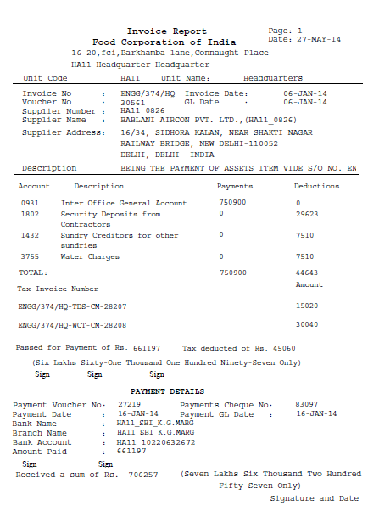

20.6 Changes in Retirement Gain/Loss

Function Path: Choose Assets > Asset Workbench >Retire from the Navigator window.

Steps:
To FULLY retire an asset:
- Choose Assets > Asset Workbench from the Navigator window.
- Find the asset you want to retire
- Choose Retirements.
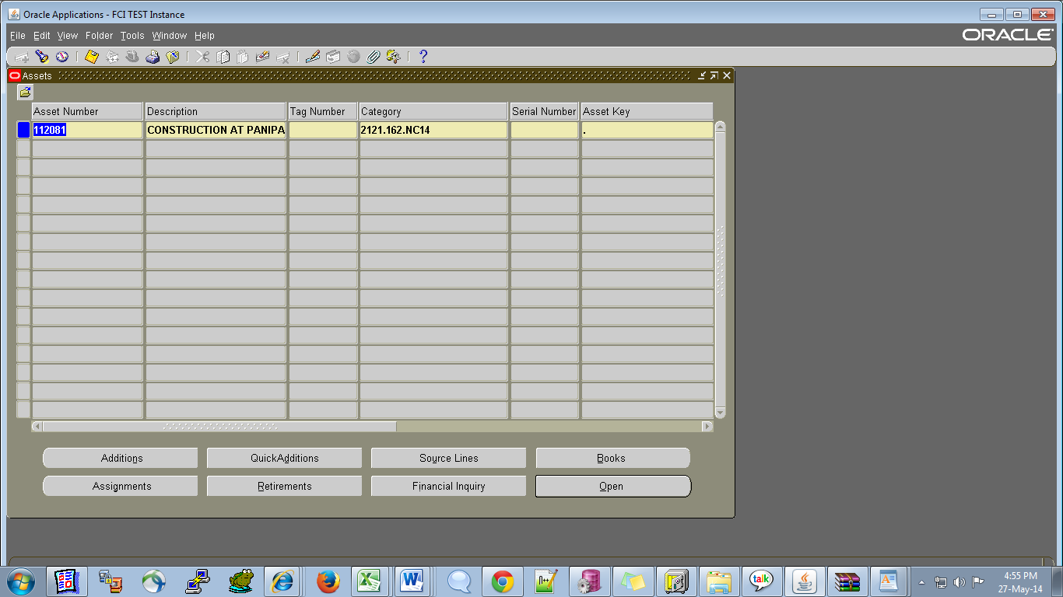

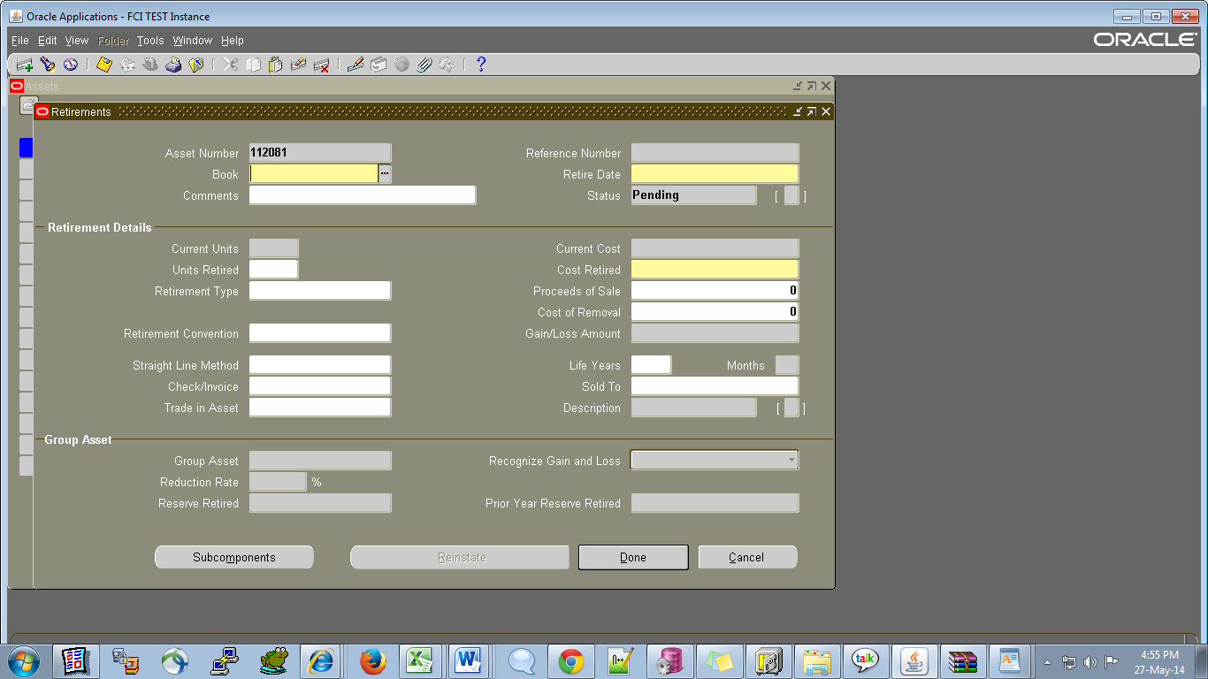

- Select the depreciation Book from which you want to retire the asset.
- Enter the date of the retirement. It must be in the current fiscal year, and cannot be before any other transaction on the asset.
- To fully retire the asset, enter all the units or the entire cost.
- Enter the asset Type and unit in the DFF.(. Otherwise Transfer if asset to be transferred at other unit.)
  - If asset to be retire than select asset type Retired.
  - If asset to be transfer at any other unit than asset type should be Transfered. In this case Gain/Loss amount should be zero. If system calculate a non-zero gain /loss than error out depreciation reports. As below screen shot.

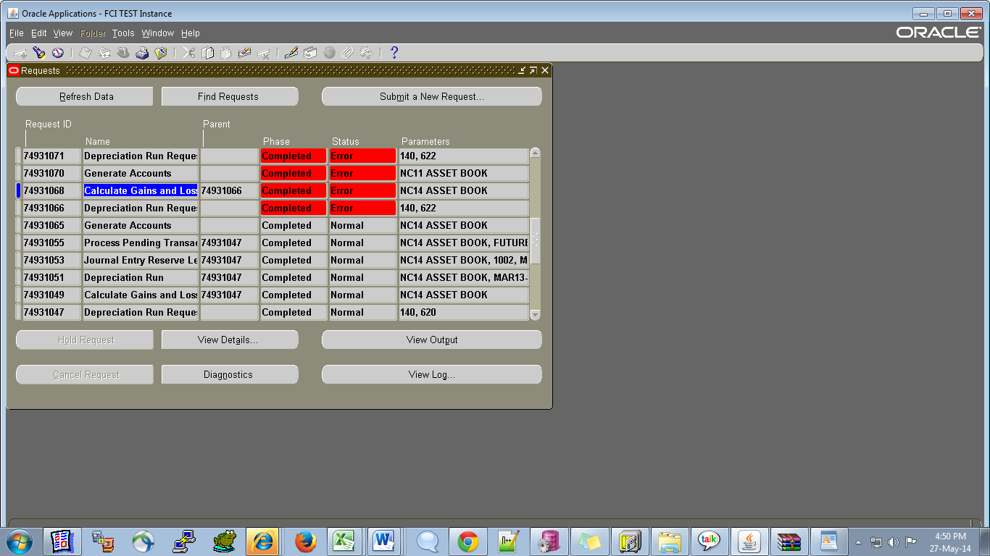

Check view log in this case “Asset number 112081 with transfered type is having gain /loss of Rs -621354.46 instead of zero amount.
Please correct the proceed of sale amount in retirement screen, so that gain /loss becomes zero.”

Adjust the sale amount according to Profit /loss and rerun the depreciation.

- Save your work.

- Note: Oracle Assets assigns each retirement transaction a unique Reference Number that you can use to track the retirement.
- On Depreciation Run , the status of the retirement transaction will be changed from PENDING to PROCESSED
- Create accounting entry of selling asset in Accounts receivable module crediting Proceeds of sale account and debiting Cash/Bank account.

Note: 1.1 If the asset type is retired while retiring the asset, then user cannot take any unit In ‘Transferred Unit’ apart from his unit.
1.2 If the asset type is ‘Transferred’ while retiring an asset, then user cannot take his unit in the Transferred Unit segment.

User can view retirement transaction from financial inquiry screen also.
- Navigate to Inquiry.

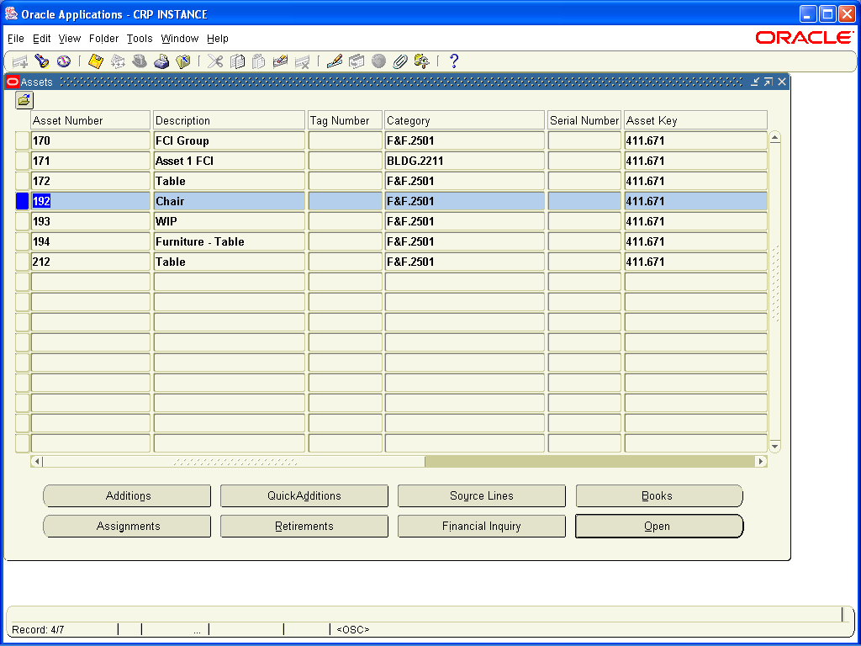

- Click on financial Inquiry screen. Click on Cost history tab
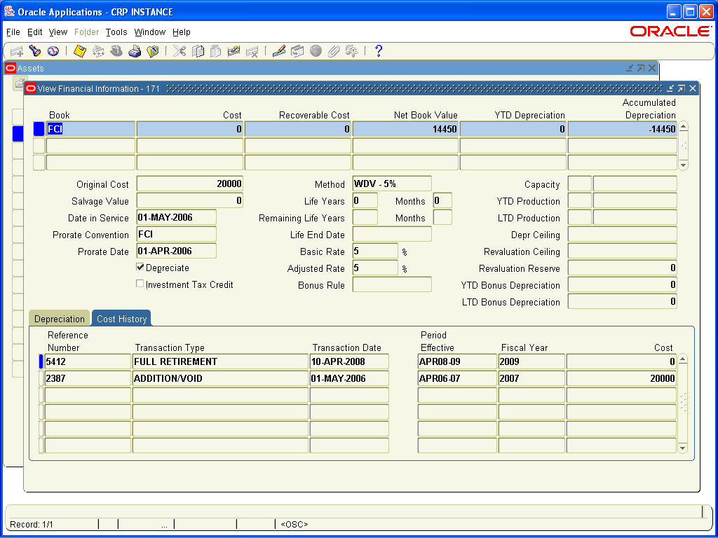

20.7 CR 382- Creation of new a/c heads 3794 against existing account head 29.100 And 5402 against existing account heads 13.111, 13.112 and 13.113
- Creation of account heads 3794 against account number 29.100 (expenses incurred on staff Union).
- Creation of account heads 5402 against account number 13.111 (Railway Freight 1. A-Freight paid/payable Rice (Rebooking Charges).
- Creation of account heads 5402 against account number 13.112(Railway Freight 1. A- Freight paid/payable Wheat (Rebooking Charges).
- Creation of account heads 5402 against account number 13.113(Railway Freight 1. A- Freight paid/payable Paddy (Rebooking Charges).
- Following constrain will be applicable to the new account heads

Existing Account Number | New Account Number | Account Description | Parent Account | Type of Account | Allow Budgeting flag | UOM | FCI Account Type | Unit | Dependent Product | Dependent Scheme | Depot | Effective Date | Remarks
029.100 | 3794 | Expenses incurred on staff Union Election | 3700 | Expense | Yes | No | Nil | All | 0000 | 0000 | No | 01.04.2008 | Circular No. 1035 dated 16.02.2009 w.e.f 01.04.2008
013.111 | 5402 | Railway Freight  1. A- Freight paid /payable  Rice(Rebooking Charges) | 5400 | Expense | Yes | No | Nil | All | 0201 to 0205 | 0000 | No | 01.04.2013 | Circular 1139 dated 24.03.14 w.e.f 01.04.13
013.112 | 5402 | Railway Freight  1. A- Freight paid /payable  Wheat(Rebooking Charges) | 5400 | Expense | Yes | No | Nil | All | 0101 to 0103 | 0000 | No | 01.04.2013 | Circular 1139 dated 24.03.14 w.e.f 01.04.13
013.113 | 5402 | Railway Freight  1. A- Freight paid /payable  Paddy(Rebooking Charges) | 5400 | Expense | Yes | No | Nil | All | 0301, 0302 | 0000 | No | 01.04.2013 | Circular 1139 dated 24.03.14 w.e.f 01.04.13

21 Deployments – Jun- 2014

21.1 CR 388- Addition of Asset Category and updating Existing Vs Final
- The minor category 457 is activated with description Furnitures And Fittings - Guest House And Canteen . A new category of assets is created with major account head 2161 (Furnitures And Fittings) with minor category 457 for all the units with description Furniture & Fitting Guesthouse & Canteen. A depreciation method of WDV 25.88% is created and attached to this category.
- A scheme 3457 with description same as minor category 457 (Furnitures And Fittings - Guest House And Canteen), is created in the system.
- The scheme 3457 is allowed with account heads 2161 (major category for Furniture and Fittings ), 2261 (Furniture and Fittings Depreciation Reserve Account ),2361 (Furniture And Fittings Depreciation Account) as per circular no. 1145 dated 05-jun-2014.

21.2 CR 391- Distribution parameter from FCI India cash/Bank Book Report
Distribution parameter is removed FCI India cash/Bank Book Report.
FCI India cash/Bank Book Report runs on the following parameters now:

- Bank Account Name
- Account Number
- Book Type
- Start Date
- To Date

21.3 CR 366- DM-REFUND Functionality
- DM-Refund” transaction type has been made inactive (end dated on 24-Jun-2014)
- The request ‘FCI Create Auto Inv in AP - From AR’ will create the auto invoice from AR to AP for refund amount for the account heads- 1803, 1804, 1805, 1806, 1808, 1809, 1810 (with already existing account 1801,1802,1809)
- The invoice number format of the auto invoice created in AP is: ‘Trx Number in AR-Unit Code-line number EMD-Month (MON)-Year of Invoice Date(YYYY)‘.
- Auto invoice in AP will be created from AR for the account heads-1803, 804, 1805, 1806, 1808, 1809, 1810 (with already existing account 1801,1802,1809) from the day the functionality will be deployed on production instance(Deployed on 25-Jun-2014)

21.4 CR 390- FCI India - Debtors Ledger Report
The report has been modified to fetch the opening balance for the customer even if there are no transaction in the Period for which report is executed.
The Customer Name parameter has been made mandatory.

21.5 CR 393- Creation of new STL Depreciation methods
- In FCI, the life of an asset is generally about 3 years or is too high (about 50-60 years). For assets whose life is high, is not affected by the depreciation calculated as per the current system. (Depreciation calculated on original cost-accumulated depreciation) but for assets whose life is less, is affected.Hence, new STL depreciation methods has been created in the system for 1 month to 36 months.
- New prorate convention of 1 month (FCI MONTH) has been created so that for Assets having per unit value of less or equal to 5000, is completely depreciated in the same FY (if date placed in service of the asset is more than 1st March.)
- System check has been modified such that no depreciation is charged for land (Block of Assets: LAND - FREE HOLD LAND and LAND - LEASE HOLD LAND) even when cost of land is less then or equal to Rs 5000.

21.6 CR 397- Personalisation applied on DFF on goods purchse invoice

A check had been applied on the system :
- For standard goods purchase invoice the paid quantity on the DFF has to be positive.
- For credit memo goods purchase invoice the paid quantity on the DFF has to negative.

22 Deployments – JUN 2014

22.1 CR 396- Removal of "Post in summary/Summarize Journal Entries" Parameter

  - Withdrawal of input parameter ‘Summarize Journal Entries’ in ‘Create Journal Entries’ request in FA module from user with default value ‘No’ assigned to it.

  - Withdrawal of input parameter ‘Post in Summary’ in ‘General Ledger Transfer Program’ in AR module from user with default value ‘No’ assigned to it.
Note: In ‘Payables Transfer to General Ledger’ Request in AP module, input parameter ‘Summarize Journal Entries’ is not provided to user and default value ‘No’ is assigned to it.

22.2 CR 369- InterCo IOCPF has to be automated in the system

- Document category InterCo IOCPF has been made available through General Ledger Interco responsibility.

- Document category InterCo IOCPF has been automated in the system so that the zero account is populated automatically just like IOR.

- Same unit will not be able to approve the InterCo IOCPF Journals. It must be approved by another unit.

23 Deployments – JUL 2014

23.1 CR - 399 Requirement of Document Sequence in Trial balance report & debit / credit total in Trial balance Detail report.

A new report FCI Trial Balance detail with document sequence has been created to display Last document sequence used in all modules at the time of running report.
It will be displayed as below at the end of the existing report.
Sequence Name | Module | Last used Document Number

23.2 CR - 363 FCI Consolidated Trial Balance

This report wil fetch the balances in different account head on the basis of grouping given in Existing Vs Final sheet under the head S.No For TB.(The balances will be consolidated if the report is executed at parent level unit).
It will be based on three segments of the code combination that are Account, Product and Scheme. The description of all three will be fetched in the report . The report will be governed by the following input parameters :

Parameter Name | Optional/Mandatory | Description
Unit | Mandatory | Unit for which report has to be executed , can be executed for RO, ZO and at parent level.
Period Name | Mandatory | Period for which report has to be executed.
Balance Type | Mandatory | YTD/PTD/PJTD

The output will be fetched group wise and totals will also be done group wise. This report will also fetch last document sequence details at sub – ledger level.
Note : this sequence will be fetched only when the erport is executed for the child unit and not at any parent level.

Sample output is attached for your reference :
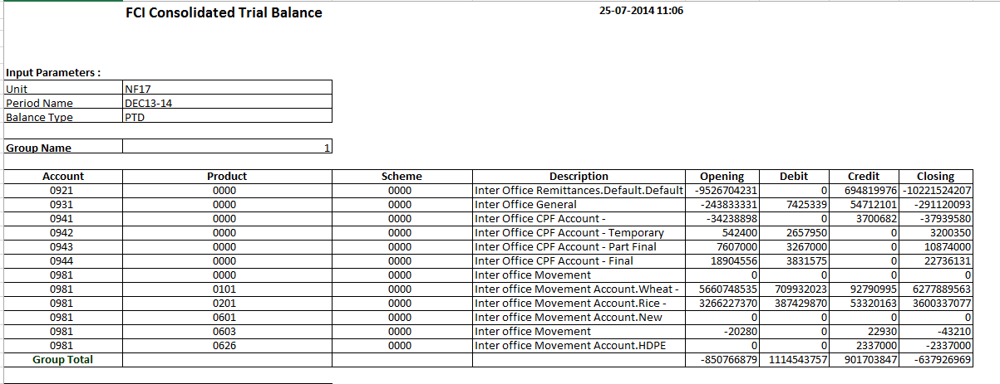
Also as per this CR , following reports have been withdrawn from the system :
- FCI Trial Balance Detail Report
- FCI Trial Balance Sumamry Report
- Consolidated Trial Balance (All FSG Menus)

CR – 402 CR 402 Closing balance parameter in FCI - Bank Reconciliation Statement
The closing balance parameter will allow only 17 digits including the – (negative) sign if any and the . (decimal point).

Deployments – AUG 2014

CR- 323 FCI SLS For Stores And spares
This report will fetch the balances booked in account heads for stores and spares . It is provided in the normal general ledger responsibilities.
It will be based on three segments of the code combination that are Account, Product and Scheme. The description of all three will be fetched in the report .Following points are to be considered:
- Report Shows balances at unit level given and breakup of that sub unit wise or depot wise will be not available.
- The report for stores and spares will contain grouping and sorting similar to SLS- for Gunnies and Food Grains.
- Balances in report will be fetched after posting in GL only.
- Stores and spares report do not contain within zone or outside zone bifurcation for transfer in and transfer out.
- Balances will be shown with similar sign conventions as in SLS- for Gunnies and Food Grains report.
- Sign convention will be applied for Opening, Net and Closing balances.
- Group total will be based on amounts for display and Report total will be based on totalling sign convention.
Note : Only those accout heads will occur in this report , which are marked for stores and spares ,provided by FCI in the annexure attached with the CR.
The report will be governed by the following input parameters :

Parameter Name | Optional/Mandatory | Description
Unit | Mandatory | Unit for which report has to be executed , can be executed for RO, ZO and at parent level.
Depot | Mandatory | Depot for which report has to be executed
Period Name | Mandatory | Period for which report has to be executed.
Balance Type | Mandatory | YTD/PTD/PJTD
Product | Mandatory | Product for which report has to be executed

The output will be fetched account type wise and totals will also be done in the same manner.
Sample output is attached for reference :
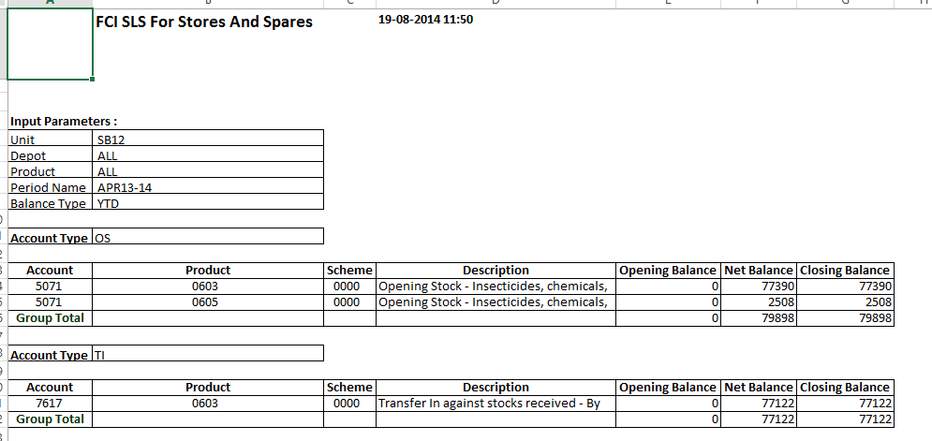

CR 363 - FCI Profit & Loss Statements Report
This is an excle report which will bring the balances as per the grouping provided by FCI for Profit And Loss Statement. This grouping will be based on three segments , that are account head , product and scheme. The account combinations with opening balance , period activity and closing as zero , will not be fetched in the report. The input parameters are :

Parameter Name | Optional/Mandatory | Description
Unit | Mandatory | Unit for which report has to be executed , can be executed for RO, ZO and at parent level.
Period Name | Mandatory | Period for which report has to be executed.
Balance Type | Mandatory | YTD/PTD/PJTD
The report is provided in normal Genral Ledger, Fci support user and audit user responsibilities.
The output will be fetched group wise and totals will also be done group wise
Sample output is attached for your reference.
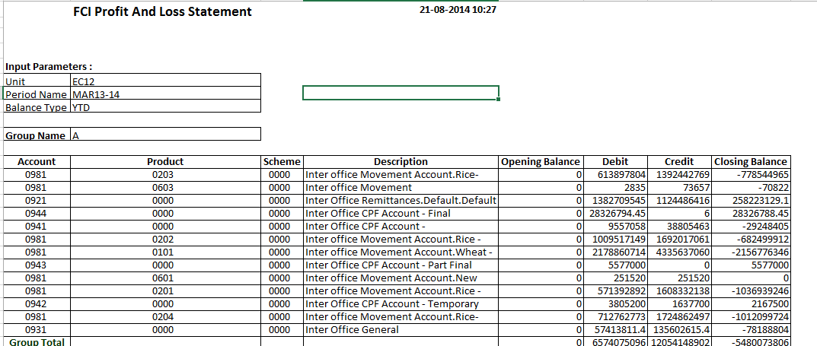

25 Deployments – SEP 2014

CR 403 – Period Opening Rights in Apps

- A new responsibility ‘FCI Period Control User’ will be created which will contain the request ‘FCI Custom Period Open Program’ to open the periods. This responsibility can only be given by TCS team. FCI Support user does not have the right to assign this responsibility to any user. This responsibility will be given to Sh R.R Agarwal , GM (FAP) , user id : HA11_SH039297C & Smt. Rashmi Gulati , DGM (A/cs) , user id : HA11_SH047585C by TCS team.
- The right to open periods will be withdrawn from FCI Support User.

CR 406 - FCI Asset Adjustment Report

A new concurrent program ‘FCI Asset Adjustment Report’ has been created , which will be fetching details of all types of adjustments (Cost , Depreciation method change, category change, unit adjustment ) done on any asset.

The report will be containing following parameters :

Parameter Name | Optional/Mandatory | Description
Unit | Mandatory | Unit for which report has to be executed . Will be hierarchy driven.
Date From | Mandatory | Staring Date (Date on which adjustment has been done).
Date To | Mandatory | Ending Date (Date on which adjustment has been done).

The unit changes occurring due to retirement , will not be fetched in the report.Also, the final changes done in any month will be fetched in the report. For instance, if user has changed the wdv method from 20% to 30% and then again to 50% in the month of March-14 , then only one line showing old wdv method as 20% and new wdv method as 50% will be shown in the report. In between changes will not get reflected .

If two changes (say on category and on wdv method ) has been done on the same date, then only they will be shown in single line in the report, or else they will be shown in two diffferent lines with the respective dates.One line will show the category change and other will show the wdv method change.

The output is attached in the below format :
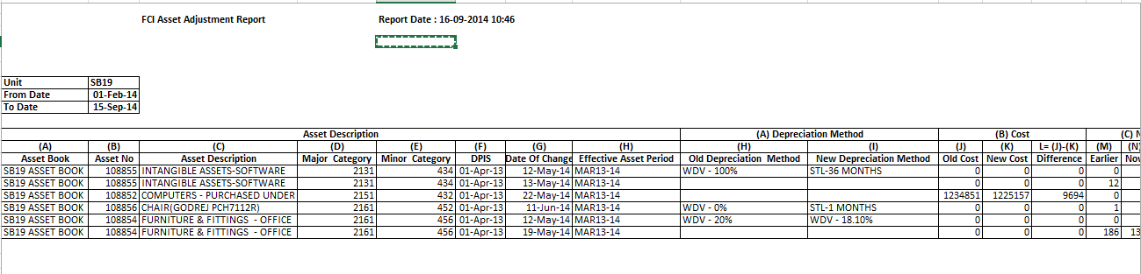

CR 423 - Updation of Account/Unit/Product/Scheme segment values
The following changes have been made:
- For unit FC00, FC11 and FC12 have been defined as child unit
- Account heads 3209 and 3212 have been disabled
- Account heads 3250, 4700, and 6300 have been made parent account.
- Products 0041, 0056, 0057, 0058, 0150, 0250, 1150 have been made parent product
- For Product ALL budgeting and posting has not been allowed
- Schemes 2167,2202 have been made parent scheme
- Account head 4005 has been allowed with product 0201 to 0205
For account 3250, as per existing vs final sheet accounts 3251, 3252, 3253, 3254, 3255 and 3256 have been defined as child accounts.

For account 4700, as per existing vs final sheet accounts 4701, 4702, 4703, 4704, 4705, 4706, 4707, 4708, 4709, 4710, 4711, 4712, 4713 and 4714 have been defined as child accounts.

For account 6300, as per existing vs final sheet accounts 6301, 6302 and 6303 have been defined as child accounts.

For Product 0041, as per existing vs final sheet product 1600 have been defined as child product.

For Product 0056, as per existing vs final sheet product 1600 have been defined as child product.
No child product have been defined for products 0056, 0057 and 0058 as no child is defined for these products in the existing vs final sheet

For Product 0150, as per existing vs final sheet products 0101 and 0103 have been defined as child products.

For Product 0250, as per existing vs final sheet products 0201, 0202, 0203 and 0204 have been defined as child products.

For Product 1150, as per existing vs final sheet products 1101 and 1103 have been defined as child products.

No child is required to be defined for product All. The product ALL was created for report generation, hence it has not been marked as parent but budgeting and posting has not been allowed so that user cannot use the product at code combination.

For Scheme 2167, as per existing vs final sheet schemes 2176 and 2186 have been defined as child schemes.

For Scheme 2202, as per existing vs final sheet schemes 2216 and 2226 have been defined as child schemes.

All code combinations corresponding to the changes required have been disabled as of 31-MAR-2013.

As per discussion with GM (FAP), the substitute provided for the changes are as follows:
Segment | Changes | Substitute
Account Heads
3209 | To be disabled | Balance not to be moved
3212 | To be disabled | Balance not to be moved
3250 | Should be parent | Balance to be moved to account head 3251
4700 | Should be parent | Balance to be moved to account head 4731
6300 | Should be parent | Balance to be moved to account head 6303
7331 and 7321 | To be disabled | Balance not to be moved
7411 to 7442 | To be disabled | Balance not to be moved
Product
0041 | Should be parent | Balance to be moved to product 1606
0056 | Should be parent | Balance to be moved to product 1606
0057 | Should be parent | Balance to be moved to product 0606
0058 | Should be parent | Balance to be moved to product 1606
0150 | Should be parent | Balance to be moved to product 0101
0250 | Should be parent | Balance to be moved to product 0201
1150 | Should be parent | Balance to be moved to product 1101
ALL | Should be parent | Balance to be moved to product 0101
Scheme
2167 | Should be parent | Balance to be moved to scheme 2176
2202 | Should be parent | Balance to be moved to scheme 2216

The balance for the disabled code combinations have been transferred in two steps. At first step, balance have been transferred as of 31-Mar-2014 and at second step when CR 371 is deployed on production

Cross validation rule for account head 4005 have been modified so as to allow product 0201 to 0205.

Deployments – DEC 2014

CR 409 – Validations in AR

- In Oracle AR module customer will be made mandatory in standard receipts.
- On Account application will be disabled in receipts.
- In Transaction form distribution - receivable by default ‘null’ should be given in account head field instead of "4731".

CR 444 – Changes for Asset Module
- Run Depreciation form is withdrawn from normal asset user responsibility and FCI Support User responsibility.
- The check of depreciation status , and FA to GL posting is removed from ‘FCI Custom Period Closure Report - Autoinvoice & Interface’ report , so that it doesnot get checked at the time of period closure.
- The check of AP invoices which are not transferred to FA in the report, will still remain .

CR 445 – Changes in FCI Profit & Loss Statements
- The grouping of this report has been changed as per the below annexure attached.
- The sorting of the report was only on group name. It has been done on account , product and scheme.

Deployments – Jan 2015

CR 426 – Asset Transfer Reconciliation Report

A new concurrent program will be created under the name ‘FCI Asset Transfer Reconciliation Report’, which will be fetching details of all assets which are transferred to or transferred from one unit to another in excel format.
The report will be containing following parameters:
Parameter Name | Optional/Mandatory | Description
Unit | Mandatory | Unit for which report has to be executed. Will be hierarchy driven.
Date From | Mandatory | Starting Date (Date on which adjustment has been done).
Date To | Mandatory | Ending Date (Date on which adjustment has been done).

The output is attached in the below format :
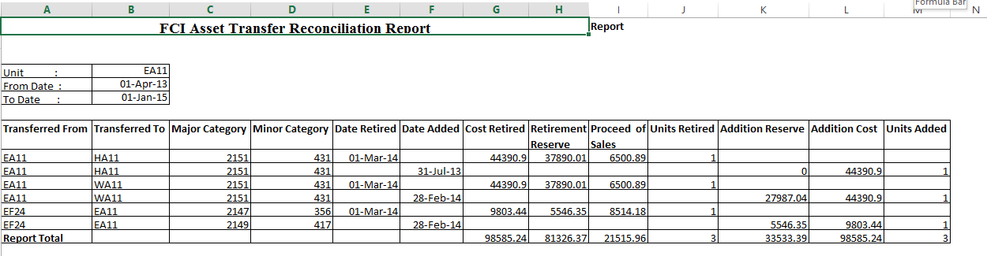

CR 443 – Changes in FCI Asset Addition Report and personalizations in FA module
- Current cost of the asset will be fetched in the report.
- Asset Type (Capitalized / CIP) will be fetched in the report.
- All the calculation in the report like WDV etc. will be done on current cost, rather than original cost.
- Check is applied in the system, such that only valid code combination segment of depreciation expense account for major and minor category of assets should be taken up by the system.
For instance, if major category is 2161, and minor category is 456 , then in assignments window, the expense account can be 2361, and scheme can be 3456 only.
- Mass Transfer form is revoked from normal Asset User Responsibility.

CR 416 – Changes in Payment form for discount field
As per the above CR, the discount amount and discount available fields should be disabled, while entering and adjusting invoices from payment form .

CR 394 – FCI A2S Report: Statement A to S
The reports are in excel format which will be generating output in below mentioned formats,
- product in the verticals and accounts in the horizontals
- product in the horizontals and accounts in the verticals
- account in the verticals with products where ever applied
- accounts in the verticals and accounts in the horizontals where ever applied
- account in the verticals with combination in all products
- schemes in the horizontals and accounts in the verticals.

The input parameters are:
S. No | Parameter Name | Optional/ Mandatory | Description
1 | Period Name | Mandatory | The period for which statement has to be viewed.
2 | Balance Type | Mandatory | YTD/PTD
3 | Statement Type | Mandatory | Type of statement starting from A to S. Consolidation of All statements will come under option of “FCI Costing Reports” in this LOV.
4 | Unit | Mandatory | Unit hierarchy will be followed.

CR 412 – Limit on Quantity in AR Forms
- On all the forms in AR module from where quantity is entered (Line Level of Transactions Form), restriction should be applied such that user cannot enter the quantity in decimal digit more than 5 digits after decimal.
- In the SLS report, the quantity field should be rounded off to 5 decimal digits.

CR 453 – Allowing pass/approve JE to the user of HQ11 GL having cat. HQ11_Others by taking Unit Code of Other units at line level
- A new responsibility ‘HQ11 GENERAL LEDGER INTERCO USER’ has been created. Forms available in this responsibility are:
  - JournalsEntry
  - InquiryBudget, Journal, Funds, Account, Account analysis and drilldown
  - OthersRequests, Notification
  - Report Run, Set
  - FCI XLS UPLOAD
- User can enter journal having multiple units at line level ‘HQ11 GENERAL LEDGER INTERCO USER’ responsibility only.
- User cannot enter lines for multiple units using any other responsibility including HQ11 PAYABLES SUPER USER , HQ11 RECEIVABLES SUPER USER and ‘HQ11 GENERAL LEDGER USER’.
- User can select only ‘HQ11 Other’ in journal category in ‘HQ11 GENERAL LEDGER USER’ and ‘HQ11 GENERAL LEDGER INTERCO USER’ responsibilities.
- No security rule are applicable to ‘HQ11 GENERAL LEDGER INTERCO USER’ responsibility thus user can enter multiple units at line level of the journal.
- Intercompany setup for ‘HQ11 Other’ category is defined in the system. The natural account which is defined in the setup is ‘0962’ and the natural account is end dated so that no intercompany lines are created for intercompany journals.
- All journals in ‘HQ11 Other ‘ category stuck in Error 16, will be cleared by FCI Team.
- All journals created through ‘HQ11 GENERAL LEDGER INTERCO USER’ responsibility in ‘HQ11 Other’ category will be approved by the user who has the access to ‘HQ11 GENERAL LEDGER INTERCO USER’ responsibility and has the right to approve the journal and approval limit is correctly set.
- Journals of all categories will be queried through ‘HQ11 GENERAL LEDGER INTERCO USER’ responsibility but user cannot make any changes in the journals which has category other than ‘HQ11 Other’.
- User can enter unit at line level whose accounting period is custom closed but the period for HQ11 is custom open. The journal will be posted in the same period.

CR 371 – Disabled code combination handling

1. Information for disabling to be provided in specific template with approved change request. The template is available on the homepage --> library -->Data templates --> 'Template_For_Disabling_Account'.

2. Deactivated accounts will be replaced with substitute account from any setup area if exists. Including custom processes ,Auto invoice Payroll to Payables, Payables to Payables, Payables to Receivables, Receivables to Payables or Payables to Asset, distribution sets and similar places.

3. During cleaning of previous transactions new entries cannot be made. on the following screens:
a. Payables
i. Invoice entry screen
ii. Supplier and site default accounts entry
iii. Bank account combination entry screen
iv. Distribution Set screen
b. Receivables
i. Transactions distribution entry screen.
ii. Receipt class account combination entry screen.
iii. Transactions default entry screen.
iv. Receipt activity setup screen
c. General Ledger
i. Journal Entry screen
ii. Budget organization screen
iii. Budget transfer screen
d. Assets
i. Category setup screen
ii. Assignment screen
iii. Mass transfer screen
4. The list of incomplete transaction will be provided to FCI HQ as a report so that the entries can be cleared.
5. Future restrictions:
A. For invoices(Payables), If
I. Liability Account is disabled then-
1. Payment cannot be voided.
2. Prepayment applied on the invoice cannot be unapplied.
3. Invoices cannot be cancelled.
II. Distribution Account is disabled then-
1. Invoices cannot be cancelled.
2. Prepayment cannot be unapplied (If prepayment account is disabled).
2. Prepayment cannot be cancelled. (If prepayment account is disabled).
B. For Payments(Payables), if
I. Bank Account is disabled–
1. Payment cannot be voided.
C. For Transaction( Receivables) ,If
I. Receivable and Revenue Account is disabled–
1. Cannot un apply any application with transaction.
D. For Receipts (Receivables), If
I. Un apply account is disabled-
1. Cannot un apply any application on receipt
2. Cannot reverse receipt
II. End Dated Bank combination is disabled-
1. Cannot un apply any application from this bank.
2. Cannot reverse receipt
E. General Ledger -No check is required for General Ledger as reversed Journals can be deleted.
F. Assets- No check is required in assets

Deployments – Feb 2015

CR 451 – Addition of Banks in Valid Bank List

- The below said banks will be added in the valid bank list lookup with effective date as 01-APR-2010.The field in system will be populated as following:

MEANING | DESCRIPTION | EFFECTIVE START DATE
THE NASHIK MERCHANTS COOP BANK LTD | THE NASHIK MERCHANTS COOP BANK LTD | 01-APR-2010
KESHAV SEHKARI BANK LTD | KESHAV SEHKARI BANK LTD | 01-APR-2010
THE DELHI STATE CO-OPERATIVE BANK LTD | THE DELHI STATE CO-OPERATIVE BANK LTD | 01-APR-2010
JHARKHAND GRAMIN BANK | JHARKHAND GRAMIN BANK | 01-APR-2010
SARVA U.P. GRAMIN BANK | SARVA U.P. GRAMIN BANK | 01-APR-2010
MADHYA BIHAR GRAMIN BANK | MADHYA BIHAR GRAMIN BANK | 01-APR-2010
BARODA UP GRAMIN BANK | BARODA UP GRAMIN BANK | 01-APR-2010
SIRSI URBAN SAHAKARI BANK LTD | SIRSI URBAN SAHAKARI BANK LTD | 01-APR-2010
COOCHBEHAR CO-OPERATIVE & RURAL DEVELOPMENT BANK LTD. | COOCHBEHAR CO-OPERATIVE & RURAL DEVELOPMENT BANK LTD. | 01-APR-2010
KARNATAKA STATE COOP APEX BANK | KARNATAKA STATE COOP APEX BANK | 01-APR-2010
GRAMIN BANK OF ARYAVRAT | GRAMIN BANK OF ARYAVRAT | 01-APR-2010
PUNJAB GRAMIN BANK | PUNJAB GRAMIN BANK | 01-APR-2010
MAHARASHTRA GRAMIN BANK | MAHARASHTRA GRAMIN BANK | 01-APR-2010
THE SANGRUR CENTRAL CO-OPERATIVE BANK LTD | THE SANGRUR CENTRAL CO-OPERATIVE BANK LTD | 01-APR-2010
CHATTISGARH RAJYA GRAMIN BANK | CHATTISGARH RAJYA GRAMIN BANK | 01-APR-2010
THE PATIALA CENTRAL CO-OPERATIVE BANK | THE PATIALA CENTRAL CO-OPERATIVE BANK | 01-APR-2010
UTTAR BIHAR GRAMIN BANK | UTTAR BIHAR GRAMIN BANK | 01-APR-2010
PRATHAMA BANK | PRATHAMA BANK | 01-APR-2010
PURVANCHAL GRAMIN BANK | PURVANCHAL GRAMIN BANK | 01-APR-2010
KERALA GRAMIN BANK | KERALA GRAMIN BANK | 01-APR-2010

NOTE: The Bank meaning field is used by user on FORM.

CR-429: Automation of flow of bank details from apps to payroll
As per CR 429 , if a supplier of ‘FCI Employee / FCI Retired Employee’ type creates or modifies his/her bank details at his current site ,the changes will be automatically reflected in payroll, however the changes made at non-current site will not get reflected in payroll. No changes can be done from payroll end, as the field of bank account number is now disabled for update or entry.
If a supplier updates/ attaches bank details using ‘FCI Bank Detail Attachment Report’ to his current site , then the changes will be reflected in payroll by a temporary scheduled program (which can be revoked further), however the changes will take some time to reflect and will only be reflected if the updation was made at the current site.
If supplier is transferred from one location to another his/her bank details in payroll will be removed. In such cases the vendor level bank details for the employee will be updated in payroll, if they exist. Else the details will remain blank and will have to be updated manually at current site in APPS, only then the details will be reflected in payroll.
NOTE:
- Two banks of same type cannot have same MICR, however same MICR can exist for an internal and an external bank.
- Two banks of same type cannot have same IFSC code, however same IFSC code can exist for an internal and an external bank.
- Duplicate MICR can exist for two or more banks of same type or of different type with dummy value ‘DUMMYMICR’. But this dummy value can only be entered by the FCI Support User responsibility.
- Duplicate IFSC can exist for two or more banks of same type or of different type with dummy value ‘FCIDUMMYMICR’. But this dummy value can only be entered by the FCI Support User responsibility.

Deployments – Mar 2015

CR-437 FCI India Creditor Trial Balance Report
- Vendor type input and output parameter will be removed from the report.
- Unit parameter will be based on hierarchy level.
- Invoice Category will be added as an input parameter of report. This will be having an LOV with two options, ‘Goods Purchased’ and ‘Others’
- The details of invoices namely Input Category, invoice number, gl date will be fetched in the report output.
- The report will get executed only for the unit hierarchy from which the user is logged in.
For instance, if the user is logged in from NA11 then he can execute the report for NA00, but he cannot execute it for NB00.Also, user will be able to select H000, only if he is logged in from HA11 responsibility.

The new format of the report:
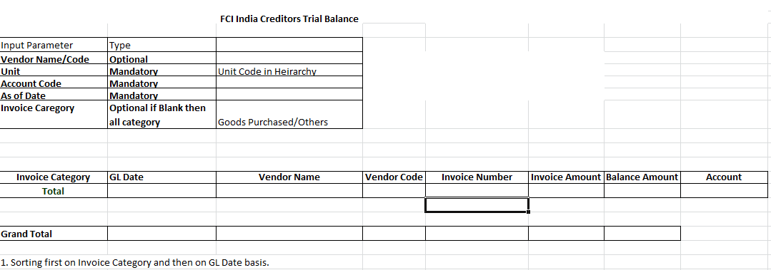

CR -456 Checks in Asset Module :
- User will not be able to run depreciation in below scenarios. He will be prompted with an error saying to execute an exception report (FCI Pre- Depreciation Run Program) , which will list the below type of assets:
- If there exists any asset having per unit current cost (current cost /current no. of units )less than or equal to Rs. 5000 , and depreciation method not as STL 1- Month. CIP type assets falling in this category will be excluded from the report. Any fully retired assets falling under this category will be excluded from the report. This category will be the first one to be displayed in the report output.
- If there exists any mis-match in category and depreciation method in any of assets of that asset book (other than STL 1- Month ). Fully retired assets will not be catered in this scenario. CIP type of assets will be excluded from this category.
- Assets having WDV – 100% and having above two issues and not fully depreciated will not be excluded from the exception report.
- If there exists any asset having different minor category and scheme in expense account combination . Fully retired assets of such category will not come in this category.
- Assets which are having Asset Type as ‘CIP’ and category other than ‘2193.481.Unit’.
- Assets which are having asset type as ‘Capitalized‘ and category as ‘2193.481.Unit’ .
- Fully Depreciated assets will not come in this report in any of the categories.
If data in above categories exist, the user will get a prompt , saying you need execute ‘FCI Pre-Depreciation Run Program ’ first , clear the data fetched in this report ,and then only you can run depreciation .
- For assets with type ‘Capitalized ’ and category as ‘2193.481.Unit’ , user will have to change the category of the asset , and then only he will be able to run depreciation. In case he wants to keep this asset as CIP, he will have to change the category of this asset , retire it, and create a new CIP asset with category 2193.481.Unit.
- ‘FCI Pre-Depreciation Run Program’ will be a concurrent program (with text output), which will display all the assets of the above categories , along with asset number and specific issue description in its output. User will have to clear all the data displayed in the output of this request, and then only user will be able to run depreciation of that particular asset book.The output format of this report is attached in the annexure.
- There will be a check on all forms (which are currently identified—Mass Change form , Book form , Source Lines Form) having amortization date column , so that date in this column should be either first of current financial year or DPIS whichever later.For Mass Change form , following cases will take place:
a. When user has not given any 'FROM' and 'TO' Asset Number : In this case , amortization date is 1st of current financial year or not , only this will be checked.(As DPIS of asset number will not be available to be checked for greater than comparison with 1st of current financial year .)
b. When user has given a range of asset numbers: (For example "FROM Asset Number" 108418 to "TO Asset Number" 108423) In this case also , only one thing will be checked that whether the amortization date is 1st of current financial year or not. (As DPIS of asset number will not be available to be checked for greater than comparison with 1st of current financial year .)
c. When user gives only one asset number : ( FROM and TO Asset Number are same ), then amortization date should be DPIS or first of current financial year , whichever later ,both conditions will be checked.
- FCI Asset Cost Adjustment Report will be modified such that , it fetches the asset type changes also. In case of DPIS change on asset , new DPIS will be fetched in the report output.
- The Cost of removal field on asset retirement form , will be disabled , so that user does not enter any value in it.
- A check will be applied in the system, so that user cannot take any other category apart from (2193.481.Unit) while making a ‘CIP’ asset. User will have to change the type , re-class it , and chage its depreciation method , when he wants to capitalize it.This check will be applied for future data entry .User will be allowed to change the category/asset type of existing assets to clear them.
- Also, a check will be applied in the system, so that category ‘2193.481.Unit’ will not be allowed with ‘Capitalized ’ type of assets.
- ‘FCI Mass Addition Create Program’ will, be modified in such a way that , assets having natural account ‘2193.481.Unit’ in AP invoice, will be imported in FA with type ‘CIP’.
- For changing the type of asset from CIP to Capitalized , user will have to use the below path
Unit Fixed Asset Responsibility >> Asset Workbench >> Capitalize to CIP Asset.
No check on the DPIS displayed at ‘Capitalize CIP Asset ‘ is to be applied.
- CIP type of assets will be removed from the automation done at time of asset addition, for changing depreciation method to STL- 1 month for assets having per unit original cost less than Rs. 5000.
- Data of all assets having mis-match in depreciation method and category will be given to FCI

CR-464 , No changes allowed in invoice flowing from payroll to Apps module.
Once an invoice is flown from Payroll to Apps module the user will not be able make any kind of modifications in any of the fields except for the ‘Payment method’.

CR-455 Modification in chart of accounts and grouping
A Request Set ‘FCI Chart Of Accounts Master’ has been created. The following 5 child requests are there:
      - FCI Chart of Accounts Detail
      - FCI Asset Categories Detail
      - FCI Unit Detail
      - FCI Product Detail
      - FCI Scheme Detail
This request set is available to FCI support User responsibility.
For every CR in which there is any change is COA, TCS will generate these reports, merge the output of the request set sheet wise in an excel and will provide it to FCI HQ to verify the changes. Once the sheet is verified the same will be uploaded in the FCI Financials Homepage.
All code combinations disabled due to change in COA or CVR will be disabled through the process mentioned in CR 371.
The format of the reports will be:
Report Name | Format
FCI Chart of Accounts Detail
FCI Asset Categories Detail
FCI Unit Detail
FCI Product Detail
FCI Scheme Detail

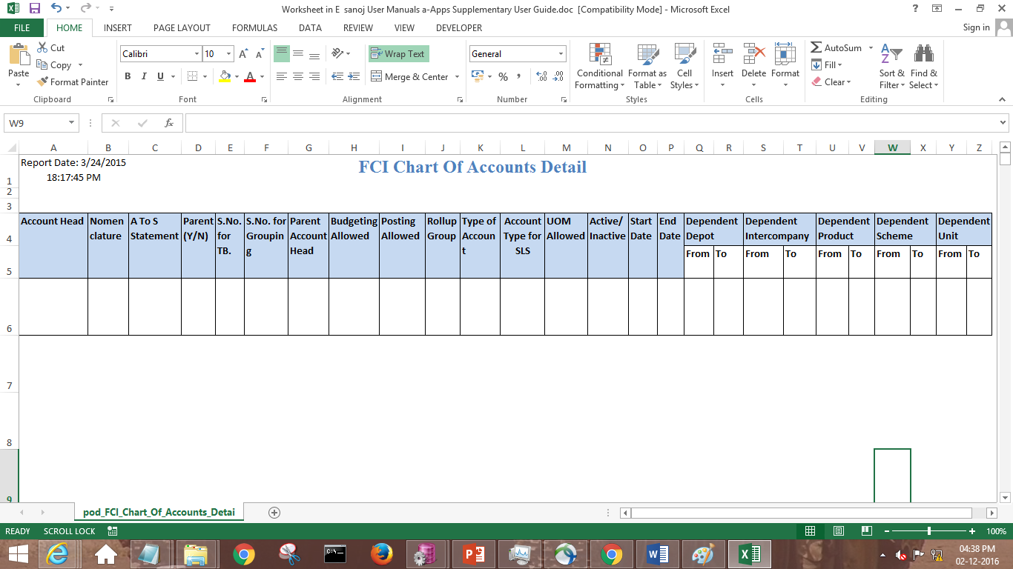

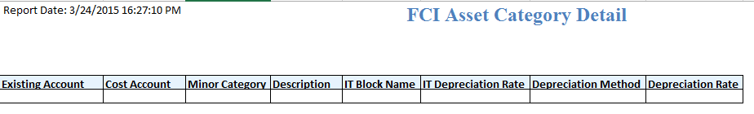

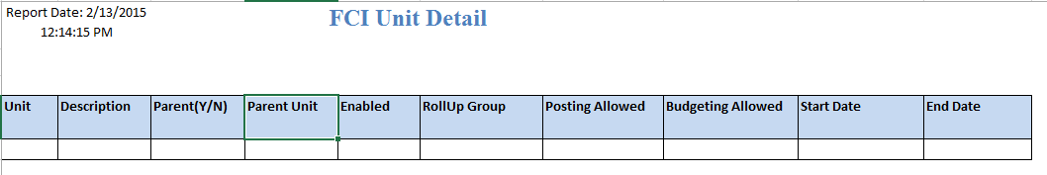

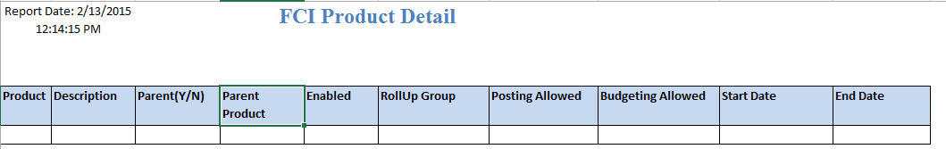

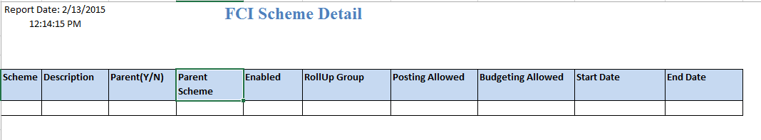

CR-419 Creation of new Report
- A new report ‘FCI Debtor/Creditor Age-wise Report’ has been created.
- The Report fetches the data based on accounting date of the transaction.
- The accounting date must be custom closed.
- The buckets are fixed on number of days.
- Upto six months – 180 Days
- Six Months to One Year- 181 Days to 365 Days
- More than One Year to Three Years-366 Days to 1095 Days
- More than Three Years to Five Years-1096 Days to 1825 Days
- More than Five Years- More than 1826 Days
- A process has been created which will take the snapshot of creditor and debtor account (for creditor- Account is used in Liability code combination and for Debtor- Account is used in Receivable code combination), based on the period closed for the unit. This process will be scheduled.
Eg.- For HA11 if Mar13-14 is custom closed then the process will take the snapshot of all the invoices and payments in AP and of all the transactions and receipts in AR whose accounting date is less than equal to 31-Mar-2014
- The input parameters for the report are :
Sl. No. | Parameter | Description
1 | Unit | Can be executed for a zone, for a region, for a unit or all India. For executing the report on Zone, data for units which belongs to the zone will be fetched
2 | As on Date | This will be last date of the period selected above.
5 | Type | Either Creditor or Debtor. Anyone can be selected.

Eg: If User has selected N000 is Unit parameter. In case any unit which is under N000 is open then data will not be fetched for the units. In the output message,’ Aging process is not completed for all the units. Kindly verify the following Units and rerun the report. ‘ and also the units for which data cannot be fetched will be shown.
If the snapshot for the accounting date less than the date parameter for which user is executing the report is not fetched then also the message, ’ Aging process is not completed for all the units. Kindly verify the following Units and rerun the report. ‘ and also the units for which data cannot be fetched will be displayed in the report output.
The report will be sorted on account head and there will be no rounding off in the values.
The sample report format:
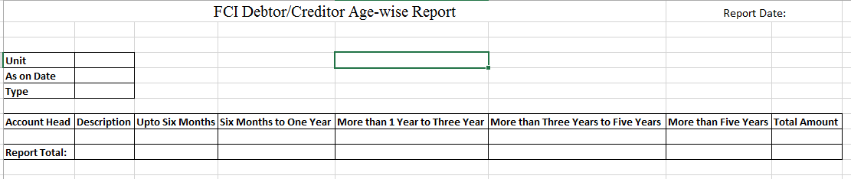

CR- 420 Changes In FA Module:
- At the time of asset addition :
- Referencing is maintained between the newly added asset and assets which are transferred or which can be transferred.
- In the DFF of asset detailed addition, an additional field of asset number is added, which is having an LOV.
This LOV is governed by unit which is given in “Transferred unit” field of DFF, and category entered by user at time of asset addition. To meet the business requirements stated above, all the assets of unit entered in “Transferred Unit” field of DFF and category entered by user are fetched irrespective of the fact that these old assets are transferred yet or not.
For instance, if unit HA11 is doing asset addition and has entered category 2161.246.HA11, and in “Transferred Unit” field of DFF, NA11 is taken, then all the assets of unit NA11 and category 2161.456.NA11 will be fetched in LOV of asset number, irrespective of fact that assets belonging to category 2161.456.NA11 are actually transferred from NA11 or not till now.
- User has to pick an asset number from the above LOV in DFF, on the basis of which prorated details will come then. This is a mandatory field.
- If user tries to make any asset addition (of any type) , in any asset period other than February and March , through Detailed Asset Addition forms, then error message is shown to user, and addition cannot be done.
- Quick Addition Form is revoked from all users as no field is there for mentioning depreciation reserve details of asset to be added.
- The DPIS of newly added asset should be DPIS of the old asset (refers to asset which has been selected in LOV of “Transferred Asset” field in DFF) or 01st April of current financial year, whichever later.
- The number of units that a user can add at the time of addition (for assets which are transferred and not yet added) can be equal to or less than number of units transferred and not more than that.
For instance , if unit A has transferred 10 units out of 100 for asset number XXXX to unit B , then unit B can add 10 or less number of units only .
Once the unit B has added these 10 units, rest of 90 units will be available for addition. Unit B cannot run depreciation until it has added minimum 10 number of units. This will be catered via FCI Asset Pre-Depreciation Run program , in which pending transfers will be shown to the user.
- The number of units that a user can add at the time of addition (for assets which are not yet transferred) can be equal to or less than total number of current units available for that asset.
- The cost and depreciation reserve details of newly added asset, should be equal to the prorated cost and reserve of the old asset depending on the number of units added (transfer type) as on DPIS. In case user enters any other amount, an error message is displayed, in which the correct values are displayed. The formula for calculating the cost is:

FORMULA:
- Added Cost = (Total cost retired in year A– Cost already added in year A) * units to be added/Available units
The above formula is applicable in case of assets which are retired (transfer type).
- Added Cost = Total Cost * Units to be added /Available Units
The above formula is applicable in case of assets which are never transferred before.
- Depreciation Reserve = (Depreciation Reserve as on 1st date of Financial Year or DPIS whichever is later) * Added Units / Available Units
This formula is applied for both Partially Retired (transfer type) and Never Retired (transfer type) assets.
- Check is applied on Books form, so that user cannot make cost adjustment in such a way that it results in negative WDV.
- User can adjust cost or depreciation of already added assets of transferred type using addition form.
- A check is implemented on addition DFF that user cannot change ‘Transfer unit’ and ‘Asset number’ of added assets which are processed in system after depreciation run.
- At the time of Asset Retirement
- The date of retirement for “Transferred Type “of retirements should be equal to DPIS of asset or 01st April of current financial year whichever is later. In case it is not, user will be prompted an error.
- If user tries to make any retirement in any asset period, other than March, then user will be prompted with an error.
- The FCI Asset Transfer Reconciliation report is modified such that it also fetches the asset number along with other details.
- A check is also implemented on depreciation run as:
If unit B has transferred some assets to unit A and Unit A has not added them till date of depreciation run, then check does not allow to run depreciation for unit A. Similarly if A has added units and they are not transferred from unit B than Unit B cannot run depreciation. User will encounter an error, which will ask user to run the depreciation exception report (FCI Asset Pre Depreciation Run Program). This report show him the pending additions of ‘Transfer Type’/ pending Transfers, along with asset numbers and number of units.
- User has to clear this exception report, by making suitable transfers and additions, and then only he can execute depreciation for his asset book.
- Partially transferred assets present in the system (done in the month of MAR13-14 , data given to FCI on issue id 21023) till date are not picked in this process (for formula calculation).They will be visible in DFF at the time of addition.
- A check is implemented on Retirement DFF that user cannot change ‘Transfer To unit’ of any asset once it is Processed (that depreciation is executed).
NOTE: A check is implemented so that Assets with LAND Category ‘FREE HOLD LAND’ (major account 2111) and STL 1 month are not catered in Exception Report for this category. This check was to be implemented in CR 456 but CR is already deployed on Prod Instance so same is deployed with CR 420.

Deployments – Apr 2015

CR 428- APP Change in calculation of TDS and WCT:
A rounding factor of 1(it will work on nearest one basis) will be setup in the system for the financial year 15-16 active from 01-Apr-2015. By 01-Apr-2015, we mean GL date. This rounding factor will work for both TDS and WCT.
Let us take an example of threshold setup for ‘EC11 WCT @ 10 %’ with rounding factor at organizational level set to nearest 1 having:
Vendor type: OTHER PERSONS-IND
Section code: EC11 WCT @ 10 %
Start Date: 26-JUN-2010
End Date:

From Amount | To Amount | Tax rate (%)
0 | 1000 | 0
1001 |  | 10

Let us create an invoice ‘INV1’ for a vendor of this vendor type of amount Rs.500.
For this invoice the tax rate will be 0 %. So tax calculated will be zero in this case.
Let us make another invoice ‘INV2’ for the same vendor of amount Rs.1111. The cumulative amount for this particular vendor is now Rs.1611 for the current financial year. So tax rate applicable will be 10% for this case.
Tax calculated will be 10% of 1611 = Rs.161.1. This tax will be round off to Rs.161 by the system (rounding factor at organization level is 10) and tax invoice of amount 161 will be generated by the system
Let us make another invoice ‘INV3’ for the same vendor of amount Rs.1231. The cumulative amount will now be 2842.
Tax calculated will be 10% for Rs.2842= Rs.284.2 .This tax will be rounded to Rs.284 by system. But as system has already generated a tax invoice for Rs.161, system will now create a tax invoice of amount 284-161= Rs.123.

If we see the above example the total amount of tax invoices generated by the system is 161 + 123 = Rs.284
The actual tax needed to be paid to the WCT authority should be 161.1+ (284.2-161.1) = Rs.284.2.
So the tax generated by the system is less than the actual tax needed to be paid to the WCT authority by Rs.0.2.
In case of scenarios when rounded to tax cumulatively leaves some tax, the maximum value per vendor will be Rs. 0.49.

CR 471: Addition of Banks in Valid Bank List
- The below said banks will be added in the valid bank list lookup with effective date as 01-APR-2010.The field in system will be populated as following:
S.NO | MEANING | DESCRIPTION | EFFECTIVE START DATE
1. | PRERANA CO-OPERATIVE BANK LTD | PRERANA CO-OPERATIVE BANK LTD | 01-APR-2010
2. | PIMPRI CHINCHWAD SAHAKARI BANK | PIMPRI CHINCHWAD SAHAKARI BANK | 01-APR-2010

CR 477: Addition of Banks in Valid Bank List
- The below said banks will be added in the valid bank list lookup with effective date as 01-APR-2010.The field in system will be populated as following:

S.NO | MEANING | DESCRIPTION | EFFECTIVE START DATE
1. | THE SEVA VIKAS CO-OP BANK LTD | THE SEVA VIKAS CO-OP BANK LTD | 01-APR-2010

CR 468 : Changes in Asset Category and creation of new ones
Following solution methodology will be opted:
- Nomenclature of the existing categories , asset account heads and relative schemes is changed as per annexure provided by FCI.
- Depreciation methods for existing categories is changed as per the details provided by FCI.
- Creation of new asset accounts and schemes will be done as per Annexure given.
- New Cross validation rules applied , sheet for which was provided by FCI as per Annexure
- Creation of new asset categories is done as per annexure provided , and depreciation method (as given in the sheet) are associated to them.
- Depreciation methods of the existing assets (including fully reserved assets ) is changed as per the revised rates of their category.
- Also, fully retired assets are not catered in this update activity.
- STL 1 month automation at the time of addition of assets , is withdrawn.
- Changes deployed for STL 1 – month in CR 456 , are withdrawn.
- Depreciation method for all the assets are updated as per revised methods .Only fully retired assets will not be catered for update of depreciation method.
- New block of assets ‘ROADS_5’ and ‘ROADS_10’ are created with effect from ’01-APR-2013’.
- Major category ‘2112’ is removed from the report ‘FCI Asset Pre Depreciation Run Program’ under category ‘Depreciation method and category mis match’.
- A new category is introduced in the report namely ‘Assets having major Category as 2112 and depreciation method as WDV’, which will fetch all assets having major category 2112 and depreciation method as WDV.User will have to change this method to STL, and then only he can proceed.

CR 481 :Run Depreciation form and incorporation of Depreciation check
- Run Depreciation form is given in normal fixed asset user responsibilty.
- Create Journals form is given on FCI Support User responsibility.
‘FCI Custom Period Auto Invoice & Interface ’ report , will fetch the data of FA module, when depreciation is not processed for the period which is getting closed, or when the journals from FA are not transferred to GL

CR 478 : Creation of 2 Units(District Office)under Jharkhand region in Payroll & Apps
- The above mentioned District Office are added as FCI Units:

S.No. | Unit Name | Description | Parent Unit | Budgeting Allowed | Posting Allowed
1. | ED14 | Daltonganj | ED00 | Yes | Yes
2. | ED15 | Deoghar | ED00 | Yes | Yes
- The units (ED14, ED15) are added as Intercompany segments.
- Once, ED14 and ED15 are added as child of ED00, the summary template are also updated.
- No change are done in cross validation rules for ED14 and ED15.
- The following responsibilities are created with effective date as 01-APR-2014:
- ED14 PAYABLES INTERCO USER
- ED14 PAYABLES USER
- ED14 RECEIVABLES USER
- ED14 RECEIVABLES INTERCO USER
- ED14 GENERAL LEDGER INTERCO USER
- ED14 GENERAL LEDGER USER
- ED14 CASH MANAGEMENT USER
- ED14 RECEIVABLES SUPER USER
- ED14 GENERAL LEDGER BUDGET USER
- ED14 FIXED ASSETS USER
- ED14 PAYABLES SUPER USER
- ED15 PAYABLES INTERCO USER
- ED15 PAYABLES USER
- ED15 RECEIVABLES USER
- ED15 RECEIVABLES INTERCO USER
- ED15 GENERAL LEDGER INTERCO USER
- ED15 GENERAL LEDGER USER
- ED15 CASH MANAGEMENT USER
- ED15 RECEIVABLES SUPER USER
- ED15 GENERAL LEDGER BUDGET USER
- ED15 FIXED ASSETS USER
- ED15 PAYABLES SUPER USER

- The existing security rules are applicable to the responsibilities created for ED14 and ED15.
- ED14 and ED15 Asset Book and respective categories are created.
- The following categories are created:
GL Category for ED14 | GL Category for ED15
ED14 IOM Within Same Unit | ED15 IOM Within Same Unit
ED14 InterCo IOCPF | ED15 InterCo IOCPF
ED14 InterCo IOGA | ED15 InterCo IOGA
ED14 InterCo IOM RailRoad | ED15 InterCo IOM RailRoad
ED14 InterCo IOR | ED15 InterCo IOR
ED14 InterCoFastColln | ED15 InterCoFastColln
ED14 Loss Regularisation | ED15 Loss Regularisation
ED14 Other | ED15 Other
ED14 Paddy Milling | ED15 Paddy Milling
ED14 Prior Period Item | ED15 Prior Period Item
ED14 Trf In Stocks Recvd | ED15 Trf In Stocks Recvd
ED14 Unconn/Missing Wagon | ED15 Unconn/Missing Wagon
AP Category for ED14 | AP Category for ED15
ED14_PAY | ED15_PAY
ED14_Goods Purchased | ED15_Goods Purchased
ED14_Others | ED15_Others
ED14_Prior Period | ED15_Prior Period

AR Category for ED14 | AR Category for ED15
ED14_CASH_RECEIPTS | ED15_CASH_RECEIPTS
ED14_OTHERS | ED15_OTHERS
ED14_DEPOSITS | ED15_DEPOSITS
ED14 EARNED DISCOUNT | ED15 EARNED DISCOUNT
ED14 MISCELLANEOUS RECEIPTS | ED15 MISCELLANEOUS RECEIPTS
ED14 UNEARNED DISCOUNT | ED15 UNEARNED DISCOUNT
ED14 DEBIT MEMO | ED15 DEBIT MEMO
ED14 SALES | ED15 SALES
ED14 PRIOR PERIOD | ED15 PRIOR PERIOD
ED14 CREDIT MEMO | ED15 CREDIT MEMO
ED14 VOID INVOICE | ED15 VOID INVOICE
ED14 NON SALES | ED15 NON SALES

- DM-REFUND is not be created as it is obsolete.
- The sequence are also created and assignments are alsofdone for FY 14-15 as well as 15-16.
- ED14 and ED15 are added in custom period close look up and the same will be closed till ADJ13-14.
- Transaction types and source are created for ED14 and ED15
- Security and Folder options are applied on both the units.
- In Payroll ED14 and ED15 are made with below details:

LOCATION ID | UNIT CODE | LOCATION DESCRIPTION | LOCATION TYPE | PARENT LOCATION ID | EMPLOYEE TYPE
418 | ED14 | ED14 District Office Daltonganj | D.O | 182 | E,L
419 | ED15 | ED15 District Office Deoghar | D.O | 182 | E,L

- Salary initialization will be started from 01-APR-2015 in payroll for employee type (E,L).

CR 476: Creation of a new report ‘FCI Unplanned Depreciation’

A new report ‘FCI Unplanned Depreciation’ has been created.
- This report will fetch the details of all the unplanned depreciation for any asset for the period specified by the user.
- The report will be containing following input parameters:
Parameter Name | Optional/Mandatory | Description
From Date | Mandatory | Starting Date (Any date within the effective financial period).
To Date | Mandatory | Ending Date (Any date within the effective financial period).
Unit Code | Mandatory | The unit for which the report has to be executed. (Can be executed on hierarchy).
- The report will run on hierarchy, i.e. if a parent unit like H000 is given as the input parameter, the report will also fetch the data for all of its child units.
- Report will fetch the data for the effected period.

For instance, if user makes an unplanned depreciation of Rs.50 for asset XYZ during the Period APR14-15 and runs the report from 1-APR-2014 to 31-APR-2014 the record will be fetched by the report. The same record will also be fetched when the report is run from 1-APR-2014 to 31-MAY-2014.
- The output of report will be containing following columns:
Column Name | Description
Asset Book | The Asset Book for which report has been executed.
Asset Number | Asset number.
Expense Account Segment | Depreciation Expense account for the respective asset number as per the category.
Description | Description of the asset.
Date of Amortization | Amortization date given at the time of inserting unplanned depreciation for asset.
Effective Period | Effective open period of the asset book, in which the unplanned depreciation was entered in the system.
Amount of Unplanned Depreciation | Amount of the unplanned depreciation entered.

- In case of many number of unplanned depreciation entered for a particular asset in the same period, all the iterations will be shown in the report.

For instance, if for Asset XXXX, in the month of APR14-15, first time entered unplanned depreciation is Rs.500, and then for the second time if again user enters some unplanned depreciation amount of Rs.-400 on the same asset in APR14-15, then if the report is executed for Apr14-15, then two lines showing separate details for the same asset will be fetched in the report.
- Sorting of data will be done first on Asset Book and then on Expense A/C Segment.
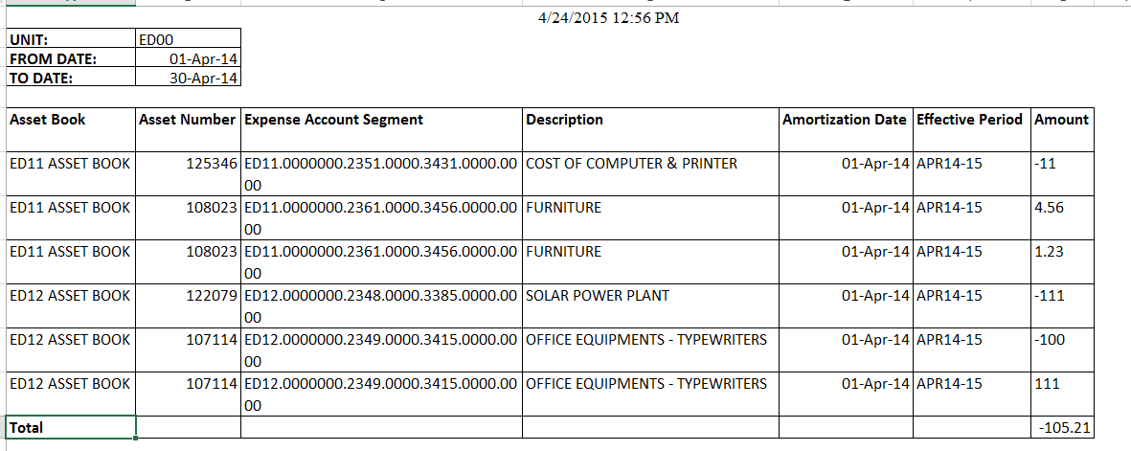

Deployments – MAY 2015

CR-484: Restriction on Distribution lines of prepayment
- Restriction on Distribution line of Prepayment Invoices is applied so that user can enter only one distribution line in prepayment invoices.

CR 494 : Addition of Bank in Valid Bank List
- The below said banks will be added in the valid bank list lookup with effective date as 01-APR-2010.The field in system will be populated as following:

MEANING | DESCRIPTION | EFFECTIVE START DATE
BARODA RAJASTHAN KSHETRIYA GRAMIN BANK | BARODA RAJASTHAN KSHETRIYA GRAMIN BANK | 01-APR-2010

NOTE: The Bank meaning field is used by user on FORM

CR 480 : Changes in FCI Asset Book report
- The input parameter “Asset Book” is changed to Unit and hierarchy is applied to this parameter. New output parameter “BOOK TYPE CODE” is added in the report output so that user can view the book code in which asset lies.
- The original cost column is renamed to current cost as it brings the current cost in value.
- Fully retired assets belonging to the financial year for which the report is executed is fetched in the report whereas when the report will be executed for next financial year ,these assets will not be fetched.
For instance, if an asset XXX is retired in Mar13-14 then it will be fetched in the report only when the period parameter is given till Mar13-14. If the parameter is given as Apr14-15 then it will not be fetched.

Deployments – JUN 2015

CR-467: Changes in FCI Debtor Trial Balance
FCI Debtor T.B. Report is a custom report that displays balance details for a specific account combination based on input parameters. This report fetches the AR invoices and receipts based on the input parameters. For AR invoices the accounts used in Receivable account is considered and Unapplied Receipts are fetched.
Report Parameters
Sl. No. | Parameter | Required | Description
1 | Unit | Yes | This report can be executed for a particular unit or parent unit. For parent unit, data for children will be fetched
3 | Account | Yes | This report can be executed for a particular account
8 | As of GL Date | Yes | This report fetches the record whose gl date of application and payment schedule is less than and equal to as of gl date
9 | Customer Number | No | This report can be executed for a particular customer
10 | Customer Name | No | This report can be executed for a particular customer
11 | Invoice category | No | It will have two values. Sales/ Non Sales. This parameter will be valid for AR invoices only , as receipts do not have category.
Note: The output of the report will be sorted first on Invoice Category, then on code combination and then on GL Date and fully applied receipt and transaction that is customers whose outstanding balance is zero will not be shown.
For Receipts, Invoice Category will show ‘N/A’ in the output of the report.

Deployments – JUL 2015

CR-496:Restriction of double posting of JEs from FA to GL

Customization is applied in the ‘Create Journal Entry ’ form , which will check that if any un-reversed JE already exists for that asset book for that period or not.
If any such JE exists , user will be given an error while executing Create JE , and he will have to reverse all the Journals of that period, perform Rollback JE for that book , and then only he will able to Re-send the Journals.

For instance : If for HA11 ASSET BOOK, for the period of FEB14-15 , user has already sent the JEs, then if he again executes depreciation with period close check box checked , and sends the JE again, he will be
prompted with an error message.
User will have to reverse all the JEs of FEB14-15 , with source as Assets , perform rollback JE for that asset book, and then only he can re-send the JE.
In cases when differential JEs are to be send , then also , user will have to reverse all the JEs of that period , perform rollback JE , from source as ‘Assets’ , and then only he can re-send the JE.

CR-503 :Withdrawl of period closure of MAR period in FA from FCI Support User
The check (March period of Fixed Assets for all the units can be closed by FCI Support User Responsibility only) , has been withdrawn, and now from FCI Support User responsibility also, the period of March for Fixed Assets cannot be closed.

CR-434: Requirement of New Report in GL module- FCI Account Head Balance Report
- A new report ‘FCI Account Head Balance Report’ has been created in FAP system.
- The report is executed for actual balances only.
- The sum of amounts of the transactions which are posted in General ledger are fetched.
- The sum of balance for parent unit is based on the sum of balance in child units.
- The output considers the sum of balance existing in disable code combinations also if any.
- Format for account, product and scheme in the output is: “Code - its description”.
- Report presents the data for level 2 child when the report is executed All India and zonal level (based on parent child relationship exist in FAP system).
  - For e.g. If user is executes the report for H000 then balance for EA00, EC00, ED00, EE00, EF00, FA00, FB00, FC00, FD00, FE00, HA11, HC11, NA00, NB00, NC00, ND00, NE00, NF00, NG00, NH00, NI00, SA00, SB00, SC00, SD00, SE00, WA00, WB00, WC00, WD00, WF00 and HQ11 will be fetched in report output.
  - If user is executing the report for F000 then balance for FA11, FB11,FB12, FB13, FB14, FB15, FB16, FB17, FB18, FB19, FB20, FB21, FC11, FC12, FD11, FD12, FD15, FD16, FE11, FE13 and FE14 will be fetched in report output.
- Report presents the data for level 1 child when the report is executed Regional level (based on parent child relationship exist in FAP system).
- For e.g. If user is executes the report for FB00 then balance for FB11, FB12, FB13, FB14, FB15, FB16, FB17, FB18, FB19, FB20 and FB21 will be fetched in report output.
- If report is executed for District office then the data is fetched for that particular district office
- The report output is sorted on Unit Office.
- The input parameters are :
Sl.No | Parameter | Mandatory | Description
1 | Unit Code | Yes | The unit for which user wants to review the balance. The report can be executed for parent units also
2 | Depot | No | The depot code (only child) for which user wants to review the balance.
3 | Account Head | Yes | The account code (only child) for which user wants to review the balance.
4 | Product Code | Yes | The product code (only child) for which user wants to review the balance.
5 | Scheme Code | Yes | The scheme (only child) for which user wants to review the balance.
6 | Intercompany | No | The intercompany segment (only child) for which user wants to review the balance.
7 | Period | Yes | The period for which user wants to review the balance
8 | Balance Type | Yes | Only two value YTD/PTD

- Report total is displayed at the end of the report.
- The output of the report have the following columns:
Sl.No | Parameter | Description
1 | Account | Description of the account code along with account code
2 | Product | Description of the product code along with product code
3 | Scheme | Description of the scheme along with the value of scheme
4 | Unit Office | The value of unit. For two level of child values data will be fetched.
5 | Opening Balance | Opening balance for the unit based on balance type input parameter.
6 | Debit | The total amount debited for the unit in the period for which user is executing the report
7 | Credit | The total amount credited for the unit in the period for which user is executing the report
8 | Closing Balance | Opening balance +(debited-credited)

The report is in excel format.
Sample output:
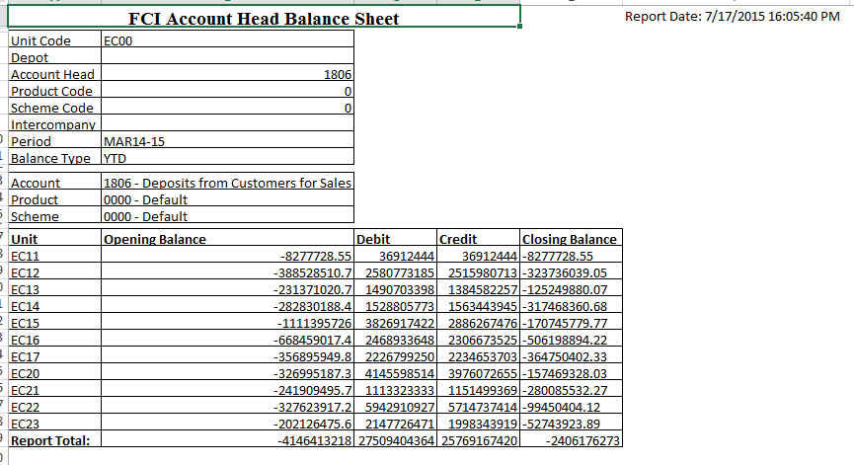

CR 499 : Restriction of unbalanced JEs from FA to GL
Whenever any asset is created in FA module, with old DPIS (DPIS not belonging to current month, and of current financial year , for instance 01-APR-2014 in month of FEB14-15) , and amortized from that DPIS, two categories of expense are booked.
- Current Period depreciation: This carries expense amount of current period only.
- Old Expense (Expense belonging to months prior to current month.For instance if DPIS is 01-APR-2014 , and asset is added in FEB14-15 , then old expense will carry expense of APR14-15 to JAN14-15 ): This carries depreciation of all the back periods from where it is amortized.
Many times in case of old expense booking, system takes the old reserve amount to GL, but not able to take the old period depreciation expense, which is one of the major reasons of Unbalanced JE from FA to GL. This happens because system is not able to populate few fields, which are required to book the old expense amount correctly.
It is identified that whenever code combination is void in transaction this kind of issue appears.So
An automatic program unit is created which will populate the code combinations in the required fields , by this old expense amount gets booked correctly along with reserve.

Deployments – AUG 2015

CR- 519: Asset Deletion not allowed after JE sent to General Ledger
A check is implemented in system such that asset will not be deleted if journal entry for the asset is present in GL (posted or unposted).
For e.g. If asset ‘A’ is added in MAR14-15 and depreciation is calculated and Create Journal Entries is run to produce Journals then user cannot delete the asset. In case user needs to delete the asset, he/she should reverse the JES, roll back the journals and then should try deleting the asset.
In above scenario an error message will be displayed to user stating causal of error, when he/she attempts to delete an asset, for which JE has already been sent and not reversed.
NOTE: The check is not dependent on GL Import i.e. if JE are created and are present in GL interface (not yet imported), user will not be able to delete the asset.

CR- 482: Creation of New Report - FCI Depot Detail Report
In a Request Set ‘FCI Chart Of Accounts Master’ a new "FCI Depot Detail Report" report is added.
This request set is available to FCI support User responsibility. The report "FCI Depot Detail Report" will show all depot and its details like Depot Name, Depot Code, Agency Code, Agency Description, Labour Type, Type (Depot Type), Capacity, Effective date from and Effective date to.
Format attached
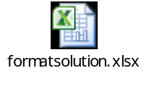

CR- 414: FCI Stock Ledger Summary Report – Addition of Parameters
- A marking of all available depots in the system will be done for different agencies and labour working in these depots.
- For marking of depots, a DFF named ‘FCI Depot Detail’ will be provided in FCI DEPOT value set available in FCI Support User Responsibility. The requirement of ‘Depot DFF’ will be handled in CR 482 as per format given by FCI.
- Following columns will be provided in ’FCI depot detail’ DFF:
Column Name | Description
Depot Type | Type of depot  Available values: Depot, Bank, Others (For any future use)
Labour Type | Type of labour in FCI.  Available values: Contract, DPS ,DEPT , NWNP
Agency Code | Agency Detail of depot.  Available values:  A1-FCI Owned Depot/Silo/Cap/Open  A2-Hired from State Govt./Port and managed by FCI  A3- Hired from State Agencies and managed by FCI  A4- Hired from Private Parties and managed by FCI  A5- Hired from PEG and managed by FCI  B1- Hired and managed by CWC  B2- Hired and managed by SWC  B3- Hired and managed by State Govt./Port  B4- Hired and managed by State Agencies  B5- Hired and managed by Storing Agents  B6- Hired and managed by Private Silo  B7- Hired and managed by PEG 6/9 YEARS CWC/SWC  B8- Hired and managed by PEG-PVT PARTIES WITH SERVICES  B9- Hired and managed by PEG-PVT PARTIES THROUGH NODAL AGENCY  B10- Hired and managed by PWS 2010

- The following two user parameters will be added in the report with existing parameters and the parameter ‘Agency’ (as of now) will be removed.
Parameter Name | Mandatory/Optional | Description
Labour Type | Optional  (For no value data for all Available values will come) | Type of labour in FCI.  Available values: Contract, DPS, DEPT, NWNP  (In case any values need to be appended, will be given by FCI)
Agency Code | Optional  (For no value data for all Available values will come) | Agency Detail of depot.  Available values: SWC, CWC, FCI, Private, PEG, State Govt./Agency  (In case any values need to be appended, will be given by FCI)

- For User Parameter ‘FCI’ in Agency Code data for following agencies will be fetched in the report:
- A1-FCI Owned Depot/Silo/Cap/Open
- A2-Hired from State Govt./Port and managed by FCI
- A3- Hired from State Agencies and managed by FCI
- A4- Hired from Private Parties and managed by FCI
- A5- Hired from PEG and managed by FCI
- For User Parameter ‘CWC’ in Agency Code data for following agencies will be fetched in the report:
- B1- Hired and managed by CWC
- For User Parameter ‘SWC’ in Agency Code data for following agencies will be fetched in the report:
- B2- Hired and managed by SWC
- For User Parameter ‘State Govt./Agency’ in Agency Code data for following agencies will be fetched in the report:
- B3- Hired and managed by State Govt./Port
- B4- Hired and managed by State Agencies
- For User Parameter ‘Private’ in Agency Code data for following agencies will be fetched in the report:
- B5- Hired and managed by Storing Agents
- B6- Hired and managed by Private Silo
- For User Parameter ‘PEG’ in Agency Code data for following agencies will be fetched in the report:
- B7- Hired and managed by PEG 6/9 YEARS CWC/SWC
- B8- Hired and managed by PEG-PVT PARTIES WITH SERVICES
- B9- Hired and managed by PEG-PVT PARTIES THROUGH NODAL AGENCY
- B10- Hired and managed by PWS 2010
- The above two parameters will be shown in the report , along with depot name in the below format:
EF22001(RANINAGAR CWC COVERED) Type(DEPT) Agency (A1-FCI Owned Depot/Silo/Cap/Open)

- Values of Quantity column in the report will not be rounded off to 5 digits after decimal like other columns of the report.
- Report will fetch data for those depots only for which ‘FCI Depot DFF’ has been entered otherwise not.
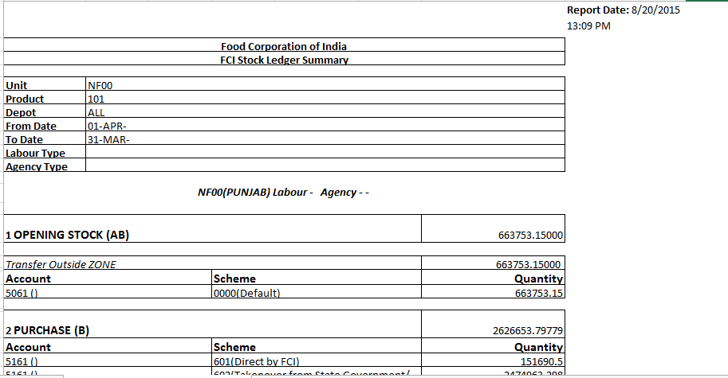

CR 529 : Creation of a new scheme 436 for LAN/ WAN Restructuring

Following changes have been made as per CR 529.
- New scheme 3436 with description (LAN / WAN Restructuring has been created).
- New minor category (436) with description (LAN / WAN Restructuring has been created).
- CVR has been allowed for accounts 2151,2251 and 2351 with scheme 3436, and minor category has been allowed with major category 2151.
- New asset categories 2151.436.Unit has been created for all the units (with description LAN / WAN Restructuring).

CR 505 : Check On Invoice Number
As per CR 505, customization on the format of invoice number created by user, is applied on Invoice workbench in AP module. Form Personalization is applied for the below checks:
- Invoice number cannot start with 20 and cannot have only 12 or 13 digits length altogether (all numerals).
- In case user has to create any invoice with same number ,it should have at least one character appended to it .

CR 483 : FCI Part I & Part II Account Variance Master (Request Set)
This request set can be used , to view the transactions in which part 1 and part II accounts are used together . In all, this report can be used to view the variance in part1 and part2 accounts . It is a request set which contains below two reports
1. FCI Part I & Part II Variance Marking Program
This program is used for marking all the lines of journals of a given period , that whether the combination belongs to Part1 or Part2.
Input Parameters are :
i. From Date : Starting Date
ii. To Date : Ending Date

2. FCI Part I & Part II Variance Report
This will fetch the output for all the transactions which are containing both the reports. The input Parameters are :
i. From Date: Starting Date
ii. To Date : Ending Date
iii. Unit : Unit for which report has to be executed . Can be given for hierarchy .
Sample output is attached for reference:
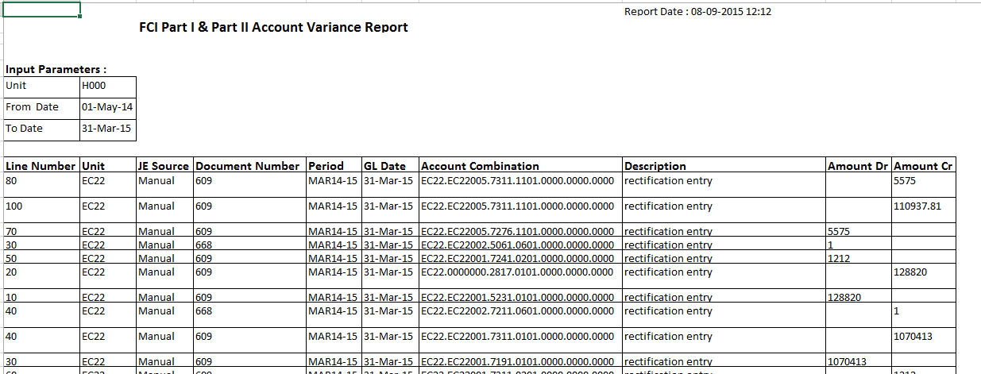

CR 446 : Modifications in FCI Asset Schedule As per Company’s Act Report.
Following changes have been made as per this CR :
- Asset when Reclassified from one category combination to another, then the negative amount will be shown in the Adjustment column of earlier Asset Category combination at the time of reclassification and secondly this amount will be reflected in the adjustment column of new category combination.
- If an asset is reclassified (from one category to another), in such cases schedule of closed period will not get affected from such Reclassification & the value of the assets will be same for closed periods. The effect will be shown in the period in which reclassification is done.
- Only the final adjustment of the period will get reflected in the report. Intermediate if there are ‘n’ number of adjustments done, it will not affect the report.
- “Transfer In/ Out/ Adjustment” column is bifurcated on two columns “Transfer In/ Out” column and “Adjustment” column.
- Date appearing in the column headings will be full date i.e. date will be with year as well.
- Sorting of report will be on major category then on minor category.
- DFF on at the time of addition will not have type ‘OB’ w.e.f 01-Apr-2014 , as Obs are already uploaded in FY 13-14 and is no more required.

Deployments – SEP 2015

35.1 CR-528 : Creation of New Account Heads in FAP.
1. The heads of account for storage charges payable for Godowns constructed under PEG scheme have been reviewed and accordingly account heads for the PEG godowns is to be created.
2. 3157,3162,3163,3158,3164,3159,3160,5227 account heads do not exists . 3150,5200 are parent accounts.

35.2 CR-514: Amortization Check and Asset Addition Check
- A customisation added for NEW type of assets which will restrict user to enter depreciation reserve for asset.
- Amortisation Flag made mandatory and initial value will be set as DPIS of transfer type asset added.

Deployments – OCT 2015

CR-491: Addition of India Income Tax Report for Fixed Asset March Period Closure
A Customization is added in the system to execute India - Income Tax Act Fixed Asset Schedule report when depreciation for MARCH in FA Module with Close Period Check Box Checked is run.
This customization will fire ‘Income Tax Act Fixed Asset Schedule report’, with the input parameter ‘Start Date’ as 1st of the FY which is getting closed.
For instance if Mar14-15 is getting closed in FA for ‘HA11 ASSET BOOK’, then ‘Income Tax Act Fixed Asset Schedule report’ will be fired with the start date as ’01-Apr-2014’ and book name as ‘HA11 ASSET BOOK’ .
This program will create a closing WDV of ‘31-Mar-2015’ for all the blocks of ‘HA11 ASSET BOOK’, and will create new blocks with start date as ’01-Apr-2015’ and opening WDV same as closing WDV of ‘31-Mar-2015’ for every block.
Also, if the ‘Run Depreciation’ completes in error , then too ‘India - Income Tax Act Fixed Asset Schedule report’ will be fired , as at re-running depreciation with period closure check box, will again fire the ‘India - Income Tax Act Fixed Asset Schedule report’ , which will cater the requirement.

Deployments – Nov 2015

CR-497: Creation of New report FCI Sales/Purchase Summary Report (FCI Stock Detail Report)
- A new Report “FCI Stock Detail Report “has been created.
- The new report can be executed using Unit specific General Ledger responsibility.
- The output columns “Depot Code with Nomenclature”, ”Labour Type” and ”Agency Type” are fetched for all input parameters.
- Any one of the output column “Opening Stock”, “Purchase”, Unconnected Wagons”, “Transfer In”, “Transit Gain”, “Storage Gain”, “Sales”, “Transfer Out”, ‘Internal Consumption”, “Transit Loss”, “Storage Loss” ,”Closing Stock” and “Missing wagon” will be fetched based on ‘SLS Type’ input parameter.
- The report cannot be executed for multiple SLS type at a time in a single request.
- The report can be executed for child products only.
- The list of SLS type for which report can be executed is:
SLS Code | Description
MW | Missing Wagon
OS | Opening Stock
S | Sales
PU | Purchase
SH | Shortages
TG | Transit Gain
TI | Transfer In
TL | Transit Loss
TO | Transfer Out
UW | Unconnected Wagon
SG | Storage Gain
IC | Internal Consumption
SL | Storage Loss
CS | Closing Stock
- PI and PE will be removed from the list of SLS type as it is not required by FCI
- The output of the report will be in excel. Sample output format:
Food Corporation of India
FCI Stocks Detail Report |  |  |  | Report Date:
Unit Code
Product
SLS Type
From GL Date
To GL Date
Depot Code with Nomenclature | Labour Type | Agency Type
Depot Code with Nomenclature | Labour Type | Agency Type | account1.scheme1 | account2.scheme1

- In the output of the report for column SLS type the output is of the form : Code – Description of SLS type
- The report fetches Stock detail based on the input parameter.
- The output shows the sum of stock based on Depot, account, scheme.
- The depots which do not have any stock in the given period for the SLS type will not be fetched in the report output.
- If no transactional data exists for the input parameter then data will not be fetched in the report. The output columns will be blank
- Input parameters:
Sl. No | Parameter | Mandatory | Description
1 | Unit Code | Yes | The unit code for which data is to be fetched. The unit can be parent or child
2 | Product | Yes | The product code for which data is to be fetched. The product code will be child value only
3 | SLS Type | Yes | The SLS type for which data is to be fetched.
4 | From Date | Yes | The Gl date of the transactions for which data is to be fetched. This “From Date” parameter will used in combination with “To Date”. “From Date” will be the lower range for the GL date
5 | To Date | Yes | The Gl date of the transactions for which data is to be fetched. This “To Date” parameter will used in combination with “From Date”. “To Date” will be the upper range for the GL date.

CR-521: CR-497- Modifications in Purchase Day Book report
Modification in purchase day book depot excel report:-
1) In request parameter addition of field for supplier Name, Supplier No. as non-Mandatory fields.
2) In report output addition of supplier No. , Invoice date and Invoice Description, supplier Tin no.
3) report will not fetch data if there is miss match in supplier name and supplier number.
New Input Parameters:-
S.no | Parameter name | Description | Optional/Mandatory
1 | District | Specify unit code for which the report is to be executed | mandatory
2 | Depot | Specify depot code for which the report is to be executed | mandatory
3 | product | Specify product code for which the report is to be executed | mandatory
4 | Scheme | Specify scheme code for which the report is to be executed | mandatory
5 | GL Start Date | Specify the lower range of the invoice GL date for which report has to be executed | mandatory
6 | GL End Date | Specify the upper range of the invoice GL date for which the report has to be executed | mandatory

New Output Columns:-

S.No | Column Name | Description
1 | Depot | Shows unit of the data fetched
2 | Product | Shows product of the data fetched
3 | Scheme | Shows the scheme of the data fetched
4 | GL Date | Shows the GL dates of the data fetched
5 | Supplier | Shows the supplier of the data fetched
6 | Supplier Site | Shows the supplier site of the data fetched
7 | Supplier TIN | Shows the supplier TIN of the data fetched
8 | Invoice Number | Shows the of the invoice numbers of the data fetched
9 | Voucher Number | Shows the voucher number of the invoice data fetched
10 | Number of Bags | Shows the number of bags of the invoice data fetched
11 | Crop Year | Shows the crop year of the invoice data fetched
12 | Quantity Received | Shows the quantity received of the invoice data fetched
13 | Quantity Paid | Shows the quantity paid of the invoice data fetched
14 | Rate | Shows the rate of the invoice data fetched
15 | Amount Payable | Shows the amount payable of the invoice data fetched
16 | Components of Distribution | Components of distribution are split and balance corresponding to that is shown

Deployments – Dec 2015

CR-473: Changes in FCI Prepayment Status Schedule Report and withdrawal of Unpaid and Partially Paid Invoices Report

Changes in FCI Prepayment Status Schedule Report:
- The output of the report will be sorted first on Document Category and second on Supplier Number.
- Report will be generated on unit hierarchy.
New Input Parameters:
Sr. No. | Parameter | Required/Optional | Description
1 | Supplier Number | Optional(leave blank to execute the report for all supplier number) | Selection of particular supplier
2 | Supplier Name | Optional(leave blank to execute the report for all suppliers) | For a particular supplier
3 | As Of GL Date | Required | To GL date
4 | Prepayment Type | Optional | Permanent/Temp (For prepayment type)
5 | Unit | Required | Selection of Unit hierarchy wise
6 | Account Code | Required for all units | Selection of Account

New Output Columns:

Column Name | Description
Document Category | Document Category of the prepayment invoice
Supplier Name | Name of Supplier for the prepayment invoice
Supplier Number | To identify a Supplier for a prepayment invoice
Supplier Site | Corresponding Supplier Site for the supplier
GL Date | GL date of the prepayment for which accounting is reflected.
Voucher Number | Voucher Number of the prepayment invoice
Invoice Number | Invoice Number of prepayment to identify the prepayment invoice
Invoice Amount | Amount of the prepayment in total
Balance Amount | Amount Remaining of the prepayment that is available to be applied
Description | Description of the prepayment (if present in the system)

Note: ‘Unpaid Invoice Report’ and ‘Partially paid invoice report’ will be withdrawn with effect from ’16-Dec-2015’.

CR-553: Output Format of FCI Payment Batch Report to be modified
- The value for User Number allotted by NPCI at the time of registration has to be entered in the field ‘EFT Requester Id ‘ in Bank Account Screen Account Holder Tab
- The input parameter “Credit Limit” has been removed from the request ‘FCI Payment Batch Output ‘.
- The changes has been done as per the Excel sheet ‘ECS New format Solution’ attached below. The detail of the field from which value will be fetched is mentioned the solution row.
- Space in the value fetched for any field has not been removed, If field is number type then characters other than number (except space) has been removed. Similarly, if the field is alpha numeric then characters other than number and alphabets (capital letters and small letters) (except space) has been removed.
E.g if Supplier name is ‘JAMIL KHAN (SN001964C)’ will reflect as ‘JAMIL KHAN SN001964C’
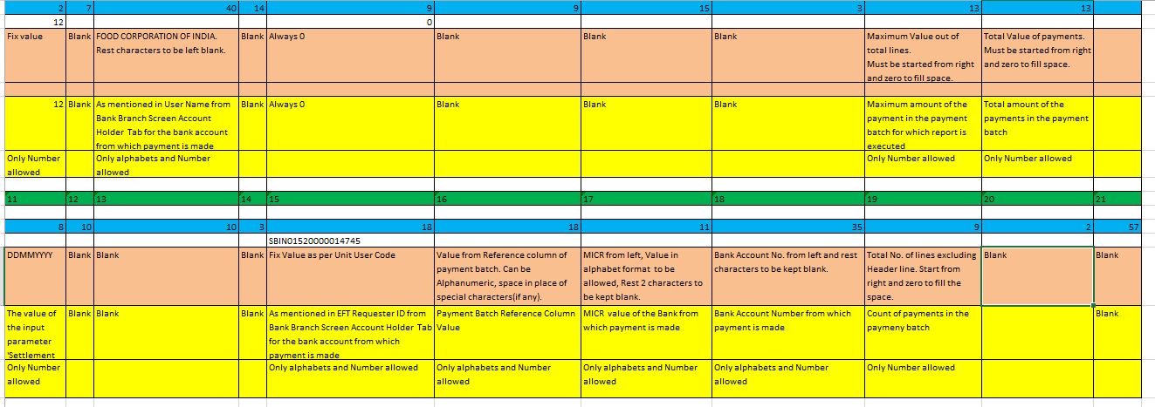
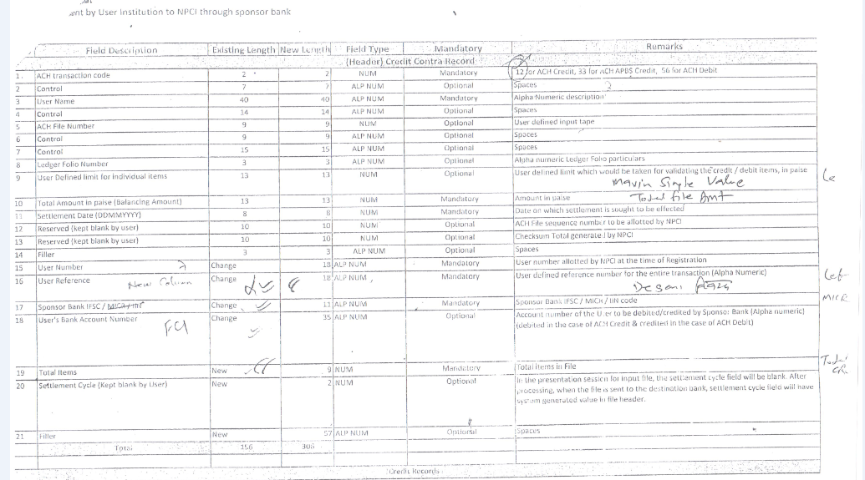
ACH input1.jpeg
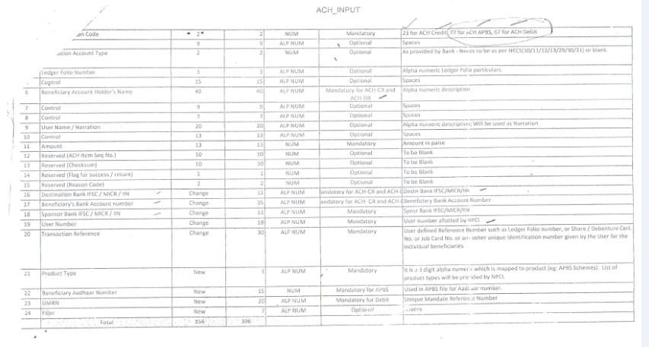
ACH input2.jpeg
Note: Particulars in ECS New Format Solution is mapped to Sl. No column in ACH input1.jpeg (for header sheet) and to ACH input2.jpeg (for supplier sheet)
Sample output is attached for reference: 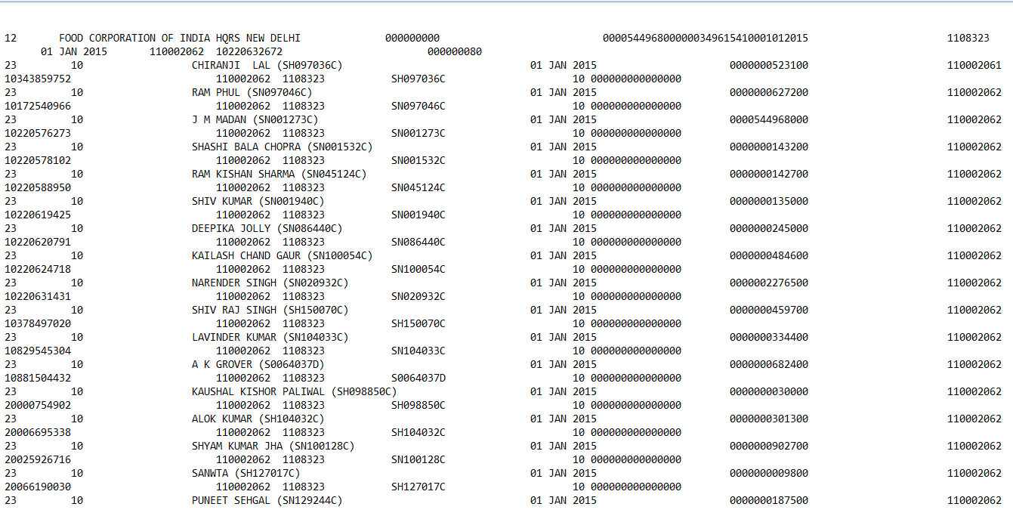

The Old Output Format of FCI Payment Batch Report is also retained.
This report provides the payment batch statement for the given set of parameters, the softcopy is send to bank for ECS payments.
S.No | Parameter Name | Optional/Mandatory | Description
1 | Payment Batch | Mandatory | Specify payment batch detail
2 | Credit Limit(In Paise) | Mandatory | maximum amount that can be paid
3 | Settlement Date | Mandatory | Specify settlement date

CR 518: With-drawl of FA from period closure and check on salary initialize
The period closure report (FCI Custom Period Closure Report - Auto invoice & Interface) is modified in such a way, that FA module will not be considered for period closing in any period unless the next set of instructions get implemented.
Moreover the check of AP invoices not yet transferred to FA will still remain in the report.
- A check is implemented on the screen of salary initialize in payroll (for employee, DPS and departmental modules), that will check that whether the last three months (whichever number given by FCI Helpdesk), (for which the user is processing salary), have been custom closed in APPS or not. If not, user will not be able to process salary of that month, he will have to first close those periods, and then only he can process salary.
For instance, if he is trying to process the salary for month of Oct15-16 (and the lookup ‘FCI PERIOD FOR PAYROLL PROCESS’ contains value 5), then he will get an error if the periods up to MAY15-16 are not closed in APPS. He will have to first close the period and then only he can process the salary in Payroll.
- This check of months on payroll initialize is governed by a lookup ‘FCI PERIOD FOR PAYROLL PROCESS’, and contains number of months till which the custom close period in APPS will be checked.
For instance, if the lookup contains value 5 , and the salary has to be processed for month of OCT15-16 , then system checks that whether 5 months prior to OCT 15-16 (i.e MAY15-16) has been custom closed in APPS or not.
- A concurrent program ‘FCI APPS CLOSE CHECK FOR PAYROLL INITIALIZE ’, is created and given in FCI Support User, through which FCI Help Desk can change the value in this lookup.
- The program ‘FCI APPS CLOSE CHECK FOR PAYROLL INITIALIZE ’ contains following parameters :
S.NO | Name | Optional/Mandatory | Description
1 | Months to be checked | Mandatory | Number of months prior to which salary is being processed, to be checked in APPS.

- ‘Run Depreciation’ form is revoked from normal asset and FCI Support User responsibility from APR15-16 onwards.

CR 557 : Addition of Bank in Valid Bank List
- The below said banks will be added in the valid bank list lookup with effective date as 01-APR-2010.The field in system will be populated as following:

MEANING | DESCRIPTION | EFFECTIVE START DATE
GOPINATH PATIL PARSIK JANTA SAHAKARI BANK LTD | GOPINATH PATIL PARSIK JANTA SAHAKARI BANK LTD | 01-APR-2010

NOTE: The Bank meaning field is used by user on FORM

CR 552: Creation on new product codes for pulses & new account heads, updation of CVR and updation of A to S report.
- Products with following details were created:
Product | Description | Parent | Parent Product | Rollup Group | Posting allowed | Budgeting allowed | Start Date
0450 | Pulses and oil seeds | Y | NA | No | No | No
0451 | Arhar | N | 0450 | No | Yes | Yes
0454 | Gram | N | 0450 | No | Yes | Yes
0457 | Masoor | N | 0450 | No | Yes | Yes
0460 | Moong | N | 0450 | No | Yes | Yes
0463 | Urad | N | 0450 | No | Yes | Yes

- Accounts with following details were created:-
- Account code ‘4536’
  - Description: Current Account for pulses and oil seeds
  - Parent account : No
  - Serial number for TB : ‘143’
  - Serial number for grouping for profit and loss statements : ‘BA18’
  - Parent : ‘4530’
  - Budgeting allowed : ‘Yes’
  - Rollup group : No
  - Type of Account : ‘Asset’
  - FCI Account Type for SLS : NO
  - CVR:
a) Unit: ALL
b) Depot: ALL
c) Dependent Product: Default
d) Dependent Scheme: Default
e) Dependent Intercompany segment: Default
k) Start Date: 01-Apr-2015

- Account code ‘1908’
  - Description: TRADE PAYABLE -FOR PULSES AND OIL SEEDS
  - Parent account : No
  - Serial number for TB : ‘158’
  - Serial number for grouping for profit and loss statements : ‘BL11’
  - Parent : ‘1900’
  - Budgeting allowed : ‘Yes’
  - Rollup group : No
  - Type of Account : ‘Liability’
  - FCI Account Type for SLS : NO
  - CVR:
a) Unit: ALL
b) Depot: Default
c) Dependent Product: Default
d) Dependent Scheme: Default
e) Dependent Intercompany segment: Default
k) Start Date: 01-Apr-2015

- Account code ‘5191’
  - Description: PURCHASE-PULSES AND OIL SEEDS
  - Parent account : No
  - Serial number for TB : ‘158’
  - Serial number for grouping for profit and loss statements : ‘PD38’
  - Parent : No parent
  - Budgeting allowed : ‘Yes’
  - Rollup group : No
  - Type of Account : ‘Expense’
  - FCI Account Type for SLS : PU
  - CVR:
a) Unit: ALL
b) Depot: ALL
c) Dependent Product: 0451/0454/0467/0460/0463
d) Dependent Scheme: 600-604
e) Dependent Intercompany segment: Default
k) Start Date: 01-Apr-2015
l) Grouping A to S: A01OP

- Account code ‘5272’
  - Description: Labour charge at Godown
  - Parent account : No
  - Serial number for TB : ‘166’
  - Serial number for grouping for profit and loss statements : ‘PD43’
  - Parent : 5200
  - Budgeting allowed : ‘Yes’
  - Rollup group : No
  - Type of Account : ‘Expense’
  - FCI Account Type for SLS :No
  - CVR:
a) Unit: ALL
b) Depot: Default
c) Dependent Product: 0450 to 0463
d) Dependent Scheme: 600-604
e) Dependent Intercompany segment: Default
k) Start Date: 01-Apr-2015
l) Grouping A to S: A02OP

- Account code ‘5273’
  - Description: Quality Survey inspection
  - Parent account : No
  - Serial number for TB : ‘166’
  - Serial number for grouping for profit and loss statements : ‘PD43’
  - Parent : 5200
  - Budgeting allowed : ‘Yes’
  - Rollup group : No
  - Type of Account : ‘Expense’
  - FCI Account Type for SLS :No
  - CVR:
a) Unit: ALL
b) Depot: Default
c) Dependent Product: 0450 to 0463
d) Dependent Scheme: 600-604
e) Dependent Intercompany segment: Default
k) Start Date: 01-Apr-2015
l) Grouping A to S: A02OP

- Account code ‘5274’
  - Description: Cost of Gunny Bags, sutli etc
  - Parent account : No
  - Serial number for TB : ‘166’
  - Serial number for grouping for profit and loss statements : ‘PD43’
  - Parent : 5200
  - Budgeting allowed : ‘Yes’
  - Rollup group : No
  - Type of Account : ‘Expense’
  - FCI Account Type for SLS :No
  - CVR:
a) Unit: ALL
b) Depot: Default
c) Dependent Product: 0450 to 0463
d) Dependent Scheme: 600-604
e) Dependent Intercompany segment: Default
k) Start Date: 01-Apr-2015
l) Grouping A to S: A02OP

- Account code ‘5275’
  - Description: Gunny bags to procurement center
  - Parent account : No
  - Serial number for TB : ‘166’
  - Serial number for grouping for profit and loss statements : ‘PD43’
  - Parent : 5200
  - Budgeting allowed : ‘Yes’
  - Rollup group : No
  - Type of Account : ‘Expense’
  - FCI Account Type for SLS :No
  - CVR:
a) Unit: ALL
b) Depot: Default
c) Dependent Product: 0450 to 0463
d) Dependent Scheme: 600-604
e) Dependent Intercompany segment: Default
k) Start Date: 01-Apr-2015
l) Grouping A to S: A02OP

- Account code ‘5276’
  - Description: Stock from Mandi to Godowns
  - Parent account : No
  - Serial number for TB : ‘166’
  - Serial number for grouping for profit and loss statements : ‘PD43’
  - Parent : 5200
  - Budgeting allowed : ‘Yes’
  - Rollup group : No
  - Type of Account : ‘Expense’
  - FCI Account Type for SLS :No
  - CVR:
a) Unit: ALL
b) Depot: Default
c) Dependent Product: 0450 to 0463
d) Dependent Scheme: 600-604
e) Dependent Intercompany segment: Default
k) Start Date: 01-Apr-2015
l) Grouping A to S: A02OP

- Account code ‘5277’
  - Description: Insurance of stock during transit
  - Parent account : No
  - Serial number for TB : ‘166’
  - Serial number for grouping for profit and loss statements : ‘PD43’
  - Parent : 5200
  - Budgeting allowed : ‘Yes’
  - Rollup group : No
  - Type of Account : ‘Expense’
  - FCI Account Type for SLS :No
  - CVR:
a) Unit: ALL
b) Depot: Default
c) Dependent Product: 0450 to 0463
d) Dependent Scheme: 600-604
e) Dependent Intercompany segment: Default
k) Start Date: 01-Apr-2015
l) Grouping A to S: A04OP

- Account code ‘5278’
  - Description: Administrative charges payable- Other
  - Parent account : No
  - Serial number for TB : ‘166’
  - Serial number for grouping for profit and loss statements : ‘PD43’
  - Parent : 5200
  - Budgeting allowed : ‘Yes’
  - Rollup group : No
  - Type of Account : ‘Expense’
  - FCI Account Type for SLS :No
  - CVR:
a) Unit: ALL
b) Depot: Default
c) Dependent Product: 0450 to 0463
d) Dependent Scheme: 600-604
e) Dependent Intercompany segment: Default
k) Start Date: 01-Apr-2015
l) Grouping A to S: A02OP

- Account code ‘5279’
  - Description: Administrative charges payable-FCI
  - Parent account : No
  - Serial number for TB : ‘166’
  - Serial number for grouping for profit and loss statements : ‘PD43’
  - Parent : 5200
  - Budgeting allowed : ‘Yes’
  - Rollup group : No
  - Type of Account : ‘Expense’
  - FCI Account Type for SLS :No
  - CVR:
a) Unit: ALL
b) Depot: Default
c) Dependent Product: 0450 to 0463
d) Dependent Scheme: 600-604
e) Dependent Intercompany segment: Default
k) Start Date: 01-Apr-2015
l) Grouping A to S: A02OP

- Account code ‘5280’
  - Description: Other Charges
  - Parent account : No
  - Serial number for TB : ‘166’
  - Serial number for grouping for profit and loss statements : ‘PD43’
  - Parent : 5200
  - Budgeting allowed : ‘Yes’
  - Rollup group : No
  - Type of Account : ‘Expense’
  - FCI Account Type for SLS :No
  - CVR:
a) Unit: ALL
b) Depot: Default
c) Dependent Product: 0450 to 0463
d) Dependent Scheme: 600-604
e) Dependent Intercompany segment: Default
k) Start Date: 01-Apr-2015
l) Grouping A to S: A04OP

- The ‘A to S’ report was modified to add row ‘O’ for statement A ,The grouping value description :
1st letter: Statement no
2, 3rd letters: column no
4th letter: Row
5th letter: No significance
- 1. Changes were done in A to S for the following accounts:
Account | Description | Product | Grouping A TO S
5191 | PURCHASE-PULSES AND OIL SEEDS | 0451/0454/0467/0460/0463 | A01OP
5201 | Mandatory/ Statutory Charges Mandi Fee/ APMC cess on basic price, if applicable | 0451/0454/0467/0460/0463 | A02OP
5207 | VAT on basic price, if applicable | 0451/0454/0467/0460/0463 | A02OP
5210 | Commission of Mandi Agents/ Arhatic, if applicable | 0451/0454/0467/0460/0463 | A02OP
5203 | Labour charges at Mandi/ procurement centre | 0451/0454/0467/0460/0463 | A02OP
5272 | Labour charge at Godown | 0451/0454/0467/0460/0463 | A02OP
5273 | Quality Survey inspection | 0451/0454/0467/0460/0463 | A02OP
5274 | Cost of Gunny Bags, sutli etc. | 0451/0454/0467/0460/0463 | A02OP
5275 | Gunny bags to procurement centre | 0451/0454/0467/0460/0463 | A02OP
5276 | Stock from Mandi to Godowns | 0451/0454/0467/0460/0463 | A02OP
5278 | Administrative charges payble- Other | 0451/0454/0467/0460/0463 | A02OP
5279 | Administrative charges payable-FCI | 0451/0454/0467/0460/0463 | A02OP
5280 | Other Charges | 0451/0454/0467/0460/0463 | A02OP
5277 | Insurance of stock during transit | 0451/0454/0467/0460/0463 | A04OP

- Modifications were made so that user can take 4536 as a cash account for internal banks.

39Deployments –Jan 2016

CR-542: Inclusion of additional fields in FCI Asset Status Report & FCI closed period Status Report Output
1. In “FCI Asset period Status report” two new columns are added namely “Last Period Closed By” and “Last Period Closed Time”.
2. For “FCI Asset period Status report” as Oracle does not store “Period closed by” information, a personalization is added on Depreciation Run form which captures the user id which is closing the period.
For e.g. if user “SN12345” runs the depreciation for feb14-15 with close period “checked”, his ID will be stored and displayed in the report. Also the same is updated on next period closure.
3. In “FCI closed period Status Report Output” two new columns are added namely “Period Closed By” and “Period Closed Time”.
4. “FCI closed period Status Report Output” brings details of both oracle period closed and custom period closed details. However, new columns are added for custom closure part.
5. In “FCI closed period Status Report Output” ‘Period Closed Time’ ‘and period Closed By’ column shows the latest period closed time and closed by.
For Example: If HA11 is having ‘FEB14-15’ closed on ‘1-MAR-2015’ by ‘HA11_SHRUTI’ then report will show period closed time as ‘1-MAR-2015’ and period closed by ‘HA11_SHRUTI’. In case, if ‘FEB14-15’ is opened for some reason and closed on 1-APR- 2015 by ‘HA11_AMIT’ then in this report shows period closed time as ‘1-APR-2015 and period closed by ‘HA11_AMIT’.
- In “FCI closed period Status Report Output” on request from FCI, if period is updated by data-fix (not by concurrent program) then ‘Period Closed Time’ will empty and ‘Period Closed By’ would be ‘SYSTEM’
- Input Parameter: for “FCI closed period Status Report”

Sl. No. | Parameter | Mandatory (Yes/No) | Description
1 | Periods | yes | It takes the period value for which user want to see the status
Sample Output:
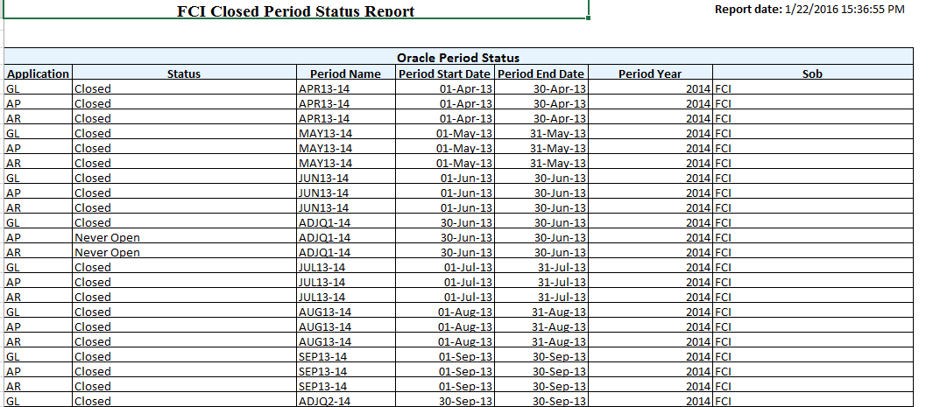
- No Input parameter in ‘FCI Asset period Status report.
Sample output:
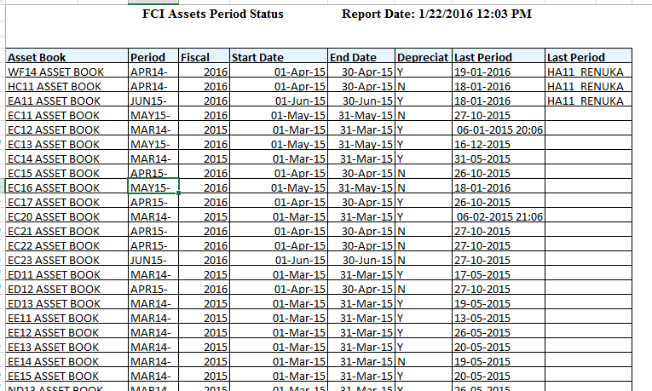

40Deployments – MAR2016

(CR-564) Addition of value in input parameters of SLS report and DFF of Depot Creation Form

Depot Creation Form:
- In the DFF of the value set ‘FCI_DEPOT’ for the context ‘FCI Depot’, one more value in Labour type field: Notional-Notional BY FAP , is added.
- In the DFF of the value set ‘FCI_DEPOT’ for the context ‘FCI Depot’, one more value in Agency Code type field: B11-Notional BY FAP is added.

SLS Report:
- In the ‘List of Value’ of the ‘Labour Type’ parameter in the ‘SLS’ Report one more value is added: ‘Notional-Notional BY FAP’ and in the ‘List of Value’ of the ‘AGENCY’ parameter one more value is added :’ NOT-B11 Notional BY FAP’.
Note : Report Logic is not changed.

(CR-568) Check on rate/section selection (for auto TDS and WCT deduction from payment) in DFF of invoice distribution form.
- A check is implemented on rate/section selection in DFF of invoice distribution. Such rate/section can only be selected on the basis of unit code available in the respective expense CCID i.e user now won’t be able to select the taxes of any unit other than its unit.

(CR-571)Creation of new schemes for NFSA & Updating of CVR
- New schemes added for NFSA 421 to 425.

Scheme | Description | Parent (Y/N) | Parent Scheme | Enabled | Rollup Group | Posting Allowed | Budgeting Allowed | Start Date | End Date
421 | Sale under other than NFSA- TPDS Scheme (Tide Over) | No | 100 | Yes | No | Yes | Yes | 1-Apr-15
422 | Sale under other than NFSA- TPDS Scheme (Priority) | No | 100 | Yes | No | Yes | Yes | 1-Apr-15
423 | Sale under other than NFSA- TPDS Scheme (AAY) | No | 100 | Yes | No | Yes | Yes | 1-Apr-15
424 | Sale under NFSA- TPDS Scheme (Tide Over) | No | 100 | Yes | No | Yes | Yes | 1-Apr-15
425 | Sale under NFSA- TPDS Scheme (Priority) | No | 100 | Yes | No | Yes | Yes | 1-Apr-15

- Newly Added schemes (421 to 425) mapped with account head 5701.
- Depot Range modified from (0000000-ZZZZZZZ) TO (0000001-ZZZZZZZ) for 4536 and 5191 account head.
- CCID with above mentioned default depot disabled.

(CR- 559) Check on Assets Major-Minor Category Combination and Asset Block
- A Check will be implemented such that whenever user query asset through Asset Workbench and tries to update Block/Category without updating respective Category/Block an error message will be displayed and user has to make changes accordingly.
For E.g. Let asset id “ABC” have category “2161.456.HA11” and block “Furniture & Fittings”, Now if user changes fields as below than:
S.NO. | Category Code (change) | Block Name (change) | Error Message Displayed
1 | 2147.434.HA11 | Furniture & Fittings | Yes
2 | 2161.456.HA11 | P & M | Yes
3 | 2147.434.HA11 | P & M | No

- Also as a second level of checking check will also be applied at Pre-Depreciation Run Report, which will bring all assets for the unit where category is not correctly mapped with block name. Thus user will not be able to close period in FA without correcting data.

41Deployments – APR 2016

(CR-573) "ALL" value is required in LOV of input parameter unit code of FCI Intercompany Reconciliation Report
- The UNIT parameter for the FCI Intercompany Reconciliation Report is modified so as to show ALL value in LOV, irrespective of the unit.

(CR-560) Restriction on receivable line at the distribution form while creating Manual Transaction in AR
- A check will be placed on the transactions form in AR form for manually created transactions (source SALES and NON SALES), which will prevent the user from saving any non-asset type account in the receivable line of the transaction and will give an error every time user tries to do so.
- For transactions already created before check application, the system will not give any error (irrespective of the account type), but if the user makes modification in ‘RECEIVABLE’ line and tries to save a non-asset type account, the system will give error.

(CR-582) Inclusion of Account head-1806 in receivable of transaction
- Existing check in the system will be modified to allow user to take only account head 1806 or an asset type account in the receivable line (In Distribution) of manually created transactions. The system will not allow the user to take any other account (except A/C head 1806 or an asset type account) and will give an error every time user tries to do so.
- For transactions already created before check application, the system will ignore this check, but if the user makes modification in ‘RECEIVABLE’ line and tries to save a non-asset type account, excluding A/C head 1806, the system will give error.

42Deployments – MAY2016

(CR-430)Creation of two new reports (Balance Sheet and Profit and Loss Report)
Two new reports are created in system namely ‘FCI Balance Sheet Request Set’ and ‘FCI Profit and Loss Request Set’ which fetches balances in the required grouping provided by FCI.
- A new request set ‘FCI Balance Sheet Request Set’ is created, which runs two different reports:
- FCI Balance sheet annexures: This report fetches the note wise balances on the basis of format specified by FCI, attached in the annexures.
- FCI Balance sheet: This report fetches summary of the balances (from FCI Balance sheet annexures) on the basis of format specified by FCI, attached in the annexures.
- Another request set FCI Profit and Loss Request Set’ which runs two different reports:
        - FCI Profit and Loss annexures: This report fetches the note wise balances on the basis of format specified by FCI, attached in the annexures.
        - FCI Profit and Loss: This report fetches summary of the balances (from FCI Profit and Loss annexures) on the basis of format specified by FCI, attached in the annexures.
- For both requests sets YTD balance type report fetches closing balance as on that period and for PTD balance type report fetches period net activity.
- Any columns with no balance will have zero as a default value in both summaries as well as annexure reports of both request sets created.

(CR-583) Incorporation of Run Depreciation Form and Checks
In the given CR Fixed Asset Module will be included again in Period Closure Functionality. All the changes made in CR 518 are reverted back. The depreciation forms earlier revoked from users against CR 518 are reinstated, though MARCH closure is not provided for users.

43Deployments – JUNE2016

CR 584 : Bank Name to be Added In Valid List
- The following bank has been added in valid bank list lookup with effective date as 01-APR-2015 and fields were populated as below:-
CODE | MEANING | DESCRIPTION | EFFECTIVE START DATE
THE VARACHHA CO-OP BANK | THE VARACHHA CO-OPERATIVE BANK | THE VARACHHA CO-OPERATIVE BANK | 01-APR-2015

CR 588 : Bank Name to be Added In Valid List
- The below said banks will be added in the valid bank list lookup with effective date as 01-APR-2015.The field in system will be populated as following:

MEANING | DESCRIPTION | EFFECTIVE START DATE
PASCHIM BANGA GRAMIN BANK | PASCHIM BANGA GRAMIN BANK | 01-APR-2015

43.3 CR 591: Creation of New Account Heads
- Account heads 7375, 7376, 7377, 7378, and 7379 of account type expense created with description specified as nomenclature in Annexure-A.
- Changes in CVR as per annexure-A.
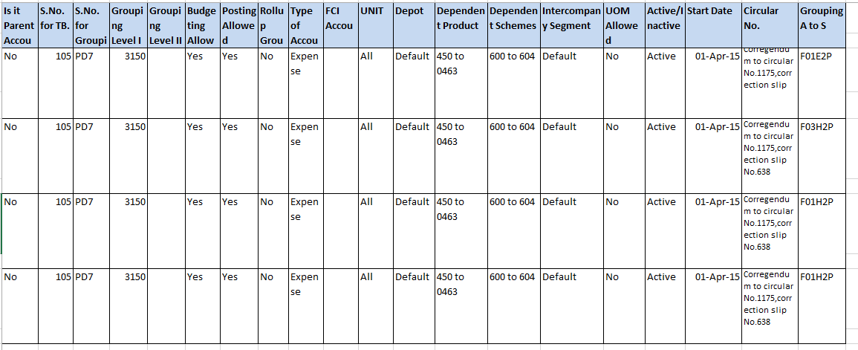

CI 9684: India Income Tax Report in FA
- FCI Fixed Asset Income Tax Schedule Report is given to user which will fetch data on All India - Block and major category wise basis. No further classifications will come in the report. Also all the reclass and transfer in/out will be catered in the report. Also the report will bring OB as provided by FCI for initial year and then it will be carry forwarded in the following years.
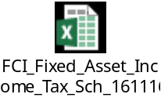
- FCI IT Act Report Adjustment Program is given to enter a manual adjustment in Closing Balance for a Financial Year. The adjustment will be made on Block and Category Combination on All India Level. The program is given to FCI PERIOD CONTROL USER Responsibility.
- FCI IT ACT Manual Adjustment Report is given to view the adjustments made (using the FCI IT Act Report Adjustment Program) in a Financial Year on a block. The adjustments done using the above said program will be brought by this report and the cumulative effect can also be seen in FCI Fixed Asset Income Tax Schedule.
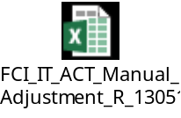

CR 592: Incorporation of customization in FA module
There is enhancement in check applied via CR: 357 in which units retired column cannot be null in asset retirement form. Now, via CR: 592 user do cost retirement leaving quantity field blank while doing non-transfer type asset retirement.

CR 599 :Creation Of BANDHAN BANK
- The below said banks will be added in the valid bank list lookup with effective date as 01-APR-2015.The field in system will be populated as following:

MEANING | DESCRIPTION | EFFECTIVE START DATE
BANDHAN BANK | BANDHAN BANK | 01-APR-2015

44Deployments – JULY2016

CR 602 : Bank Name to be Added In the Valid Bank List
- The following bank has been added in valid bank list lookup with effective date as 01-APR-2015 and fields were populated as below:-
CODE | MEANING | DESCRIPTION | EFFECTIVE START DATE
JILA SAH KYA BANK MDIT BLSPR | JILA SAHAKARI KENDRIYA BANK MARYADIT BILASPUR | JILA SAHAKARI KENDRIYA BANK MARYADIT BILASPUR | 01-APR-2015

45Deployments – OCT2016

CR-567 :No Change should be allowed in the CCID of internal bank
Check has been applied on the ‘Bank Accounts’ form so that once CCID is entered and saved, user will not be able to change it in future.

CR-565 : Creation of New Account Heads, Updation of CVR and updation of all relevant reports.
- Account heads 3165,3166,3167,3168 of account type expense created with description specified as nomenclature in Annexure-A.
- Changes in CVR as per annexure-A.
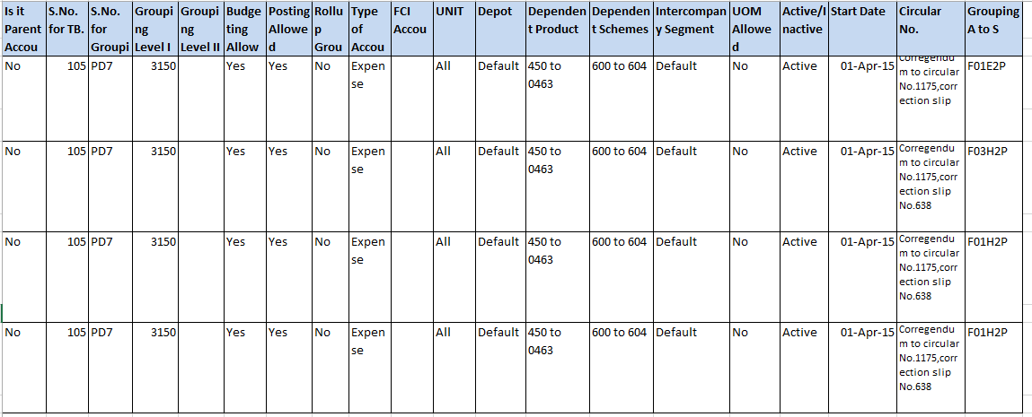

45.3 CR-612 : Bank Name to be Added In the Valid Bank List
- The following bank has been added in valid bank list lookup with effective date as 01-APR-2015 and fields were populated as below:-
CODE | MEANING | DESCRIPTION | EFFECTIVE START DATE
CHANDIGARH STATE COOPERATIVE | THE CHANDIGARH STATE CO-OPERATIVE BANK LTD | THE CHANDIGARH STATE CO-OPERATIVE BANK LTD | 01-APR-2015

45.4 (CR-581) Bank name to be modified in valid bank list
Following bank in Valid Bank List of the system of FCI:
CODE | MEANING | DESCRIPTION | EFFECTIVE DATE FROM
THE RATNAKAR BANK | THE RATNAKAR BANK | THE RATNAKAR BANK | 01-APR-2004

Has been modified to:
CODE | MEANING | DESCRIPTION | EFFECTIVE DATE FROM
RBL BANK LTD | RBL BANK LTD | RBL BANK LTD | 01-APR-2004

46Deployments- NOV2016

46.1 (CR 575) Creation of new account head, scheme
- New account heads were created, namely:5228 and 5229
- New schemes were created, namely:3437, 3438, 3420 and 605
- Changes in CVR as per annexure-A
- Changes in A to S statement as per annexure-B
- Changes in nomenclature of account heads as per annexure-C
- Creation of new minor categories and new asset categories as per details mentioned in annexure-E.
- Updation of asset CVR as per annexure-D.

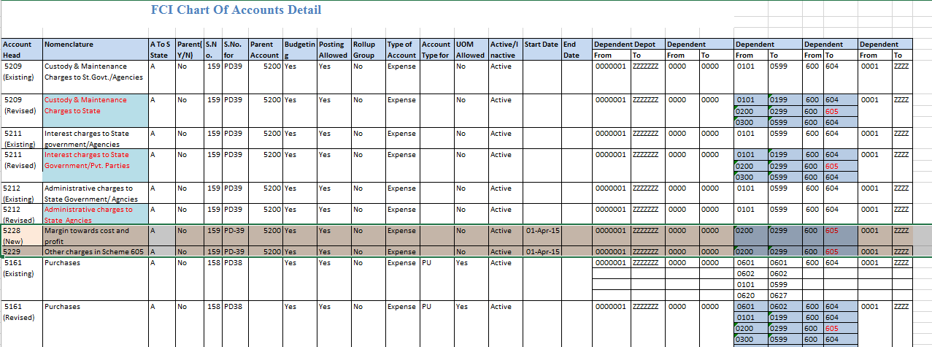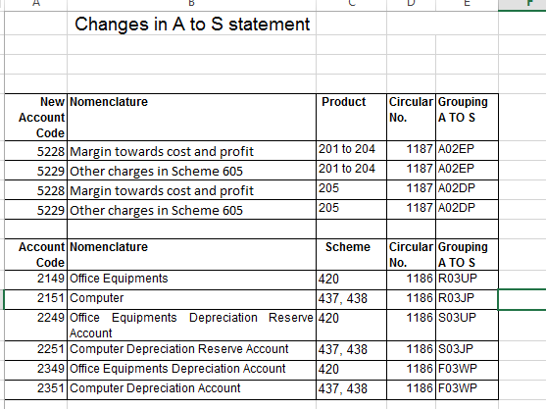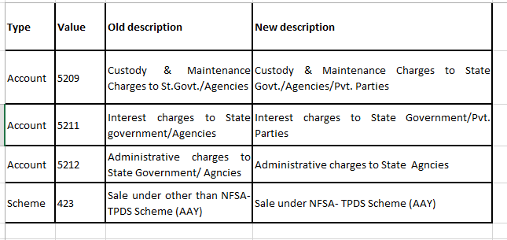
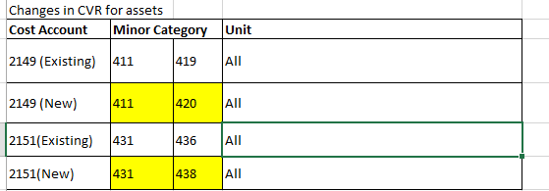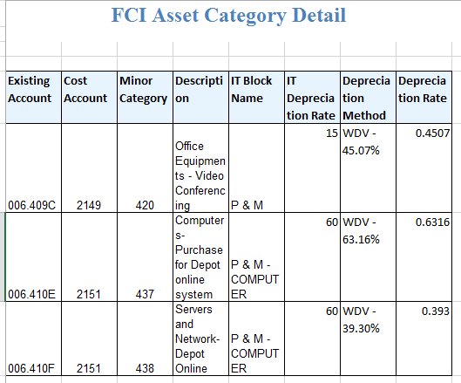

46.2 (CR 606) Creation Of New Scheme
- Creation of new schemes, namely:
3421
- Changes in CVR as per annexure-A
- Changes in A to S statement as per annexure-B
- Creation of new minor category and new asset category as per details mentioned in annexure-C
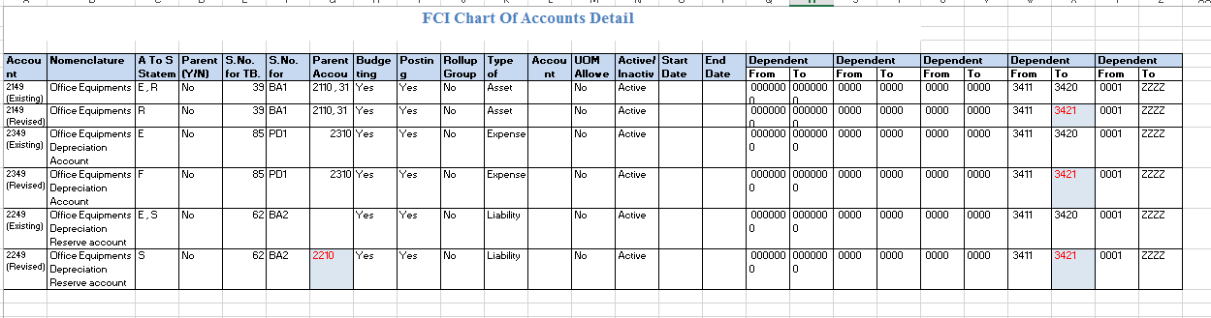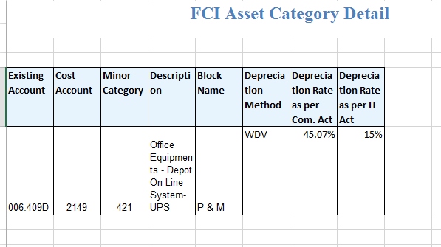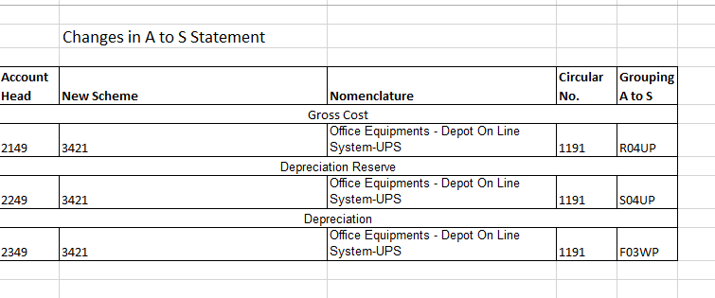
.

47Deployments- JAN2017

47.1 (CR 631) Conversion of FCI Consolidated Report to FCI.

As per CR 631, the report can be fetched in PDF format also, as after 14 digits excel starts rounding the number, due to which exact balance could not be seen.
For executing report in PDF format, select the report to run, fill in the parameters and click on Options.
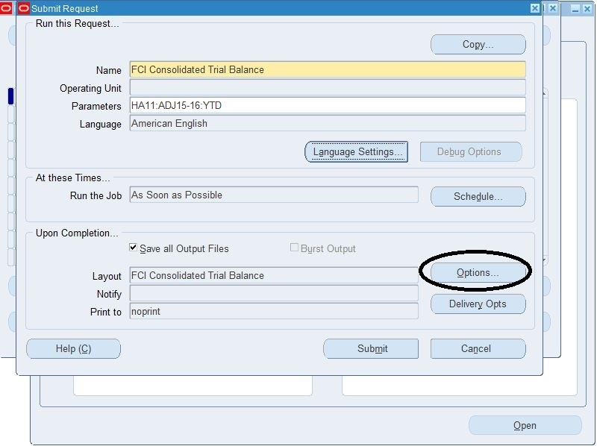

Change the format to PDF. You will have to click it twice, as in one go, it will give an error, and will open the LOV in second click only. Now execute the report, to get the below PDF output.
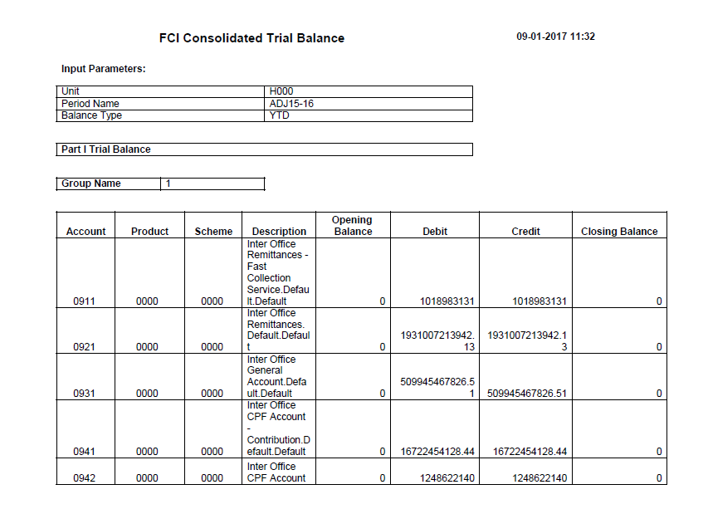
The option of running the report in PDF format is available only for FCI Consolidated Report Only, and not for any other report, as it affects the performance of the report.

(CR- 587) Custom Period Closure Fixed Assets:
- System checks will be applied such that user will not be able to perform any asset adjustment/transaction given below in FA Module after Custom Period Closure of operational month:
- Addition
- Retirement
- Reinstate any Asset
- Reclassification
- Cost Adjustment
- Unit Adjustment
- Assignment Change
- Unplanned Depreciation
- Mass Adjustments i.e. Deprn Method Change
- Capitalise Asset
- Increasing Source Lines for Assets
- In FCI Custom Period Closure Report - Auto invoice & Interface Report, assets whose depreciation is not run and transferred in respective period will be shown.
For e.g. If an asset is added in MAR15-16 (after depreciation for the book is run) and addition JE’s are sent to GL for that asset but depreciation for the asset is not calculated for MAR15-16. Then in the said case while closing period in GL (custom) FCI Custom Period Closure Report - Auto invoice & Interface Report will state that deprn for book is not complete. The user has to run the depreciation for the book again thus creating entries for respective asset.

CR-622 : Creation of New Account Heads, Updation of CVR and updation of all relevant reports.
- Account heads 0933 of account type asset created with description specified as nomenclature in Annexure-A.
- Changes in CVR as per annexure-A.
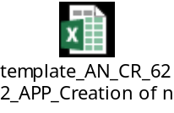

Supplier Bank as selection criteria in PPR.
In Additional Tab information which was earlier stored in DFF, had been moved to additional Information tab. In context field, there are two values check and Electronic.
- Reference: In the reference field, cumulative check number is used which is provided by the bank
- Month: Month on which payment is done.
- Year: Year of the payment
- Date of Settlement: Date on which cumulative check payment is done
- Supplier Bank: Supplier Bank details can be added. Invoices having bank account in this bank, will be selected in this batch. This is applicable only for electronic type of invoices. Moreover the bank details should be at payment schedule level of invoice level.
There can be two cases for creation of invoice:
Case1: When an invoice is created, for a supplier who is already having bank details linked to it – For these type of invoices, bank details automatically flow to payment schedule and no extra effort is required. The invoice gets selected on basis of supplier bank in schedule easily.
Case2: When bank details are added after the invoice is created, user needs to add the bank detail at invoice header level, and at payment schedule level, manually. The invoice will be selected on the basis of supplier bank only when bank details exist at payment schedule level.
Note: While adding bank details in Case2, at payment schedule level, user might get an error of ‘Field Does not understand operation’. This is a seeded error, for which Oracle has not yet provided with a solution .In such cases, user will have to click on the LOV for twice.
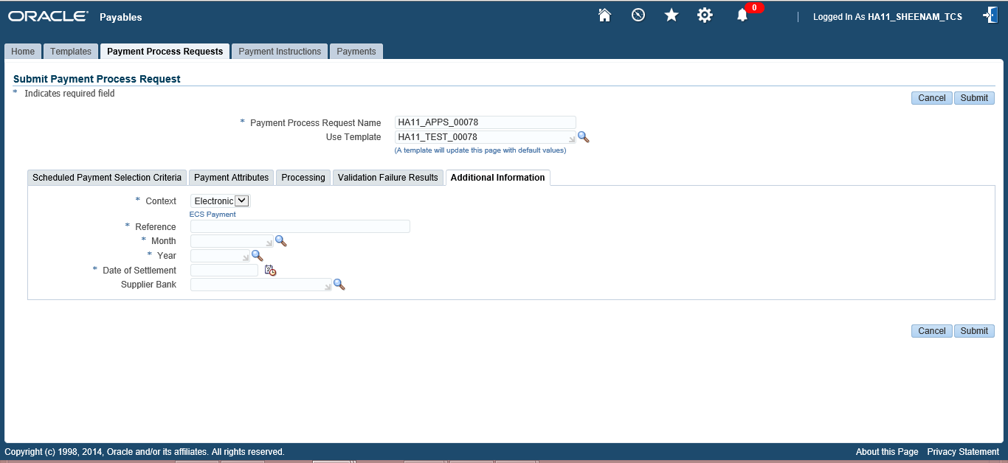
Also, the payment method in selection criteria has been made mandatory as per this development.

48Deployments- APR2017

48.1 CR-617 : Updation of Name of block of assets/depreciation rate
- For the following categories, the name of IT Block of Assets have been changed from ‘BUILDINGS’ to ‘BUILDINGS - STAFF QUARTERS’ and the IT Depreciation Rate from 10% to 5%.
S No. | Major Category | Minor Category
1 | 2128 | 531
2 | 2129 | 556

- IT Block name ‘ROADS_5’ have been renamed to ‘ROADS - STAFF QUARTERS’, thus below given major category combination will be tagged in “ROADS - STAFF QUARTERS”.
S No. | Major Category | Minor Category
1 | 2171 | 586
2 | 2172 | 616
3 | 2173 | 646

- The Opening Balance (OB) of the five categories that was provided in FY13-14 for IT Act is kept intact without any change.
- The changes that are made are effective from FY13-14.

49Deployments- MAR2017

49.1 CR-673 : Bank Name to be Added In the Valid Bank List
- The following bank has been added in valid bank list lookup with effective date as 01-APR-2016 and fields were populated as below:-
CODE | MEANING | DESCRIPTION | EFFECTIVE START DATE
IDFC Bank | IDFC Bank | IDFC Bank | 01-APR-2016

49.2 CR-656: Creation Of new account heads and modification in certain existing account heads
- Account codes 6206, 1702, 1723, 1724, 1725, 1726, 1727, 1728, 1729, 1730, and 1733 are newly created in system.
- Modification in the description of account codes 1701, 1711, 1721 and 1722 are done.
- Details of accounts created and modified are provided below:-
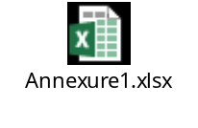

49.3 CR- 659: Asset Period Closure Form at FCI Support Level
- For MARCH15-16 Run depreciation is already present at FCI Support User. The checks applied for prevention of closure of MARCH period will be revoked for FCI Support User till the time ALL India is closed in FA Module.
- Inclusion/Exclusion of FA module in “FCI Custom Period Closure Report - Auto invoice & Interface Report” is governed by Look up Code made in Payables (FCI EXCLUDE FA IN CUSTOM CLOSE). The periods need to be entered in that lookup to exclude in custom period closure.

49.4 CR-662: Creation Of new account heads and change in the nomenclature of account heads 3157 and 3158
- Account codes 3169, 3170, 3171, 3172, 3173 and 3174 are newly created in system.
- Modification in the nomenclature of account codes 3157 and 3158 are done.
- Details of accounts created and modified are provided below:-

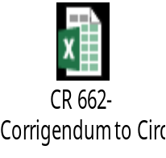

49.5 CR- 660 Tax Setup at FCI Support User Responsibility
- The Menu for below given responsibilities will be modified and Tax Setup will be removed.
  - Payables Super User
  - Payables User
  - Payables Interco User

49.6 CR-658: Creation of new account head, updating of CVR and updating of A to S statement

- Account codes 0953, 0955, 0956, 1602, 1603, 1604, 1605, 1606, 1607, 1608, 1609, 1610, 6251, 6252, 6253 and 5091are newly created in system.
- Changes in CVR as per annexure-A.

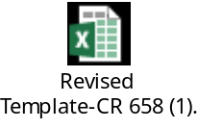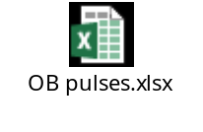

49.7 CR-595: Modification in Purchase Day book
- FCI require following modifications in FCI Purchase Day Book:
1)Addition of account head parameter as a mandatory fields.
2) Account parameter should contain only one purchase account.
3) Parameter will consists of LOV of all Purchase Account.
4) Report should generate the output accordingly.
- A check will be modified w.r.t. to CR-291 which will allow users to enter only one purchase account in the distribution of Goods Purchase Invoice in Payables for all purchase accounts.

49.8 CR-676: Creation of new product codes for non issuable pulses and oil seeds viz. 1451,1454,1457,1460 and 1463

- PRODUCT CREATION
Parent product 1450 (Pulses-Non-issuable) with following details was created along with 5 child products:-
Product | Description | Parent (Y/N) | Parent Product | Enabled | Rollup Group | Posting Allowed | Budgeting Allowed | Start Date | End  Date
1450 | Pulses-Non Issuable | YES | - | Yes | No | No | No | 01/04/2016
1451 | Arhar- Non Issuable | No | 1450 | Yes | No | Yes | Yes | 01/04/2016
1454 | Gram- Non Issuable | No | 1450 | Yes | No | Yes | Yes | 01/04/2016
1457 | Masoor-Non Issuable | No | 1450 | Yes | No | Yes | Yes | 01/04/2016
1460 | Moong-Non Issuable | No | 1450 | Yes | No | Yes | Yes | 01/04/2016
1463 | Urad-Non Issuable | No | 1450 | Yes | No | Yes | Yes | 01/04/2016

- UPDATION OF CVR
Earlier account head 5731 was grouped (PNL Grouping) to PC26. Further it is now grouped to PC26.8. 426 being single dependent scheme is now being support by 201 and 205 as dependent scheme for account head 5731 as per the annexure attached below:-
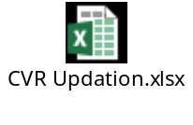
- Changes in A TO S Statements are done with the details as blow:-
Account Code | Nomenclature | Dependent products (New) | U O note no. | Grouping A TO S
5731 | Sale for pulses (retail distribution through stste channels) | 1451, 1454, 1457, 1460 and 1463 | UO Note no. Acctts./ 9 (1)/ 2014 Vol I/ 70 dated 21.02.2017 | L02JP

49.9 CR-680: Change of Address-Zonal Office

- The below mentioned address for WA11 Zonal Office was updated as specified. The Print Invoice Notice report would fetch the updated address to be used for letter head purpose.
EXISTING ADDRESS | UPDATED ADDRESS
Food Corporation of India  WA11 Z.O. MUMBAI MUMBAI  2nd Floor,Dheeraj Arma,Dr.Anant Kanitkar  Marg,Bandra(East) | Food Corporation of India  WA11 Z.O. MUMBAI MUMBAI  FCI NEW BUILDING 4TH FLOOR RAJENDRA NAGAR  ,DATTAPADA ROAD, BORIVALI (EAST)MUMBAI-  400066

49.10 CR-630: Creation of Pay groups for New Units

- Different new pay groups was created for units NH27 and EE12. These pay groups are meant for incentives, remittance, salary and other payments to Labours. The details of pay groups for both units are mentioned below.

Pay Groups for units NH27 and EE12
Sr. No. | Unit | Pay Groups | Remarks
 | NH27 | NH27_DPS_INCT | For incentives payment to labours.
 | NH27 | NH27_DPS_OTHR | For payment not falling in category of incentives, remittance, salary
 | NH27 | NH27_DPS_REMT | For remittance payment to labours.
 | NH27 | NH27_DPS_SAL | For salary payment to labours.
 | EE12 | EE12_DPS_INCT | For incentives payment to labours
 | EE12 | EE12_DPS_OTHR | For payment not falling in category of incentives, remittance, salary
 | EE12 | EE12_DPS_REMT | For remittance payment to labours.
 | EE12 | EE12_DPS_SAL | For salary payment to labours.

49.11 CR-675: Creation of Pay groups for New Units

- Different new pay groups was created for units NH32, SB13 and SB19. These pay groups are meant for incentives, remittance, salary and other payments to Labours. The details of pay groups for both units are mentioned below.

Pay Groups for units NH32, SB13 and SB19
Sr. No. | Unit | Pay Groups | Remarks
 | NH32 | NH32_DPS_INCT | For incentives payment to Labour
 | NH32 | NH32_DPS_OTHR | For payment not falling in category of incentives, remittance, salary
 | NH32 | NH32_DPS_REMT | For remittance payment to Labour.
 | NH32 | NH32_DPS_SAL | For salary payment to Labour.
 | SB13 | SB13_DEPT _INCT | For incentives payment to Labour
 | SB13 | SB13_ DEPT _OTHR | For payment not falling in category of incentives, remittance, salary
 | SB13 | SB13_ DEPT _REMT | For remittance payment to Labour.
 | SB13 | SB13_ DEPT _SAL | For salary payment to Labour.
 | SB19 | SB19_DEPT _INCT | For incentives payment to Labour
 | SB19 | SB19_ DEPT _OTHR | For payment not falling in category of incentives, remittance, salary
 | SB19 | SB19_ DEPT _REMT | For remittance payment to Labour.
 | SB19 | SB19_ DEPT _SAL | For salary payment to Labour.

50Deployments- APR2017

50.1 CR-684: Creation of new account head 5220, updating of CVR and updating of A to S statement

- Account code 5220 under parent account 5200 was newly created in system.
- Changes in CVR was done as per annexure-1
- Changes in A2S statement was done as per the annexure-1
Annexure-1: Accounts template and change in A2S statement
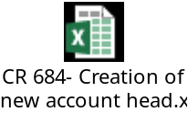

50.2 CR-650: Goods Purchase Invoice with zero quantity.
A check has been applied in the system:
- In case of zero quantity invoices, Purchase Accounts is used with zero amounts only.
- In case of zero quantity invoices,delivered quantity should be zero (in the DFF at Invoice line level)

51Deployments- MAY2017

51.1 CR-686: Creation of new account heads 1308, 3576 and 1906 for National Small Saving fund loan to FCI and modification in nomenclature of existing account head 3720

- Account codes 1308, 3576 and 1906 are newly created in system.
- Modification in the nomenclature of account code 3720 is done.
- Details of accounts created and modified are provided below:-
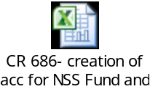

51.2 CR-625: Enhancement In Oracle’s Account Analysis Report
- Parameter’s ‘Include User Transaction Identifiers’ and ‘Include Statistical Amount ‘Lines has removed from the report.
- New columns in the report output namely Trading Partner Name, Trading Partner Number and Voucher Number has been added.
- Output layout of the report has been changed.
- Report has given in support and audit user responsibility.
- Report output name has been changed from Account Analysis Report to FCI Account Analysis Report.

Existing_Account_Analysis_Report_Format:
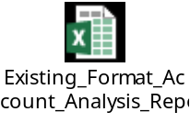
Revised_FCI_Account_Analysis_Report_Format:
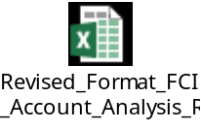

51.3 CR- 624:

Phase 1: Creation of FCI Receipts and Payment Summary Report.
This Report will provide the information about amount disbursed/Received through FAP on the basis of input parameter.

- It will show the amount disbursed/received by FCI via payment method i.e Cash and Digital ( all Non-Cash transactions).
- The Output of the Report will be in MS Excel .
- It will bring the data on the basis of creation date as entered in input parameter.
- Three input parameters – Unit code , Date from , Date to are mandatory .
- Unit code will consist of LOV.
- This report will show total number and Sum of payments in AP & AR modules via payment method i.e. Cash and Digital ( All Non-Cash transactions).
- This report will be assigned to FCI Audit User and FCI Support User Responsibility.

The input parameters of report are as follows:

S No. | Parameter | Description
1 | Unit Code | Can be a child and parent unit of hierarchy
2 | Date From | Creation Date of Payments and Receipts
3 | Date To | Creation Date of Payments and Receipts

Report Output: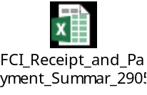

Report Format: 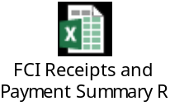

Phase 2: Creation of FCI Receipts and Payment Detail Report
FCI Receipts and Summary Report has been developed which will contain all the data about the amount disbursed/received through payment methods.

- The output of this report will be in MS Excel.
- This report will give the detailed information about the data disbursed/received from AP & AR in given event creation date range.
- This report is used to verify the ‘FCI Receipts and Payment Summary Report’.
- It will bring the data based on creation date as entered in input parameter.
- This report will consists of three input parameters – Unit code, Date from and Date to.
- All parameters will be mandatory and Unit code will consist of LOV.
- This report will show the desired detailed information of payments done in AP and AR modules as per the format desired by FCI.
- This report will be assigned to FCI Audit User and FCI Support User Responsibility.
- The input parameters of report are as follows:

S No. | Parameter | Description
1 | Unit Code | Can be a child and parent unit of hierarchy
2 | Date From | Creation Date of Payments and Receipts
3 | Date To | Creation Date of Payments and Receipts
- The Output parameters of report are as follows :

S No. | Parameter | Description
1 | Unit Code | Can be a child and parent unit of hierarchy
2 | Module | Creation Date of Payments and Receipts
3 | Supplier Name | Creation Date of Payments and Receipts
4 | Supplier Number | It will contain Supplier/Customer number
5 | Receipt/Check Number | It will contain Receipt/Check number
6 | Receipt/Check Dates | It will contain Receipt/Check Date
7 | Bank Account Name  n | It will contain bank account name
8 | Count | Number of event on Payment/Receipt within given date range
9 | Creation Date Event 1 | Creation Date of Payment / Receipts
10 | Creation Date Event 2 | “Reversal/Voiding Date” of “Payment / Receipts”
11 | Amount | Amount of Payment or Receipt.

Report Output:
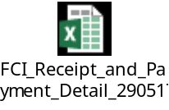

Report Format:


52 Deployments-JUNE2017

52.1 CR 634: Rectification of Bug identified in Debtors TB
- Both the reports, Debtor Trial Balance and Debtor Age wise were be modified to bring approved adjustments whose gl_date is on or before the gl_date for which the report is run.
- In order to avoid any changes w.r.t the reports of previous financial years, all the pending adjustments on the transactions were be marked as approved and were also marked as posted to GL. Since the modified reports are required to check both the approval status as well as the gl_date of an adjustment, the gl_date of all the pending adjustments was updated to the gl_date of their respective transactions. This includes the adjustments entered during FY16-17 also.
Note: Since these pending adjustments are being marked approved by a data fix, they will not have any effect on the remaining balance of the corresponding transactions.
- To rectify the mismatch between report and form because of the data fix in step 2, we added a new counter adjustment with an amount equal to the sum of all the older adjustments (sign reversed) for each of the affected transactions with gl_date ‘1-MAY-2016’. Doing so will nullified the effects of old adjustments in the reports from current FY onwards (Period MAY16-17). These new adjustments were also approved and were marked as posted to GL by data fix.
- Once the counter adjustments were marked as accounted and posted to GL, the report ‘FCI Debtor Trail Balance’ and AR transaction form came in sync. But since ‘FCI Debtor Age wise report’ works on data already fetched from the base tables in AR, the data in the custom tables of ‘FCI Debtor Age wise report’ was refreshed to bring the outstanding transactions along with the consideration of old and new adjustments w.r.t their gl_dates.
- A check was applied on the system such that:
- The amount allowed for new adjustments should be between -1 and 1.
- Only the user having the approval authority/limit set in the system should be able to enter and save the adjustment.
- The adjustment should only be allowed to save with status ‘APPROVED’

52.2 CR-701: Creation of Pay groups for New Units

Different new pay groups was created for WD15(D.O. Indore). These pay groups are meant for incentives, remittance, salary and other payments for Departmental Labour categories
- The details of pay groups are mentioned below.

Pay Groups for unit WD15
Sr. No. | Unit | Pay Groups | Remarks
 | WD15 | WD15_DEPT_INCT | For incentives payment to Labour
 | WD15 | WD15_DEPT_OTHR | For payment not falling in category of incentives, remittance, salary to Labour
 | WD15 | WD15_DEPT_REMT | For remittance payment to Labour.
 | WD15 | WD15_DEPT _SAL | For salary payment to Labour.

52.3 CR-704 : Bank Name to be Added In the Valid Bank List

- The following bank has been added in valid bank list lookup with effective date as 01-APR-2016 and fields were populated as below:-
CODE | MEANING | DESCRIPTION | EFFECTIVE START DATE
THE VAISH COOP ADARSH BANK LTD | THE VAISH COOPERATIVE ADARSH BANK LTD | THE VAISH COOPERATIVE ADARSH BANK LTD | 01-APR-2016

52.4 CR-702: Creation of new account heads for GST Implemenation

- Account heads 1600 , 1612 to 1620 , 1622 , 2923 to 2934 , 3771, 3773 to 3775 are newly created in system for GST Implementation
- Updation of CVR as per newly created account.
- Updation in the A to S report and other relevant reports.
- Changes in CVR as per annexure.

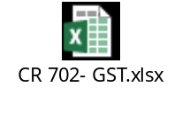

53Deployments- JUL2017

53.1 CR-654 : Editing in FCI Intercompany Reconciliation Report

As per Change Request: 654, the following two modification in the existing report of FCI Intercompany Reconciliation Report is incorporated:-
- Earlier one of the report input parameter namely As of Date is now removed and is being replaced by two new input parameters namely Period From and Period To. This modification is done to allow user to gather data between two periods. For example, If users select Period From as ‘APR15-16’ and Period To as ‘DEC15-16’, then the report will generate data from 01-APR-2015 to 31-DEC-2015. The users can select Period From and Period To value from LOV.
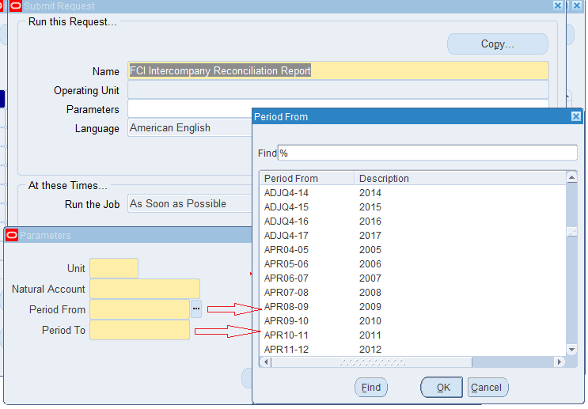
Fig: 53.1.1 LOV for addition of Period From and Period To as input parameters.
- Earlier FCI Intercompany Reconciliation report used to bring data for either single unit or for ALL unit. Now this report will generate data for single unit. In addition to this the report is modified in a way that it will run on the hierarchy basis too. For example if users select unit as ‘EC00’, then report will generate data for EC11, EC12, EC13 and so on. The users can select Unit value from the LOV.
Note: The report will run on hierarchy basis with General Ledger responsibility at headquarter level. For General Ledger responsibility at other units (except headquarter), input field Unit will fetch the first four character of the responsibility taken
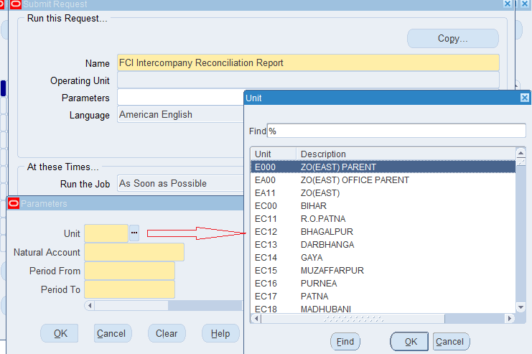
Fig: 53.1.2 Change in LOV for Unit as input parameter.

53.2 CR-694: Rectification in Existing reports "FCI SLS for Stores and Spares" & "FCI Stock Ledger Summary Report"

Mantis ID: 63409 & 64307 has been reported in which there are journal entries for account 7703, the effect of which is not getting reflected in “FCI SLS for Stores and Spares Report” but it is getting reflected in "FCI Stock Ledger Summary Report"
So the modification in the mapping of account head has been done on the basis of following points and attached list.
- Account Head 7703 to be mapped in "FCI SLS for Stores and Spare” under "Transfer Out".
- Account Head 7121 to be mapped in "FCI Stock Ledger Summary Report" under "Transfer In".
- Account Head 7621 to be mapped in "FCI SLS for Stores and Spare” under "Transfer In".
- Account Head 7203 to be mapped in "FCI Stock Ledger Summary Report" under "Transfer Out".

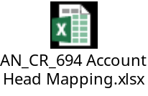

53.3 CR-664: Creation of a new Programme “FCI Stock Ledger Summary Programme” and change in output of “FCI SLS for Stores and Spares”
- 'FCI Stock Ledger Summary Report for ALL products' program will submit the 'FCI Stock Ledger Summary Report' for 'n' number of times. Here 'n' will be number of products mapped with input value as entered in product parameter.

- In “Product” parameter only 7 values will be available
- All food grains- issuable: 0101 - 0103, 0201 - 0205, 0301-0302, 0401-0402, 0501 -0506.
- All food grains- non-issuable: 1101 to 1103, 1201 - 1205, 1301-1302, 1401-1402, 1501 -1506
- All pulses- issuable: 0451-0463
- All pulses- non-issuable: 1451-1463
- All gunnies and other- issuable- 0601-0602, 0626-0627, 0902-0903
- All gunnies and others- non issuable- 1601-1602, 1626-1627
- For all Products
- Format of the output will remain same as for “FCI Stock Ledger Summary Report”. The product to Request mapping can be viewed from the log file of the program.
- Output of each product will be generated separately.
- 'FCI Stock Ledger Summary Report for ALL products’ program will be available FCI General Ledger user, FCI audit user and FCI support user.
- Product- Request ID mapping will be displayed in the log file of the submitted Program.

- Modifications are done in 'FCI SLS for Stores and Spares' report to generate the details Unit hierarchy wise.

53.4 CR-693 Editing in FCI Asset Additions Report, Access of unplanned Depreciation and Calculate Gains and Losses program

As per this change request following points need to be catered:-
- Unplanned depreciation button is to be removed from end-user, except FCI Support user responsibility.
- Calculate Gains and Losses single program is to be provided to Fixed asset end user.
- FCI Asset Additions Report to have Asset reference no. column for showing the asset no. of preceding unit from where it is transferred.

Existing Report Output Format:
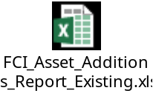

Revised Report Output Format:
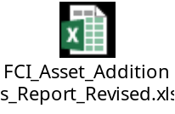

53.5 CR-698: Creation Of new account head 4762 viz. sundry debtors against CPF Trust
- Account code 4762 newly created in system.
- Details of account created is provided below:-

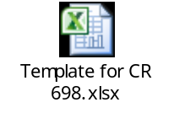

53.6 CR-596: Disable the Discount Field In Payment Batch Form
- A new validation has been applied on payments batch form while reviewing the invoices for payment through PPR to disable the discount field.
- Another validation has been applied on invoices work bench under scheduled payments tab through which the discount amounts and discount dates are disabled for 1st,2nd and 3rd discount.

53.7 CR-698: Creation Of new account head 3795 for expenses on Swachhta Action Plan and change in nomenclature of account head 1810

- Creation of new account head 3795 for for exclusive recording expenses on Swachhta Action Plan.
- Updating CVR as per newly created account.
- Updating A to S Statement and other relevant report.
- Change in nomenclature of an existing account 1810.
- Details of both the accounts are attached below:

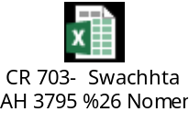

53.8 CR-706: Change of Address-Regional Office

- The below mentioned address for WC11 Regional Office was updated as specified. The Print Invoice Notice report would fetch the updated address to be used for letter head purpose.
EXISTING ADDRESS | UPDATED ADDRESS
Food Corporation of India  WC11 R.O. MAHARASTRA MUMBAI  2nd Floor,Dheeraj Arma,Dr.Anant Kanitkar  Marg,Bandra(East) | Food Corporation of India  WC11 R.O. MAHARASTRA MUMBAI  FCI NEW BUILDING 6TH FLOOR RAJENDRA NAGAR  ,DATTAPADA ROAD, BORIVALI (EAST)MUMBAI-  400066

54Deployments- AUG2017

54.1 CR-618: Restriction on change of type while creating a credit memo through Credit Transaction

- A check is applied on the credit transaction form that freezes the source of transaction while creating a credit memo against the transaction

54.2 CR-682: DPIS as GL Date of AP Invoice and Check on Control Total on Split of Asset
As per this change request following points need to be catered:-
- DPIS of assets created through prepare mass addition form should be the GL date of the invoice.
- The constraints have been applied which allow user to update the cost in case of split assets and will check that the total cost of split mass addition lines should be equal to the cost of source invoice line which is split.

54.3 CR- 648: New Field in DFF as actual date of installation &Changes in FCI Asset Book Report
- On FA Asset Addition Form (DFF) a new field is to be added as “Actual Date of Installations”.
- Personalization has been applied on Actual Date of Installations so that it will not allow to enter future date and it has to be less than or equal to the date of acquisition for those with Date of Acquisition on ‘1-APR-2013’.
- Personalization has been applied on Actual Date of Installations and it has to be more than or equal to the date of acquisition for that assets.
- It is a date type of field in “DD-MON-YYYY” format.
- Default date is equal to Date of Acquisition for all old data present in the system.
- It is a mandatory field.
- The same field is present in column of report “FCI Asset Book Report” with column name “Actual Date of Installations”.
- Personalization has been created which will let you modify DOI for Asset Type 'OB'.

- In FCI Asset Book Report column the “YTD Projected Depreciation” has been changed with “YTD Depreciation” with value and column brings depreciation calculated from 1st date of FY on asset.

54.4 CR- 697: Modification in the invoice after accounting
Following checks has been applied in the system:
1. Invoice Header: Personalization is added at Header Level, to prevent user from data alteration at Invoice Header Level Block when accounting of invoice is partial (accounting of invoice is partial in case when prepayment is applied/unapplied).
2. Line Level: Personalization is added at Line level to prevent user from data alteration at Invoice Line Level Block post accounting.
3. Distribution Level: Personalization is added to prevent user alteration at distribution of invoice post accounting.
4. Discard Line button is frozen after the invoice is accounted.

55 Deployments- SEP 2017

55.1 CR-714: Changes in A to S grouping of existing account heads

- Two new rows S1 as PRMS Contribution and S2 as DCPS Contribution of Statement E is created in the system.
- The newly created rows S1 as PRMS Contribution and S2 as DCPS Contribution of Statement E will get reflected in the report just before TOTAL row.
- Products 0451, 0454, 0457, 0460 and 0463 of account 7331 is mapped in O row (Pulses & Oil Seeds) under Statement B.
- A2S grouping in the existing accounts is done as per Annexure below:-
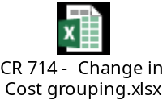

55.2 CR-716: Changes in A to S grouping of existing account heads
1.Mapping of the above products 0451, 0454, 0457, 0460 and 0463 of account 5421 in newly created row H1 (Pulses & Oilseeds) under statement C for getting the value for the Lorry Freight Charges in FCI Costing Report.

55.3 CR-724: Changes in A to S grouping of existing account heads
- Accounts head 2349 with scheme 3421 is mapped to first column (Storage Freight) in W row (W Depreciation) under Statement F as per the annexure below.
- Accounts head 2351 with schemes 3437 and 3438 is mapped to first column (Storage Freight) in W row (W Depreciation) under Statement F as per the annexure below.
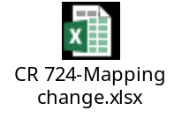

55.4 CR-721: Creation of new account head 3577

- Account heads 3577 (Interest paid on Bank borrowing/overdrafts for pulses operation) is newly created in system.
- Updation in the A to S report is done as per the table below:-
New Account Code | Nomenclature | Grouping A TO S
3577 | Interest paid on Bank borrowing/overdrafts for Pulses Operation | H01C₁P

- Changes in CVR is done as per annexure below:-
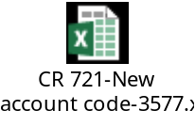

55.5 CR-663: Restriction on taking Receivable activity of other units while creating the transaction from C.M Module

- A validation has been applied in the system to check whether the activity taken by the user on miscellaneous receipts form in CM is of the same responsibility from which the user is logged on.
- System will prompt with an error message i.e. ‘Kindly choose receivables activity of your unit’, if the receivables activity of some other unit is selected.

56 Deployments- SEP 2017

56.1 CR-610: Creation of new account head 5731

- The account head 5731 is created.
- The scheme 426 is created.
- The CVR updation is done for account 5701 and 5731 as per the below annexure1 and annexure2 respectively.
- Modification in A2S statement is done for account head 5731 as per annexure2.
- The PNL grouping for account head 5701 and 5731 is done.
- The account head 5701 is disabled with possible combinations of followings:-
- Products- 0000,0450,0451,0454,0457,0460,0463,1450,1451,1454,1457,1460 and 1463.
- Depot- 0000000 (Default).
- Scheme- 0000 (Default).
The complete details of CCIDs comprises of 7 segments are mentioned in the below annexure3.

ANNEXURE-1

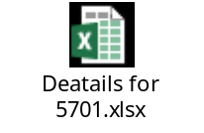
ANNEXURE-2
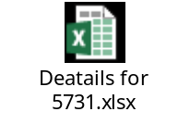
ANNEXURE-3
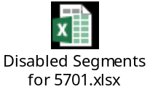

57 Deployments- OCT 2017

57.1 CR-726: Creation of new A/c head for Usage Charges for packaging of procured paddy (5281)
- Account head 5281 (Usage Charges for packaging of procured paddy) is newly created in system.
- Updation in the A to S report is done as per the table below:-
New Account Code | Nomenclature | Product Code | Circular No. | Grouping A TO S
5281 | Usage Charges for packaging of procured paddy | 0301 | - | A02CP
5281 | Usage Charges for packaging of procured paddy | 0302 | - | A02CP

- The CVR updation is done for account 5281 as per the below annexure.

ANNEXURE-1
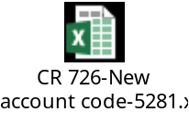

57.2 CR-727: Changes in existing grouping of account heads
- Changes in the grouping of account code 1308 from ‘BL11’ to ‘BL4.1’
- Changes in the grouping of account code 3576 from ‘PD25.1’ to ‘PD27.1’
- Changes in the grouping of account code 1906 from ‘BL11.2’ to ‘BL11.3’

ANNEXURE-1
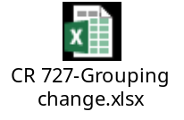

58 Deployments- NOV 2017

58.1 CR-646: FCI Journal Voucher Detail Report
Journal Voucher Detail report runs on unit hierarchy to bring JE line details like amount, status etc. The report is helpful in identifying amount booked by user in different account code combinations in JE Line.
Input Parameters:
Parameter Name | Type | Description
Unit Code | Mandatory | This is the Balancing segment at Journal line level.
From Period | Mandatory | Starting period parameter.
To Period | Mandatory | End Period Parameter
Category | Optional | Category of JE
From Amount | Optional | Smallest amount used in Journal Line
To Amount | Optional | Largest amount used in Journal Line
From Document No | Optional | Starting Document Number
To Document No | Optional | Ending Document Number

Output Parameters:
Serial No. | Parameter Name | Purpose
1 | Journal Category | Journal Category of the JE line.
2 | Batch Name | Name of Batch for the JE Line
3 | Journal Name | Journal Name which belongs to the JE Line.
4 | Document Number | Document Number for the JE Line
5 | Account Combination | The code combination used at JE Line
6 | Description | Description of JE Line
7 | Amount (dr) | Amount on JE Line in debit.
8 | Amount (cr) | Amount on JE Line in credit
9 | Status (Posting/Reversal) | Status of JE either Posted or Reversed only.
10 | Reversal Period | Period of reversal if exists.
11 | Created By | Username of creator of JE
12 | Updated By | Last Updated by Username
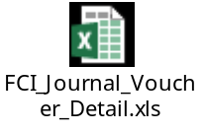

58.2 CR-674: Transfer Asset SB to SF Region
In reference to CR 512, new region/units for Telangana SF was created and Asset Books were created for it. The assets, which are tagged at old SB regions needs to be transferred to newly effective SF region in FY 16-17 by unit offices. However, this activity was to be carried in initial period of FY16-17, which is not allowed as per SYSTEM checks. Thus, this CR enabled user to perform transfers and additions respectively.
Following solution is implemented:
- SYSTEM Check for retirement/transfer was withdrawn for SB and SF Region. Afterwards client will perform the transfer activity at SB region to SF in APR16-17.
- SYSTEM check for permitting addition in FEB and MAR was withdrawn for SB and SF Region. Afterwards client will perform addition (transferred assets from SB region) on SF region in MAY16-17. DPIS data for addition should be first date of FY16-17.
Note: Addition of Asset cannot be done in APR16-17 with Depreciation Reserve as per Oracle Seeded Functionality. Thus addition needs to be done in MAY16-17 with DPIS as 01-APR-2016 and amortising the asset for reserve added w.e.f First date of FY16-17.
- Once above activity is completed FCI needs to revert to TCS for re-application of these checks.

58.3 CR-730: Creation of new A/C head for Trade Receivable-DCP Trust (4763)
- Creation of new account head, namely: 4763 for “Trade Receivable-DCP Trust”
- Mapping of BS grouping for account head 4763
- Updation of Relevant Reports
- Changes in CVR as per Annexure-1.
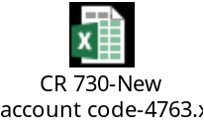

58.4 CR-723: Creation of new account heads

- The account heads 2826 and 3997 for claims and income on account of recovery of excess PLI paid are created in the system.
- The CVR updation is done for accounts 2826,3997 and 5061 as per the below annexure
- Modification in A2S statement is done for account head 3997 as per annexure
- The account head 5061 has been disabled with Product range 0451-0463.The complete details of CCIDs comprises of 7 segments are mentioned in the below annexure.

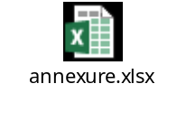

58.5 CR-738: Creation of new account head
- Creation of new account head, namely: 5282 for “Cost of gunnies used for pulses”
- Changes in CVR as per Annexure-1.
- Updating A to S Statement as per given grouping in the annexure attached.
- Mapping of PNL grouping for account head 5282.
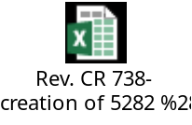

59 Deployments- DEC 2017

59.1 CR-572: Changes in Profit and Loss Statement Report
Changes has been done in grouping of FCI Profit & Loss Statement Report as there are changes in Balance sheet and PNL reports. The annexure for the same has been attached in CR as well as MID: 40339.
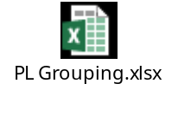

59.2 CR-GST: FCI GST Job Work Register
This report covers the details of the job work being outsourced to the vendors/suppliers. It includes all the mandatory information related to a job work, which will be required to be GST complaint.
Following Journal Categories are covered under the report:
Paddy Mill-Rice In
Paddy Mill-Paddy Out

Report Parameters:
GSTIN (Mandatory) – GSTIN Number for the FCI Region
Vendor Num (Non Mandatory) - Supplier to whom job work is assigned.
Category (Non Mandatory) – Paddy Out/Rice In, if left blank, report will fetch the data for both categories
GL Date From (Mandatory)- Date Range From within GL period
GL Date To (Mandatory)- Date Range To within GL period
Challan Date From (Non Mandatory)- Date Range From against Paddy Out
Challan Date To (Non Mandatory)- Date Range To against Paddy Out

- The report has two sections, one for Paddy-Out journal lines and second for Rice-In journal lines. The fields for Paddy-Out journal remain blank if the line corresponds to Rice-In journal and vise-versa.
- In case of Paddy Out journals, the net amount displayed for each line in the report is Cr-Dr value for that line.
- In case of Rice In journals, the net amount displayed for each line in the report is Dr-Cr value for that line.
- Only lines with specific accounts are shown in the report:
- For Rice-In Journal, lines with account 7131 only
- For Paddy-Out Journal, lines with account 7204 only
- If user enters multiple lines for above mentioned accounts in one journal, then all such lines are displayed in the report.
- The report brings data for posted journals only.
- In addition to this report, following additional checks have been applied on journal entry form:
For Rice-In Journal, user will be allowed to take only 7311 and 7131 as natural accounts.
For Paddy-Out Journal, user will be allowed to take only 7311 and 7204 as natural accounts.

Report will contain following fields:
S.No. | Field Name | Information/Data Source
Details for Paddy Out
1 | Job-worker code | Supplier Number of the supplier to whom the goods are sent for job work. From Header DFF.
2 | Name of Job worker | Name of the supplier to whom the goods are sent for job work. From Header DFF.
3 | Address of job-worker | Address of the supplier to whom the goods are sent for job work.
4 | Registered/ Unregistered Job worker | Third party registration information for the supplier selected at journal header level DFF.
5 | GSTIN of Job worker | GSTIN from the Third party registration information for the supplier selected at journal header level DFF.
6 | Job Name  (nature of processes required) | Paddy OUT
7 | GST Challan No. | GST Document Sequence Number for paddy out (from zoom window)
8 | Document No | Document Sequence Number for paddy out
9 | Challan Date | GL date of the Paddy Out Journal
10 | Date of receipt of goods (in case of direct delivery to job worker from FCI's vendor) | N/A- Column not required, will be left blank
11 | Place of supply (FCI business which has instructed vendor to send goods to job worker) | State Name from Line DFF
12 | Description of goods | Description of the product entered by the user at journal line level
13 | Type of Goods  (Inputs) | Paddy
14 | HSN for goods | HSN mapped with the product entered at the journal line level.
15 | UOM | UOM for the product entered at journal line level
16 | Quantity removed to job worker | Quantity of the product entered at journal line level
17 | Taxable Value  (value of goods based on the invoice through which FCI has procured) | Amount entered by the user at journal line level
Details for Rice In
18 | Original challan No. | Invoice/Challan no. Entered by the user at journal line level DFF.
19 | Original challan date | Entered by the user at journal line level DFF.
20 | Invoice details in case of sent out directly  (Invoice No.) | N/A- Column not required, will be left blank
21 | Invoice details in case of sent out directly  (Invoice date) | N/A- Column not required, will be left blank
22 | Description  (of the processed product) | Rice in
23 | HSN  (of the processed product) | HSN mapped with the product entered at the journal line level.
24 | UOM | UOM for the product entered at journal line level
25 | Quantity | Quantity of the product entered at journal line level
26 | Taxable value | Amount entered by the user at journal line level.
27 | Type of goods (Inputs/ capital goods) | Inputs
28 | Date of receipt of inputs from job worker | GL Date of Rice in Journal
29 | Quantity of waste material (scrap) received back | N/A- Column not required, will be left blank.
30 | Quantity of waste material (scrap) not received back | N/A- Column not required, will be left blank.
31 | Invoice No. of job worker | Will be blank
32 | Invoice date of job worker | Will be blank

- Since Job worker related information is required in case of ‘Rice-In’ lines also, hence first five fields from ‘Paddy-Out’ section in the format above will also be displayed for ‘Rice-In’ lines. These fields are :
- Job-worker code
- Name of Job worker
- Address of job-worker
- Registered/ Unregistered Job worker
- GSTIN of Job worker

60 Deployments- JAN 2018

60.1 CR-740: Creation of New account heads, change in PNL grouping of existing account head, change in Organizations’ name
- The accounts 1416 and 1417 for Trade payable for demurrage and wharfage and Trade Payable for Siding and Shunting res. are created in the system.
- The CVR updation is done for accounts 1416 and 1417 as per the below annexure.
- The Balance Sheet grouping is done for accounts 1416 and 1417 into BL5 group as per annexure.
- The changes in PNL grouping for account 5091 is done from PD37 to PD37.8.
- The Organization name for SC12 unit is changed from SC12 D.O. Alleppy to SC12 D.O. ALAPPUZHA (Alleppy) in Global HRMS.
- The Organization name for SC12 unit is changed from ALLEPPY to ALAPPUZHA (Alleppy) in Value Set.
- The Organization name for SC12 unit is changed from SC13 D.O. Calicut to SC13 D.O. KOZHIKODE (Calicut) in Global HRMS.
- The Organization name for SC12 unit is changed from CALICUT to KOZHIKODE (Calicut) in Value set.

60.2 CR-623: Changes in Asset Adjustment Report.

As per this Cr following points have been catered.
- Report has been changed to run on period parameter i.e. From Period and To Period instead of system date parameter.
- CIP adjustments and DPIS adjustments are also shown in this Report as per the below attached format.
- Reclassification amounts are shown in this report, for this two columns are added to the report output (Reclassified Cost, Reclassified Reserve) and are put under separate heads as per below report format.
- Block changes are also shown in this report. Assets with block change is brought in the report with the changes in their respective columns as per below format attached.
- The columns (A) to (F) except (C) as per below format has been changed to period date parameter and will show the data for the last period for which the report is run. The (C) column has no audit trail in the system so this particular column will always show t<HTML><HEAD><TITLE>Weblogic Bridge Message</TITLE></HEAD> <BODY><H2>Failure of server APACHE bridge:</H2><P><hr><PRE>Internal Server failure, APACHE plugin. Cannot continue.</PRE><hr> </BODY></HTML>
he annexure attached below.



60.4 CR- 729: Rounding off should be on invoice level instead of line level.
1. Changes in existing personalization are done and now a single revenue line is generated for rounding off.
2. Account code for revenue line is 4206 whose description is “Petty excess collection on sales”.
3. For the auto generated revenue line, quantity is 1 and unit price is the Rounding off amount.

60.5 CR- 746: Creation of new Account heads
1. Account code 6306, 6307 and 6308 are newly created in system.
2. Details of account created are provided below:-
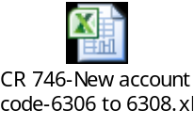

61 Deployments- FEB 2018

61.1 CR- 737: Asset Period Closure Form At FCI Support level

- For MARCH16-17 Run depreciation is already present at FCI Support User. The checks applied for prevention of closure of MARCH period are revoked temporary for FCI Support User till the time ALL India is closed in FA Module.
- Create accounting for assets are revoked temporary from FA module until the time all units are closed for period MAR16-17 in FA.Entries are generated after running the depreciation of MAR16-17 for all units the same has shared to FCI.

61.2 CR- 707: Addition of new classification for supplier and changes in reports "FCI Receipt and Payment Detail Report" and "FCI Receipt and Payment Summary Report"
- New supplier type for Farmer, UT Government Agencies, Artiya, Agents, Miller, Consultants, Transporter-Other, Transporter-RTC, Transporter-HTC has been added in the system.
- Reports "FCI Receipt and Payment Detail Report" and "FCI Receipt and Payment Summary Report" now have one optional parameter of “Supplier Type”. This parameter will consist of LOV of all the supplier type available in system.
- Reports "FCI Receipt and Payment Detail Report" now contain one more column as Supplier Type.

61.3 CR- 641: Modification in FCI Trial Balance Detail With Document Sequence Report to introduce A to S, Balance Sheet, P&L and P&L statement Grouping.

As per this CR following changes are incorporated in “FCI Trial Balance Detail with Document Sequence Report”
- Four new columns are included in “FCI Trial Balance Detail with Document Sequence Report”.
- Balance Sheet Group- It will display the Balance Sheet group the Code Combination is mapped with. (Nomenclature- Only Group Name will be displayed, E.g.- ‘A’)
- AtoS Group- It will display the AtoS group the Code Combination is mapped with. (Nomenclature- Statement: Column-Group Name, Statement: Row- Group Name, E.g. – ‘F:C-Admn.,F:R-K Audit fees’)
- P and L Account- It will display the Profit and Loss account the Code Combination is mapped with. (Nomenclature- Only group Name will be displayed, E.g.- ‘PD67’)
- P and L Statement- It will display the Profit and Loss statement account the Code Combination is mapped with. (Nomenclature- Only group Name will be displayed, E.g.- ‘PD67’)

- Unit parameter has been discarded, instead Two Additional Mandatory Report parameters- From Unit and To Unit are introduced to provide User option to generate the Trial Balance for a Unit Range.

62 Deployments- MAR 2018

62.1 CR- 753: Creation Of new Account Head

- Account code 2935 is newly created in the system.
- The CVR updation is done for account 2935 as per the below annexure.
- Annexure:-

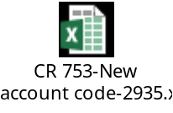

62.2 CR- 745: Regarding Supplier Type
A check has been applied in system which will make supplier type mandatory. User will not be able to create address until supplier type is not present in the system.

62.3 Personalization on supplier form for GST
While creating new Supplier or updating basic details of existing supplier, Supplier name cannot start with space.

62.4 CR-756, GSTIN 14TH character as Alphanumeric
1. Modification in the personalization is done that allows the user to enter the 14th digit as alphanumeric.
2. The Error message which currently mentions 14th character as Character is changed and in modified message 14th digit is denoted as No/Char.

62.5 CR-758, Creating New Items, HSN-SAC mapping & New Report Development detailing the FCI Item List
- New Inventory Items are created in FAP.
- HSN/SAC Code mapping done for the newly created Items.
- New report developed in FAP- “FCI Inventory Item Detail Report”. It‘s included in the FCI Chart of Account Master Request Set.

63 Deployments- APR 2018

63.1 CR- 671: Pending invoices against inactive suppliers

This particular Change request deals with the following changes as mentioned below:-
- The data of pending invoices against inactive suppliers is provided to FCI.
- The data of pending receipts and transactions against inactive customer’s w.r.t all inactive suppliers is provided to FCI.
- The check is applied on Supplier level and Supplier site level to check pending entries in Account Payables and Account Receivables to restrict inactivation of supplier and supplier site. This check will work with the following logic:-
- The invoices that are unpaid/Partially paid and not cancelled will be considered as pending invoices in Account Payables.
- The receipts and transactions that are having amount due remaining and amount due status is ‘OPEN’ will be considered as pending receipts and transactions.
- With the application of this check, if user will enter the ‘End Date’ at the supplier form level, the program will check the pending entries for this particular supplier at all supplier sites level in Account Payables and Account Receivables models. If program encounters count of pending entries (invoices, receipts, transactions) greater than 0, it will throw message at supplier level and user could not inactivate supplier.
- With the application of this check, if user will enter ‘End Date’ at supplier site level, the program will check pending entries at that particular site only in Account Payables and Account Receivables, If program encounters count of pending entries (invoices, receipts, transactions) ) greater than 0, it will throw message at supplier site level and user could not inactivate that particular supplier site.

63.2 CR- 754: Changes in existing mapping in A to S statement
This change request deals with below mentioned changes in statement F of A to S reports.
 | Account Code | Product | Existing Cost Grouping | Revised Cost Grouping
 | 3768 | 0000 | F01AP | F03AP
 | 3166 | 0450 to 0463 | F03H2P | F01H2P
 | 3156 | 0000 | F01EP | F01D2P

A separate row D2 for account code 3156 in F statement report with nomenclature “Rent in r/o Silo" was created.

63.3 CR 752 : Email ID and Contact Number of Supplier’s Site inclusion in FCI Supplier Master Report

As per this CR below mentioned changes have been done in “FCI SUPPLIER MASTER REPORT”.
FCI Supplier Master Report is modified to include 2 new columns.
- Email ID- detail of Supplier Site Level Email Address.
- Contact No- detail of Supplier Site Level Phone Number.

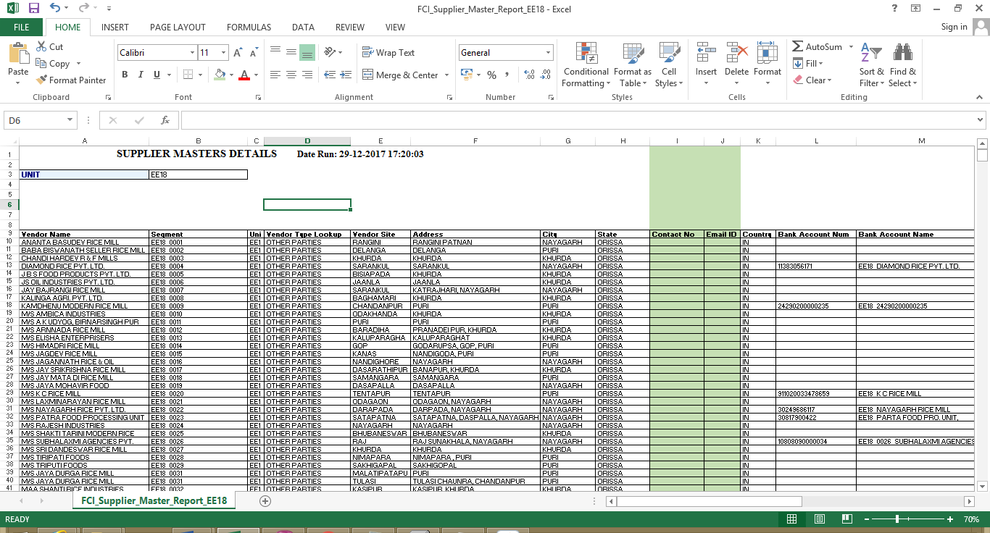

64 Deployments- MAY 2018

64.1 CR 763: Opening of DFF at transaction form in AR Module

As Per this CR One field naming “Reference“ is provided in DFF available at transaction header level in transaction form in AR to capture the reference detail of transaction.
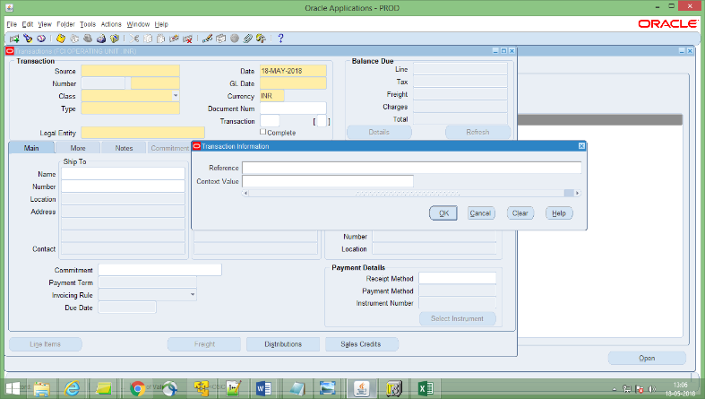

64.2 CR 743: Closure of two units of EF region
- All Code Combinations for EF16 and EF20 created till date were marked inactive by Disable CCID process to restrict creation of new financial data. The end date for the process was ’31-MAR-2017’.
- Inventory Organization for EF16 and EF20 was disabled in the system with end date on ’31-MAR-2017’.
- Budget Organization for EF16 and EF20 was disabled in the system with end date ’31-MAR-2017’, as now there is no need to check funds to these units.
- Values for EF16 and EF20 were disabled in the FCI_UNIT value set with end date ’31-MAR-2017’. Since this value set is used to fetch values for segment1 in accounting key flex field, system will not allow the user to take EF16 and EF20 as segment1 in any new transactions with GL date greater than ’31-MAR-2017’.
- TDS Section Codes for EF16 and EF20 were disabled with end date ’31-MAR-2017’.
- Transaction Types, Transaction Source, Receipt classes and Receivable Activities in AR were disabled with end date ’31-MAR-2017’.
- All document sequences for EF16 and EF20 were end dated on 31-MAR-2017.
- In Fixed Assets Module, Asset Books and categories were end dated from 31-MAR-2017. This will prevent addition or alteration of data in Sub ledger.
- For MIS purpose, changes were made in the custom FCI data reports so the user can still run the reports and view old data

64.3 CR 739: Creation of 2 units (District offices) under Bihar region (Patna) in Payroll & Apps & change in Unit Office Name
- Two new units DO ‘EC24 - Jamui’ (start date 1-AUG-2017) and ‘EC25 - Rohtas’ (start date 1-JUL-2017) were created in APPS.
- All the setup corresponding to these two new units was done in APPS.
- W.r.t newly created units, locations were created in payroll and employees were mapped accordingly.
- The name for unit office "EC20 District Office Chhapra" was changed to "EC20 District Office Hajipur(Chappra)".
Note: For complete details on the setup done for new units, please refer AN for the CR.

64.4 CR- 769: Creation of new Account heads
1. Account code 1740 and 1741 are newly created in system.
2. Details of account created are provided below:-
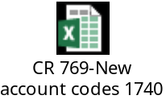

65 Deployments- JUN 2018

65.1 CR- 759: Addition of scheme code 3422 in account codes 2149, 2249, 2349
1. New scheme code 3422 is created in the system and addition of scheme code 3422 in account code 2149, 2249, 2349.

2. A new minor category (422- Office Equipment - CCTV Camera) is created in Fixed Asset.
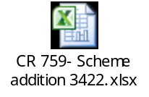

65.2 CR 734: Amortization Mandatory in Fixed Assets
- Following Areas are analysed where Amortization is not mandatory.
  - Cost, DPIS changes done via Books Form
  - Mass Change functionality
  - Source Line cost Adjustment
- Check are applied as per CR 456 amortization rule (DPIS or 1st date of FY whichever is later).

65.3 CR 774: Check on Manual entry of Account Head-4206 in AR distributions

- A check is implemented on AR Transaction form which will throw an error in case user manually enters account code-4206 in distributions (For any Line type- Receivable, Revenue or Tax). User will have to change the account code to move further.
- All the Incomplete AR transactions in which account code- 4206 is used in distributions & Transaction value is un-rounded are deleted.

65.4 CR 780: Creation/ Updation of HSN Codes

- New Inventory Item is created with following details-
Item Code | Item Name | Item Description | Taxable/  Exempted | Sales/ Non Sales | HSN Code
1626 | HDPE Bags – New (Non- issueable) | HDPE Bags – New (Non- issueable) | Taxable | Sales | 3915

- HSN Code of Item-1627 is changed to 3915 from 3926.

65.5 CR 761: To Cater In Transit Assets in Custom Period Closure
- Auto Invoice and Interface Report of Custom Period Closure will be modified such that following will suffice:
  - If HA11 is closing Custom period, report must check for pending assets that are transferred by other units but not added on HA11.
  - Similarly, if HA11 is closing Custom period, report must check for assets that are added by other units (type transferred) but not transferred from HA11.
- Checks will be applied to cater below cases:
  - If HA11 is transferring any asset to any unit (e.g. EA11), that unit's custom period must be open. i.e. EA11 must have custom period open. This check however is needed for MARCH period only.

66 Deployments- JUL 2018

66.1 CR- 511: Replacement of Account Heads

With reference to CR: 511 (MID: 27367), the following changes has been done:-

- The existing receipt class (enabled and disabled) setup for Unidentified (7964), Unapplied (7961) and On Account (7962) is replaced with account head 1806. In case any other accounts than 7961, 7962 and 7964 being used in setup is also replaced with 1806.
- Manual entry in the account heads 7901, 7902, 7903, 7931, 7951, 7952, 7961, 7962, 7963, 7964 are restricted in AP, AR ,GL ,FA ,Treasury , CM.

As a part of discussion on 28-May-2018, the below approach is finalized and deployed for all the data that exists in the system with CCIDs includes accounts 7961,7962 and 7964 for receipts that are unapplied till 22-Jun-2018 :-
- All such receipts that were unapplied as on 22-Jun-2018, the balances on CCIDs involving account heads 7961,7962 and 7964 is moved to new CCID having same 7 segments as per Old CCID except segment3 (Account) that is changed to 1806. This balance movement is done Via dual accounting process i.e. One accounting line impacted old CCID and the other accounting line impacted new CCID. Say earlier old CCID (Unapplied/On Account) was Credited. Now two lines is added through data fix in the system wherein Old CCID (Unapplied/On Account) is debited and new CCID (Unapplied/On Account) with account 1806 is credited. In this way the balance is shifted to new CCID. This process is done till subledger level with accounting status marked as transferred to General Ledger. But in actual these additional added lines are not transferred To GL.
NOTE:
The dual accounting entries are created with GL data as ’22-Jun-2018’ i.e. the date on which deployment is done.

Additionally, as a part of discussion on 26-Jun-2018, the below approach is finalized and deployed for all the data in just above step:-
- In contrast, all the data that was marked as transferred to GL at subledger level but actually not transferred in GL in just above step, is now transferred to General Ledger. For all these transferred data in GL, data is provided to FCI on MID: 27367. This data is given in detail that contain the individual receipt details too w.r.t respective journals. This is because the drill down of GL to subledger level is not feasible due to custom data fix.

66.2 CR- 749: Creation of New account Heads and opening of new pay code.
With respect to this Change Request, below work is deployed on Production environment:-
- The account code 6070 is created along with updation of CVR, A2S mapping (Cost Grouping) ,PNL (Profit and Loss) grouping and PFMS maaping.
- The account code 0934 is created along with CVR Updation and Balance Sheet Grouping.
- The new pay code 227 is created on Production Environment.

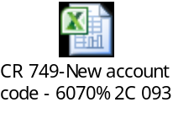

66.2 CR- 788: Creation of New account Head.
With respect to this Change Request, below work is deployed on Production environment:-
- The account code 5232 is created along with updation of CVR, A2S mapping (Cost Grouping) ,PNL (Profit and Loss) grouping and PFMS maaping.
- The cost grouping (A to S grouping) for existing account head 6308 is changed from D01AP to D06AP.
- A new row D named ‘Input Tax Credit’ under Statement G is created as it was not available in the system from the purpose of reflecting costing under Input Tax Credit.
- Annexures:-
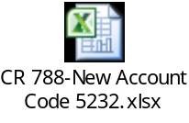
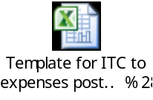

66.3 CR-785: Uploading of expenditure for period from 01.04.2017 to 30.09.2017 on PFMS portal
- Since user can make payment for any of the old unpaid invoices, all the goods purchase invoices were be updated in following manner:
- For pre-R12 upgrade invoices, crop year was moved from invoice header to invoice line for all lines of type ITEM. Because PFMS reports pick crop year from invoice line level. And post R12 upgrade crop year is entered at invoice line level only.
- Once step above was complete, we’ll appended KMS/RMS to the crop year at invoice line level for each of the Goods purchase invoice where it is not already present. This update of KMS/RMS was be based on the list of eligible products finalized by FCI during CR 713 (list attached in annexure).
- After updating the crop year for goods purchase invoices, all the data from PFMS MIS was removed and was refilled in PFMS MIS table in following manner:
- This data re-filling was only done for combinations of unit, bank, bank account, PFMS scheme and PFMS Data category for which user has run the report at least once. For any new combination the data would be fetched via PFMS data upload report on report run.
- Since the entire data was being regenerated and system only had new FCI PFMS COA mapping. The resultant data was having PFMS component codes as per the new FCI PFMS COA mapping only.
- The start date for filling the data was 1-Apr-2017 (check date for expense and advance type data and gl date of prepayment application for advance settlement data).
- The end date for filling the data was the date till which user has run the report for a combination of unit, bank, bank account, PFMS scheme and PFMS Data category.
The data re-filled was marked as reported and will reflect in FCI PFMS Data Upload History report only.
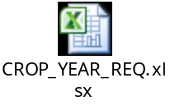

66.4 CR-589: Activation of account heads, creation of new journal category and updating of SLS Report

1. Activation of account heads 7411, 7424, 7431, 7432, 7441 and 7442.

2. Creation of new journal category (Unit_Stock) for single entry of STAT currency only with account heads: 7411, 7421, 7422, 7423, 7424, 7431, 7432, 7442, 7441 and these account heads should not be used for double line.

3. Creation of separate responsibility (UNIT GL USER STAT ENTRY) where only above mentioned accounts are provided.

4. Introduced a new section in ‘FCI Stock Ledger Summary Report’ in which certain new accounts are mapped as per the template attached in the annexure.

5. CVR is updated as per template attached in annexure.

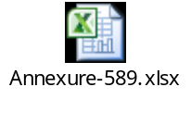

67 Deployments- AUG 2018

67.1 CR- 792: Period Closure rights of SF region
Period closure access for units under SF region is now available with following users:
- A user with user name starting with ‘HA11’ (i.e the users at headquater level) and any of the following responsibilities:
FCI Support User
FCI Period Control User
- A user posted at RO Heydrabad (SB11) and having any of the following responsibilites:
FCI Period Closure Tool
FCI Support User
FCI Period Control User

67.2 CR- 640: Automatic updating of Bank Account on Employees Present Site
Following changes were made in the Apps to Payroll banks account automation of FCI Employee type suppliers:
- If a “FCI EMPLOYEE” type supplier is transferred from ‘A’ site with bank details ‘X’ to ‘B’ site and ‘B’ site does not have ‘X’ bank details. Then ‘B’ site will be updated with ‘X’ bank details and same will be transferred in PAYROLL.
- If a “FCI EMPLOYEE” type supplier is transferred from ‘A’ site with bank details ‘X’ to ‘B’ site and ‘B’ site have ‘X’ bank details active. Then the same bank details will be transferred in PAYROLL.
- If a “FCI EMPLOYEE” type supplier is transferred from ‘A’ site with bank details ‘X’ to ‘B’ site and ‘B’ site have ‘X’ bank details and it is end dated. Then it will active the ‘X’ bank details and same will be transferred in PAYROLL.
- In case any other bank Y exist on B site already which active, it will be end dated so X can become primary bank.
- Bank details entry at supplier level will remain enabled for “FCI Employee” type suppliers in AP. In place of earlier suggested approach, following approach will be applicable:
- If a bank account exists at site level which is active and has order of preference 1, it will be moved to payroll.
- If bank account is not found at site level or is inactive at site level, system will select the bank account from supplier level and move the same to payroll. Provided a bank account exists at supplier level which is active and has order of preference 1.

67.3 CR- 750: Updation of CVR for Account Head 5281 & 5171

      - CVR and PFMS mapping for account head 5281 and 5171 is updated as per sheet attached below.
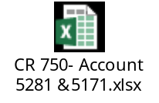

      - Nomenclature for account head 5171 is changed from “Purchases at prices other than MSP” to “Purchases at MSP under URS”

67.4 CR- 793: Creation of new account head and product codes

With respect to CR-793, the following work has been done:-
- Account code 5712 has been created as per the attached annexure.
- The A2S mapping for account head 5712 is done as per the attached annexure.
- The PNL grouping for account head 5712 is done is done as per the attached annexure.
- The product codes 0904, 0905 and 0906 is created as per the attached annexure.
Annexure:-


67.5 CR- 790: Creation of new report FCI Payment Batch Output Report – Excel

With respect to CR-790, the following work has been done:-
- The ‘FCI Payment Batch Output Report - Excel’ will be created as requested as per Annexure.

68 Deployments- SEP 2018

68.1 CR- 795: Modification to be made in 1740, 1741 and 5232
1. Change in the start date for account codes 1740 & 1741.
2. Changes in the account code 5232 as per attached annexure

68.2 CR- 757: Creation of New account Heads
With respect to CR-757, the following work has been done:-
- Account codes 3796, 3797 and 3798 are created w.r.t account creation template.
- CVRs are modified w.r.t account creation template.
- PFMS mappings are done.
- Account disabling of account head 3702 is done. The details of 7 segments are in the template, Disabled CCIDs.
Templates:-
1. Account Creation:-
2. Disabled CCIDs:-

68.3 CR- 802: Creation of New account Head 5403(Freight Container- Operations)
1. New account 5403 to be created.
2. Updating of CVR as per template attached in CR.
3. Modification in the A to S statement as per newly created account.

68.4 CR- 794: Creation of New HSN Codes

New Inventory Items are created with following details-
Item Code | Item Name | Item Description | Taxable/  Exempted | Sales/ Non Sales | HSN Code
9868 | Note Pad | Note Pad | Taxable | Non Sales | 4820
9867 | Ball Pen/Sketch Pen | Ball Pen/Sketch Pen | Taxable | Non Sales | 9608
9866 | Folders | Folders | Taxable | Non Sales | 3926
9865 | Pen Drive | Pen Drive | Taxable | Non Sales | 8523
9864 | Photography | Photography | Taxable | Non Sales | 9983
9863 | Chart Paper | Chart Paper | Taxable | Non Sales | 4802
9862 | Bisleri Water | Bisleri Water | Taxable | Non Sales | 2201

68.5 CR- 791: Modifications in format of GL GST Delivery Challan
In Delivery Challan-
- Instead of the column- Taxable Amount, Tax Amount column will be displayed with amount 0.

In Delivery Challan, Bill of Supply, Tax Invoice-
- Column Labels- Description of Goods/Services, HSN Goods/SAC of Services are changed to Description of Goods, HSN of Goods respectively.
- Columns- Customer Name & Name of Consignee will display FOOD CORPORATION OF INDIA incase of IOM.

68.6 CR- 712: Reflection of void payment and receipt reversal in FCI BRS report
Following points of modification were made in report:
- The report was modified to include cross month voided payment under Unreconciled Payments, if the report is run for period prior to the period in which it was voided. Payments voided in the same period will not be reflected in the report.
- Receipts reversed in the same month, irrespective of the reversal method will not reflect in the report.
- Receipts reversed in cross month with reversal method 'Stop Payment' and 'Non-sufficient funds' will reflect in the report, if the report is run for the periods prior to its reversal.
- Receipts reversed with reversal method 'Reverse Payment' was completely excluded from the report for same as well as cross month reversal.
- In addition to above checks, receipt reversal method 'Reverse Payment' was also revoked from receipt reversal form.

68.7 CR- 804: Changes in CVR w.r.t account codes 1723, 1727, 6206
- Change in the start date for account codes 1723, 1727 & 6206.
- Changes in the CVR of account codes 1723, 1727 & 6206 as per attached annexure.

CR-805: Creation of new account heads

- The account heads 4219(Rebate avails from payment to CWC) and 4220(Rebate avails from payment to SWC) are created in the system.
- The CVR updation is done for these accounts as per the below annexure
- Modification in A2S statement is done for these account heads as per annexure

69 Deployments- OCT 2018

69.1 CR-678: Creation of new report FCI Purchase Tally Report

This report shows the summary of all purchases made in FCI and shows the output as per format attached. This report is created under CR-678.
Input parameter:-

Sl. No | Parameter | Mandatory | Description
1 | Unit Code | Yes | The unit code for which data is to be fetched. The unit will be parent and child both.
2 | Account | Yes | All Purchases account i.e. 5161, 5171, 5181 and 5191.
3 | Product | Yes | The product code for which data is to be fetched. The product code will be child value of wheat, rice and paddy.
4 | Scheme | Yes | The scheme code for which data is to be fetched. The scheme code will be child value of wheat, rice and paddy.
5 | From Date | Yes | The Gl date of the transactions for which data is to be fetched. This “From Date” parameter will used in combination with “To Date”. “From Date” will be the lower range for the GL date
6 | To Date | Yes | The Gl date of the transactions for which data is to be fetched. This “To Date” parameter will used in combination with “From Date”. “To Date” will be the upper range for the GL date.

Sample output is attached below

To enable correct entry in the system following security has been applied for the accounts listed in the file attached below:-
  - For Account Heads which are marked as SLS Type-Sales(S): Allowed for use in AR Module only.
  - For Account Heads which are marked as SLS Type-Purchase (PU): Allowed for use in AP Module only.
  - For Account Heads of 52 Series: Allowed for use in AP Module only.

70 Deployments- NOV 2018

70.1 CR-781: Restrict the transaction completion if product at line and distribution are different.
1. Personalization is added on the AR transaction form:
That restricts the user to complete the transaction if product at line and distribution level is different except when item code starting with 99 is selected at line then default (0000) product will be allowed at distribution and an error message ‘Either product should be default or same at line and distribution level’ will be displayed when user clicks on Complete button.

2. Exiting personalization on AR transaction form (for Sales transactions that restricts the user to change the product at distribution) will be disabled.

71 Deployments- NOV 2018

71.1 CR-811: Bank Name to be added in the Valid List
The below mentioned bank will be added in the valid bank list lookup with effective date as specified below. The fields in system will be populated as following:

CODE | MEANING | DESCRIPTION | EFFECTIVE START DATE
AU SMALL FINANCE BANK LTD | AU SMALL FINANCE BANK LTD | AU SMALL FINANCE BANK LTD | 01-Apr-2018

71.2 CR-787: Modification in Transfer Functionality
- A new report ‘FCI Open Workflow Notifications’ was created in apps. The report is available with 'FCI Payroll User' responsibility.
- Report can be executed for following input parameters.
USER NAME | Mandatory

- Report will show all open Notifications from GL and AP modules, all which are pending with user or which are initiated by User and yet open.
- Report will display data in following format (Please see below excel file)
- In addition to above points, the existing error message that comes on transfer of user regarding pending workflow in FCI Payroll was updated to prompt the user to run 'FCI Open Workflow Notifications' report. Following message was appended after existing error message:
‘To see all the open notifications with the user, you can use 'FCI Open Workflow Notifications' report available in 'FCI Payroll User' responsibility.’

71.3 CR-807: Modification in the DFF in Paddy out category and UOM field in IOM category
1. The header level DFF for journal categories category ‘Paddy Milling Paddy out’ and ‘Paddy Milling rice IN’ was updated in such a way that user will now be able to select registered as well as unregistered sites for supplier/miller .
2. A new UOM ‘Others’ (code: OTH) was defined in system.
3. The old UOM ‘Quintal/Number’ was replaced with ‘Others’ for below mentioned list of items in item master:
0601, 0602, 0603, 0604, 0605, 0606, 0626, 0627, 1601, 1602, 1603, 1604, 1605, 1606, 1626, 1627

71.4 CR-6 Creation of New Account Heads
- Accounts with following details were created:-

Account code 1442
Sr. No. | Attribute | Value | Remarks
 | Account Code | 1442
 | Parent account | Nil
 | Budgeting allowed | Yes
 | Rollup group | No
 | Posting Allowed | Yes
 | Type of Account | Liability
 | FCI Account Type for SLS | Nil
 | UOM allowed | No
 | DESCRIPTION | Income Tax liability on FCI owned accommodation
 | PARENT | No
 | SERIAL NO. FOR TB REPORT | 7
 | SERIAL NO. FOR GROUPING FOR P&L STATEMENTS REPORT | BL6.2
 | To be included in BS report or PNL report | Balance Sheet Report
 | SERIAL NO. FOR A to S REPORT | Nil
 | CVR | - Unit-0001 to ZZZZ  - Depot- Default to Default  - Dependent Product- Default to Default  - Dependent Scheme- Default to Default  - Dependent Intercompany- Default to Default
 | Start Date | 21-JUN-2018
 | PFMS Mapping | N/A

Account code 6136
Sr. No. | Attribute | Value | Remarks
1. | Account Code | 6136
2. | Parent account | Nil
3. | Budgeting allowed | Yes
4. | Rollup group | No
5. | Posting Allowed | Yes
6. | Type of Account | Expense
7. | FCI Account Type for SLS | Nil
8. | UOM allowed | No
9. | DESCRIPTION | Income Tax expenses on FCI owned accommodation.
10. | PARENT | No
11. | SERIAL NO. FOR TB REPORT | 188
12. | SERIAL NO. FOR GROUPING FOR P&L STATEMENTS REPORT | PD67
13. | To be included in BS report or PNL report | PNL report
14. | SERIAL NO. FOR A to S REPORT | F
15. | CVR | - Unit-0001 to ZZZZ  - Depot- Default to Default  - Dependent Product- Default to Default  - Dependent Scheme-2111 to 2226  - Dependent Intercompany- Default to Default
16. | Start Date | 21-JUN-2018
17. | PFMS Mapping | Seg1- 7  Seg2-0  Seg3-0  Seg4-1  Seg5-0  Seg6-0

- Following A2S mapping was done for account 6136:
New Account Code | Nomenclature | Grouping A TO S
6136 | Income Tax expenses on FCI owned accommodation | F03GP

71.5 CR-4 Disable the check so that FCI Custom Period Closure Report – Auto invoice& Interface
The requirement of FCI is to disable the check so that FCI Custom Period Closure Report – Auto invoice& Interface will not restrict user to close the GL custom period regarding “Asset not posted in GL Period” to keep its business moving swiftly and efficiently.
Solution Approach:
As per FCI Requirement, the check has been disabled through Form Personalization. Now the FCI Custom Period Closure Report – Auto invoice& Interface will not restrict user to close the GL custom period (FCI EXCLUDE FA IN CUSTOM CLOSE’ Lookup) swiftly and efficiently.

71.6 CR-8 Asset period closure from at Fci Support User for Mar17-18
- FCI Support Team should be able to close the MAR17-18 period in FA and once MAR17-18 period is closed the check needs to be applied again.
- FCI needs the data of entries that may be generated after running the depreciation of Mar17-18 for all units.
Solution Approach:
1. FCI Support Team should be able to close the MAR17-18 period in FA and once MAR17-18 period is closed the check needs to be applied again.
2 FCI needs the data of entries that may be generated after running the depreciation of Mar17-18 for all units.

72 Deployments- FEB 2019

72.1 CR-20 (MID: 86342), Creation of account codes, product codes and modification in product codes’ nomenclature & grouping of account codes 5274
The CR is related to definition of some new accounts along with new product codes. Modification in mapping of the existing accounts in CVR is also required. The relevant reports (like Costing Report, PFMS Report etc.) Also to be modified as per new account definitions and modifications.
Requirement:
- Creation of new account heads.
- Creation of New product codes.
- Modification in nomenclature of existing product codes.
- Modifications in grouping of account code 5274.
- Updating CVR for new and modified accounts.
- Updating A to S statements.
- Update/Verify the other relevant reports for newly created Account Heads and Product Codes.

Please find the attached templates for this complete CR:

72.2 CR-24 (MID: 86477), Modification to be made in account codes 1908 & 5279
There are some modification in mapping of the existing accounts in CVR is required. The relevant reports are also to be modified as per new account definitions and modifications.
Requirement:
- Updating CVR for existing accounts, i.e. 1908 and 5279.

Please find the attached templates for this complete CR:


72.3 CR-3 (MID: 82178), Change Existing SLS Mapping of account head 5231
Enhance the “FCI Stock Ledger Summary Report” to show AP Invoices data for account 5231 under section “2 UNCONNECTED WAGONS (C)”.
Requirement:
“FCI Stock Ledger Summary Report” should show AP Invoices data for account 5231 under section “2 UNCONNECTED WAGONS (C)” rather, SLS should reflect quantity of A/C head 5231 irrespective of the module through which it is entered.
Sample AP Invoice created for account 5231 and its output:

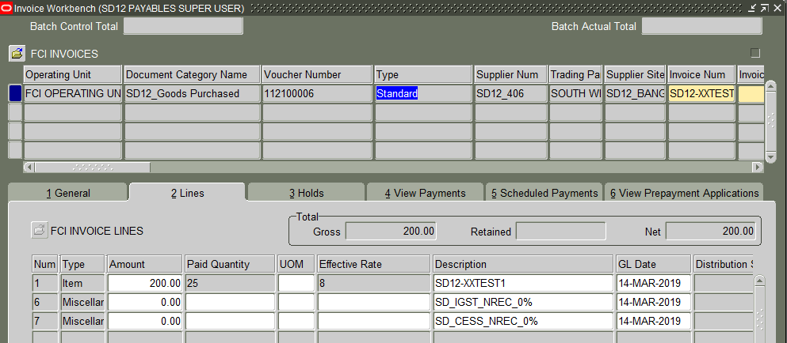
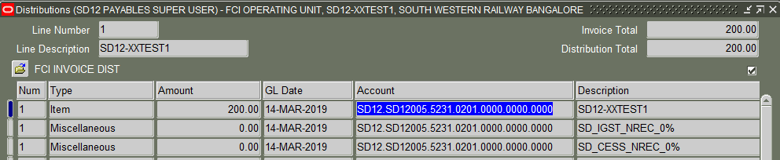
Below is the Sample output of “FCI Stock Ledger Summary Report” after changes:

73 Deployments- APR 2019

73.1 CR-43 (MID: 88118), Exclusion of Inactive Bank Account of WB15 District Office Adipur viz. WB15_10316662384 from PFMS reporting.
The CR is related to exclusion of inactive bank account ID from “FCI PFMS Data Upload” Report if there are two bank accounts with same name.
Solution Approach:
In such case a lookup is maintained where data of Bank Account not to be picked/reported for PFMS is kept, the report fetches the data of required bank and will exclude the bank accounts maintained in this lookup.
The below mentioned Inactive bank account ID is added in the FCI_PFMS_EXCLUDE_BANK_ACCOUNTS lookup with effective date.
Ref: MID-81976 => Inactive Bank Account ID 10386 of Bank Account Name = "WB15_10316662384" is added in this lookup.

The fields in system will be populated as following:

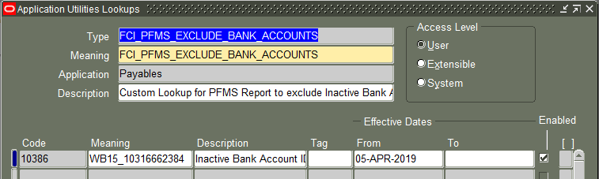

Below is the Sample output of “FCI PFMS Data Upload”” after changes:

73.2 (MID- 86258), Exclusion of Old 11i Paid Invoices from Trial Balance reporting.

Old 11i Fully Paid invoices are appearing in trial Balance Report due to some Account events are missing, We are not able to fix those old invoices. A lookup is to be maintained where data of Fully old Paid Invoices not to be picked/reported for TB is kept, the report fetches the data of required Invoices and will exclude the Fully Old Paid Invoices maintained in this lookup.
The below mentioned Old Paid Invoice is added in the FCI_EXCLUDE_INVOICES_FROM_TB lookup with effective date as specified below. The fields in system will be populated as following:
Ref: MID- 86258 => Fully Paid Invoice ID 627945 of Invoice Number = " SB1562 " is added in this lookup.

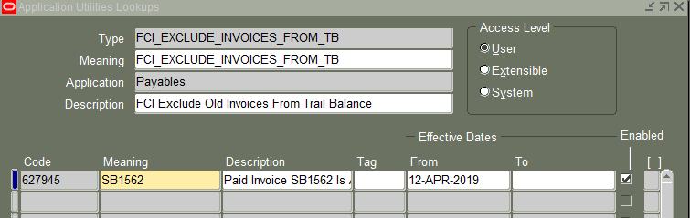

CODE | MEANING | DESCRIPTION | EFFECTIVE START DATE | Enabled
627945 | SB1562 | Paid Invoice SB1562 Is Appear in TB(MID:86258) | 12-APR-2019 | Yes

Code: It is the backend Invoice ID that is Fully Paid.

Meaning: Invoice Number

Description: It will contain the details of Mantis ID of issue reported.

NOTE: This lookup is used in the Trail Balance report to exclude the OLD (11i) Fully Paid Invoices setup in this lookup.

73.3 CR-22 (MID: 88066), Modifications to be made in “FCI Payment Batch Output Report for CMP - Excel” Report.
The CR is related to modifications to be made in “FCI Payment Batch Output Report for CMP - Excel” Report. FCI Hqrs is in a process of making online payments to employees through SBI Cash Management Product (CMP). This payment batch output report in excel format is required to be uploaded on portal with 11 mandatory fields as required by the bank.
In the report “FCI Payment Batch Output Report for CMP - Excel” we have added the below mentioned new columns:

Parent Child Identifier | Customer Code | Customer Name | Debit Account No. | Additional Field 10

Parent Child Identifier: The value for this column is “P” which will be static in nature.

Customer Code: This field contains the EFT code of the Payer and mapped with “Secondary Account Reference” field.

Customer Name: This field contains the name of the Payer and mapped with “Alternate Account Name” field.

Debit Account No.: This field contains the bank account number of the Payer and mapped with “Bank Account Number” field.

Additional Field 10: The value for this column is “yes” which will be static in nature.

Please find below the attached latest output having all the 11 required fields:

73.4 CR-45 (MID: 88328), New Account Code 2827 & Modification in Account Code 5731
The CR is related to definition of some new and existing account heads along with new Scheme codes. Modification in mapping of the existing accounts in CVR is also required. The relevant reports (like Costing Report, Scheme Template etc.) also to be modified as per existing account definitions and modifications.
Requirement:
- Creation of new account head 2827.
- Creation of New Scheme codes 427 and 428.
- Updating CVR for new and modified accounts.
- Update/Verify the other relevant reports for newly created Account Head and Scheme Codes.

Please find the attached templates for this complete CR:

74 Deployments - MAY 2019

74.1 CR-23(MID: 89036), Modification in Nomenclature of account code-4302
As per CR 23 the nomenclature of the following account heads have been changed:
Account head | Old Name | New Name
4302 | Short Realisation on Sugar Operations Transferred to SPEF | Short Realisation on other operations

74.2 CR-14 (MID: 82433), Modifications to be made in CVR for account codes 2121, 2221, 2321, 2122, 2222 & 2322
The CR is related to definition of some existing account heads along with new Scheme codes. Modification in mapping of the existing accounts in CVR is also required. The relevant reports (like Costing Report, Scheme Template, and FCI Asset Category Detail Report etc.) also to be modified as per existing account definitions and modifications.
Requirement:
- Creation of new Scheme Codes 3177, 3178, 3193 & 3194.
- Modifications in grouping of account code 2121, 2221, 2321, 2122, 2222 & 2322.
- Updating CVR for modified accounts and Scheme codes.
- Updating A to S statements.
- Update/Verify the other relevant reports for newly created Account Heads and Product Codes.

Please find the attached templates for this complete CR:
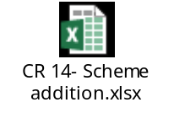

74.3 CR-19 (MID: 86270), Creating New Items, HSN-SAC mapping
- New Inventory Item “9861 (Stone Aggregate)” is created in FAP.
- HSN/SAC Code “2517” mapping done for the newly created Item.
- New Inventory Item created with following details:

Item Code | Item Name | Item Description | Taxable/  Exempted | Sales/ Non Sales | HSN Code
9861 | Stone Aggregate | Stone Aggregate | Taxable | Non Sales | 2517

75 Deployments - JUN 2019

75.1 CR-32(MID: 89035), Bank Name to be added in The Valid List

The below mentioned banks are added in the valid bank list lookup with effective date as specified below. The fields in system will be populated as following:

CODE | MEANING | DESCRIPTION | EFFECTIVE START DATE
TRIPURA GRAMIN BANK | TRIPURA GRAMIN BANK | TRIPURA GRAMIN BANK | 01-APR-2019
TRIPURA STATE CO-OPERATIVE | TRIPURA STATE CO-OPERATIVE BANK LTD. | TRIPURA STATE CO-OPERATIVE BANK LTD. | 01-APR-2019
UJJIVAN SMALL FINANCE BANK | UJJIVAN SMALL FINANCE BANK LTD. | UJJIVAN SMALL FINANCE BANK LTD. | 01-APR-2019

Following Bank is already existing in Lookup but business needs to update the Meaning and Description in Valid Lookup as Below.
CODE | OLD MEANING | OLD DESCRIPTION | NEW MEANING | NEW DESCRIPTION
THANE BHARAT S BANK | THANE BHARAT S BANK | THANE BHARAT S BANK | THANE BHARAT SAHAKARI BANK LTD. | THANE BHARAT SAHAKARI BANK LTD.

75.2 CR-66(MID: 0089814), Generation of Bill of supply in respect of Non GST transactions
Report Query is modified so that System generate bill of supply/AR Tax Invoice for GST Transaction only.

75.3 CR-61(MID: 89583), Inclusion of segment code for PFMS crop year (2019-20 RMS and 2019-20 KMS)
- Mapping for following crop year was done in PFMS segment 3 master
FAP Crop Year | PFMS Segment3 Code
2019-20 RMS | 4
2019-20 KMS | 5

- For the data that had been reported for above crop year with null PFMS component code, we refreshed the data in following manner:
- We generated the PFMS component code for all the reported lines in accordance to their respective crop year (2019-20 KMS/RMS).
- We marked all of these lines as unreported so that when user runs ‘FCI PFMS data upload’ report these will reflect in the same.

76 Deployments - JUL 2019

76.1 CR-62 (MID: 89645), AR INTERCO-Responsibility creation for unit ED14 and ED15
The following responsibilities were added in the system with effective start date ’01-APR-2018’
ED14 RECEIVABLES INTERCO USER
ED15 RECEIVABLES INTERCO USER

We added the responsibilities in the system for resolution of MID: 89269

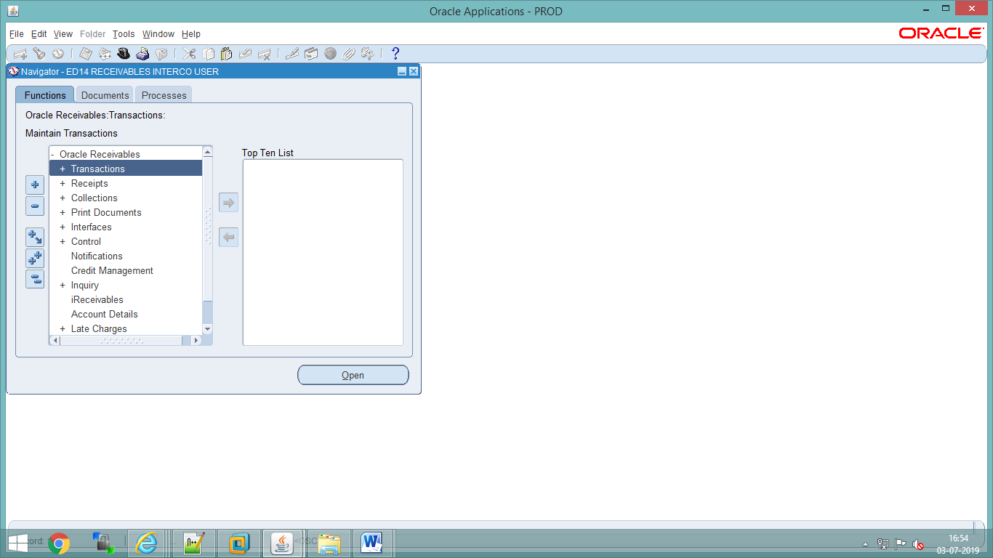

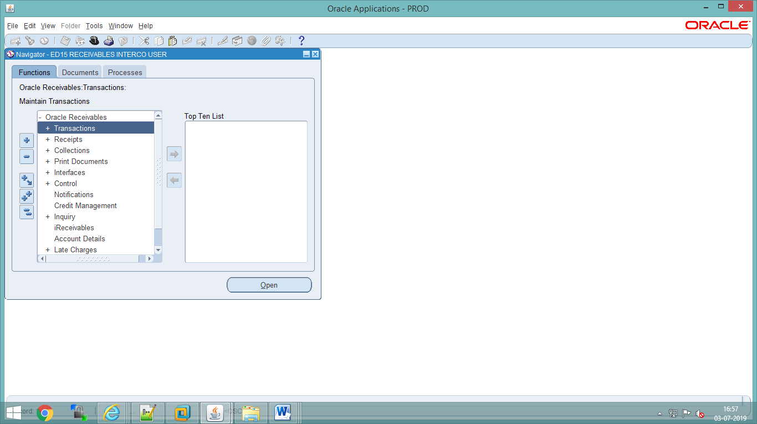

76.2 CR-71 (MID: 90443), Removal of additional items from LOV of transaction type (input parameter) of Report FCI GST AR Tax invoice/Bill of supply.
Value Set of LOV ( i.e FCI_GST_AR_TRANSACTION_TYPES) modified , LOV only show “Sales and Non Sales” items for all Receivables responsibility and for the FCI SUPPORT USER Responsibility LOV is same as before.

76.3 CR-29 (MID: 90240), Creation of new HSN Code
- New Inventory Item was created with following details-
Item Code | Item Name | Item Description | Taxable/  Exempted | Sales/ Non Sales | HSN Code
9860 | Scrap of Asbestos Cement Sheet | Scrap of Asbestos Cement Sheet | Taxable | Non Sales | 6811

76.4 CR-40(MID: 89303), Creation for new account head, Creation of new scheme codes & Change in CVR of existing A/C head.

- Creation of new account heads.
- Creation of New Scheme codes.
- Creating grouping of account code 5233.
- Updating CVR for new and modified accounts.
- Updating A to S statements.
- Update/Verify the other relevant reports for newly created Account Heads and Product Codes.
- PFMS mapping w.r.t. A/C head 5233.
- Need to disable all code combinations of account head 1308 with default scheme to follow the disabling process.

1. New account heads will be created in FCI_ACCOUNT value set (Detailed Template is attached in Annexure-1):

Account head | Nomenclature
5233 | Handling Charges- Loading at Mandi

2. New Scheme codes will be created in FCI_SCHEME value set (Detailed Template is attached in Annexure-1):

Scheme Code | Nomenclature
701 | 8.80% NSSF loan I 2016-17
702 | 8.80% NSSF loan II 2016-17
703 | 8.40% NSSF loan III 2017-18
704 | 8.80% NSSF loan IV 2017-18
705 | 8.52% NSSF loan | 2018-19

76.5 CR-68(MID: 90309), Improvement in the logic of Reverse charge register.

- Adding & enhancement of conditions for getting data based on Reverse Charge Category.
- Enhancement of code for extracting reverse charge category based data only from Accounts Payables.

76.6 CR-52(MID: 90228), Change in CVR & PFMS mapping of existing AC heads
- Products 0452, 0455, 0458, 0461, 0464 and 0465 were allowed in the CVR with account heads 5091 and 5403, in addition to the existing allowed products.
- A2S mapping of products 0452, 0455, 0458, 0461, 0464 and 0465 with account heads 5091 and 5403 , in addition to the existing A to S mapping of already allowed products with mentioned account heads was done as per following:
Table 1:-
S.No. | Nomenclature | FAP A/C Head | Product | Cost Group
1. | Opening Balance for Pulses | 5091 | 0451-0465 | B01OP
2. | Freight Container Operation | 5403 | 0452 | C07H1P
3. | Freight Container Operation | 5403 | 0455 | C07H1P
4. | Freight Container Operation | 5403 | 0458 | C07H1P
5. | Freight Container Operation | 5403 | 0461 | C07H1P
6. | Freight Container Operation | 5403 | 0464 | C07H1P
7. | Freight Container Operation | 5403 | 0465 | C07H1P

77 Deployments - AUG 2019

77.1 CR-41(MID: 89304),:-Organization & location field should be made mandatory during filling of "India Tax Details " at ITD Form in AP & AR.
Organization and Location details has been changed as mandatory fields in “India Tax Details" In both AP and AR modules.

77.2 CR-67(MID: 90306) :- Distribution's CCID field should be freezed after completion of the transactions in AR Module.
A new personalization is developed to restrict and freeze the distribution segments block on the form after completion of the AR Transactions.

- There was no restriction available on distribution segments after completion of the AR Transaction for the user, because of which user was able to change the product code or other segments in the distribution accounting which was creating the difference in product line level and distribution level.

77.3 CR-25(MID: 87216), Creation of new functionality for bulk supplier creation
The Creation of supplier in oracle application is done manually which is a time taking process and also there are chances of manual errors hence this CR is to create a process by which multiple suppliers can be created into system.

Requirement is to create a process by which bulk loading of suppliers can be done in Oracle applications.
- Supplier detail will be uploaded as per annexure format through FCI XLS UPLOAD form which will be assigned at FCI Support User responsibility.
- Required field for uploading :
- File Type: Can select any name form LOV
- Unit Name: Can select any name form LOV
- File Name: it should be unique (eg: FCI_Supplier_Migration_2256) and file name should always be prefix with “FCI_Supplier_Migration”.
- No of columns: Non Mandatory Column.
- After uploading the excel support user will run the below given Request set.
- Request set will be written in order to validate the data received and import into oracle.
This request set will include three stages which are as follows.

- FCI Supplier Migration Validation Program
- FCI Supplier Bank Account Assign Program
- FCI Supplier Migration Output Report

Template Related Validation:

S.No. | Name of fields of Input Template | Validation if any
1 | SNO | Mandatory field in data template.
2 | Vendor Name | Mandatory field in data template and it should be unique.
3 | Oracle vendor number | Oracle vendor number should be unique and mandatory field in data template else it will be error out with duplicate record. It should be non existing record in oracle. First four letter of Vendor Number should be Unit Code.
4 | Vendor Site Code | Vendor site code should be unique and mandatory in data template else it will be error out with duplicate record. It should be non existing record in oracle. There is a validation in code where first four character of oracle vendor number and first four character of oracle vendor site should be match. Vendor site code length should not exceed more than 15 characters.
5 | Vendor Type | Vendor type should be mandatory in data template else it will be error out. It should be existing record in oracle, Also it should not be FCI Retired employee, Employee, Retired employee.
6 | Address Line 1 | Mandatory field in data template.
7 | City | Mandatory field in data template.
8 | State | State should be mandatory and it will accept short code only.
9 | Country | Mandatory field in data template.
10 | Name of Bank | Mandatory field in data template.
11 | Bank Branch Name | Mandatory field in data template.
12 | Bank Account Number | Account number should be unique and mandatory in data template else it will be error out with duplicate record. It should be non existing record in oracle.
13 | Account Name | Mandatory field in data template.
14 | IFSC Code | IFSC code will be unique and mandatory for branch if not then it will restrict to create the vendor.
15 | MICR Code | MICR code will be unique for branch if not then it will restrict to create the vendor.
16 | Payment Method | Payment method should be previously defined in system.
17 | Liability Account | Liability Account should ne previously defined in system.
18 | Prepayment Account | Prepayment Account should ne previously defined in system.
19 | PFMS_Payee_Type | Can only be A/V
20 | PFMS_Vendor_Type | System will always take this '2' irrespective of user input.
21 | PFMS_Code | Can not be null for PFMS Payee Type 'A'
22 | State_LGD_Code | As per PFMS State LGD code master
23 | District_LGD_Code | As per PFMS Dist LGD code master for State LGD code specified by user.

Other Key Validation:

S.NO. | Validation
1 | Template File Name is mandatory and it should be unique.
2 | There is no validation of case sensitive for data template fields.
3 | Multiple unit data can be uploading in single data template file.
4 | Data template should be in Excel 97-2003 workbook format.
5 | All the data template fields are mandatory.

FCI Supplier Migration Validation Program report to load the supplier and supplier site data.
Parameters: File Name
FCI Supplier Migration Output Report to export the error and success records in excels for specific request submitted by user.
Parameters: File Name

77.4 CR-46 (MID: 89306) :- Check should be applied to ensure TAX category, HSN should only be applied where item code is there for transaction in AR module.
We have developed a check through personalization for source: Non Sales Transactions, so that system will allow completing the transaction only in these 2 cases –
1. Users enter the Item Code, Tax Category and HSN Code.
2. Users do not enter Item Code, tax Category and HSN Code.
And in rest of all the cases, system will not allow to complete the transactions and will give error as below screen shot.
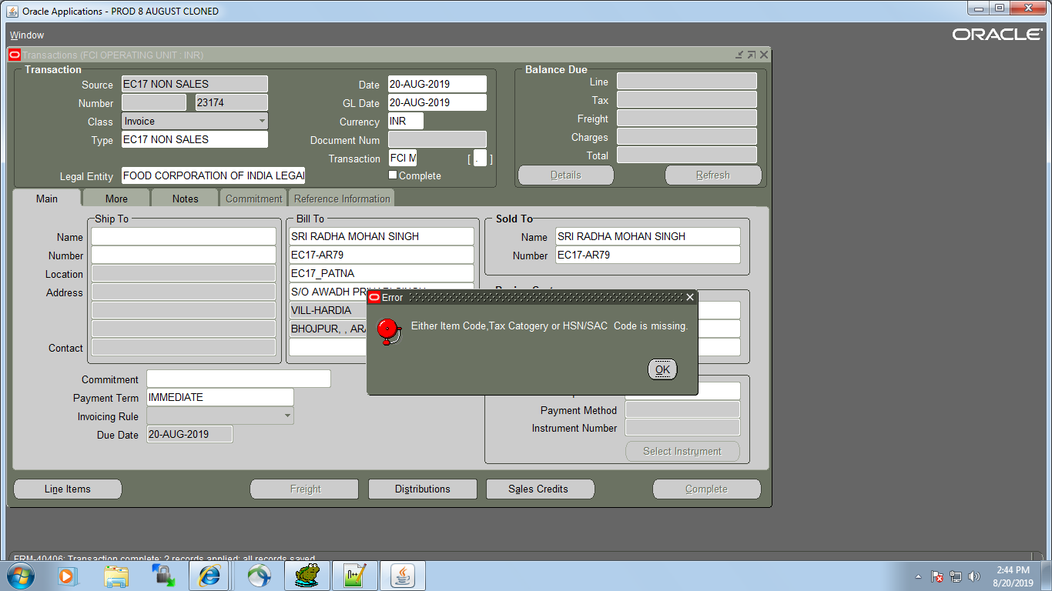

77.5 CR-92(MID: 91618), Adding name in valid bank look up

The below mentioned banks are added in the valid bank list lookup with effective date as specified below. The fields in system will be populated as following:

CODE | MEANING | DESCRIPTION | EFFECTIVE START DATE
THE MEHSANA URBAN CO. OP. BANK | THE MEHSANA URBAN CO. OP. BANK LIMITED | THE MEHSANA URBAN CO. OP. BANK LIMITED | 01-APR-2019
RAJKOT NAGARIK SAHAKARI BANK | RAJKOT NAGARIK SAHAKARI BANK LTD | RAJKOT NAGARIK SAHAKARI BANK LTD | 01-APR-2019

77.6 CR-53(MID: 90230), Change in the name of Regional Offices, SB11 & SF11
The below mentioned Regional Offices names and addresses modified in all modules of APPS & Payroll in FAP.

Type | Value | Regional Office (Existing) | Regional Office (Revised) | Payroll code  (Existing) | Payroll code  (Revised)
Regional Office | SB11 | R.O Hyderabad | R.O. AMRAVATI | R.O Hyderabad | R.O. AMRAVATI
Regional Office | SF11 | R.O Telangana | R.O. HYDERABAD | R.O Telangana | R.O. HYDERABAD

- Updated Address details –
For SB11 - Amaravati Rajanarendra Building, D.No.74-14-2A, Krishna Nagar, Patamata, enamalakuduru Road, Vijayawada-520007.

For SF11 - 3rd floor, HACA Bhavan, Public Gardens road, opposite Telangana State Assembly, Nampally, Hyderabad, Telangana – 500004

77.7 CR-17(MID:89301)Restriction in payable responsibility w.r.t to supplier & bank & creation new report "FCI SUPPLIER BANK DETAIL UPDATION REPORT”
- The report display data of only those suppliers whose bank accounts/priority/end date details have been updated/ changed.
- The report produce output as per hierarchy.
- The report captures events if any supplier bank account information is modified.
- The report captures events if priority or end date of supplier bank account is modified.
- The report run on the basis of UNIT, date range provided.
- Supplier form is removed from “Payable User responsibility”.

78 Deployments - SEP 2019

78.1 CR-90 (MID: 0091412) Creation of new account codes 3175 & 3176 and corrections in dependent scheme codes for account code 6070
- New Account heads (3175,3176) is to be created for the Arrear of storage charges paid to CWC and SWC.
- CVR is to be updated as per new accounts as shown in Annexure-1.
- ‘A to S’ report is required to be modified, as per Annexure-1.
- Mapping of PFMS value for account head 3175, 3176.
- Updation of CVR for account head 6070, 3175, 3176 as per Annexure-1.

Accounts with following details will be created:-

- Account code 3175
Sr. No. | Attribute | Value | Remarks
 | Account Code | 3175
 | Parent account | 3150
 | Budgeting allowed | Yes
 | Rollup group | No
 | Posting Allowed | Yes
 | Type of Account | Expense
 | FCI Account Type for SLS | Nil
 | UOM allowed | No
 | DESCRIPTION | Arrear of storage charges paid to CWC
 | PARENT | No
 | SERIAL NO. FOR TB REPORT | 105
 | SERIAL NO. FOR GROUPING FOR P&L STATEMENTS REPORT | PD 8
 | To be included in BS report or PNL report | P & L report
 | SERIAL NO. FOR A to S REPORT | F
 | CVR | - Unit-0001 to ZZZZ  - Depot- Default to Default  - Dependent Product- Default to Default  - Dependent Scheme- Default to Default  - Dependent Intercompany- Default to Default
 | Start Date | 01-Apr-2019

 | PFMS Mapping | Segment1 | Segment2 | Segment3 | Segment4 | Segment5 | Segment6
 | PFMS Mapping | 5 | 0 | 0 | 1 | 0 | 0

- Account code 3176
Sr. No. | Attribute | Value | Remarks
 | Account Code | 3176
 | Parent account | 3150
 | Budgeting allowed | Yes
 | Rollup group | No
 | Posting Allowed | Yes
 | Type of Account | Expense
 | FCI Account Type for SLS | Nil
 | UOM allowed | No
 | DESCRIPTION | Arrear of storage charges paid to SWC
 | PARENT | No
 | SERIAL NO. FOR TB REPORT | 105
 | SERIAL NO. FOR GROUPING FOR P&L STATEMENTS REPORT | PD 7.1
 | To be included in BS report or PNL report | P & L report
 | SERIAL NO. FOR A to S REPORT | F
 | CVR | - Unit-0001 to ZZZZ  - Depot- Default to Default  - Dependent Product- Default to Default  - Dependent Scheme- Default to Default  - Dependent Intercompany- Default to Default
 | Start Date | 01-Apr-2019

 | PFMS Mapping | Segment1 | Segmen2 | Segment3 | Segment4 | Segment5 | Segment6
 | PFMS Mapping | 5 | 0 | 0 | 2 | 0 | 0

- A to S report will be modified as per the details mentioned below:
New Account Code | Nomenclature | Grouping A TO S
3175 | Arrear of storage charges paid to CWC | F01BP

New Account Code | Nomenclature | Grouping A TO S
3176 | Arrear of storage charges paid to SWC | F01CP

78.2 CR-93 (MID: 0091778) Modifications to be made in account code 5233

- Addition of dependent product 0301 & 0302 to be done in account code 5233, new CVR to be created and also A to S and other relevant reports needs to be updated or to verify.
- Account Head 5233 grouping with “A02CP” for both product codes of 0301 & 0302.
- PFMS mapping w.r.t. A/C head 5233 needs to be done for new CVR w.r.t 0301 & 0302 product codes.
- Also cater P&L annexure mapping for relevant product codes of mentioned A/C head.

1. Existing product codes related CVR to be modified for A/c head 5233 (Detailed Template is attached in Annexure-1):
Product Code | Nomenclature (Existing)
0301 | Paddy - Grade A
0302 | Paddy – Common

2. PFMS mapping w.r.t. A/C head 5233 for newly added product codes in CVR.
Account head | Product Code | PFMS
 |  | Segment One | Segment Two | Segment Three | Segment Four | Segment Five | Segment Six
5233 | 0301 | 2 | 10 | 1 | 8 | 0 | 0
5233 | 0302 | 2 | 9 | 1 | 8 | 0 | 0

S.No. | Nomenclature | FAP A/C Head | Product Code | Cost Group (New)
1 | Handling Charges- Loading at Mandi. | 5233 | 0301, 0302 | A02CP

Account Head | Product Code | S.No. for Grouping
5233 | 0301,0302 | PD39.2

78.3 CR-95(MID: 0092016) Moving of the GST reports to General Ledger user responsibility.

We need to add these reports with Existing GL Request Group under General Ledger user responsibilities. So that Divisional office users can run the below reports under General Ledger user responsibilities.
  - 1) FCI GSTR1 Business To Business
  - 2) FCI GSTR1 Credit/Debit Note
  - 3) FCI GSTR2 B2B RCM
  - 4) FCI GSTR2 Credit Debit Note
  - 5) FCI GSTR2 Voucher

78.4 CR-99(MID: 0092317) Modification in logic for the quantity to be shown under PU (Purchases) in FCI Stock Detail Report.
- ‘FCI Stock Detail Report’ FCI Stock detail report" is not generating data properly or sometimes coming blank for some of the parameters due to the logic defined earlier which was picking the quantity from header level DFF of AP invoice but after upgrading to R12 it was required at line level DFF and report logic was not changed.
- For Instance, when the report is run for PU-Purchases for some of the units, it either generates report with 0 (zero) quantity or is coming blank.
- So this CR is to change report logic for the quantity to be shown under PU (Purchases) in ‘FCI Stock Detail Report’.

78.5 CR-73(MID:0090445) GST details reflected in the "PRINT INVOICE NOTICE REPORT" and report generate output only for validated invoices.
- Existing “PRINT INVOICE NOTICE ” report is modified so that it generate output only for those invoices having invoice status is validated and GST information is reflect only for such AP invoices on which GST is applied through “INDIA TAX DETAIL” Form and this information is reflected line wise.

79 Deployments - OCT 2019

79.1 CR-84(MID: 91063) Creation of new report supplier payment history report-Excel and addition of new field at AP invoice header
Following changes were made in the FAP system:
- Changes to invoice header level on AP invoice workbench:
- Existing field ‘Date Invoice received’ was renamed as ‘Date of Invoice Receipt in Bill Section’
- Oracle seeded field ‘Date Goods Received’ was made visible and renamed to ‘Date of Invoice receipt in FCI’
- Existing form personalization to make ‘Date Invoice received’ mandatory was replaced with a new form personalization. This personalization will throw an error and restrict the user if the user tries creating a manual invoice with ‘Date of Invoice Receipt in Bill Section’ or ‘Date of Invoice receipt in FCI’ as null. The check will be effective for new manual invoices only.
- Both the fields once entered will be frozen after invoice status becomes validated/needs revalidation/cancelled.
- The custom trigger at AP invoice interface was removed as these two columns are not to be populated for auto created invoices.
- A new report ‘FCI Supplier Payment History Report-Excel’ as per format specified in annexure1 was created in FAP. The report will generate output in excel format and will run hierarchy wise.
- The report will fetch data for voided and refund type payments also.
- If a payment is made and voided in the same duration for which the report has been run, the report would bring two separate rows for the same payment, once for payment creation and once for payment void. The sign for payment amount would be reverse of the original payment amount in void payment row.
- The invoice amount column would always fetch the original invoice amount, even after invoice cancellation.
- The report would fetch data only for invoices created on or after ‘1-OCT-2019’.
- Auto invoices from Payables, Receivables and Payroll are excluded from the report. The report would bring manual invoices only in the output.
The report was made available to all the payable user responsibilities, FCI Support User responsibility and FCI Audit User Responsibility.
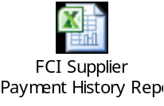

79.2 CR-74(MID: 90540) Modification in the logic of FCI Asset addition report & FCI Asset Register report
- FCI Asset addition report:-
When we run FCI Asset addition Report, it displays the cost based on location assigned to Asset. If user takes same location for every unit of asset on assignment form with employee details, then “FCI Asset addition report” displays cost only for one unit. So this CR is to change the logic of report so that asset, having different unit assignments on same location should be reflected in the report.
- FCI Asset register report:-
- Details of the Employee, to whom assets have been assigned, are required in the existing “FCI Asset register report.
- FCI Asset register report not displaying the correct event wise cost under the closing balance after Cost adjustment and each and every time adjusted cost has been added as addition despite of its nature i.e. negative or positive adjustment. So, this CR is to change the logic of the report in order to display the correct event wise cost under closing balance by reflecting the exact nature of cost adjustment.

- FCI Asset addition Report logic will be changed so that asset, having different unit assignments on same location will be reflected in the report.

- i) In the report “FCI Asset register report” we will add the below mentioned new columns:-

Employee Code | Employee Name

Employee Code: This field contains the employee number, to which the unit has been
assigned.

Employee Name: This field contains the employee name, to which the unit has been
assigned.

ii) FCI Asset register report logic will be changed in order to display the correct event wise cost under the closing balance by reflecting the exact nature of cost adjustment i.e. positive or negative.

79.2 CR-102(MID: 92526), Adding name in valid bank look up

The below mentioned banks are added in the valid bank list lookup with effective date as specified below. The fields in system will be populated as following:

CODE | MEANING | DESCRIPTION | EFFECTIVE START DATE
THE JAIPUR CENTRAL CO_OP | THE JAIPUR CENTRAL CO-OPERATIVE BANK LTD | THE JAIPUR CENTRAL CO-OPERATIVE BANK LTD | 01-APR-2019

79.3 CR-100 (MID: 92459), Creation of new HSN Codes
- New Inventory Item was created with following details-
S No | Item Name | Description | HSN/SAC Code | Item Code | Taxable/  Exempted | Sales/ Non Sales
1 | E-Waste of Centralised data processing: Mainframes, Minicomputers | E-Waste of Centralised data processing: Mainframes, Minicomputers | 8471 | 9859 | Taxable | Non  Sales
2 | E-Waste of Personal Computing: Personal Computers(Central Processing Unit with input and output devices) | E-Waste of Personal Computing: Personal Computers(Central Processing Unit with input and output devices) | 8471 | 9858 | Taxable | Non Sales
3 | E-Waste of Personal Computing: Laptop Computers(Central Processing Unit with input and output devices) | E-Waste of Personal Computing: Laptop Computers(Central Processing Unit with input and output devices) | 8471 | 9857 | Taxable | Non Sales
4 | E-Waste of Personal Computing: Notebook Computers | E-Waste of Personal Computing: Notebook Computers | 8471 | 9856 | Taxable | Non Sales
5 | E-Waste of Personal Computing: Notepad Computers | E-Waste of Personal Computing: Notepad Computers | 8471 | 9855 | Taxable | Non Sales
6 | E-Waste of Printers including cartridges | E-Waste of Printers including cartridges | 8443 | 9854 | Taxable | Non Sales
7 | E-Waste of Copying equipment | E-Waste of Copying equipment | 8443 | 9853 | Taxable | Non Sales
8 | E-Waste of Electrical and electronic typewriters | E-Waste of Electrical and electronic typewriters | 8472 | 9852 | Taxable | Non Sales
9 | E-Waste of Facsimile | E-Waste of Facsimile | 8443 | 9851 | Taxable | Non Sales
10 | E-Waste of Telephones | E-Waste of Telephones | 8517 | 9850 | Taxable | Non Sales
11 | E-Waste of Pay telephones | E-Waste of Pay telephones | 8517 | 9849 | Taxable | Non Sales
12 | E-Waste of Cordless telephones | E-Waste of Cordless telephones | 8517 | 9848 | Taxable | Non Sales
13 | E-Waste of Cellular telephones | E-Waste of Cellular telephones | 8517 | 9847 | Taxable | Non Sales
14 | E-Waste of Answering systems | E-Waste of Answering systems | 8519 | 9846 | Taxable | Non Sales
15 | E-Waste of Television sets (including sets based on (Liquid Crystal Display and Light Emitting Diode technology) | E-Waste of Television sets (including sets based on (Liquid Crystal Display and Light Emitting Diode technology) | 8528 | 9845 | Taxable | Non Sales
16 | E-Waste of Refrigerator | E-Waste of Refrigerator | 8418 | 9844 | Taxable | Non Sales
17 | E-Waste of Washing Machine | E-Waste of Washing Machine | 8450 | 9843 | Taxable | Non Sales
18 | E-Waste of Air-conditioners excluding centralised air conditioning plants | E-Waste of Air-conditioners excluding centralised air conditioning plants | 8415 | 9842 | Taxable | Non Sales
19 | E-Waste of Fluorescent and other Mercury containing lamps | E-Waste of Fluorescent and other Mercury containing lamps | 8539 | 9841 | Taxable | Non Sales

79.4 CR-103 (MID:92594) Rounding off line should be grey out in AR Transactions.

- We have developed logic in AR either sales or non sales transactions through form personalization. if the rounding off line generated by system, it should be greyed out so that users can’t able to update that line before/after completion of AR transaction.

- The below rounding columns will be greyed out ,if the rounding line generated by system.
Serial Num | Item | Description | UOM | Quantity | Unit Price | Amount

79.5 CR-69 (MID:91336) Creation of new scheme code 3482 & new minor category 482 and modifications in nomenclature of scheme code 3481.
- Addition of new scheme code 3482 "Capital Work in Progress-Construction of Storage Godowns" in account code 2193 & creation of new minor category 482 in asset module.
- Modifications in nomenclature of scheme code 3481 and minor category 481 in assets from "capital work in progress" to "capital work in progress others".
- Modifications in nomenclature and dependent units of accounts codes-
a) 3723 - from "Fee, commission paid to Arranger/Trustee/Registrar/CR Agency" to "Fee, Commission & other expenses for bond issue".
b) 1901- from "Interest Payable" to "Interest Payable - on Government Loans".
- Updation of CVR for account head 1901, 3723, 2193 as per Annexure-1.
- Updation of other relevant reports.

1. Existing scheme code related CVR to be modified for A/c head 2193 (Detailed Template is attached in Annexure-1):
Account Head | Start Date | Dependent Scheme
Account Head | Start Date | From | To
2193 Existing |  | 3481 | 3481
2193 Revised | 01.04.2019 | 3481 | 3482
2. Existing scheme code related CVR to be modified for A/c head 3723 (Detailed Template is attached in Annexure-1):
Account Head | Nomenclature | Start Date | Dependent Unit
Account Head | Nomenclature | Start Date | From | To
3723 Existing | Fee/Commission paid to Arranger/Trustee/Registrar/CR Agency |  | HHHH | HHHH
3723 Existing | Fee/Commission paid to Arranger/Trustee/Registrar/CR Agency |  | HA11 | HA11
3723 Revised | Fee, Commission & other expenses for bond issue | 01.04.2019 | HA11 | HA11
3. Existing scheme code related CVR to be modified for A/c head 1901 (Detailed Template is attached in Annexure-1):

Account Head | Nomenclature | Start Date | Dependent Unit
Account Head | Nomenclature | Start Date | From | To
1901 Existing | Interest Payable |  | EA11 | EA11
1901 Existing | Interest Payable |  | FA11 | FA11
1901 Existing | Interest Payable |  | NA11 | NA11
1901 Existing | Interest Payable |  | HA11 | HA11
1901 Existing | Interest Payable |  | WA11 | WA11
1901 Existing | Interest Payable |  | SA11 | SA11
1901 Revised | Interest Payable- on Government Loans | 01.04.2019 | HA11 | HA11

Scheme Template
Scheme | Description | Parent(Y/N) | Parent Scheme | Enabled | Rollup Group | Posting Allowed | Budgeting Allowed | Start date
3481 existing | Capital Work in progress | NO |  | Yes | No | Yes | Yes
3481- Revised | Capital Work in Progress- Others | NO |  | Yes | No | Yes | Yes | 01-04-2019
3482 | Capital Work in Progress -Construction of Storage Godowns | NO |  | Yes | No | Yes | Yes | 01-04-2019

Existing Account | Cost Account | Minor Category | Description | IT Block Name | IT Depreciation Rate | Depreciation Method | Depreciation Rate
 | 2193 | 482 | Capital Work in Progress- Construction of Storage Godowns | CIP | 0 | WDV -0% | 0

80 Deployments - NOV 2019

80.1 CR 91 (MID: 91411) Development of New report ‘FCI Comparative Analysis Report’
- A new report ‘FCI Comparative Analysis’ was developed as per the output format specified in annexure 1.
- The report runs on hierarchy basis and fetches the closing balances for same period of two corresponding financial years.
- The report will brings data in the form of row wise combination of FCI account, FCI product and FCI scheme values.
- If for a particular combination of account, product and scheme no balances exist for current or previous financial year, then the balance reflects as zero.
- The report is available with following responsibilities:
General Ledger User Responsibilities
FCI Support User
FCI Audit User
Input Parameter | Description | Mandatory
Unit | Hierarchy basis | Yes
Account Type | Expense/Revenue/Asset/Liability/etc. or Skip for All | No
Period Name | Period name | Yes
Balance Type | YTD or PTD | Yes
Account From | From accounting code combination except Unit segment | Yes
Account To | To accounting code combination except Unit segment | Yes
Annexure1 : 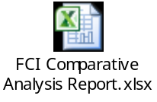

80.2 CR: 105 Modification in dependent scheme for account head (6121 to 6135) to be allowed scheme 211 to 2226

- Updation of CVR for accounts (6121 to 6135) as per Annexure- A.
- Updation in A to S report for accounts (6121 to 6135).
- Updation of Account head to be linked with scheme codes and grouping.
- Updation of other relevant reports
- Existing scheme code related CVR to be modified for A/c heads 6121 to 6135 (Detailed Template is attached in Annexure-1):

Account Head | Start Date | Dependent Scheme
Account Head | Start Date | From | To
6121(Existing) |  | 2141 | 2141
6121(Existing) |  | 2111 | 2111
6121(Existing) |  | 2151 | 2151
6121 (Revised) | 01-Apr-2019 | 2111 | 2226
6122(Existing) |  | 2141 | 2141
 |  | 2111 | 2111
 |  | 2151 | 2151
6122 (Revised) | 01-Apr-2019 | 2111 | 2226
6123(Existing) |  | 2141 | 2141
 |  | 2111 | 2111
 |  | 2151 | 2151
6123 (Revised) | 01-Apr-2019 | 2111 | 2226
6124(Existing) |  | 2141 | 2141
 |  | 2111 | 2111
 |  | 2151 | 2151
6124 (Revised) | 01-Apr-2019 | 2111 | 2226
6125(Existing) |  | 2141 | 2141
 |  | 2111 | 2111
 |  | 2151 | 2151
6125 (Revised) | 01-Apr-2019 | 2111 | 2226
6126(Existing) |  | 2141 | 2141
 |  | 2111 | 2111
 |  | 2151 | 2151
6126 (Revised) | 01-Apr-2019 | 2111 | 2226
6127(Existing) |  | 2141 | 2141
 |  | 2111 | 2111
 |  | 2151 | 2151
6127(Revised) | 01-Apr-2019 | 2111 | 2226
6128(Existing) |  | 2141 | 2141
 |  | 2111 | 2111
 |  | 2151 | 2151
6128(Revised) | 01-Apr-2019 | 2111 | 2226
6129(Existing) |  | 2141 | 2141
 |  | 2111 | 2111
 |  | 2151 | 2151
6129(Revised) | 01-Apr-2019 | 2111 | 2226
6130(Existing) |  | 2141 | 2141
 |  | 2111 | 2111
 |  | 2151 | 2151
6130(Revised) | 01-Apr-2019 | 2111 | 2226
6131(Existing) |  | 2141 | 2141
 |  | 2111 | 2111
 |  | 2151 | 2151
6131(Revised) | 01-Apr-2019 | 2111 | 2226
6132(Existing) |  | 2141 | 2141
 |  | 2111 | 2111
 |  | 2151 | 2151
6132(Revised) | 01-Apr-2019 | 2111 | 2226
6133(Existing) |  | 2141 | 2141
 |  | 2111 | 2111
 |  | 2151 | 2151
6133(Revised) | 01-Apr-2019 | 2111 | 2226
6134(Existing) |  | 2141 | 2141
 |  | 2111 | 2111
 |  | 2151 | 2151
6134(Revised) | 01-Apr-2019 | 2111 | 2226
6135(Existing) |  | 2111 | 2156
6135(Revised) | 01-Apr-2019 | 2111 | 2226

- Account head to be linked with scheme codes and grouping (Detailed Template is attached in Annexure-1):
Account Head | Scheme Code | Grouping
6121, 6122, 6123, 6124, 6125, 6126, 6127, 6128, 6129, 6130, 6131, 6132, 6133, 6134, 6135 | 2176 | PD67.4
6121, 6122, 6123, 6124, 6125, 6126, 6127, 6128, 6129, 6130, 6131, 6132, 6133, 6134, 6135 | 2216 | PD67.4
6121, 6122, 6123, 6124, 6125, 6126, 6127, 6128, 6129, 6130, 6131, 6132, 6133, 6134, 6135 | 2186 | PD67.6
6121, 6122, 6123, 6124, 6125, 6126, 6127, 6128, 6129, 6130, 6131, 6132, 6133, 6134, 6135 | 2226 | PD67.6

- The A-N grouping for account heads linked with schemes are as follows (Detailed Template is attached in Annexure-1):

Account Head | Scheme to be Linked | A-N Grouping
6121 | 2176 | E07JP
6122 | 2176 | E07JP
6123 | 2176 | E07JP
6124 | 2176 | E07JP
6125 | 2176 | E07JP
6126 | 2176 | E07JP
6127 | 2176 | E07JP
6128 | 2176 | E07JP
6129 | 2176 | E07JP
6130 | 2176 | E07JP
6131 | 2176 | E07JP
6132 | 2176 | E07JP
6133 | 2176 | E07JP
6134 | 2176 | E07JP
6135 | 2176 | E07HP
6121 | 2216 | E07JP
6122 | 2216 | E07JP
6123 | 2216 | E07JP
6124 | 2216 | E07JP
6125 | 2216 | E07JP
6126 | 2216 | E07JP
6127 | 2216 | E07JP
6128 | 2216 | E07JP
6129 | 2216 | E07JP
6130 | 2216 | E07JP
6131 | 2216 | E07JP
6132 | 2216 | E07JP
6133 | 2216 | E07JP
6134 | 2216 | E07JP
6135 | 2216 | E07HP
6121 | 2186 | E05JP
6122 | 2186 | E05JP
6123 | 2186 | E05JP
6124 | 2186 | E05JP
6125 | 2186 | E05JP
6126 | 2186 | E05JP
6127 | 2186 | E05JP
6128 | 2186 | E05JP
6129 | 2186 | E05JP
6130 | 2186 | E05JP
6131 | 2186 | E05JP
6132 | 2186 | E05JP
6133 | 2186 | E05JP
6134 | 2186 | E05JP
6135 | 2186 | E05HP
6121 | 2226 | E05JP
6122 | 2226 | E05JP
6123 | 2226 | E05JP
6124 | 2226 | E05JP
6125 | 2226 | E05JP
6126 | 2226 | E05JP
6127 | 2226 | E05JP
6128 | 2226 | E05JP
6129 | 2226 | E05JP
6130 | 2226 | E05JP
6131 | 2226 | E05JP
6132 | 2226 | E05JP
6133 | 2226 | E05JP
6134 | 2226 | E05JP
6135 | 2226 | E05HP

80.3 CR-112 (MID: 0095440) Creation of new account code 1909 and nomenclature change for account head 7132, 7212, 1908

- Creation of new account head 1909 having nomenclature “Trade Payable -For Pulses and Oilseeds-PSS”.
- Nomenclature change for account head 7132 is – “Transfer in from PSS pulses to PSF Pulses and vice versa".
- Nomenclature change for account head 7212 is – “Transfer out from PSS pulses to PSF pulses and vice versa".
- Nomenclature change for account head 1908 is – “Trade Payable - For Pulses and Oilseeds- PSF”
- Updation of CVR as per Annexure-1.

Account head with following details will be created:

Account Head | Nomenclature | A To S Statement | Parent(Y/N) | S.No. for TB. | S.No. for Grouping | Parent Account Head | Start Date
1909 | Trade Payable -For Pulses and Oilseeds-PSS | NA | No | 158 | BL11 | 1900 | 01-OCT-18

Nomenclature change for account heads 7132, 7212, 1908 Template:

Account Head | Nomenclature | A To S Statement | Parent(Y/N) | S.No. for TB. | S.No. for Grouping | Parent Account Head | Start Date
7132  (Existing) | Stock received from NAFED/State Govt. on replacement basis |  | No | 200 | Q | 7110
7132  (Revised) | Transfer in from PSS pulses to PSF Pulses and vice versa |  | No | 200 | Q | 7110 | 01-OCT-19
7212  (Existing) | Stock issued to NAFED/State Govt. on replacement basis |  | No | 209 | Q | 7200
7212  (Revised) | Transfer out from PSS pulses to PSF pulses and vice versa |  | No | 209 | Q | 7200 | 01-OCT-19
1908  (Existing) | TRADE PAYABLE -FOR PULSES AND OILSEEDS |  | No | 158 | BL11 | 1900
1908  (Revised) | Trade Payable - For Pulses and Oilseeds- PSF |  | No | 158 | BL11 | 1900

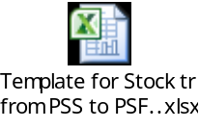

80.4 CR-110 (MID: 0095076): Creation of new account code 4557

- Creation of new account head 4557 having nomenclature “Stock held for disposal”.
- Updation of CVR as per Annexure-1.

Account head 4557 with the following details will be created:

Account Head | Nomenclature | A To S Statement | Parent(Y/N) | S.No. for TB. | S.No. for Grouping | Parent Account Head | Start Date
4557 | Stock held for disposal | NA | No | 145 | BA19 | NA | 01-Apr-19

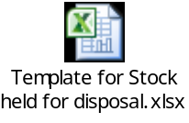

81 Deployments - DEC 2019

81.1 CR-109 (MID: 94884): Modification in CVR, Nomenclature and A to S grouping of existing A/C head 5201

- Modification in CVR of A/C head 5201 i.e. addition of one more scheme 605 under dependent scheme (Template enclosed).
- Modification in the nomenclature of A/C head 5201 from "Mandi Charges" to "Mandi Charges/Market Fee" (Template enclosed).
- Modification in A to S mapping of A/C head 5201 w.r.t. scheme 605 (Grouping provided by Cost division enclosed).
- Updation of CVR as per Annexure-1.
- Updation of other relevant reports.

Nomenclature change for A/C head 5201:

Account Head | Nomenclature | A To S Statement | Parent(Y/N) | S.No. for TB. | S.No. for Grouping | Parent Account Head | Start Date
5201 Existing | Mandi Charges | A | No | 159 | PD39 | 5200
5201 Revised | Mandi Charges/Market fee | A | No | 159 | PD39 | 5200 | 01.04.2018

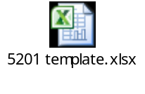

82 Deployments - JAN 2020

82.1 CR-5 (MID: 82757): Disabling of check for addition & retirement of assets

- There is a check applicable in FA module which restricts the user to add the asset in the month of Feb & March only and retire the asset in the month of March only. Now this CR is to enable the addition & retirement of assets from FY 19-20.
- System should show error of “Please execute concurrent program FCI Asset Pre-Depreciation run program” for pending assets in every month while running depreciation.
- The condition of the check will be modified in order to allow addition & retirement of assets from FY 19-20.
Below are the forms of Asset module for which the personalization will be modified.
- Asset workbenchAdditionsBooks
- Mass Additions
- Asset WorkbenchRetirement

- Below are the personalization on forms which will be modified

Seq. | Description
22 | CR420:Asset addition is permitted only in Feb and March
51 | CR420:Asset Period check feb and march
54 | CR420: Retirements can be done in March only

- Changes done in code of Package “FCI_FA_UTILITY_PKG” in a procedure “fci_fa_cat_wdv_sync1” and in a function “fci_fa_cat_wdv_sync” to get the data all month instead to get the data from February and March only.

- Query of Value set “FCI_FA_BOOK_TYPE” is changed to pick the data from “fa_deprun_periods” table.

82.2 CR-117(MID: 97448), Adding name in valid bank look up

The below mentioned banks are added in the valid bank list lookup with effective date as specified below. The fields in system will be populated as following:

CODE | MEANING | DESCRIPTION | EFFECTIVE START DATE
JANA SMALL FINANCE BANK LTD | JANA SMALL FINANCE BANK LTD | JANA SMALL FINANCE BANK LTD | 01-APR-2019

83 Deployments - FEB 2020:

83.1 CR-121 (MID: 98328): Creation of new scheme code 429 & addition of scheme 429 in dependent scheme for account code 5701
- Creation of new scheme code "429 - Sale under NFSA-NPRC Scheme" (scheme template attached).
- Addition in dependent scheme code 429 to acct. code 5701 (account template attached).
- Modification in nomenclature of acct. head 1307 from "Short Term Working Capital Loan from MIN of CAF & PD" to "Short Term Working Capital Loan".
- Addition of FCI Zonal Offices (EA11, FA11, NA11, SA11, WA11) to dependent unit code for account code 1307 (account template attached).
- Updation of CVR.
- Updation of A2S statements.
- Updation of other relevant reports.

Scheme code 429:

Scheme | Description | Parent(Y/N) | Parent Scheme | Enabled | Rollup Group | Posting Allowed | Budgeting Allowed | Start Date
429 | Sale under NFSA-NPRC Scheme | No | 100 | Yes | No | Yes | Yes | 01-Apr-19

Addition of scheme code to acct. code 5701:

Account Head | Nomenclature | A To S Sttmt. | Parent(Y/N) | S.No. for TB. | S.No. for Grouping | Parent Account Head | Budgeting Allowed | Posting Allowed | Rollup Group | Dependent Scheme
 |  |  |  |  |  |  |  |  |  | From | To
5701 Existing | Sales | L | No | 181 | PC26 |  | Yes | Yes | No | 100 | 425
5701 Revised | Sales | L | No | 181 | PC26 |  | Yes | Yes | No | 100 | 425
 |  |  |  |  |  |  |  |  |  | 429 | 429

Addition of FCI Zonal Offices (EA11, FA11, NA11, SA11, WA11) to dependent unit code for account code 1307 (account template attached):
Account Head | Nomenclature | A To S Statement | Parent(Y/N) | S.No. for TB. | S.No. for Grouping | Parent Account Head | Budgeting Allowed | Dependent Unit
1307 Existing | Short Term Working Capital Loan from Min of CAF & PD |  | No | 5 | BL4 | 1300 | Yes | HA11 | HA11
1307 Revised | Short Term Working Capital Loan |  | No | 5 | BL4 | 1300 | Yes | HA11 | HA11
 |  |  |  |  |  |  |  | NA11 | NA11
 |  |  |  |  |  |  |  | EA11 | EA11
 |  |  |  |  |  |  |  | WA11 | WA11
 |  |  |  |  |  |  |  | FA11 | FA11
 |  |  |  |  |  |  |  | SA11 | SA11

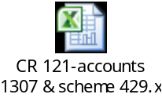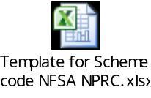

83.2 CR-106 (MID: 94400): Creation of new account code 3799 & new minor categories 505 to 514 and 515, 516, 522, 523

- Creation of scheme codes 3505 to 3516 with account heads 2126, 2226, 2326 and creation of scheme codes 3522, 3523 with account head 2127, 2227, 2327.
- Modification in nomenclature of scheme codes 3177, 3178, 3193, 3194(account template attached).
- Creation of new minor category 505 to 516 and 522, 523 in asset module.
- Creation of new account head 3799 having nomenclature “Expense incurred on purchase of Petroleum product”.
- Updation of CVR as per Annexure-1.
- Updation of other relevant reports.

Account Head | Nomenclature | A To S Statement | Parent(Y/N) | S.No. for TB. | S.No. for Grouping | Parent Account Head | Start Date
3799 | Expense incurred on purchase of Petroleum product | F | No | 121 | PD31 | 3700 | 01-Apr-19

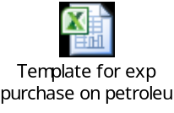

83.3 CR-118 (MID: 97592): Creation of new account codes 2728 & 7195 and modifications in nomenclature & dependent scheme codes for account codes
- Creation of new account codes (account template attached)
(i.) 2728 - Advance payment to CWC.
(ii.) 7195 - Transfer in-gunnies returned.
- Dependent Product and Schemes to be updated for account codes 7191 & 6099 (account template attached).
- S.No. for Grouping to be updated for account code 6099.
- S.No. for T.B. to be updated for account codes 6300, 6301, 6302, 6303, 6304, 6305, 6306, 6307, 6308.
- Nomenclature to be modified for account codes 3991, 3992, 5731, 3104 & 5205 as per template attached.
- Updation of CVR as per Annexure-1.
- Updation of A to S statements.
- Updation of other relevant reports.
- New account codes 2728, 7195 are currently not available in the system.
- S.No. for Grouping for account code 6099 is ‘PD69’.
- Nomenclature for:
- 3991 is “Recoveries for storage shortages from Handling & Transport Contractors”.
- 3992 is “Recoveries for storage shortages from Millers/ Agents”.
- 5731 is “Sales for pulses (Retail distribution through state channels)”.
- 3104 is “Canteen Infrastructure Expenses”.
- 5205 is “Internal Movement”.

Existing dependent scheme code and dependent product code related CVR to be modified for A/c head 6099 & 7191(Detailed Template is attached in Annexure-1):

Account Head | Start Date | Dependent Scheme |  | Dependent Product
Account Head | Start Date | From | To | From | To
6099 Existing |  | 2241 | 2271 | 0000 | 0000
6099 Revised | 01.04.2019 | 2241 | 2271 | 0000 | 0000
6099 Revised | 01.04.2019 | 2301 | 2301
7191 Existing |  | 0000 | 0000 | 1620 | 1627
 |  |  |  | 1101 | 1602
 |  |  |  | 0620 | 0627
 |  |  |  | 0101 | 0602
7191 Revised | 01.04.2019 | 0000 | 0000 | 0101 | 0599
 |  |  |  | 1101 | 1599

New Account head creation Template (Detailed Template is attached in Annexure-1):

Account Head | Nomenclature | A To S Statement | Parent(Y/N) | S.No. for TB. | S.No. for Grouping |  | Parent Account Head | Start Date
2728 | Advance payment to CWC |  | No | 98.2 | BA7.3 | 2710 |  | 01-Apr-19
7195 | Transfer in- gunnies returned |  | No | 204 | Q | 7190 |  | 01-APR-19

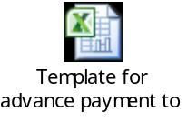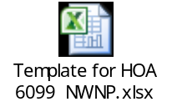

83.4 CR-124 (MID: 99225): Modification in nomenclature of acct. code 4219 and deactivation of acct. code 4220

- Modification in nomenclature of acct. head 4219 from 'Rebate avails from payment to CWC' to 'Rebate for timely payment to Godown owners/other agencies'.
- Acct. code '4220-Rebate avails from payment to SWC' to be deactivated/disabled (account template attached).
- Mapping for account code 4219 to be done in Statement F.
- Updation of CVR.
- Updation of A to S statements.
- Updation of other relevant reports.

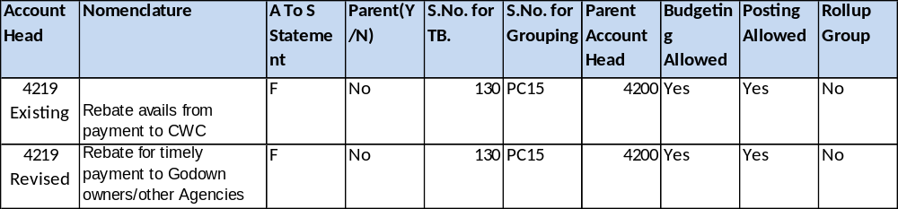

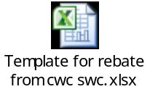

83.5 CR-128 (MID: 100594): Creation of HSN Codes

In reference to UO Note: F-19/GST/2019-20/part-I dated 03.03.2020 provided by FCI Finance Division:
- New Inventory Item has been created in FAP & mapped with HSN Codes as per the below table-
S No | Item Name | Description | HSN/SAC Code | Item Code
1 | Security services | Security services | 9985 | 9840

Following has been done:
- The mentioned Item is Taxable & will be used in Non-Sales Transactions only.

83.5 CR-127 (MID: 0099642): New banks name should be added in the valid bank look up.

The below mentioned banks have been added in the valid bank list lookup in FAP with effective date as specified below.
CODE | MEANING | DESCRIPTION | EFFECTIVE START DATE
ASSAM GRAMIN VIKASH BANK | ASSAM GRAMIN VIKASH BANK | ASSAM GRAMIN VIKASH BANK | 01-APR-2019
THE GAUHATI CO OPERATIVE URBAN BANK LTD. | THE GAUHATI CO OPERATIVE URBAN BANK LTD. | THE GAUHATI CO OPERATIVE URBAN BANK LTD. | 01-APR-2019
SOLAPUR JANATA SAHAKARI BANK LTD. | SOLAPUR JANATA SAHAKARI BANK LTD. | SOLAPUR JANATA SAHAKARI BANK LTD. | 01-APR-2019
HIMACHAL PRADESH STATE CO-OPERATIVE BANK LTD.. | HIMACHAL PRADESH STATE CO-OPERATIVE BANK LTD.. | HIMACHAL PRADESH STATE CO-OPERATIVE BANK LTD.. | 01-APR-2019
THE KURMANCHAL NAGAR SAHKARI BANK LTD. | THE KURMANCHAL NAGAR SAHKARI BANK LTD. | THE KURMANCHAL NAGAR SAHKARI BANK LTD. | 01-APR-2019
PUDUVAI BHARATHIAR GRAMA BANK | PUDUVAI BHARATHIAR GRAMA BANK | PUDUVAI BHARATHIAR GRAMA BANK | 01-APR-2019
NORTH EAST SMALL FINANCE BANK LTD | NORTH EAST SMALL FINANCE BANK LTD | NORTH EAST SMALL FINANCE BANK LTD | 01-APR-2019
UTTAR PRADESH CO-OPERATIVE BANK LTD. | UTTAR PRADESH CO-OPERATIVE BANK LTD. | UTTAR PRADESH CO-OPERATIVE BANK LTD. | 01-APR-2019
NUTAN NAGARIK SAHAKARI BANK LTD. | NUTAN NAGARIK SAHAKARI BANK LTD. | NUTAN NAGARIK SAHAKARI BANK LTD. | 01-APR-2019
NALBARI URBAN CO OP BANK LTD | NALBARI URBAN CO OP BANK LTD | NALBARI URBAN CO OP BANK LTD | 01-APR-2019
J&K GRAMEEN BANK | J&K GRAMEEN BANK | J&K GRAMEEN BANK | 01-APR-2019
TELANGANA STATE CO-OPERATIVE APEX BANK LTD. | TELANGANA STATE CO-OPERATIVE APEX BANK LTD. | TELANGANA STATE CO-OPERATIVE APEX BANK LTD. | 01-APR-2019
THE ANDHRA PRADESH STATE CO-OPERATIVE BANK LTD. | THE ANDHRA PRADESH STATE CO-OPERATIVE BANK LTD. | THE ANDHRA PRADESH STATE CO-OPERATIVE BANK LTD. | 01-APR-2019
THE KARNAL CENTRAL CO OPERATIVE BANK LTD | THE KARNAL CENTRAL CO OPERATIVE BANK LTD | THE KARNAL CENTRAL CO OPERATIVE BANK LTD | 01-APR-2019
BARCLAYS BANK | BARCLAYS BANK | BARCLAYS BANK | 01-APR-2019
ANDHRA PRADESH GRAMEENA VIKAS BANK | ANDHRA PRADESH GRAMEENA VIKAS BANK | ANDHRA PRADESH GRAMEENA VIKAS BANK | 01-APR-2019
THE MANIPUR STATE CO-OPERATIVE BANK LTD | THE MANIPUR STATE CO-OPERATIVE BANK LTD | THE MANIPUR STATE CO-OPERATIVE BANK LTD | 01-APR-2019
UTKARSH SMALL FINANCE BANK | UTKARSH SMALL FINANCE BANK | UTKARSH SMALL FINANCE BANK | 01-APR-2019
PRAGATHI KRISHNA GRAMIN BANK | PRAGATHI KRISHNA GRAMIN BANK | PRAGATHI KRISHNA GRAMIN BANK | 01-APR-2019
EQUITAS SMALL FINANCE BANK LTD. | EQUITAS SMALL FINANCE BANK LTD. | EQUITAS SMALL FINANCE BANK LTD. | 01-APR-2019
BNP PRIBAS | BNP PRIBAS | BNP PRIBAS | 01-APR-2019
FIRST ABU DHABI BANK PJSC | FIRST ABU DHABI BANK PJSC | FIRST ABU DHABI BANK PJSC | 01-APR-2019

83.6 CR-123 (MID: 0098991): New banks name should be added in the valid bank look up.

The below mentioned banks have been added in the valid bank list lookup in FAP with effective date as specified below.

CODE | MEANING | DESCRIPTION | EFFECTIVE START DATE
THE JALGAON PEOPLES | THE JALGAON PEOPLES CO-OP. BANK LTD. | THE JALGAON PEOPLES CO-OP. BANK LTD. | 01-APR-2019
THE RAJASTHAN STATE | THE RAJASTHAN STATE COOPERATIVE BANK LTD. | THE RAJASTHAN STATE COOPERATIVE BANK LTD. | 01-APR-2019
PRIME CO OPERATIVE | PRIME CO OPERATIVE BANK LTD | PRIME CO OPERATIVE BANK LTD | 01-APR-2019
THE KALUPUR COMMERCIAL | THE KALUPUR COMMERCIAL CO-OPERATIVE BANK LTD. | THE KALUPUR COMMERCIAL CO-OPERATIVE BANK LTD. | 01-APR-2019
THE SURAT DISTRICT | THE SURAT DISTRICT CO OPERATIVE BANK LTD. | THE SURAT DISTRICT CO OPERATIVE BANK LTD. | 01-APR-2019
THE GUJARAT STATE | THE GUJARAT STATE CO-OPERATIVE BANK LTD. | THE GUJARAT STATE CO-OPERATIVE BANK LTD. | 01-APR-2019
VYAVSAYIK SAHKARI BANK LTD. | VYAVSAYIK SAHKARI BANK LTD. | VYAVSAYIK SAHKARI BANK LTD. | 01-APR-2019
NAINITAL DISTRICT CO-OPERATIVE BANK LTD. | NAINITAL DISTRICT CO-OPERATIVE BANK LTD. | NAINITAL DISTRICT CO-OPERATIVE BANK LTD. | 01-APR-2019

84 Deployments - APR 2020:

84.1 CR-59 (MID: 90233): Tax Category should be default and non editable for exempted items in ITD form for AR Sales type transactions.
A new personalization is developed to tax category field should be in Non editable for exempted items and system does not allow taking HSN for statuary charges (9999) other than the HSN of exempted item taken in the transaction.

- There was no restriction available on tax category field of the AR sales type transactions for exempted items for the user, because of which user was able to change the tax category and taking HSN for statuary charges (9999) other than the HSN of exempted item taken in the transaction.

84.2 CR-129 (MID: 100616): Creation new report "FCI Bank Account Assignment Detail Report
- Report will display details of supplier with bank and bank accounts for which required bank account number is already available in FAP.
- The report run on the basis of provided bank account number.
- Report access will be provided to FCI Support User, FCI Audit User, FCI Payables super User, FCI Payables User responsibilities.
- Input parameters : Bank Account
- Sample output attached below
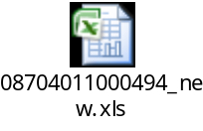

84.3 CR-131 (MID: 101445): Creation of new scheme code 430 & addition of scheme 430 in dependent scheme for account code 5701 and 5731
- New scheme code "430 - Sale under NFSA- TPDS Scheme (Pradhan Mantri Garib Kalyan Anna Yojana)-AAY" (scheme template attached) is added in the application and is being used with acct. heads 5701 and 5731.

Scheme | Description | Parent(Y/N) | Parent Scheme | Enabled | Rollup Group | Posting Allowed | Budgeting Allowed | Start Date
430 | Sale under NFSA- TPDS Scheme (Pradhan Mantri Garib Kalyan Anna Yojana)-AAY | No | 100 | Yes | No | Yes | Yes | 01/3/2020

Account Head | Start Date | Dependent Scheme
Account Head | Start Date | From | To
5701 Existing |  | 100 | 425
5701 Existing |  | 429 | 429
5701 Revised | 01.03.2020 | 100 | 425
5701 Revised | 01.03.2020 | 429 | 429
5701 Revised | 01.03.2020 | 430 | 430
5731 Existing |  | 201 | 201
5731 Existing |  | 205 | 205
5731 Existing |  | 427 | 428
5731 Existing |  | 426 | 426
5731 Revised | 01.03.2020 | 201 | 201
5731 Revised | 01.03.2020 | 205 | 205
5731 Revised | 01.03.2020 | 427 | 428
5731 Revised | 01.03.2020 | 426 | 426
5731 Revised | 01.03.2020 | 430 | 430

Nomenclature | A/C Head | Scheme Code | Product Code | A-S Grouping
Sale under NFSA- TPDS Scheme (Pradhan Mantri Garib Kalyan Anna Yojana)-AAY | 5701 | 430 | 101-103 | L01AP
Sale under NFSA- TPDS Scheme (Pradhan Mantri Garib Kalyan Anna Yojana)-AAY | 5701 | 430 | 1101-1103 | L02AP
Sale under NFSA- TPDS Scheme (Pradhan Mantri Garib Kalyan Anna Yojana)-AAY | 5701 | 430 | 201-205 | L01CP
Sale under NFSA- TPDS Scheme (Pradhan Mantri Garib Kalyan Anna Yojana)-AAY | 5701 | 430 | 1201-1205 | L02CP
Sale under NFSA- TPDS Scheme (Pradhan Mantri Garib Kalyan Anna Yojana)-AAY | 5701 | 430 | 451 | L01JP
Sale under NFSA- TPDS Scheme (Pradhan Mantri Garib Kalyan Anna Yojana)-AAY | 5701 | 430 | 454 | L01JP
Sale under NFSA- TPDS Scheme (Pradhan Mantri Garib Kalyan Anna Yojana)-AAY | 5701 | 430 | 457 | L01JP
Sale under NFSA- TPDS Scheme (Pradhan Mantri Garib Kalyan Anna Yojana)-AAY | 5701 | 430 | 460 | L01JP
Sale under NFSA- TPDS Scheme (Pradhan Mantri Garib Kalyan Anna Yojana)-AAY | 5701 | 430 | 1451 | L02JP
Sale under NFSA- TPDS Scheme (Pradhan Mantri Garib Kalyan Anna Yojana)-AAY | 5701 | 430 | 1454 | L02JP
Sale under NFSA- TPDS Scheme (Pradhan Mantri Garib Kalyan Anna Yojana)-AAY | 5701 | 430 | 1457 | L02JP
Sale under NFSA- TPDS Scheme (Pradhan Mantri Garib Kalyan Anna Yojana)-AAY | 5701 | 430 | 1460 | L02JP
Sale under NFSA- TPDS Scheme (Pradhan Mantri Garib Kalyan Anna Yojana)-AAY | 5701 | 430 | 1463 | L02JP

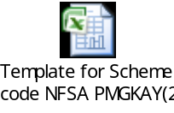

84.4 CR-72 (MID: 90444): Creation of new Receipt Register Report
- The Report will display the output in Excel Format.
- Standard and Miscellaneous Receipts has been displayed in report in “Receipt Type” Column.
- Receipt Reversal logic has been implemented in the Report where if any receipt is reversed its amount will be shown as zero.
- We have added two columns is this report (On account amount and unapplied amount) which are already in standard report name as “Unapplied and Unresolved Receipt Register”.

Below are the Input Parameters –
- Unit Code Low
- Unit Code High
- GL Date From
- GL Date To
- Customer Number
- Customer Name
- Receipt Status
- Receipt Date From
- Receipt Date To
- Document Sequence Number From
- Document Sequence Number To

Below is the report output for your reference:-

- Error! Not a valid link.

85 Deployments - MAY 2020:

CR-134 (MID: 101741): Creation of acct. heads 3116 to 3123
New acct. heads have been added in the application. (account template attached):
- 3116 - Monetary compensation to dependent/legal heir of deceased employees of Category I during duty due to COVID-19
- 3117 - Monetary compensation to dependent/legal heir of deceased employees of Category II during duty due to COVID-19
- 3118 - Monetary compensation to dependent/legal heir of deceased employees of Category III during duty due to COVID-19
- 3119 - Monetary compensation to dependent/legal heir of deceased employees of Category IV during duty due to COVID-19
- 3120 - Monetary compensation to dependent/legal heir of deceased Departmental Labourers during duty due to COVID-19
- 3121 - Monetary compensation to dependent/legal heir of deceased DPS Labourers during duty due to COVID-19
- 3122 - Monetary compensation to dependent/legal heir of deceased NWNP Labourers during duty due to COVID-19
- 3123 - Monetary compensation to dependent/legal heir of deceased Contract Labourers during duty due to COVID-19

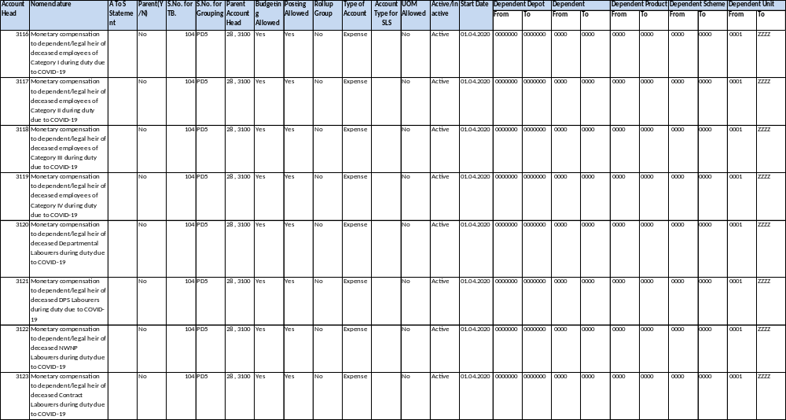
PFMS mapping for acct. heads 3116-3123:
PFMS
Segment One | Segment two | Segment three | Segment Four | Segment Five | Segment six
8 | 0 | 0 | 12 | 0 | 0

Sl. No. for TB | Nomenclature | A/C Head | A-S Grouping
104 | Monetary compensation to dependent/legal heirof deceased employees of Category I during duty due to COVID-19 | 3116 | F03A1P
104 | Monetary compensation to dependent/legal heir of deceased employees of Category II during duty due to COVID-19 | 3117 | F03A1P
104 | Monetary compensation to dependent/legal heir of deceased employees of Category III during duty due to COVID-19 | 3118 | F03A1P
104 | Monetary compensation to dependent/legal heir of deceased employees of Category IV during duty due to COVID-19 | 3119 | F03A1P
104 | Monetary compensation to dependent/legal heir of deceased Departmental Labourers during duty due to COVID-19 | 3120 | D01X1P
104 | Monetary compensation to dependent/legal heir of deceased DPS Labourers during duty due to COVID-19 | 3121 | D04X1P
104 | Monetary compensation to dependent/legal heir of deceased NWNP Labourers during duty due to COVID-19 | 3122 | D05X1P
104 | Monetary compensation to dependent/legal heir of deceased Contract Labourers during duty due to COVID-19 | 3123 | D06X1P

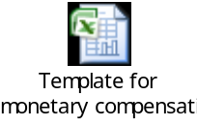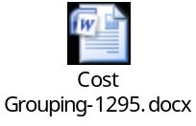

85.2 CR-135 (MID: 102053): Creation of acct. head 4626 and scheme codes 431, 432 and 433
- New acct. head (account template attached): 4626 – ‘Sundry Debtors- MOCAF&PD- Payment to DCP States out of NSSF loan’ is added in the application.
- New scheme codes 431 (‘Sale under non-NFSA beneficiary scheme during COVID-19’) and 432 (‘Sale under NFSA- TPDS Scheme (Pradhan Mantri Garib Kalyan Anna Yojana)-PHH’) and 433 (Sale under Atma Nirbhar Bharat for migrants (COVID-19)) are added in the application
- Scheme 431, 432, 433 are being used in dependent scheme of acct. head 5701 and scheme code 432 and 433 are being used in dependent scheme of acct. head 5731.

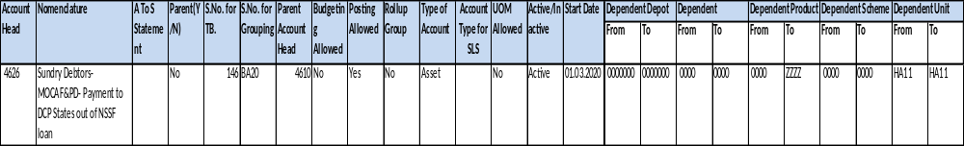
Scheme | Description | Parent(Y/N) | Parent Scheme | Enabled | Rollup Group | Posting Allowed | Budgeting Allowed | Start Date
431 | Sale under non-NFSA beneficiary scheme during COVID-19 | No | 100 | Yes | No | Yes | Yes | 1-Apr-20

Scheme | Description | Parent(Y/N) | Parent Scheme | Enabled | Rollup Group | Posting Allowed | Budgeting Allowed | Start Date
432 | Sale under NFSA- TPDS Scheme (Pradhan Mantri Garib Kalyan Anna Yojana)-PHH | No | 100 | Yes | No | Yes | Yes | 1-Apr-20

Scheme | Description | Parent(Y/N) | Parent Scheme | Enabled | Rollup Group | Posting Allowed | Budgeting Allowed | Start Date
433 | Sale under Atma Nirbhar Bharat for migrants (COVID-19) | No | 100 | Yes | No | Yes | Yes | 1-Apr-20

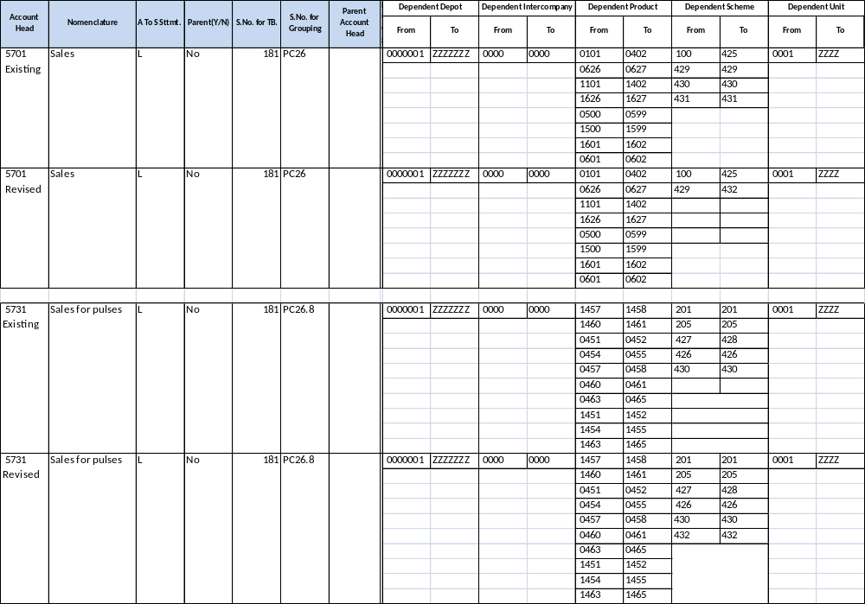
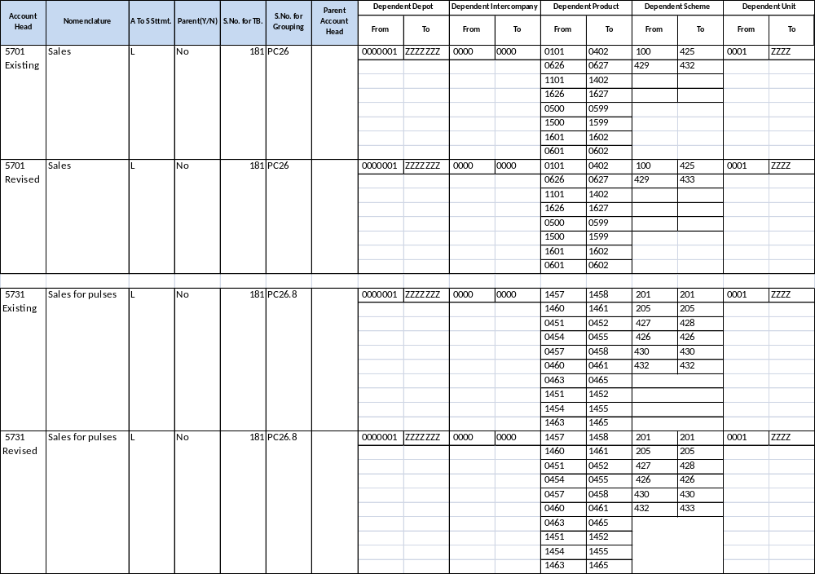
Nomenclature | A/C Head | Scheme Code | Product Code | A-S Grouping
Sale under non-NFSA beneficiary scheme during COVID-19 | 5701 | 431 | 101-103 | L01AP
Sale under non-NFSA beneficiary scheme during COVID-19 | 5701 | 431 | 1101-1103 | L02AP
Sale under non-NFSA beneficiary scheme during COVID-19 | 5701 | 431 | 201-205 | L01CP
Sale under non-NFSA beneficiary scheme during COVID-19 | 5701 | 431 | 1201-1205 | L02CP
Sale under non-NFSA beneficiary scheme during COVID-19 | 5701 | 431 | 451 | L01JP
Sale under non-NFSA beneficiary scheme during COVID-19 | 5701 | 431 | 454 | L01JP
Sale under non-NFSA beneficiary scheme during COVID-19 | 5701 | 431 | 457 | L01JP
Sale under non-NFSA beneficiary scheme during COVID-19 | 5701 | 431 | 460 | L01JP
Sale under non-NFSA beneficiary scheme during COVID-19 | 5701 | 431 | 1451 | L02JP
Sale under non-NFSA beneficiary scheme during COVID-19 | 5701 | 431 | 1454 | L02JP
Sale under non-NFSA beneficiary scheme during COVID-19 | 5701 | 431 | 1457 | L02JP
Sale under non-NFSA beneficiary scheme during COVID-19 | 5701 | 431 | 1460 | L02JP
Sale under non-NFSA beneficiary scheme during COVID-19 | 5701 | 431 | 1463 | L02JP
Sale under NFSA- TPDS Scheme (Pradhan Mantri Garib Kalyan Anna Yojana)-PHH | 5701 | 432 | 101-103 | L01AP
Sale under NFSA- TPDS Scheme (Pradhan Mantri Garib Kalyan Anna Yojana)-PHH | 5701 | 432 | 1101-1103 | L02AP
Sale under NFSA- TPDS Scheme (Pradhan Mantri Garib Kalyan Anna Yojana)-PHH | 5701 | 432 | 201-205 | L01CP
Sale under NFSA- TPDS Scheme (Pradhan Mantri Garib Kalyan Anna Yojana)-PHH | 5701 | 432 | 1201-1205 | L02CP
Sale under NFSA- TPDS Scheme (Pradhan Mantri Garib Kalyan Anna Yojana)-PHH | 5701 | 432 | 451 | L01JP
Sale under NFSA- TPDS Scheme (Pradhan Mantri Garib Kalyan Anna Yojana)-PHH | 5701 | 432 | 454 | L01JP
Sale under NFSA- TPDS Scheme (Pradhan Mantri Garib Kalyan Anna Yojana)-PHH | 5701 | 432 | 457 | L01JP
Sale under NFSA- TPDS Scheme (Pradhan Mantri Garib Kalyan Anna Yojana)-PHH | 5701 | 432 | 460 | L01JP
Sale under NFSA- TPDS Scheme (Pradhan Mantri Garib Kalyan Anna Yojana)-PHH | 5701 | 432 | 1451 | L02JP
Sale under NFSA- TPDS Scheme (Pradhan Mantri Garib Kalyan Anna Yojana)-PHH | 5701 | 432 | 1454 | L02JP
Sale under NFSA- TPDS Scheme (Pradhan Mantri Garib Kalyan Anna Yojana)-PHH | 5701 | 432 | 1457 | L02JP
Sale under NFSA- TPDS Scheme (Pradhan Mantri Garib Kalyan Anna Yojana)-PHH | 5701 | 432 | 1460 | L02JP
Sale under NFSA- TPDS Scheme (Pradhan Mantri Garib Kalyan Anna Yojana)-PHH | 5701 | 432 | 1463 | L02JP

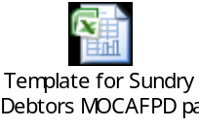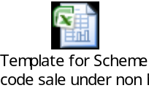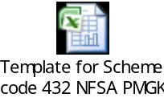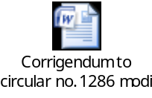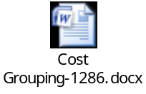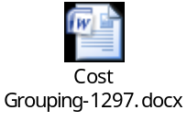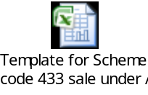

85.3 CR- 139(MID: 102890): Creation of new scheme code 706 & addition of scheme 706 in dependent scheme for account code 1308
- New scheme code “706 - 8.50% NSSF loan VI 2019-20” is added in the application and is being used in dependent scheme code of acct. head 1308.

Scheme | Description | Parent(Y/N) | Parent Scheme | Enabled | Rollup Group | Posting Allowed | Budgeting Allowed | Start Date
706 | 8.50% NSSF loan VI 2019-20 | No | 700 | Yes | No | Yes | Yes | 01.04.2019

Account Head | Start Date | Dependent Scheme
Account Head | Start Date | From | To
1308 Existing |  | 701 | 705
1308 Revised | 01.04.2019 | 701 | 706

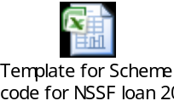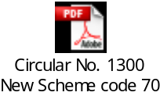

85.4 CR-136(MID: 0102716): Changes in the TDS Rate Regarding
- Tax rates for all the rates defined under TDS regime is reduced by 25%.
- The line for old rate is end dated on 13-MAY-2020 and effective date for new tax rate is 14-MAY-2020.
- No modifications done in nomenclature of TDS tax rates or TDS tax categories.
- The end date is not specify for new rates as 31-Mar-2021.

86 Deployments - JUN 2020:

86.1 CR- 143(MID: 103150): Creation of HSN Codes
In reference to UO Note: dated 29.05.2020 provided by FCI Finance Division:
New Inventory Items have been created in FAP & mapped with HSN Codes as per the below table-
S No | Item Name | Item Description | HSN/SAC Code | Item Code | Transaction Type | Item Type
1 | Handling and Transportation Services | Handling and Transportation Services | 9965 | 9839 | NON-SALES | EXEMPTED ITEM
2 | Storage and Warehousing Services | Storage and Warehousing Services | 9986 | 9838 | NON-SALES | EXEMPTED ITEM

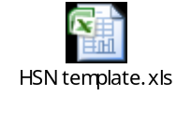

86.2 CR- 144(MID: 103325): Creation of new scheme code 434 & addition of scheme 434 in dependent scheme for account code 5701
- New scheme code “434 - Sale at Economic Cost for prisons/jail/correctional homes” has been added in the application and is being used in dependent scheme code of acct. head 5701.

Scheme | Description | Parent(Y/N) | Parent Scheme | Enabled | Rollup Group | Posting Allowed | Budgeting Allowed | Start Date
434 | Sale at Economic Cost for prisons/jail/correctional homes | No | 100 | Yes | No | Yes | Yes | 1-Apr-20

Account Head | Start Date | Dependent Scheme
Account Head | Start Date | From | To
5701 Existing |  | 100 | 425
5701 Revised | 01.04.2020 | 429 | 434

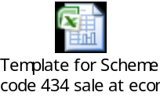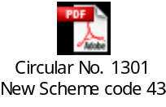

86.3 CR-142 (MID: 0103141): CR-142 New banks name should be added in the valid bank look up.

The below mentioned banks have been added in the valid bank list lookup in FAP with effective date as specified below.

CODE | MEANING | DESCRIPTION | EFFECTIVE START DATE
TJSB SAHAKARI BANK LTD | TJSB SAHAKARI BANK LTD | TJSB SAHAKARI BANK LTD | 01-APR-2019
NKGSB CO-OP. BANK  LTD. | NKGSB CO-OP. BANK LTD. | NKGSB CO-OP. BANK LTD. | 01-APR-2019
CAPITAL SMALL FINANCE BANK LIMITED | CAPITAL SMALL FINANCE BANK LIMITED | CAPITAL SMALL FINANCE BANK LIMITED | 01-APR-2019

86.4 CR-16 (MID: 0089914): Unit Code (Hierarchy) as mandatory input parameter should be created in the report named "FCI Bank Statement summary report".

- Bank Statement Summary Report is now renamed to FCI Bank Statement Summary Report, this can be ran same as Bank Statement Summary report was running.
- Unit code added as a new input parameter which is mandatory.
- Report type parameter is added which gives flexibility to run report output on summary as well as detail.
- Specific bank account number can now be selected on the basis of selected unit code
- Output of the report will be in text format delimited by pipe “|” which can later be converted into excel by using “Text to Column” functionality of Microsoft excel.
- Summary and detail outputs of report have been attached for reference.
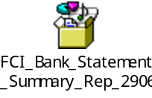

86.5 CR- 140(MID: 0102901): Freeze Journal Source 'Financials India'
- New Personalization is developed so that a reversal button is not display in Journal form where journal source is Financials India.

86.6 CR- 96(MID: 0092171): Provision to enter Physical balance of Fixed Assets in FAP & development of Reconciliation Report.

- Web ADI (Fixed Assets - Physical Inventory) is used for the Provision in FAP to enter physical balance of Fixed Assets.
- Physical Inventory -Line Entry layout is used in the Web ADI (Fixed Assets - Physical Inventory) also direct entry through open tab can be done.
- Web ADI (Fixed Assets - Physical Inventory) is provided to each asset book responsibility.
- FCI Physical vs Oracle Asset Reconciliation Report is developed for the reconciliation Physical and Oracle Asset Inventory.
- FCI Physical vs Oracle Asset Reconciliation Report is provided to each asset book responsibility.
- Sample Web Adi attached for reference
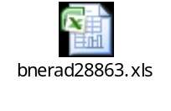

87 Deployments - JUL 2020:

87.1 CR-115 (MID: 96786): Requirement of asset period closure form at FCI Support User for Mar 18-19

- For MARCH18-19 Run depreciation is already present at FCI Support User. The checks applied for prevention of closure of MARCH period has revoked for FCI Support User till the time ALL India is closed in FA Module.
- We have checked the data for the period of MAR18-19 in all the units and provide the data to FCI.
- There were four depreciation entries generated for MAR18-19 period which were stopped on sub ledger level form flowing to GL. Later manual journal was entered in FY19-20 to correct the balances in GL.

88 Deployments – AUG 2020:

88.1 CR- 155(MID: 104047): Creation of HSN Codes
New Inventory Items have been created in FAP & mapped with HSN Codes as per the below table-
S. NO. | Item Code | Item Name | HSN Code | Transaction Type | Item Type
1 | 0206 | Rice- Fortified Raw Rice Common | 1006‬ | Sales | EXEMPTED ITEM
2 | 0207 | Rice- Fortified Raw Rice Grade A | 1006‬ | Sales | EXEMPTED ITEM
3 | 0208 | Rice- Fortified Boiled Rice Common | 1006‬ | Sales | EXEMPTED ITEM
4 | 0209 | Rice- Fortified Boiled Rice Grade A | 1006‬ | Sales | EXEMPTED ITEM
5 | 0452 | Arhar-PSS | 0713‬ | Sales | EXEMPTED ITEM
6 | 0455 | Gram-PSS | 0713‬ | Sales | EXEMPTED ITEM
7 | 0458 | Masoor-PSS | 0713‬ | Sales | EXEMPTED ITEM
8 | 0461 | Moong-PSS | 0713‬ | Sales | EXEMPTED ITEM
9 | 0464 | Urad-PSS | 0713‬ | Sales | EXEMPTED ITEM

Description of following item codes has been updated in the application as per below table:
S. NO. | Item Code | Old Description |  | Item Updated Description | HSN Code | Transaction Type | Item Type
1 | 0451 | Arhar |  | Arhar-PSF | 0713‬ | Sales | EXEMPTED ITEM
2 | 0454 | Gram |  | Gram-PSF | 0713‬ | Sales | EXEMPTED ITEM
3 | 0457 | Masoor |  | Masoor-PSF | 0713‬ | Sales | EXEMPTED ITEM
4 | 0460 | Moong |  | Moong-PSF | 0713‬ | Sales | EXEMPTED ITEM
5 | 0463 | Urad |  | Urad-PSF | 0713‬ | Sales | EXEMPTED ITEM

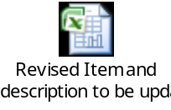

88.2 CR- 156(MID: 104627): Addition of scheme code 2301 in dependent scheme of account heads 6091, 6092 and 6095
Scheme code 2301 has been added in dependent scheme of account heads 6091, 6092 and 6095 in the application as per below table:
Account Head | Start Date | Dependent Scheme
Account Head | Start Date | From | To
6091 Existing |  | 2111 | 2271
6091 Revised | 01.03.2020 | 2111 | 2271
6091 Revised | 01.03.2020 | 2301 | 2301
6092 Existing |  | 2111 | 2271
6092 Revised | 01.03.2020 | 2111 | 2271
6092 Revised | 01.03.2020 | 2301 | 2301
6095 Existing |  | 2171 | 2271
6095 Revised | 01.03.2020 | 2171 | 2271
 |  | 2301 | 2301

PFMS mapping with scheme code 2301 for acct. heads 6091, 6092 and 6095:
 | PFMS
Scheme code | Segment One | Segment two | Segment three | Segment Four | Segment Five | Segment six
2301 | 7 | 0 | 0 | 2 | 0 | 0

Nomenclature | A/C Head | Scheme | A-S Grouping
For Indoor Treatment(Direct Payment System) | 6091 | 2301 | D05YP
For Indoor Treatment (Reimbursement) | 6092 | 2301 | D05YP
For Outdoor Treatment(Specified Diseases) | 6095 | 2301 | D05YP

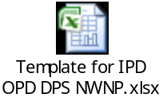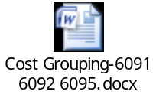

88.3 CR- 150(MID: 103706): Creation of new scheme code 3423 and minor category 423
Scheme code 3423 and minor category 423: ‘Office Equipments - Mobile phone/handsets’ has been added in the application as per below template:
Scheme | Description | Parent(Y/N) | Parent Scheme | Enabled | Rollup Group | Posting Allowed | Budgeting Allowed | Start Date
3423 | Office Equipments - Mobile phone/handsets | No | 38 | Yes | No | Yes | Yes | 01.4.2020

Existing Account | Cost Account | Minor Category | Description | IT Block Name | IT Depreciation Rate | Depreciation Method | Depreciation Rate
 | 2149 | 423 | Office Equipments - Mobile phone/handsets | P & M | 15 | WDV – 77.63% | 0.7763

Scheme code 3423 is being used in dependent scheme code of acct. heads 2149, 2249 and 2349 as per below template:
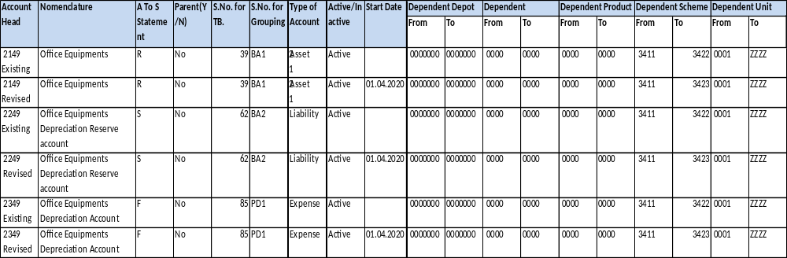
TB serial no. | Nomenclature | A/C Head | A-S Grouping
39 | Gross Cost:  Office Equipment’s – Mobile Phone/ handsets | 2149 | R02RP
62 | Depreciation Reserve:  Office Equipment’s – Mobile Phone/ handsets | 2249 | S02RP
85 | Depreciation:  Office Equipment’s – Mobile Phone/ handsets | 2349 | F03WP

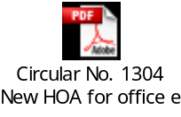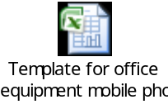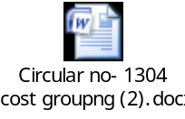

88.4 CR- 137(MID: 102806): Creation of new acct. heads 3287, 1811 and 6309 and modification in nomenclature of acct. head 3156
- New acct. heads 3287, 1811 and 6309 have been created in the application.
- Nomenclature of acct. head 3156 has been revised to ‘Rent in respect of Silo’ in the application.
- New scheme (3120) and minor category (120): 'Free Hold Land- Purchased for silo under VGF model' has been created in the application.
- New scheme (3120) is being used in dependent scheme code of acct. heads 2111, 2211 and 2311.

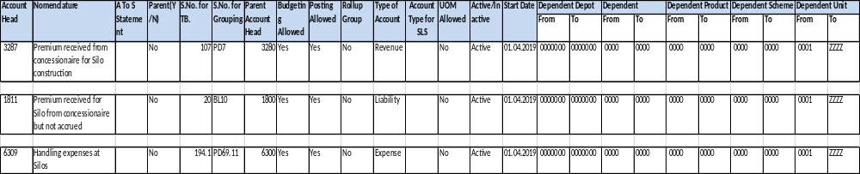

 | PFMS
Account | Segment One | Segment two | Segment three | Segment Four | Segment Five | Segment six
6309 | 6 | 0 | 0 | 3 | 0 | 0

3156 Existing | Rent in respect of Silo (operated by M/S Adani) | F | No | 105 | PD7 | 3150 | Yes | Yes | No | Expense
3156 Revised | Rent in respect of Silo | F | No | 105 | PD7 | 3150 | Yes | Yes | No | Expense

Scheme | Description | Parent(Y/N) | Parent Scheme | Enabled | Rollup Group | Posting Allowed | Budgeting Allowed | Start Date
3120 | Free Hold Land- Purchased for silo under VGF model | No |  | Yes | No | Yes | Yes | 01.4.2019

Existing Account | Cost Account | Minor Category | Description | IT Block Name | IT Depreciation Rate | Depreciation Method | Depreciation Rate
 | 2111 | 120 | Free Hold Land- Purchased for silo under VGF model | LAND - FREE HOLD LAND | 0 | WDV - 0% | 0.0000

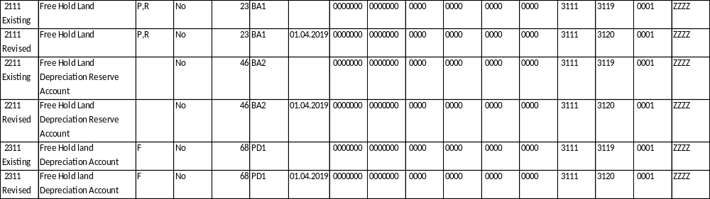

Nomenclature | A/C Head | A-S Grouping
Rent in respect of Silo | 3156 | F01D2P
Premium received from concessionaire for Silo construction | 3287 | F01D2P
Handling expenses at Silos | 6309 | F01D2P

Nomenclature | A/C Head | Scheme  Code | A-S Grouping
Gross Cost- Free Hold Land- Purchased for silo under VGF model | 2111 | 3120 | P02AP
Depreciation Reserve - Free Hold Land- Purchased for silo under VGF model | 2211 | 3120 | Q02AP#
Depreciation-Free Hold Land- Purchased for silo under VGF model | 2311 | 3120 | F01WP

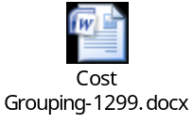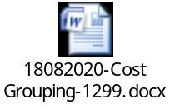

89 Deployments – SEP 2020:

89.1 CR- 154(MID: 103724): Updates in Creditor TB and Debtor TB

- We have added Supplier Category as the Input parameter which will be optional and in the output of report also in FCI India Creditor Trial Balance Report.

- We have added Supplier Site column in the report which will come in the Output of the report FCI India Creditor Trial Balance Report to view transaction site wise.

- We have added the Customer Site column in the report query to show in the Output of the FCI Debtor T.B. report in which respective transaction has been created.

89.2 CR- 63 (MID: 89617): Reflection of Updated GSTIN in GST reports
- New Custom program has been built in Supplier Third Party Registration form so that when Supplier GSTIN is updated then the customer GSTIN will reflect the same in Customer Third Party Registration Form.

89.3 CR- 116 (MID: 97135): Addition of three new columns in Asset Book Report & applying restriction on selection of depreciation limit type.

- Three new columns below were added in FCI Asset Book Report:
- Depreciation limit type
- Depreciation limit percent
- Recoverable cost

89.4 CR- 149(MID: 103492): Creation of new acct. head 6080 and addition of scheme code 707

- New acct. head 6080 - "Incentive for additional educational qualification" has been created in the application.
- New scheme code 707 – “8% NSSF loan VII 2020-21” has been created in the application and is currently being used with account head 1308.
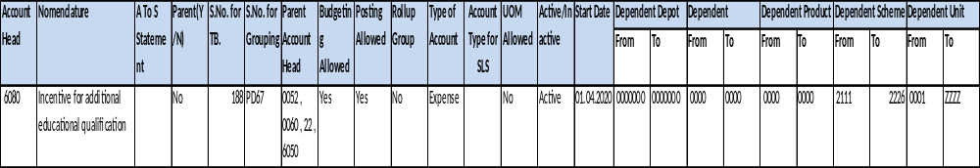
 | PFMS
Account | Segment One | Segment two | Segment three | Segment Four | Segment Five | Segment six
6080 | 7 | 0 | 0 | 1 | 0 | 0

Scheme | Description | Parent(Y/N) | Parent Scheme | Enabled | Rollup Group | Posting Allowed | Budgeting Allowed | Start Date
707 | 8% NSSF loan VII 2020-21 | No | 700 | Yes | No | Yes | Yes | 01.04.2020

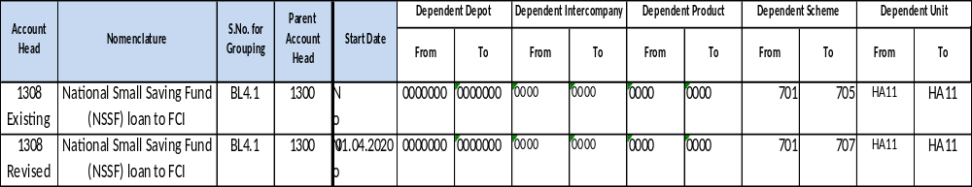
Nomenclature | A/C Head | Scheme Code | A-S Grouping
Incentive for additional educational qualification | 6080 | 2111 | E03SP
Incentive for additional educational qualification | 6080 | 2121 | E04SP
Incentive for additional educational qualification | 6080 | 2141 | E03SP
Incentive for additional educational qualification | 6080 | 2146 | E04SP
Incentive for additional educational qualification | 6080 | 2151 | E01SP
Incentive for additional educational qualification | 6080 | 2156 | E02SP
Incentive for additional educational qualification | 6080 | 2171 | E08SP
Incentive for additional educational qualification | 6080 | 2176 | E07SP
Incentive for additional educational qualification | 6080 | 2181 | E06SP
Incentive for additional educational qualification | 6080 | 2186 | E05SP
Incentive for additional educational qualification | 6080 | 2211 | E08SP
Incentive for additional educational qualification | 6080 | 2216 | E07SP
Incentive for additional educational qualification | 6080 | 2221 | E06SP
Incentive for additional educational qualification | 6080 | 2226 | E05SP

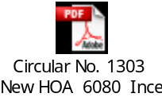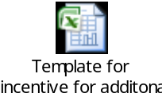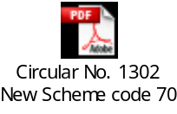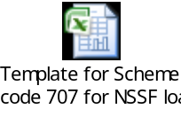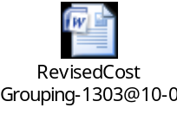

89.5 CR- 163(MID: 106376): Creation of account head 1636

- New account head 1636: “Tax Collection at Source (TCS)” has been created in the application.

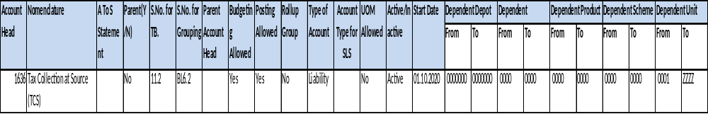
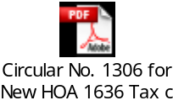

90 Deployments – OCT 2020:

90.1 CR- 161(MID: 106043): Development of Cash Flow Statement report
Following solution was implemented:
1. A new report ‘FCI Cash Flow Report’ was developed (Annexure 1)
- The amount against each of the distributions of paid invoices in AP will be reported in cash outflow. The report will bring the details of cash outflow as per the PFMS major head mapping against each of the distribution. Any additional amount that is not mapped to any of the 9 PFMS major heads will reflect under an additional head ‘Miscellaneous’.
- Amount paid against each of the following will be excluded from the report:
- Invoice distributions with negative amount.
- Credit memo and debit memo.
- Invoice with effective payment amount less than zero.
- While considering the total amount paid against each of the invoice, report will consider total effective payment amount for a given GL date range as specified during report run.
- In case of cash inflow, any miscellaneous receipts entered in AR will reflect under head ‘Miscellaneous Receipts’ whereas, normal cash receipts will reflect under ‘Deposit from customers’.
- If a receipt has reversal date within the date range specified by the user then it’ll be excluded from the report.

2. A new report ‘FCI Purchase Detail’ was developed (Annexure2)
- The report will bring details of paid invoices grouped as per the PFMS major heads ‘Procurement by FCI’ and ‘Procurement by State agency’.
- The report will be made available on FCI hierarchy basis.
- Amount paid against each of the following will be excluded from the report:
- Invoice distributions with negative amount.
- Credit memo and debit memo.
- Invoice with effective payment amount less than zero.
3. Both of the above mentioned reports were made available with ‘FCI Support User’ and ‘HA11 Payables Super User’ responsibilities.
Input Parameters:
FCI Cash flow Report
Input Parameter | Description | Mandatory
From Date | Payment Date/Receipt Date | Yes
To Date | Payment Date/Receipt Date | Yes

FCI Purchase Detail Report
Input Parameter | Description | Mandatory
Unit | Unit/Parent | Yes
From Date | Payment Date/Receipt Date | Yes
To Date | Payment Date/Receipt Date | Yes
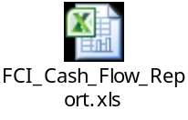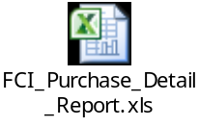

90.2 CR- 166(MID: 107144): Creation of account heads 3224, 3225 and 3226
Acct. heads below have been created in the application:
- 3224: “Storage and Warehousing Charges - private parties for godowns hired on lease with services”.
- 3225: “Storage & Warehousing and supervision charges to Nodal Agency for plinths hired from private parties on “lease only””.
- 3226: “Storage & Warehousing and supervision charges to Nodal Agency for plinths hired from private parties on “lease with services””.
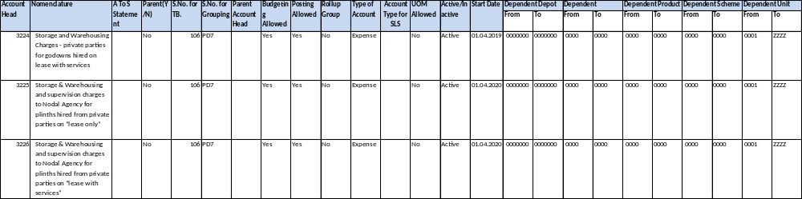
 | PFMS
Acct. head | Segment One | Segment two | Segment three | Segment Four | Segment Five | Segment six
3224 | 5 | 0 | 0 | 4 | 0 | 0
3225 | 5 | 0 | 0 | 4 | 0 | 0
3226 | 5 | 0 | 0 | 4 | 0 | 0

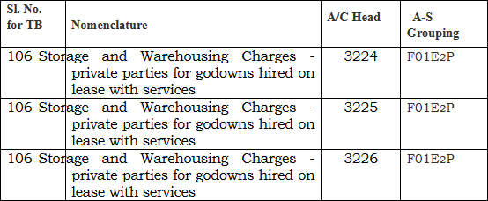
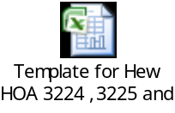

91 Deployments – DEC 2020:

91.1 CR- 175(MID: 108567): Creation of account head 2936 and modification in nomenclature of acct. heads 1636, 3105, 3221, 3981 and 3993

- New account head 2936: “Tax Collection at Source (TCS) by seller on sales to FCI” is created in the application.
- Nomenclature of acct. heads 1636, 3105, 3221, 3981 and 3993 has been modified in the application.

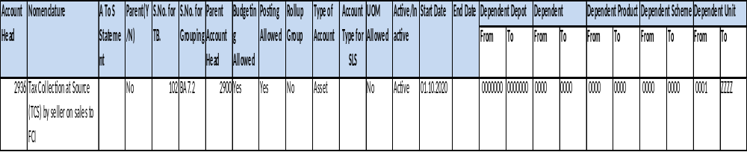
1636 Existing | Tax Collection at Source (TCS) |  | No | 11.2 | BL6.2 |  | Yes | Yes | No | Liability
1636 Revised | Tax Collection at Source (TCS) on sale made by FCI to its customers |  | No | 11.2 | BL6.2 |  | Yes | Yes | No | Liability

Account Head | Nomenclature | A To S Statement | Parent(Y/N) | S.No. for TB. | S.No. for Grouping | Parent Account Head | Budgeting Allowed | Posting Allowed | Rollup Group | Type of Account
3105 Existing | Grant in Aid for sports activities | F | No | 104 | PD5 | 3100 | Yes | Yes | No | Expense
3105 Revised | Expenses incurred on sports activities | F | No | 104 | PD5 | 3100 | Yes | Yes | No | Expense
3221 Existing | Rent - Weigh-Bridges & Weighing Machines | F | No | 106 | PD10.1 |  | Yes | Yes | No | Expense
3221 Revised | Weighment Charges | F | No | 106 | PD10.1 |  | Yes | Yes | No | Expense
3981 Existing | Recoveries for transit losses from State/Procuring agencies | N | No | 130 | PC15 | 3950 | Yes | Yes | No | Revenue
3981 Revised | Recoveries for transit losses from State/Procuring agencies/PEG Godown | N | No | 130 | PC15 | 3950 | Yes | Yes | No | Revenue
3993 Existing | Recoveries for storage shortages for cost of gunnies from Agents/HTC/State/CWC | N | No | 130 | PC15 | 3950 | Yes | Yes | No | Revenue
3993 Revised | Recoveries for storage shortages and cost of gunnies from Agents/HTC/State/CWC/SWC | N | No | 130 | PC15 | 3950 | Yes | Yes | No | Revenue

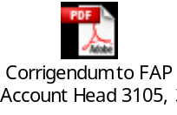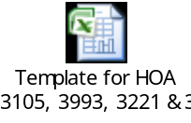

91.2 CR- 172(MID: 107575): Deactivation of account heads 3881, 3883, 3884, 3885, 2951, 4771, 2751 and 2851

- Account heads 3881, 3883, 3884, 3885, 2951, 4771, 2751 and 2851 have been deactivated in the application as on date ’31-MAR-2020’.
- Nomenclature of acct. head 2332 has been modified in the application.

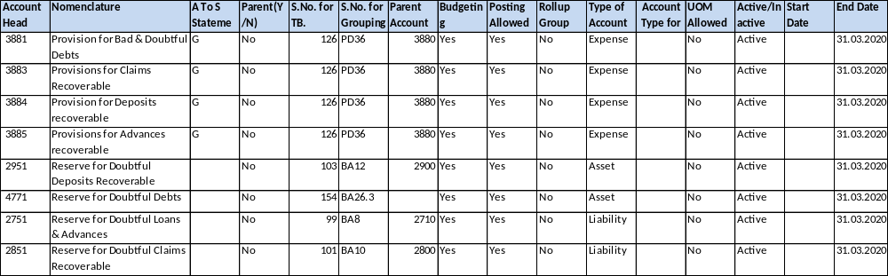
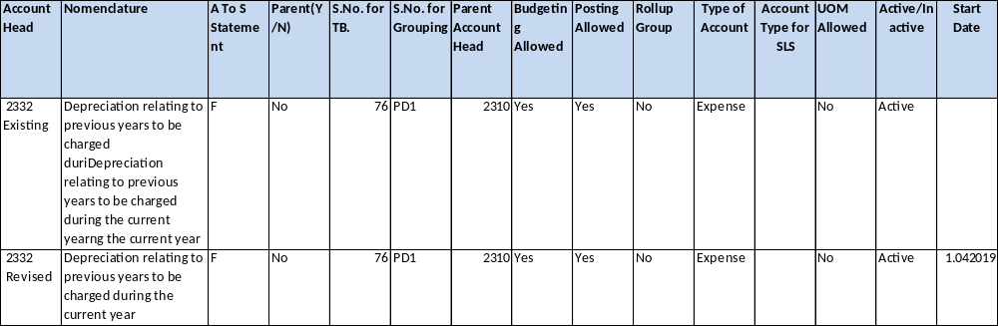
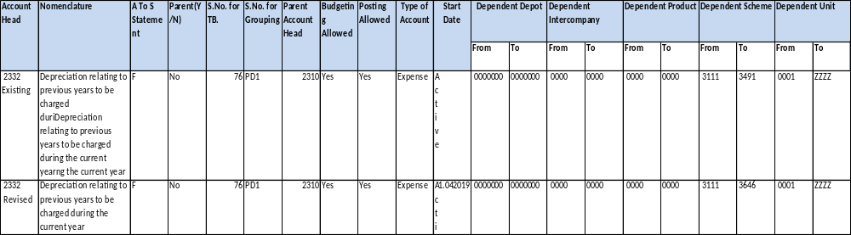
Sl. No. for TB | Nomenclature | A/C Head | Cost Grouping
76 | Depreciation relating to previous years to be charged during the current year | 2332 | F02WP

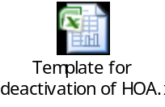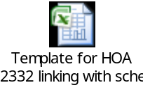

91.3 CR- 138(MID: 102862): Inclusion of MSME Categories in the LOV of Supplier Type
The below mentioned supplier types have been updated in the VENDOR TYPE list lookup in FAP with effective date as specified below.
Sl No. | Supplier Type | Description | Start Date
1. | MSME-Medium Women entrepreneur | MSME-Medium Women entrepreneur | 01-Apr-20
2. | MSME (Micro) | MSME (Micro) | 01-Apr-20
3. | MSME-Micro Women entrepreneurs | MSME-Micro Women entrepreneurs | 01-Apr-20
4. | MSME (Micro-SC/ST) | MSME (Micro-SC/ST) | 01-Apr-20
5. | MSME (Small) | MSME (Small) | 01-Apr-20
6. | MSME-Small Women entrepreneurs | MSME-Small Women entrepreneurs | 01-Apr-20
7. | MSME (Small-SC/ST) | MSME (Small-SC/ST) | 01-Apr-20
8. | MSME(Medium) | MSME(Medium) | 01-Apr-20
9. | MSME(Medium-SC/ST) | MSME(Medium-SC/ST) | 01-Apr-20

We’ve applied DFF at supplier level to capture UAM – Udyog Aadhar Memorandum number.
- UAM Number column and BTS acknowledgment no. has been added in "FCI Supplier Payment History Report- Excel" report.
- UAM Number column has been added in “FCI SUPPLIER MASTER DETAILS” Report.

91.4 CR- 177(MID: 109263): Modification in S.No. for T.B. of acct. heads 1908 and 1909

- S.No. for T.B. of acct. heads 1908 and 1909 has been modified in the application.
- Dependent product related CVR of acct. head 7191 has been updated in the application.

Account Head | Nomenclature | A To S Statement | Parent(Y/N) | S.No. for TB. | S.No. for Grouping | Parent Account Head | Budgeting Allowed | Posting Allowed | Rollup Group | Type of Account
1908 Existing | Trade Payable - For Pulses and Oilseeds-PSF |  | No | 158 | BL11.4 | 1900 | Yes | Yes | No | Liability
1908 Revised | Trade Payable - For Pulses and Oilseeds-PSF |  | No | 21.1 | BL11.4 | 1900 | Yes | Yes | No | Liability
1909 Existing | Trade Payable -For Pulses and Oilseeds-PSS |  | No | 158 | BL11 | 1900 | Yes | Yes | No | Liability
1909 Revised | Trade Payable -For Pulses and Oilseeds-PSS |  | No | 21.1 | BL11 | 1900 | Yes | Yes | No | Liability

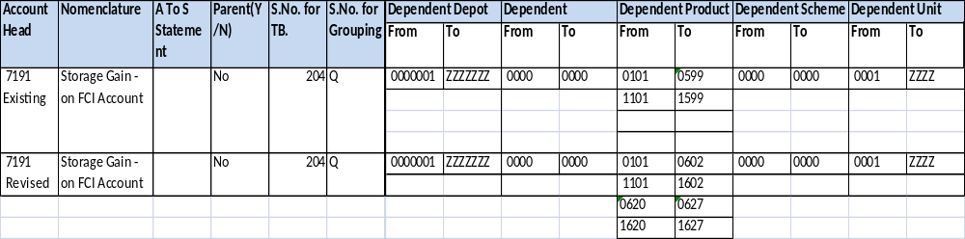

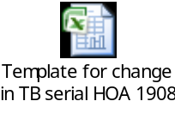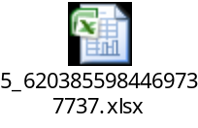

91.5 CR- 178(MID: 110033): Creation of new scheme code 209 & addition of scheme 209 in dependent scheme for account code 5701

- New scheme code "209 - Sale of rice to Oil Marketing Companies- OMSS(D) for conversion into Ethanol" has been created in the application.
- Scheme 209 exists in dependent scheme code related CVR of acct. head 5701 in the application.

Scheme | Description | Parent(Y/N) | Parent Scheme | Enabled | Rollup Group | Posting Allowed | Budgeting Allowed | Start Date
209 | Sale of rice to Oil Marketing Companies- OMSS(D) for conversion into Ethanol | No | 100 | Yes | No | Yes | Yes | 1-Apr-20

Account Head | Start Date | Dependent Scheme
Account Head | Start Date | From | To
5701 | 01.04.2020 | 100 | 425
5701 | 01.04.2020 | 429 | 434
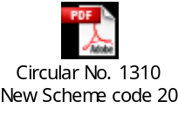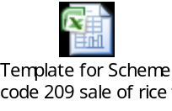

91.6 CR- 179(MID: 110556): Creation of account head 2828

- New account head: 2828: “Claims against Income Tax Deptt. for TDS refund” has been created in the application.

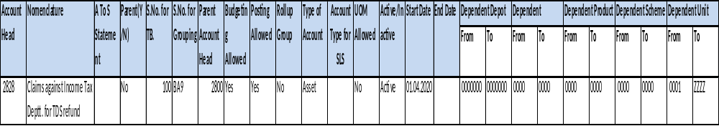
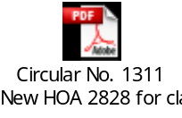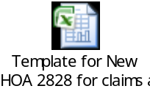

91.7 CR- 185(MID: 111555): Creation of account head 6081
- New account head: 6081: “Special cash package equivalent in lieu of LTC (2018-21)” has been created in the application.
- Product code ‘0103’ is added in dependent product code CVR of acct. head 5233 in the application.
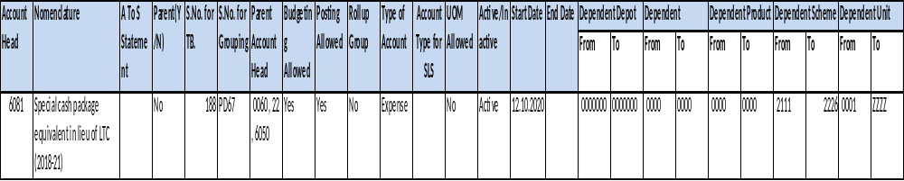

 | PFMS
Acct. head | Segment One | Segment two | Segment three | Segment Four | Segment Five | Segment six
6081 | 7 | 0 | 0 | 1 | 0 | 0

Nomenclature | A/C Head | Scheme Code | A-S Grouping
Special Cash package equivalent in lieu of LTC (2018-21) | 6081 | 2151 | E01U₁P
Special Cash package equivalent in lieu of LTC (2018-21) | 6081 | 2156 | E02U₁P
Special Cash package equivalent in lieu of LTC (2018-21) | 6081 | 2111,2141 | E03U₁P
Special Cash package equivalent in lieu of LTC (2018-21) | 6081 | 2121,2146 | E04U₁P
Special Cash package equivalent in lieu of LTC (2018-21) | 6081 | 2226,2186 | E05U₁P
Special Cash package equivalent in lieu of LTC (2018-21) | 6081 | 2221,2181 | E06U₁P
Special Cash package equivalent in lieu of LTC (2018-21) | 6081 | 2216,2176 | E07U₁P
Special Cash package equivalent in lieu of LTC (2018-21) | 6081 | 2211,2171 | E08U₁P

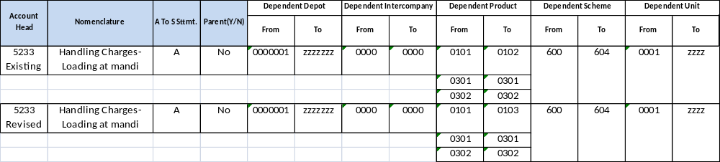
PFMS
Segment One | Segment two | Segment three | Segment Four | Segment Five | Segment six
2 | 2 | 2 | 8 | 0 | 0

A/C Head | Product Code | A-S Grouping
5233 | 0103 | A02BP

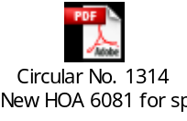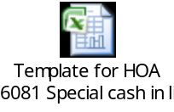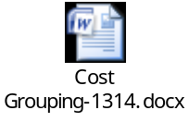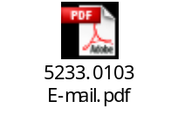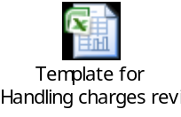

92 Deployments – JAN 2021:

92.1 CR- 182(MID: 111583): Redesign of FCI PFMS chart of account mapping report
FCI PFMS chart of account mapping report was modified as per the format specified in the annexure. And was made available to FCI Support User responsibility.
The old report was revoked from system.
FCI PFMS Chart Of Account Mapping Report
Input Parameter | Description | Mandatory
PFMS Scheme | PFMS Scheme | Yes
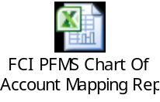

92.2 CR-157(MID: 104573), Adding name in valid bank look up

The below mentioned banks are added in the valid bank list lookup with effective date as specified below. The fields in system will be populated as following:

CODE | MEANING | DESCRIPTION | EFFECTIVE START DATE
ESAF SMALL FINANCE BANK | ESAF SMALL FINANCE BANK | ESAF SMALL FINANCE BANK | 01-APR-2020
THE FARIDKOT CENTRAL | THE FARIDKOT CENTRAL COOPERATIVE BANK LIMITED | THE FARIDKOT CENTRAL COOPERATIVE BANK LIMITED | 01-APR-2020
THE VAIDYANATH URBAN | THE VAIDYANATH URBAN CO-OP. BANK LTD. | THE VAIDYANATH URBAN CO-OP. BANK LTD. | 01-APR-2020
THE AJARA URBAN CO-OP. | THE AJARA URBAN CO-OP. BANK LTD. | THE AJARA URBAN CO-OP. BANK LTD. | 01-APR-2020
SHRI RAJKOT DISTRICT | SHRI RAJKOT DISTRICT CO-OPERATIVE BANK LTD. | SHRI RAJKOT DISTRICT CO-OPERATIVE BANK | 01-APR-2020
SHRI MAHAVIR URBAN | SHRI MAHAVIR URBAN CO-OP. BANK LTD. | SHRI MAHAVIR URBAN CO-OP. BANK LTD. | 01-APR-2020
THE BHAGYODAYA | THE BHAGYODAYA CO-OPERATIVE BANK LTD. | THE BHAGYODAYA CO-OPERATIVE BANK LTD. | 01-APR-2020
PAYTM PAYMENTS BANK | PAYTM PAYMENTS BANK | PAYTM PAYMENTS BANK | 01-APR-2020
ANDHRA PRAGATHI | ANDHRA PRAGATHI GRAMEENA BANK | ANDHRA PRAGATHI GRAMEENA BANK | 01-APR-2020
ALMORA URBAN CO-OPERATIVE | ALMORA URBAN CO-OPERATIVE BANK LTD. | ALMORA URBAN CO-OPERATIVE BANK LTD. | 01-APR-2020
SOCIETE GENERALE | SOCIETE GENERALE | SOCIETE GENERALE | 01-APR-2020
BANK OF TOKYO-MITSUBISHI | BANK OF TOKYO-MITSUBISHI UFJ LTD. | BANK OF TOKYO-MITSUBISHI UFJ LTD. | 01-APR-2020
THE ZOROASTRIAN | THE ZOROASTRIAN CO-OPERATIVE BANK LTD. | THE ZOROASTRIAN CO-OPERATIVE BANK LTD. | 01-APR-2020

93 Deployments - MAR 2021:

93.1 CR- 195(MID: 114082): Creation of HSN Codes
In reference to U.O note no-F-19/GST/2019-20/Part-1 dated 03.03.2021 provided by FCI Finance Division :-
New Inventory Items have been created in FAP & mapped with HSN Codes as per the below table-
S No | Item Name | Description | HSN/SAC Code | Item Code
1 | Old and used petrol/CNG driven Motor cars - Cylinder capacity not exceeding 1,000 cc | Old and used petrol/CNG driven Motor cars - Cylinder capacity not exceeding 1,000 cc | 87032191 | 9837
2 | Old and used petrol/CNG driven Motor cars - Cylinder capacity exceeding 1,000 cc but not exceeding 1,500cc | Old and used petrol/CNG driven Motor cars - Cylinder capacity exceeding 1,000 cc but not exceeding 1,500cc | 87032291 | 9836
3 | Old and used petrol/CNG driven Motor cars - Cylinder capacity exceeding 1,500 cc but not exceeding 3,000cc | Old and used petrol/CNG driven Motor cars - Cylinder capacity exceeding 1,500 cc but not exceeding 3,000cc | 87032391 | 9835
4 | Old and used petrol/CNG driven Motor cars - Cylinder capacity exceeding 3,000 cc | Old and used petrol/CNG driven Motor cars - Cylinder capacity exceeding 3,000 cc | 87032491 | 9834
5 | Old and used diesel/semi-diesel driven Motor cars - Cylinder capacity not exceeding 1,500 cc | Old and used diesel/semi-diesel driven Motor cars - Cylinder capacity not exceeding 1,500 cc | 87033191 | 9833
6 | Old and used diesel/semi-diesel driven Motor cars - Cylinder capacity exceeding 1,500 cc but not exceeding 2,500cc | Old and used diesel/semi-diesel driven Motor cars - Cylinder capacity exceeding 1,500 cc but not exceeding 2,500cc | 87033291 | 9832
7 | Old and used diesel/semi-diesel driven Motor cars - Cylinder capacity exceeding 2,500 cc | Old and used diesel/semi-diesel driven Motor cars - Cylinder capacity exceeding 2,500 cc | 87033391 | 9831

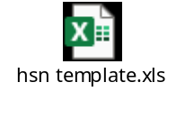

94 Deployments - APR 2021:

94.1 CR- 193(MID: 113889): Change in CVR of AC head 1554, 1555, 1560 & 1561
Following solution was implemented:
- CVR of accounts 1554, 1555, 1560 and 1561 was updated to include scheme 2301 in Apps (refer annexure 1).
- Scheme 2301 with accounts 1554, 1555, 1560 and 1561 was mapped under group BL6.1 of Balance Sheet report.
- No mapping is needed for these combinations in PFMS COA mapping and FCI costing report.
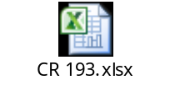

94.2 CR – 201 (MID: 116003): Creation of acct. head 3675

- Account head: 3675: “Expenses incurred on Commemoration of 75 Years of India’s Independence (Bharat Ka Amrit Mahotsav)” has been created in the application as per below template:
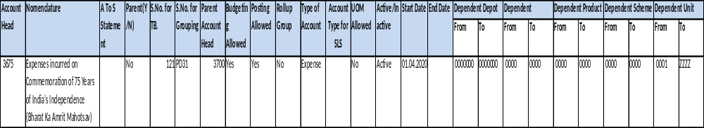
 | PFMS
Acct. head | Segment One | Segment two | Segment three | Segment Four | Segment Five | Segment six
3675 | 8 | 0 | 0 | 12 | 0 | 0

Nomenclature | A/C Head | A-S Grouping
Expenses incurred on Commemoration of 75 Years of India’s Independence (Bharat Ka Amrit Mahotsav) | 3675 | F02ZP

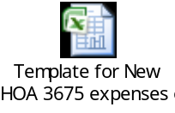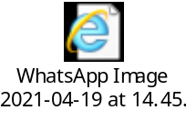

94.3 CR-146 (MID: 103377): Creation of RO Manipur and DO Imphal
- New unit codes FF00 (MANIPUR REGION), FF11 (R.O. MANIPUR), FF12 (D.O. Imphal) and FFRO (NOTIONAL MANIPUR REGION RO) have been created in the application.
- Nomenclature of unit FE00 and FERO has been changed from N & M REGION to NAGALAND REGION and NOTIONAL N & M REGION RO to NOTIONAL NAGALAND REGION RO respectively in the application.
Sl No. | New Unit | Nomenclature
1 | FF11 | R.O. Manipur
2 | FF12 | D.O. Imphal



95 Deployments MAY-2021:

95.1 CR-194 (MID: 114083): Creation of new acct. head 1812
- New account head 1812: "Advance received for procurement and shelf life study of fortified rice" has been created in the application as per below template:
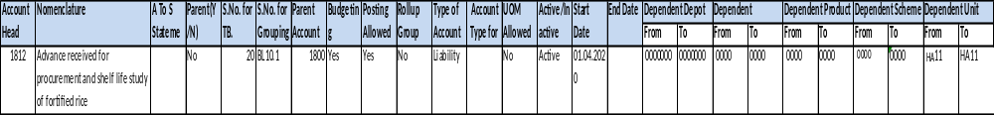

95.2 CR-203 (MID: 116922): Creation of new acct. head 1434 and scheme code 3424 and minor category 424
- New acct. head ‘1434’ has been created in the application as per below template:
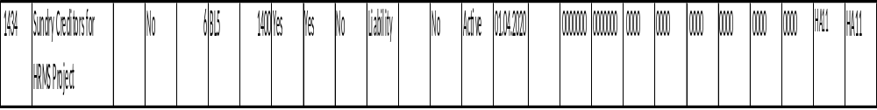
- New scheme (3424) and minor category (424): ‘Office Equipments - Biometric Attendence device under HRMS' has been created in the application as per below template:
Scheme | Description | Parent(Y/N) | Parent Scheme | Enabled | Rollup Group | Posting Allowed | Budgeting Allowed | Start Date
3424 | Office Equipments - Biometric Attendence device under HRMS | No |  | Yes | No | Yes | Yes | 01.4.2021

Existing Account | Cost Account | Minor Category | Description | IT Block Name | IT Depreciation Rate | Depreciation Method | Depreciation Rate
 | 2149 | 424 | Office Equipments - Biometric Attendence device under HRMS | P & M | 15 | WDV – 18.10% | 0.1810

- New scheme code 3424 has been added in dependent scheme code of acct. heads 2149, 2249 and 2349 as per below template:
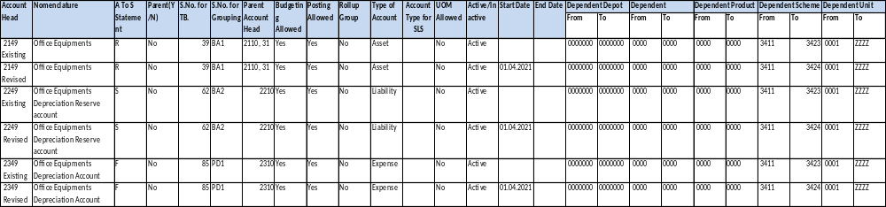
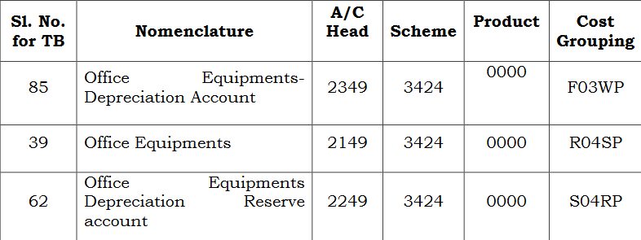



95.3 CR-200 (MID: 115646): Creation of HSN Codes
- New Inventory Item ‘9830’ has been created in the application & has been mapped with HSN Code as per the below table-

S.No. | Item Name | Item description | HSN /SAC code | item code | Transaction type | Item Type
1 | Renting of Motor Vehicle | Renting of Motor Vehicle | 996601 | 9830 | Non sales | Taxable

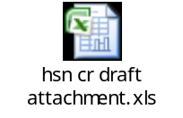

95.4 CR-181 (MID: 111330): Requirement of asset period closure tick box on FCI Support User responsibility for Mar 19-20 FA closure
- Asset Period Closure access was enabled again for FA Period Closure of Mar19-20.
- Close period check box for March has been disabled after all India periods of Mar19-20 have been closed.
- There were 52 depreciation entries lines generated for MAR19-20 period which have been stopped on sub ledger level form for flowing to GL.

96 Deployments JUN-2021:

96.1 CR-197 (MID: 117926): Addition of Column in FCI Debtor/Creditor age-wise report
- Before deployment of this CR-197, FCI uses ‘FCI Debtor/Creditor age-wise report’ with following input parameters: -
Column value | Meaning
Unit | Can be executed for a zone, for a region, for a unit or all India. For executing the report on Zone, data for units which belongs to the zone will be fetched
As on Date | This will be last date of the period selected above.
Type | Either Creditor or Debtor. Anyone can be selected.

The sample report format:
Following changes has been made in the FAP system:
- In “FCI Debtor/Creditor age-wise report” existing column will be change as from “More than Five years” to “More than Five years to Ten Years” .
- In “FCI Debtor/Creditor age-wise report” new column will be added namely “More than Ten Years”.
There is no changes in input parameters and sample report format:
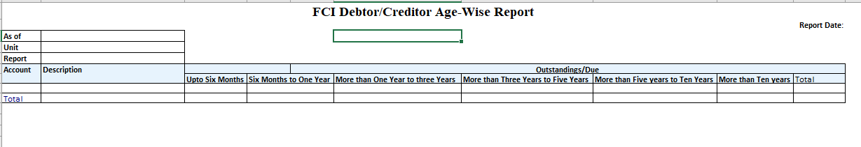
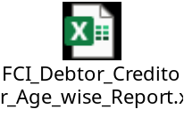

96.2 CR-202 (MID: 116467): Creation of new acct. head 5234, 0957
- New acct. heads 5234, 0957 have been created in the application.
- Product codes ‘0206-0209’ have been added in dependent product code CVR of acct. head 5281.

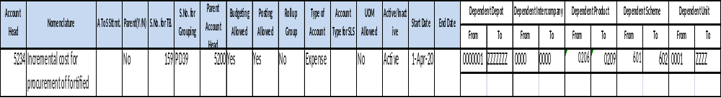
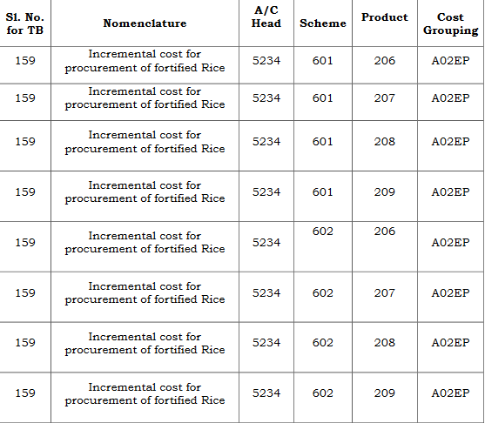

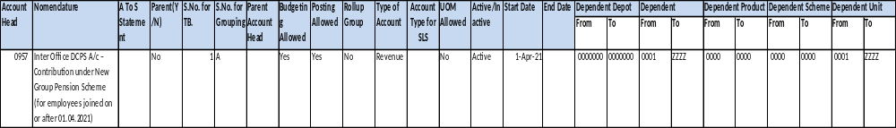

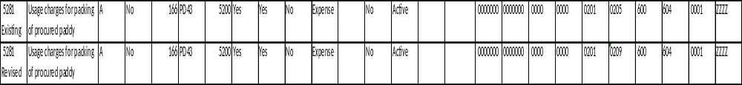

Nomenclature | A/C Head | Scheme | Product | Cost Grouping
Usage Charges for packaging of procured paddy.Rice | 5281 | 601 | 201 | A02EP
Usage charges for packing of procured paddy.Rice | 5281 | 601 | 202 | A02EP
Usage Charges for packaging of procured paddy.Rice | 5281 | 601 | 203 | A02EP
Usage Charges for packaging of procured paddy.Rice | 5281 | 601 | 204 | A02EP
Usage Charges for packaging of procured paddy.Rice | 5281 | 601 | 205 | A02DP
Usage Charges for packaging of procured paddy.Rice | 5281 | 602 | 201 | A02EP
Usage Charges for packaging of procured paddy.Rice | 5281 | 602 | 202 | A02EP
Usage Charges for packaging of procured paddy.Rice | 5281 | 602 | 203 | A02EP
Usage Charges for packaging of procured paddy.Rice | 5281 | 602 | 204 | A02EP
Usage Charges for packaging of procured paddy.Rice | 5281 | 602 | 205 | A02DP
Usage Charges for packaging of procured paddy.Rice | 5281 | 601 | 206 | A02EP
Usage charges for packing of procured paddy.Rice | 5281 | 601 | 207 | A02EP
Usage Charges for packaging of procured paddy.Rice | 5281 | 601 | 208 | A02EP
Usage Charges for packaging of procured paddy.Rice | 5281 | 601 | 209 | A02EP
Usage Charges for packaging of procured paddy.Rice | 5281 | 602 | 206 | A02EP
Usage Charges for packaging of procured paddy.Rice | 5281 | 602 | 207 | A02EP
Usage Charges for packaging of procured paddy.Rice | 5281 | 602 | 208 | A02EP
Usage Charges for packaging of procured paddy.Rice | 5281 | 602 | 209 | A02EP

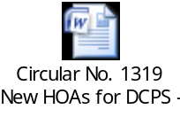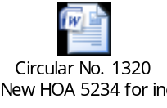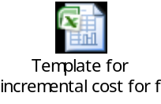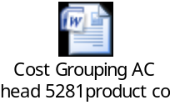

96.3 CR-133 (MID: 101570) Creation of new account codes 5422, 5423 and 5283 and addition of schemes 111 and 112
Below new account codes have been created in the application (account template attached):
- (*) 5422 - Supervision Charges on transportation at CWC godowns.
(*) 5423 - Supervision Charges on transportation at SWC godowns.
(*) 5283 - Purchases & incidental charges transferred from PSS to PSF.
(*) 3674 - Expenses incurred on COVID-19 prevention measures.
(*) 1433 - Contribution Payable- PM CARES FUND.
- New schemes 111 and 112 have been added in the application and are currently being used with acct. head 3577.
- New scheme code 208: 'OMSS (D)- Charitable/NGOs (COVID-19)' has been added in the application and is currently being used with acct. Head 5701.
- New product codes 206, 207, 208, 209 have been added in the application.

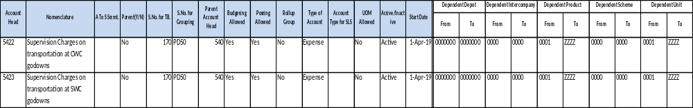
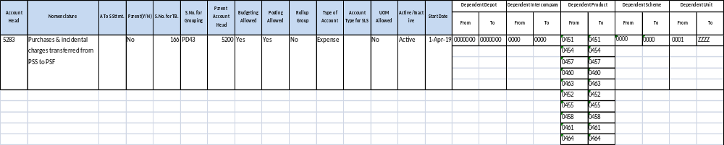
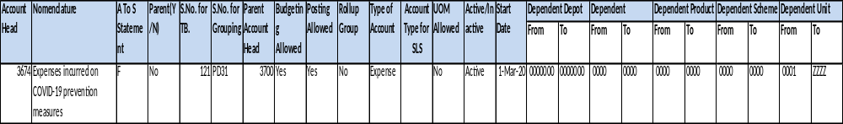
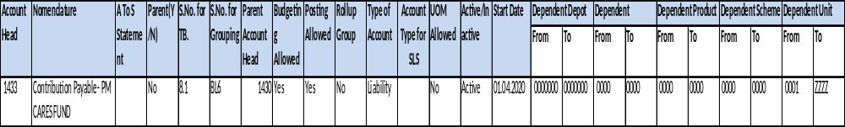
Scheme | Description | Parent(Y/N) | Parent Scheme | Enabled | Rollup Group | Posting Allowed | Budgeting Allowed | Start Date
111 | Price Stabilization Fund (PSF) | No | 100 | Yes | No | Yes | Yes | 01.04.2019
112 | Price Support Scheme (PSS) | No | 100 | Yes | No | Yes | Yes | 01.04.2019
208 | OMSS (D)- Charitable/NGOs (COVID-19) | No | 100 | Yes | No | Yes | Yes | 01.04.2020

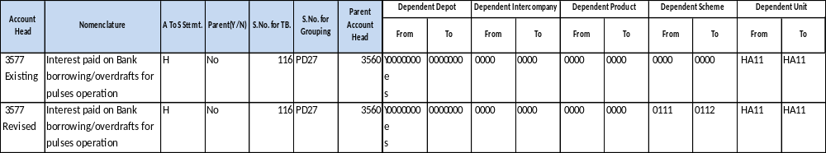

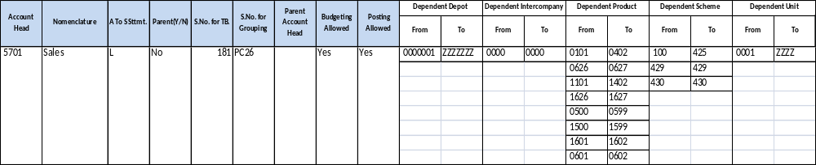

Product | Description | Parent(Y/N) | Parent Scheme | Enabled | Rollup Group | Posting Allowed | Budgeting Allowed | Start Date
206 | Rice- Fortified Raw Rice Common | No | 200 | Yes | No | Yes | Yes | 1-Oct-19
207 | Rice- Fortified Raw Rice Grade A | No | 200 | Yes | No | Yes | Yes | 1-Oct-19
208 | Rice- Fortified Boiled Rice Common | No | 200 | Yes | No | Yes | Yes | 1-Oct-19
209 | Rice- Fortified Boiled Rice Grade A | No | 200 | Yes | No | Yes | Yes | 1-Oct-19

 | PFMS
Acct. head | Segment One | Segment two | Segment three | Segment Four | Segment Five | Segment six
5422 | 4 | 0 | 0 | 2 | 0 | 0
5423 | 4 | 0 | 0 | 2 | 0 | 0

 | PFMS
Acct. head | Segment One | Segment two | Segment three | Segment Four | Segment Five | Segment six
3674 | 8 | 0 | 0 | 12 | 0 | 0

Sl. No. for TB | Nomenclature | A/C Head | A-S Grouping
170 | Supervision Charges on transportation at CWCgodowns | 5422 | F01BP
170 | Supervision Charges on transportation at SWC godowns | 5423 | F01CP

Nomenclature | Product Code | A/C Head | Scheme Code | A-S Grouping
OMSS (D)- Charitable/NGOs (COVID-19) | 101 | 5701 | 208 | L01AP
OMSS (D)- Charitable/NGOs (COVID-19) | 102 | 5701 | 208 | L01AP
OMSS (D)- Charitable/NGOs (COVID-19) | 103 | 5701 | 208 | L01AP
OMSS (D)- Charitable/NGOs (COVID-19) | 1101 | 5701 | 208 | L02AP
OMSS (D)- Charitable/NGOs (COVID-19) | 1102 | 5701 | 208 | L02AP
OMSS (D)- Charitable/NGOs (COVID-19) | 1103 | 5701 | 208 | L02AP
OMSS (D)- Charitable/NGOs (COVID-19) | 201 | 5701 | 208 | L01CP
OMSS (D)- Charitable/NGOs (COVID-19) | 202 | 5701 | 208 | L01CP
OMSS (D)- Charitable/NGOs (COVID-19) | 203 | 5701 | 208 | L01CP
OMSS (D)- Charitable/NGOs (COVID-19) | 204 | 5701 | 208 | L01CP
OMSS (D)- Charitable/NGOs (COVID-19) | 205 | 5701 | 208 | L01CP
OMSS (D)- Charitable/NGOs (COVID-19) | 1201 | 5701 | 208 | L02CP
OMSS (D)- Charitable/NGOs (COVID-19) | 1202 | 5701 | 208 | L02CP
OMSS (D)- Charitable/NGOs (COVID-19) | 1203 | 5701 | 208 | L02CP
OMSS (D)- Charitable/NGOs (COVID-19) | 1204 | 5701 | 208 | L02CP
OMSS (D)- Charitable/NGOs (COVID-19) | 1205 | 5701 | 208 | L02CP

Nomenclature | A/C Head | Scheme | A-S Grouping
Interest paid on Bank borrowing/overdrafts for pulses operation -Price Stabilization Fund (PSF) | 3577 | 111 | H01C1P
Interest paid on Bank borrowing/overdrafts for pulses operation - Price Support Scheme (PSS) | 3577 | 112 | H01C1P

T.B. Serial No. | Nomenclature | A/C Head | A-S Grouping
121 | Expenses incurred on COVID-19 prevention measures | 3674 | F04F1P

T.B. Serial No. | Nomenclature | A/C Head | A-S Grouping
166 | Purchases & incidental charges transferred from PSS to PSF | 5283 | A02OP

Nomenclature | A/C Head | Product code | A-S Grouping
Opening Stock Rice- Fortified Raw Rice Common | 5061 | 206 | B01EP
Opening Stock Rice- Fortified Raw Rice Grade A | 5061 | 207 | B01EP
Opening Stock Rice- Fortified Boiled Rice Common | 5061 | 208 | B01EP
Opening Stock Rice- Fortified Boiled Rice Grade A | 5061 | 209 | B01EP
Sales Rice- Fortified Raw Rice Common | 5701 | 206 | L01CP
Sales Rice- Fortified Raw Rice Grade A | 5701 | 207 | L01CP
Sales Rice- Fortified Boiled Rice Common | 5701 | 208 | L01CP
Sales Rice- Fortified Boiled Rice Grade A | 5701 | 209 | L01CP
Closing Stock Rice- Fortified Raw Rice Common | 7331 | 206 | B06EP
Closing Stock Rice- Fortified Raw Rice Grade A | 7331 | 207 | B06EP
Closing Stock Rice- Fortified Boiled Rice Common | 7331 | 208 | B06EP
Closing Stock Rice- Fortified Boiled Rice Grade A | 7331 | 209 | B06EP

Nomenclature | A/C Head | Product code | A-S Grouping
Purchases Rice- Fortified Raw Rice Common | 5161 | 206 | A01EP
Purchases Rice- Fortified Raw Rice Grade A | 5161 | 207 | A01EP
Purchases Rice- Fortified Boiled Rice Common | 5161 | 208 | A01EP
Purchases Rice- Fortified Boiled Rice Grade A | 5161 | 209 | A01EP

Account Head | Nomenclature | A To S Statement | Parent(Y/N) | S.No. for TB. | S.No. for Grouping | Dependent Product
5161 | Purchases | A | No | 158 | PD38.9 | 206 | 209
5061 | Opening Stock | B | No | 156 | PD37.9 | 206 | 209
5701 | Sales | L | No | 181 | PC26.9 | 206 | 209
7331 | Closing Stock (Trading Account) | B | No | 221 | Q2.10 | 206 | 209
7321 | Closing Stock (Assets Account) |  | No | 220 | Q1.10 | 206 | 209

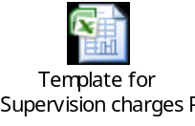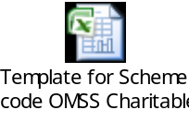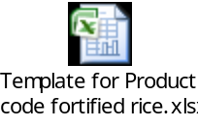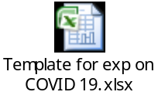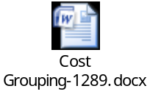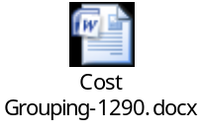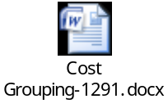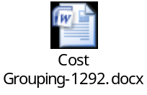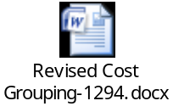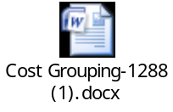

97 Deployments JUL-2021:

97.1 CR-214 (MID: 118371): Creation of new JE category 'Interco IOPS New'
Following was implemented:
• A new journal category ‘Interco IOPS New’ was created in FAP system.
• The intercompany account for new journal category is 0957.
• The new journal category was created on the same model of ‘Interco IOPS’ journal category.
• No new ad-hoc journal approval role was created for ‘Interco IOPS New’, existing ad-hoc role ‘HA11_IOPS’ will be used for new category as well.

97. 2 CR-210 (117853):FCI Purchase Dashboard Creation

Following solution was implemented:
- A dashboard link will was added to FCI Lekha homepage. Clicking on the link will direct users to a new webpage where information based on the points below will be visible to the users.
- Following are the key data extraction conditions for the dashboard:
  - Invoices with effective non-zero payments in current FY.
  - Only invoice distributions having CCID in the PFMS major head 1 or 2 mapping will reflect in the data.
  - Line type for these distributions should not be 'PREPAY' or 'MISCELLANEOUS'.
  - The amount and quantity are being prorated on following logic for all the qualifying distribution lines
Payment Amount= (effective invoice payment /Sum of all invoice distributions)* dist. amount
Quantity = Payment Amount/ Unit price from invoice line
- Data will be summarized at RO level.
- Following are the product codes which will be reported on for WHEAT, RICE and PADDY
Product | FCI Product code
WHEAT | 0101, 0102, 0103
RICE | 0201, 0202, 0203, 0204, 0205, 0206, 0207, 0208, 0209, 0904
PADDY | 0301, 0302
- Dashboard will always display data for current financial year.
- Quantity displayed will be in LMT and amount will be in crores.
- Data for the dashboard will be refreshed daily after end of day.
- The format for FCI Purchase Dashboard is attached in annexures.
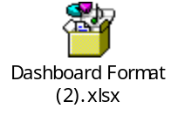

97. 3 CR-209 (0117753): Provision for uploading of bulk Invoices in FAP
- There is a need for provision of bulk uploading of invoices through excel sheet, so that system will create auto invoice in fap for goods and purchase type of invoices and also populate the GST information.
- An UI in BTS has provided where user can upload Excel sheet with invoice details.
- A program “FCI Import Goods Purchased Invoices-BTS” to upload the bulk invoices through excel will be created.
- A program “FCI Bulk Invoice Upload Exception Report” has created to show the records which gets status of invoices uploaded.
- The invoices created through Bulk upload process will be auto validated.
Validations:
- File name will always be unique
- File will contain invoice data with single line
- Format for date fields will be ‘DD-MON-YYYY’
- Excel sheet should be in “.xlsx” format only.
- Number fields should be entered till 2 decimal places only.
- Distribution set functionality is not enabled hence Distribution set field should be left blank.
- File Name size will not be more than 20 characters.
- Mandatory parameter is File name in program “FCI Bulk Invoice Upload Exception Report”.
Template for uploading invoice data
Error Message details
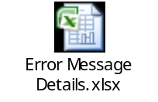

97. 4 CR-222 (120973): Mantis Bug Tracker application migration to new cloud space

Mantis application was hosted on old server of NIC and NIC informed that he is obsoleting this existing server and will not take care further. Therefore, after discussion with FCI, NIC provided the cloud space for the deployment of Mantis application.

On cloud space, NIC recommended to use the upgraded framework and database to avoid the vulnerability issues in future. So we need to use updated Framework –Apache, database and upgrade the Mantis application accordingly to make the compatible with the updated versions of packages.

Tittle | Description | No. of Components
Apache | New version of apache on new cloud server. | - Apache update from 2.2.15 to 2.4  - Run-time Loadable Multi-Processing Modules (MPMs) is added in new version of apache.  - Reduced memory usage in new version of apache.
PHP | New version of PHP on new cloud server. | - PHP 5.3.3 to PHP 7.4.12
Database /MySql | We have installed new version of MySql on new server. | - MySql database updation.  - Database migration from one server to another server.  - Updated the DB structure compatible with new Mantis Application.
Application | Upgraded mantis application has been migrated on new cloud server. | - Mantis version updation from version 1.2.11 to version 2.24.2  - New application support new version of PHP and MySql database.  - Layout and design of application has been changed.  - MD5 encryption is used for password for better protection.  - Mantis application migration from one server to cloud server.  - Multiple file selection option implemented on view issue page.  - Drag & Drop feature to upload file.  - phpmailer binaries have been updated.  - Now file is attached with comment.  - ADOdb has been updated.  - On close application session has been destroyed automatically.  - User-based security.  - Advanced search tools.  - Reporting and graphing.  - Customizable issue pages and workflow.  - Revision control integration.  - Time tracking.  - Mobile friendly website.

98 Deployments June-2022:

98.1 - CR-204 (MID: 117240): Creation of DO Aurangabad and
DO Amravati
New District offices, Aurangabad and Amravati has been created vide Hqrs. OMISS Division Sanction Order No. 01/2021/01 dated 27.04.2021 (Copy attached). Therefore, we need to create below UNITs in FAP -
- New unit codes WC21 (D.O. Aurangabad), WC22 (D.O. Amravati) needs to be created.
Following Set ups need to be catered while creating new units in Apps:
- Location for DO ‘WC21’ and DO ‘WC22’ will be created.
- The list of new units which will be created are:
Sl No. | New Unit | Nomenclature
1 | WC21 | D.O. Aurangabad
2 | WC22 | D.O. Amravati

- The new units will be added in the system. The new units will have start date as ’01-APR-2021’.
- Responsibilities for ’WC21’, ’WC22’ will be created.
- Document Categories will be created for AP, AR, GL and FA for all the new units.
- Document Sequences (for example - Voucher No. / Transaction No) will be created for AP, AR, GL and FA for all the new units.
- In AP - Good Purchase DFF - Crop Year will be set up for new units ’WC21’ and ‘WC22’.
- Security profile will be created for the new units.
- CVR changes will be done as per requirement.
- In Budget – Organization creation set up will be done for the new units.
- Range and assignments will be done based on the data in HHHH organisation.
- In GL – Interco IOM and Transfer in against Stock Received DFF set up will be done.
- Inventory Org will be created for all the new units.
- Asset book will be created ‘WC21 ASSET BOOK’, ’WC22 ASSET BOOK’.
- Asset categories will be created for the new units.
- Block of Asset needs to be created for ‘Income Tax Act’ report.
- India Localization information will be entered.
- Set up for Intercompany (for IOR, IOPF etc.) will be done for all the new units.
- In AR – Source and Transaction types will be created.
- Handling of new units in ‘Custom Period Closure reports’.
- Address of new units to be created.
- The PAN No. will be blank and ward no. will be same as old units.
- TDS section codes will be created.
- Pay group lookup code will be created.
- PFMS agency code mapped in FAP for EAT data reporting.

98.2 CR-213 (MID: 118067): Closure of D.O. Jalpaiguri (EF22) in FAP

Closure of D.O. Jalpaiguri (‘EF22’) in FAP w.e.f. ‘01-APR-2021’ as it has already been merged into D.O. Siliguri (‘EF34’).
- Unit ‘EF22’ will be disabled as per below template (Detailed template is attached in Annexure-1):
Existing | UNIT | Nomenclature | Parent(Y/N) | Parent Unit | Budgeting Allowed | Posting Allowed | Active/Inactive | Start Date | End Date
Existing | EF22 | JALPAIGURI | No | EF00 | Yes | Yes | Active
Revised | UNIT | Nomenclature | Parent(Y/N) | Parent Unit | Budgeting Allowed | Posting Allowed | Active/Inactive | Start Date | End Date
Revised | EF22 | JALPAIGURI | No | EF00 | Yes | Yes | InActive |  | 31-Mar-21

- Unit ‘EF22’ will be disabled in both Unit and Intercompany value set.
- CR371: unit/account disabling process will be followed for disabling of CCIDs of unit ‘EF22’.
- Unit ‘EF22’ will be marked as Inactive in SYSTEM. This will not allow user to take this unit in new transaction as segment1.
- Budget Organization will be end dated for FY21-22.
- TDS Section Codes for unit ‘EF22’ will be end dated.
- Inventory Organization will be end dated.
- Transaction Types, Transaction Source and Receivable Activity in AR will be end dated.
- In Fixed Assets Module, Asset Books and categories will be end dated.
- W.r.t. MIS, users will be able to generate reports of ‘EF22’ till ‘MAR20-21’ period.

Note: End date for process will be ‘31-MAR-2021’

98.3 CR-224 (MID: 122448): Creation of New Account Head- 5235

Below new account Head has been created in the application (account template attached):
      - Addition of new Account Head 5235 in FAP with nomenclature as Internal Movement of gunnies.
      - Updating of CVR
      - Updating of other relevant reports.
Error! Not a valid link.Error! Not a valid link.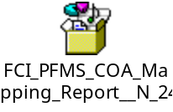

98.4 - CR-228 (MID: 124420): Change in Nomenclature of certain HOA & Scheme in FAP

- Change in Nomenclature of Account heads viz 3156, 6308, 6066, 6098 and discontinuation of mapping of Scheme code 2271-DPS with Account Head 6098.
- Addition of description of Account Head in FCI Debtors TB and Creditors TB Reports.
- In consolidated Trial Balance, "Group Name" to be changed to "Group Number".
- Change in Nomenclature of Scheme 407.
- Updation of CVR.
- Updation of other relevant reports.
- Nomenclature change of acct. head 6098 will be done and scheme code 2271 will be discontinued with Account head 6098 W.E.F. from ’01-APR-2021’ as per below template :( Detailed Template is attached in Annexure-1)

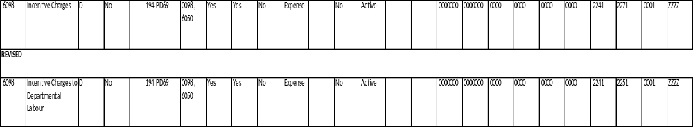

- Nomenclature of Account heads 3156, 6308, 6066 and Scheme 407 will be changed as per below template (Detailed Template is attached in Annexure-1):
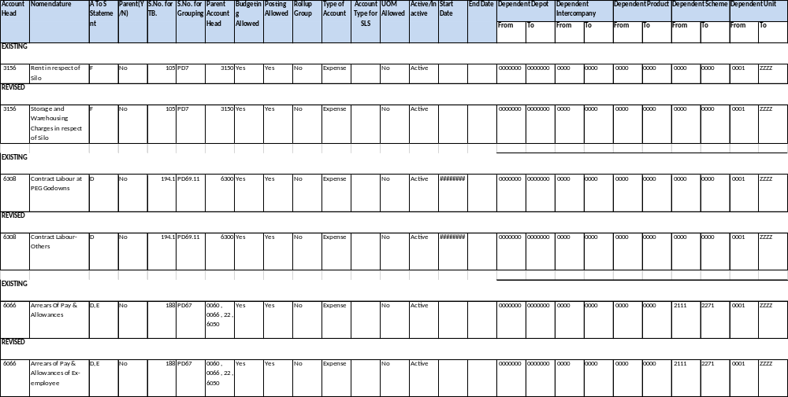

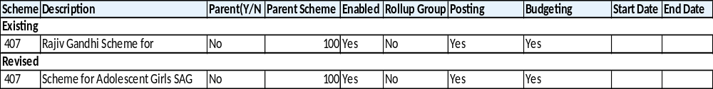

- Account head description column will be added in FCI Debtor TB and Creditor TB Report as per below Template (Detailed Template is attached in Annexure-1):
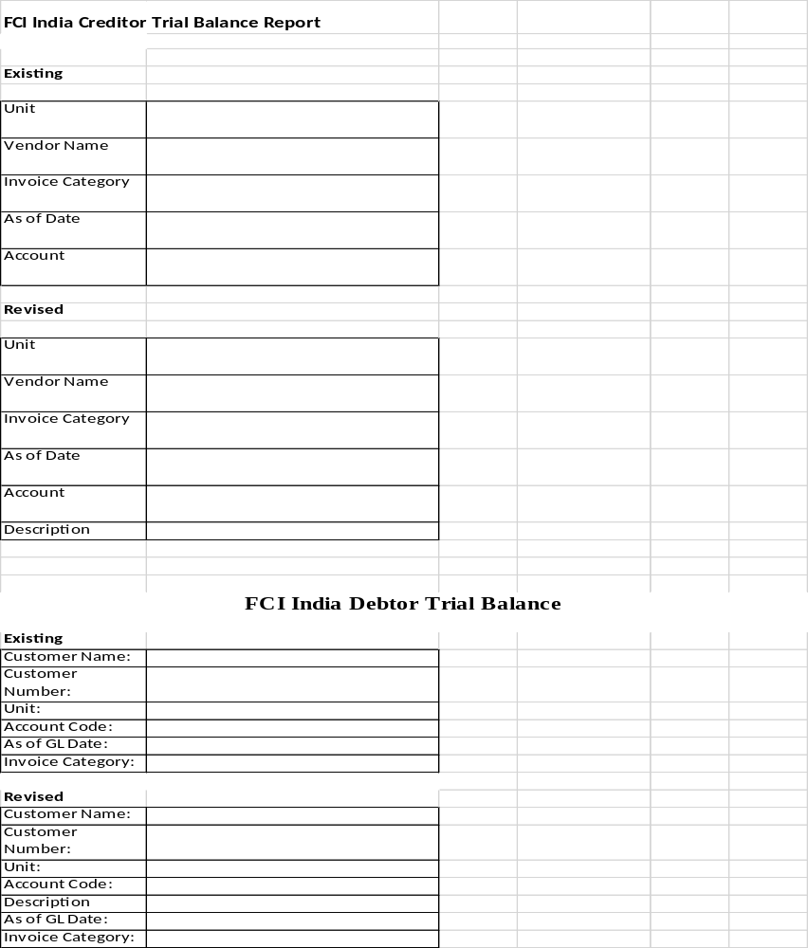

- Column Group name will be changed to group number in FCI consolidated TB Report as per below Template (Detailed Template is attached in Annexure-1):
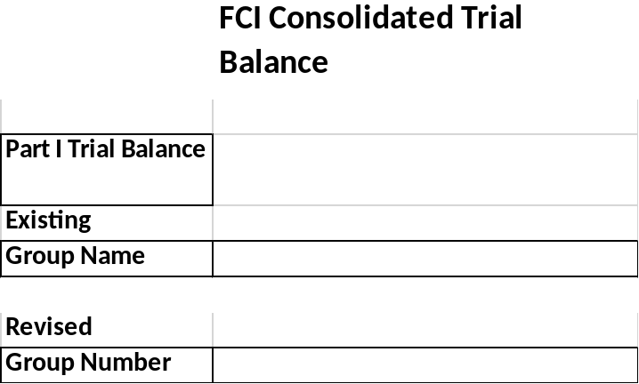
- CR 371: Process will be followed for Disabling of CCIDs of Scheme 2271 with account head 6098.

98.5 CR-246 (MID: 127426): Change in Dependent Unit under A/c Head 3577

- For Modification of Dependent Unit Under HOA 3577- Interest paid on Bank borrowing/overdrafts for Pulses operation.
- Addition of FCI Zonal offices (EA11, FA11, NA11, SA11, WA11) to dependent unit Code for Account Code 3577(account template Attached)
- Updation of CVR.
- Updation of other relevant reports.

- Addition of FCI Zonal offices (EA11, FA11, NA11, SA11, WA11) to dependent unit Code for Account Code 3577 as per below template :( Detailed Template is attached in Annexure-1)

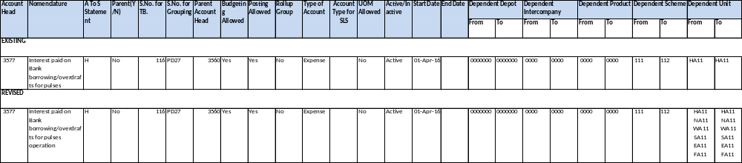

98.6 CR-247 (MID: 127642): To change NA11 for ZCC Account (40637198512) of Zonal Office(NA!!) instead of existing practice i.e. HA11.
FCI wants that North zone should also follow the same practice of IOR which is being followed in other regions. I.e. units from North Zone should be allowed to send IOR to ZCC Account (40637198512) of North Zone (NA11) only and vice versa.
Also, HC11 should also send it’s IOR to NA11 only and vice versa.

Following solution got implemented:
The existing check on the journal entry workbench in general ledger module modified as per following requirements:
- Units from North Zone allowed to send IOR to NA11 (ZCC Account 40637198512) only and vice versa.
- HC11 allowed to send IOR to NA11 only and vice versa.
- HA11 can send IOR to all ZO’s and units starting with ‘H’ except for HC11 and vice versa.
- RO Punjab and RO Rajasthan can no longer send IOR’s to the units starting from ‘N’ and HA11 or vice versa.
- All the units under a particular ZO can send IOR to their respective ZO’s only and vice versa.

98.7 CR-256 (MID: 131013): To allow Product Codes of fortified rice i.e. 206 to 209 in J.E. Category "Paddy Mill - Rice in"

- For Modification of Dependent Product under HOA 7131- Transfer In - Stocks received after conversion.
- Addition of Dependent Product (0206-0209) to dependent unit Code for Account Code 7131(account template Attached).
- Updation of CVR.
- Updation of other relevant reports.
- Addition of Dependent Product (0206-0209) to dependent unit Code for Account Code 7131 as per below template

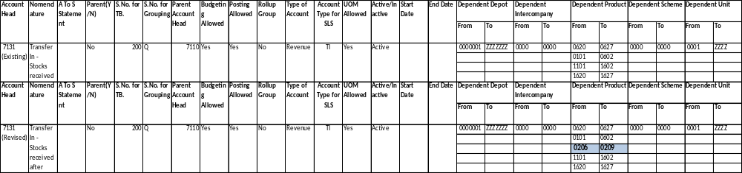
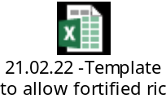

98.8 CR-250 (MID: 132228): Modify the nomenclature of HOA -4536

To Modify the nomenclature of HOA -4536
Updation in Chart of Account"

Account Head | Nomenclature | Updated Nomenclature
4536 | Current Account for pulses and oil seeds | Cash Credit Account for Pulses and Oil seeds

Error! Not a valid link.

98.9 CR-253 (MID: 132546): addition of new Product code 1206 - 1209

- Creation of New Product Code 1206-‘Rice- Fortified Raw Rice Common NonIssuable’, 1207-‘Rice- Fortified Raw Rice Grade A NonIssuable’, 1208- ‘Rice- Fortified Boiled Rice Common NonIssuable’ and 1209- ‘Rice- Fortified Boiled Rice Grade A NonIssuable’.
- New Product Code 1206,1207,1208 and 1209 to be used in dependent Product of Acct. Heads 7200, 7201, 7202, 7203, 7204, 7205, 7206, 7209, 7210, 7211, 7216, 7220, 7225, 7226, 7227, 7231, 7240, 7241, 7242, 7243, 7244, 7245, 7246, 7251, 7261, 7270, 7271, 7272, 7273, 7274, 7275, 7276, 7277, 7278, 7279, 7285, 7291, 5061, 5701, 5702, 7112, 7113, 7116, 7117, 7118, 7121, 7122, 7123, 7131, 7141, 7151, 7160, 7165, 7166, 7167, 7168, 7171, 7172, 7173, 7176, 7177, 7180, 7181, 7182, 7190, 7191, 7192, 7193, 7194.
- Updation of CVR.
- Updation of Cost Statements.
- Updation of A2S.
- Updation of other relevant reports.

Product Code 1206,1207,1208 and 1209 will be added as per below template (Detailed template is attached in Annexure-1):

Addition of New Product Code 1206,1207,1208 and 1209 to be used in dependent Product of Acct. Heads 7200, 7201, 7202, 7203, 7204, 7205, 7206, 7209, 7210, 7211, 7216, 7220, 7225, 7226, 7227, 7231, 7240, 7241, 7242, 7243, 7244, 7245, 7246, 7251, 7261, 7270, 7271, 7272, 7273, 7274, 7275, 7276, 7277, 7278, 7279, 7285, 7291, 5061, 5701, 5702, 7112, 7113, 7116, 7117, 7118, 7121, 7122, 7123, 7131, 7141, 7151, 7160, 7165, 7166, 7167, 7168, 7171, 7172, 7173, 7176, 7177, 7180, 7181, 7182, 7190, 7191, 7192, 7193, 7194 will be done as per the below template (Detail template attached in Annexure-1):

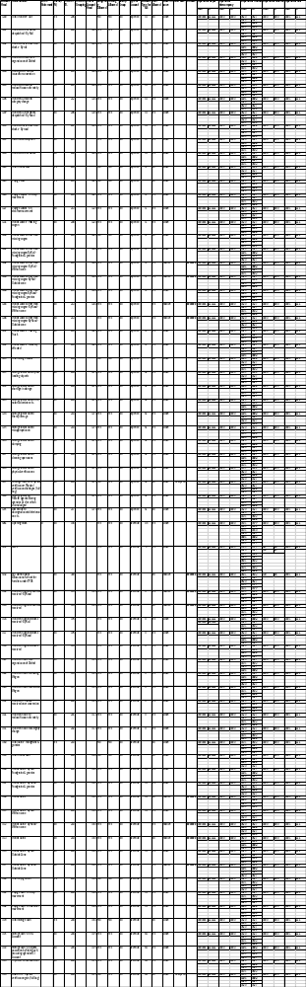

A2S mapping for Product Code 1206,1207,1208 and will be done as per below template (Detailed template is attached in annexure-1):
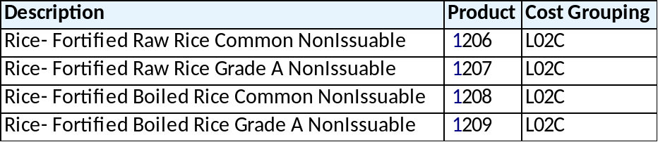

99.1 CR-242 (MID-0126869) DEACTIVATION OF HOA 5171 AND MODIFICATION IN NOMENCLAURE

- Deactivation of account head 5171 w.e.f. ‘01-APR-2021’.
- Deactivation the Dependent Product of acct. head 5171 from:
301-302,101-101,201-204.
- Deactivation dependent scheme code of acct. head 5171 from:
601-605.
- Change in Nomenclature of Scheme 103.
- Updation of CVR.
- Updation of other relevant reports.

- A/c heads 5171 will be end dated as per below template.
- 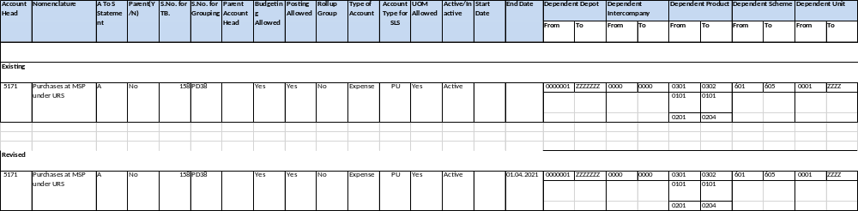

- Nomenclature of Scheme 0103 will be changed as per below template
- CR 371: Process will be followed for Disabling of CCIDs of account head 5171.

99.2 CR-267 (MID-0138415) -Change of Nomenclature of Product code 1103

To Modify the nomenclature of Product Code-1103.

Updation in Chart of Account"

99.3 CR 240 (MID-126214) Generation of QTD (Quarter-to-Date) Balance Report

Generation of “FCI Consolidated Trial Balance”,” FCI Trial Balance Detail With Document Sequence” reports for QTD(Quarter-to-Date) Balance type.
QTD(Quarter-to-Date) Balance type has to incorporate in the below existing reports
1. FCI Consolidate Trial Balance Report
2. FCI Trial Balance Detail with Document Sequence Report.

- In “FCI Consolidated Trial Balance”and “FCI Trial Balance detail with document sequence” in existing “Balance Type” input parameter name is added one more value as “QTD(Quarter-to-Date)” type. “QTD(Quarter-to-Date)” value in Balance type parameter will be taken by user to run report for "QTD (quarter -to-Date).
- In “FCI Consolidated Trial Balance” and “FCI Trial Balance detail with document sequence” logic is added in report to generate “QTD(Quarter-to-Date)” Balance type.

99.4 CR 274 (MID-142676) To create a new SAC 998311- Honorarium
New Inventory Items created in FAP & mapped with HSN Codes as per the below table-

S No | Item Name | Description | HSN/SAC Code | Item Code
1 | Honorarium | Honorarium | 998311‬ | 9828

All the Items mentioned will be Taxable & will be used in non-Sales Transactions only.

Item Code | Item Name | Item Description | Taxable/  Exempted | Sales/ Non Sales | HSN Code
9828 | Honorarium | Honorarium | Taxable | Non Sales | 998311

99.5 CR 234 (MID-125333) Creation of HSN Code for transfer of mobile phone to employee
New Inventory Items created in FAP & mapped with HSN Codes as per the below table-
S No | Item Name | Description | HSN/SAC Code | Item Code
1 | Sale/transfer of mobile phone to employee | Sale/transfer of mobile phone to employee | 85171211 | 9829

All the Items mentioned will be Taxable & will be used in non-Sales Transactions only.
S No | Item Name | Description | HSN/SAC Code | Item Code | Taxable/  Exempted | Sales/ Non Sales
1 | Sale/transfer of mobile phone to employee | Sale/transfer of mobile phone to employee | 85171211 | 9829 | Taxable | Non  Sales

99.6 CR 275 (MID-148489) For Modification in nomenclature of HOA and scheme
This enhancement is raised to modify in Nomenclature of following HOA and scheme -
a) HOA 4661- Sundry Debtors For issue under PM POSHAN-Primary Scheme.
b) HOA - 4664 - Sundry Debtors For issue under PM POSHAN- Upper Primary Scheme
c) Scheme Code 406 - Sale under PM POSHAN-Primary Scheme
d) Scheme Code 417 - Sale under PM POSHAN -Upper Primary Scheme.
2. Updation in Chart of Account."

99.7 CR 258 (MID-0131964)- Addition of new scheme code 3439 and 3440 and minor category 439 & 440 (Circ 1329)
Creation of new scheme code 3439 – ‘Computers- Printer or Scanner’ & 3440 – ‘Computers – UPS’ and minor category 439 –‘Computers- Printer or Scanner’ & 440 – ‘Computers – UPS’.
Schemes 3439 & 3440 to be used in dependent scheme of acct. heads 2151, 2251, 2351.
Updation of CVR.
Updation of A2S.

New scheme code 3439 and minor category 439 will be added as per below template
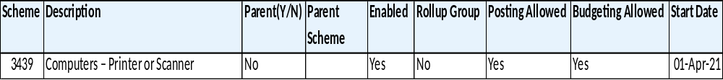

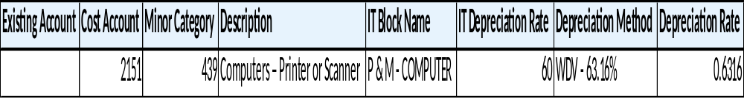
New scheme code 3440 and minor category 440 will be added as per below template
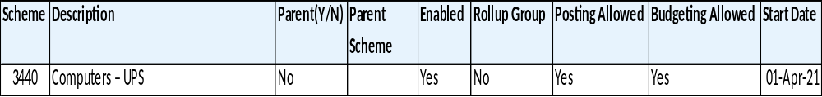

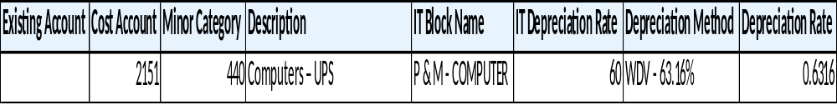
Addition of new scheme code 3439 & 3440 in dependent scheme code of acct. heads 2151, 2251 and 2351 will be done as per the below template
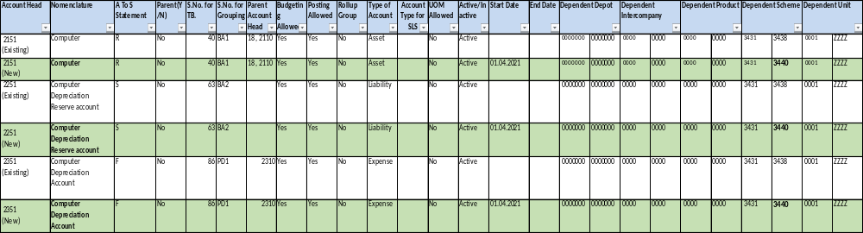
A2S mapping for acct. heads 2151, 2251 and 2351 with new scheme code 3439 & 3440 will be done as per below template
Account Head | Nomenclature | S. No of A to S Grouping
2151  (New) | Computer | R02JP
2251  (New) | Computer Depreciation Reserve account | S02JP
2351  (New) | Computer Depreciation Account | F03WP

100.1 CR 227 (MID-0124308)- Account heads to be Mapped in Profit and Loss Grouping for year 2020-21 & Cost Statement
For Mapping of Account heads in Profit and Loss Statement and in A to S
(A.H. 5201, 5202, 5203, 5204, 5205, 5207, 5209, 5210, 5211, 5212, 5220, 5221, 5222, 5224, 5227, 5244 & 5421 ) along with cost mapping of HOA 5421.
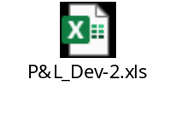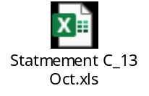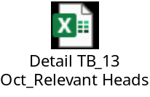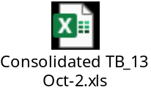

100.2 CR 265 (MID-0138412)- To create new HOA 0935-Inter Office TDS/TCS Claim
1. Opening of new HOA-0935 - Inter Office TDS/TCS Claim
2. Updating of other relevant reports like Intercompany Reconciliation Report, Trial Balance ana Profit & Loss Statement etc.
3. Updation of COA"
A/c head 0935 will be created as per below template (Detailed Template is attached in Annexure-1):
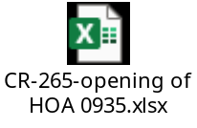

100.3 CR 276 (MID-0148575)- For Addition of new Scheme under HOA 5701 and for creation of new HOA 4665 and new scheme code 435.

1.To create new Scheme Code i.e. 435- Sale under PM POSHAN-BAL VATIKA
2. To create new HOA i.e. 4665- Sundry debtors for issue under PM POSHAN-BAL VATIKA
3. To Add new scheme 435 under HOA 5701
4. Updation in Chart of Account.
5. Update User guide reg changes under this CR

Scheme Template
Scheme | Description | Parent(Y/N) | Parent Scheme | Enabled | Rollup Group | Posting Allowed | Budgeting Allowed | Start Date | End Date
435  (New Scheme) | Sale under PM POSHAN-BAL VATIKA | No | 100 | Yes | No | Yes | Yes | 01-Apr-22

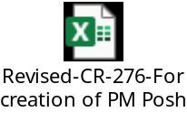

100.4 CR 268 (MID-0138698)- Creation of new HOA-2104-Provision for Audit Fee
1. Opening of new HOA-2104 - Provision of Audit Fee
2. Updating of other relevant reports like, Consolidated Trial Balance, Detailed Trial Balance and Profit & Loss Statement etc.
3. Updation of COA"

A/c head 2104 will be created as per below template (Detailed Template is attached in Annexure-1):

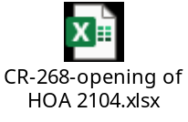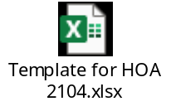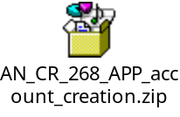

101.1 CR-263 (138028) - Modify the nomenclature of HOA -3719, 3467 & 2604 and inactivate HOA 2907, 3569, 3570, 3708, 3735, 5751, 3734, 3736.

Following are the modification required –
"1. To Modify the nomenclature of HOA -3719, HOA 3467 & HOA 2604
2. Following HOA are to be inactivated w.e.f. 01.04.02021:-
a) 2907-Revolving deposit with COA-FCI share of capitalised value of pension, DCRG(Food Transfer)
b) 3569- Interest charges for utilsn.of Fert.old funds and vice-versa
c) 3570-Interest Paid - on foreign bank borrowings for purchase of Imp. Food grains
d) 3708-Exp. on Project/Disturbance Allowance to FTS's / DEO's
e) 3735-Govt.Guarantee Fees(Fert)
f) 5751-Sub-Whole-Salers Margin
g) 3734-Govt.Guarantee Fees(Food)
h) 3736-Govt.Guarantee Fees(Sugar)
i) 3707- Certification Fee - ISO
j) 3718 - Exp. On Gifts-Parliamentary/Consultative Committee/Delegation
2. Updation in Chart of Account" and other relevant reports.

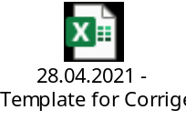

101.2 CR-266 (0138414: )-To create new HOA for NPS

Following are the modification required –
1. For opening of new HOA:--
a) 0958 - Inter Office NPS A/c – Contribution under New Pension Scheme.
b) 1643 - Liability for NPS – Corporation Compulsory Contribution under New Pension Scheme
c) 1644-Liability for NPS – Employee Compulsory Contribution under New Pension Scheme
d) 1645- Liability for NPS – Employee Voluntary Contribution under New Pension Scheme
e) 1646- Liability for NPS – Corporation Arrear Contribution under New Pension Scheme
f) 1647-Liability for NPS – Employee Arrear Contribution under New Pension Scheme
g) 1648 - Liability for NPS – Corporation Arrear Contribution under New Pension Scheme for RETIRED EMPLOYEE
h) 1649- Liability for NPS – Employee Arrear Contribution under New Pension Scheme for RETIRED EMPLOYEE
i) 1650 -Remittance of funds to FCI DCP Trust on account of forfeiture of Corporation Contribution due to disciplinary proceedings
j) 1698-One-time Member Subscription Fee for NPS under New Pension Scheme @Rs.100/- applicable in case of New Appointees/Non-DCPS Members
k) 6257-NPS – Corporation Contribution under New Pension Scheme – Regular Employee
l) 6258- NPS – Corporation Contribution under New Pension Scheme for Regular Employee (Arrear)
m) 6259- NPS – Corporation Contribution under New Pension Scheme for Retired Employee (Arrear) 2. Updating of other relevant reports like Intercompany Reconciliation Report, Trial Balance ana Profit & Loss Statement etc.
3) Updation of COA

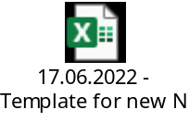

101.3 CR-272 (0141743)- For mapping of Product code 1206 – 1209

Following are the modification required –

A. For mapping of given below Product Codes with HOA 5061-Opening Stock, 5701- Sales, 7321- Closing Stock (Assets Account) and 7331- Closing Stock (Trading Account)
1.1206-Rice- Fortified Raw Rice Common Non-Issuable
2.1207-Rice- Fortified Raw Rice Grade A Non-Issuable
3.1208-Rice- Fortified Boiled Rice Common Non-Issuable
4.1209- Rice- Fortified Boiled Rice Grade A Non-Issuable.
B. Updation of Chart of Account.
C. Updation of other relevant Reports.

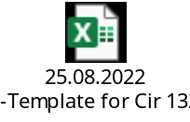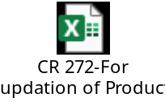

101.4 - 0152803: CR-282-Addition/Modification in existing FCI Debtor/Creditor Age-Wise Report

1. Modification in FCI Debtor/Creditor Age-Wise Report. (Revised Format is enclosed)
2. Creation of Age-wise report for MSME supplier

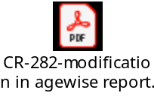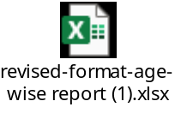

101.5 - 0160769: CR-292-To change in mapping of NPS HOA (1643 to 1649, 1698, 6257 to 6259)

Following are the modification required –
A. To update revised mapping of given below HOA:-
1. 1643 - Liability for NPS – Corporation Compulsory Contribution under New Pension Scheme.
2. 1644 -.Liability for NPS – Employee Compulsory Contribution under New Pension Scheme
3. 1645- Liability for NPS – Employee Voluntary Contribution under New Pension Scheme
4. 1646 - Liability for NPS – Corporation Arrear Contribution under New Pension Scheme
5. 1647 - Liability for NPS – Employee Arrear Contribution under New Pension Scheme
6. 1648 - Liability for NPS – Corporation Arrear Contribution under New Pension Scheme for RETIRED EMPLOYEE
7. 1649- Liability for NPS – Employee Arrear Contribution under New Pension Scheme for RETIRED EMPLOYEE.
8. 1650 - Remittance of funds to FCI DCP Trust on account of forfeiture of Corporation Contribution due to disciplinary proceedings
9. 1698 - One-time Member Subscription Fee for NPS under New Pension Scheme @Rs.100/- applicable in case of New Appointees/Non-DCPS Members
10. 6257 - NPS – Corporation Contribution under New Pension Scheme – Regular Employee
11. 6258 - NPS – Corporation Contribution under New Pension Scheme for Regular Employee (Arrear).
12. 6259 - NPS – Corporation Contribution under New Pension Scheme for Retired Employee (Arrear)
B. Updation of Chart of Accounts.
C. Updation of other relevant Reports."
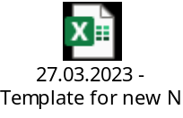

101.6 - 0160771: CR-293- For Modification in nomenclature of HOA 7192

"1. To modify in Nomenclature of following HOA:-
a) HOA 7192 - Storage Gain /Value Cut- on Food grains taken over from State Govt. procuring agencies
2. Updation in Chart of Account.
3. Updation in Relevant Reports."

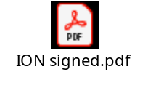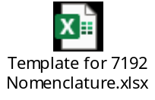

101.7 - 0163949: CR-300-Change in CVR- Depot Segment

1. CVR of multiple Head of Accounts needs to be modified to include Depot Code in Depot Segment. The detail of relevant Head of accounts is enclosed as Annexure
2. Updation in Chart of Account.
3. Updation in Relevant Reports

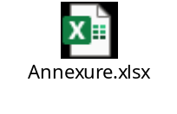

101.8 - 0165363: CR-303-To allow Product Code 0206 to 0209 in existing HOA 5231 & 5403

1. To allow Dependent Product 0206 to 0209 in the existing HOA 5231 - Purchases Unconnected Wagons & HOA 5403 - Freight - container operation (copy of template attached)
2. Updation of CVR.
4 Updation of other relevant reports.

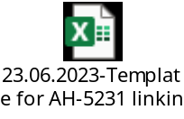

101.9 - 168613: CR-306-For Modification in nomenclature of HOA and scheme

"1. To modify in Nomenclature of following HOA and scheme
a) HOA - 3904 - Interest received on other Account
b) HOA - 4763- Sundry Debtors against DCPS Trust
c) HOA - 2636- TDS/TCS on Purchase/Sale with FCI
d) Scheme Code 3112/Minor Category 112 - (Major Category 2111) -Free Hold Land - Purchased for Conventional godowns under Crash Program
The copy of template is attached.
2. Updation in Chart of Account."

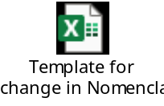

102.1- 0120697: CR-229:- Revision in mapping of group in Balance Sheet and Profit & Loss

Need to modify “FCI Profit And Loss Annexures” and “FCI Balance Sheet annexures” by creating some new groups and splitting some existing groups in to new groups (refer annexure).

Following are the approach followed to implement these changes –
- Some existing groups from PNL and BS mapping will be modified to create new groups based on specified combination of account; product and scheme as specified by FCI (refer annexure).
- The mapping for all the reports that use BS/PNL mapping as source will be updated as well.
- The mapping of the groups and structure of the reports “FCI Profit And Loss Annexures” and “FCI Balance Sheet annexures” will be modified as per the revisions specified by FCI.
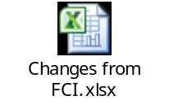

102.2. - 0156717: CR-285-To update revised mapping of existing HOA 3766, 3767 & 3997

A. To update revised mapping of given below HOA:-
1.3766-EDLI Premium.
2.3767- EDLI Administrative Charges
3.3997 - Income on account of recovery of excess PLI paid
B. Updation of Chart of Accounts.
C. Updation of other relevant Reports."

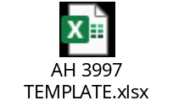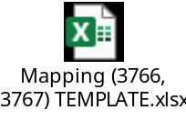

102.3 - 0180485: CR-314-De-activation of Scheme Code 3421- Office Equipment - Depot On Line System-UPS

De-activation of Scheme Code 3421- Office Equipments - Depot On Line System-UPS w.e.f. 01.04.2023
B. Updation of Chart of Accounts.
C. Updation of other relevant Reports

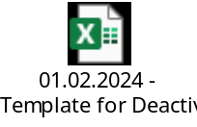

102.4 - 0170765: CR-308-De-activation of Scheme Code 604 - Direct by FCI under levyProcured under Levy

A.De-activation of Scheme Code 604 - Direct by FCI under levyProcured under Levy w.e.f. 01.04.2023
B. Updation of Chart of Accounts.
C. Updation of other relevant Reports

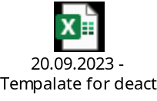

102.5 - 0179129: CR-312-Creation of new HOA-4627-Sundry Debtors for food Subsidy claims for distribution of food grains to Non-NFSA beneficiaries

1. Opening of New HOA-4627-""Sundry Debtors for food Subsidy claims for distribution of food grains to Non-NFSA beneficiaries"" (copy of template is enclosed)
2. Updation of CVR.
3. Updating of other relevant reports "

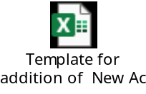

102.6 - 0181355: CR-316-Change in CVR- Depot Segment- AH 3710 and 3763

1. CVR of Two Head of Accounts modified to include Depot Code in Depot Segment. The template of relevant Head of accounts is enclosed
2. Updation in Chart of Account.
3. Updation in Relevant Reports

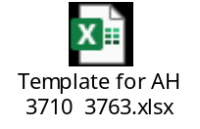

102.7 - 0169825: CR-307-Creation of new HOA-2729-"Travel Advance against Emp. for ticket arranged through Travel Agency".

1. Opening of new HOA-2729- "Travel Advance against Emp. for ticket arranged through Travel Agency".
2. Updation of CVR.
3. Updating of other relevant reports "

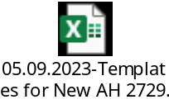

102.8 - 0123155: CR-225 Updation of 6/8 digit HSN Codes of different items (Outwards supply)

To Update mandatory mentioning of 6 digit HSN Code on Tax Invoice along with requirement of same in GSTR-1 in the table of "HSN wise summary of Outward Supply" including of exempted outward supply.

  - HSN/SAC code should be in 6/8 digits for Tax Invoices/ Bill of Supply in AR Module.
  - Above mentioned New 6/8 digit HSN Codes to be mapped with mentioned items as per list provided by FCI.

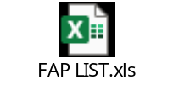

103.1 - CR-280-To assign "FCI Period Closure Tool" to Compilation Division

Till date Hqrs Compilation Division was dependent on FAP Support for closure of HQ11 unit asHQ11 unit could only be closed with Support responsibility, so they have requested to provide period closure to Hqrs Compilation Div, accordingly a new responsibility viz “FCI HQ Period Closure Tool" was created whereby any user of Hqrs who has been given the said responsibility close period of HQ11 unit.

Configuration of new responsibility –“ FCI HQ Period Closure Tool “ for period closure activity.

103.2 - CR-324-To update revised mapping of existing HOA 4627.
To update revised mapping of given below HOA 4627- Sundry Debtors for food Subsidy claims for distribution of food grains to Non-NFSA beneficiaries.
A. Updation of Chart of Accounts.
B. Updation of other relevant Reports.
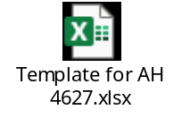

103.3 - CR-321-Creation of new HOA i.e 0936-Inter Office TDS and TCS Claim w.e.t. 01.04.2024 and Deactivation of existing HOA 0935- Int
1). For opening of new HOA:--
a) 0936-Inter Office TDS and TCS Claim w.e.t. 01.04.2024
2). For de-activation of existing HOA:--
a) 0935- Inter Office TDS and TCS Claim w.e.f. 31.03.2024
3). Updating of other relavnt reports
4) Updation of COA
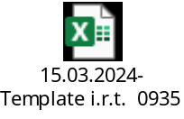

103.4 - CR-320-Creation of new HOA i.e 2829, 4628
1. For opening of new HOA:--
a) 2829- Claims for PR and Publicity activities for awareness campaign on PMGKAY and other welfare schemes of DFPD
b) 4628 - Sundry Debtors for PR and Publicity activities for awareness campaign on PMGKAY and other welfare schemes of DFPD
2. Updating of other relevant reports.
3) Updation of COA.

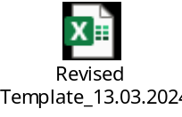

103.5 - CR-319 -Change in Dependent Scheme for AH 1554
1. To Change in Dependent Scheme under HOA 1554 -CPF Final Payment.
2. Updation in Chart of Accounts.
3. Updation in Relevant Reports


103.6 - CR-317-To create a new HSN/SAC i.e. 999794 - "Penalty levied on late submission of BG".
A. For creation of new HSN/SAC - 999794 - "Penalty levied on late submission of BG".
B. Updation of Chart of Account.
C. Updation of other relevant Reports.


103.7 - CR-325-For mapping of Dependent Product code 0201 to 0209 with HOA 4005-Recoveries from Millers on Other Account.
A. For mapping of Dependent Product code 0201 to 0209 with HOA 4005-Recoveries from Millers on Other Account. (copy of template and A to S mapping is attached.)
B. Updation of Chart of Accounts.
C. Updation of other relevant Reports.
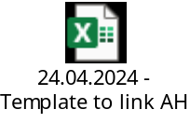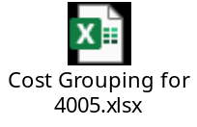

103.8 - CR-326To update revised mapping of existing HOA 3170, 3171, 3172, 3173, 3174, 3175 & 3176.
A. To update revised mapping of given below HOAs:
i) 3170- Storage charges, Godowns constructed under PEG scheme a)Private investors on lease without services-SWC
ii) 3171- Storage charges godowns constructed under PEG scheme a)private investor on lease without service-State Govt
iii) 3172- Storage charges, Godowns constructed under PEG scheme a)Private investors on lease with services-CWC
iv) 3173- Storage charges, Godowns constructed under PEG scheme a)Private investors on lease with services-SWC
v) 3174- Storage charges godowns constructed under PEG scheme a)private investor on lease with service-State Govt.
vi) 3175- Arrear of storage charges paid to CWC
vii) 3176- Arrear of storage charges paid to SWC
B. Updation of Chart of Accounts.
C. Updation of other relevant Reports.

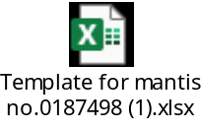

104.1 - CR 327(MID-0190891)- Updating the 8 digit HSN codes of different items (Outward supply).

1. For Updating mandatory mentioning of 8 digit HSN code on Tax Invoice along with requirement of same in GSTR-1 in the table of “HSN wise summary of Outward supply” including of exempted outward supply.
2. Updation of Chart of Account.
3. Updation of other relevant Reports.

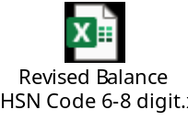

104.2 - CR-296 (MID-0162493) -To close Unit Code SB12- District Office GUNTUR

A. To close Unit Code SB12 - District Office - Guntur w.e.f. 31.03.2023.
B. Updation of Chart of Accounts.
C. Updation in FCI Period Closure Report.
C. Updation of other relevant Reports

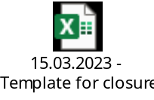

104.3 - CR305(MID-0167325): update mapping of existing HOA 2711, 4762, 4763, 3206, 3463, 3799, 6067, 6104, 6112, 1442, 1552, 1554, 1636, 1903

A. To update revised mapping of given below HOA:-
1) 2711-Interest Free Loan to Canteens (2) 4762 - Sundry debtors against CPF Trust (3) 4763 - Trade Receivable-DCP Trust (4) 3206- Rent - Railway Land (5) 3463 - Fees for Physical Verification (6) 3799- Expense incurred on purchase of Petroleum product (7) 6067 -Cash Incentive (8) 6104 -Welfare Expenses (9) 6112- ESI contribution (10) 1442- Income Tax liability on FCI owned accommodation (11) 1552- CPF Temporary Advance (12) 1554- CPF Final Payment (13) 1636 - Tax Collection at Source (TCS) on sale made by FCI to its customers (14) 1903- Interest Payable On Govt Of India Guaranteed Bonds (15) 3768 - Miscellaneous Expenses -Expenditure on Plantation
B. Updation of Chart of Accounts.
C. Updation of other relevant Reports.
Note: For all the HOA - The mapping of P&L Grouping and A to S mapping is revised and for HOA 3206, 3463, 3799, 6067, 6104 & 6112 - the PFMS mapping is also updated.


104.4 - CR-322(MID-0187162)-To Change in Dependent Scheme under HOA 1643, 1644, 1645, 1646, 1647, 1648, 1649, 1650, 1698, 6257, 6258 & 6259 in Group.

1 To Change in Dependent Scheme under HOA 1643, 1644, 1645, 1646, 1647, 1648, 1649, 1650, 1698, 6257, 6258 & 6259 in Grouping. (Profit and Loss Statement Report).
2. Updation in Chart of Accounts.
3. Updation in Relevant Reports
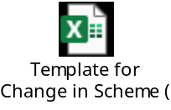

104.5 - CR-338(MID-0200113)- For creation of new Sale Schemes i.e. 210- Bharat Brand under OMSS(D) and 211- Community Kitchen under OMSS(D) w.e.f. 01.04.2024.

1). For creation of new Sale Schemes i.e. 210- Bharat Brand under OMSS(D) and 211- Community Kitchen under OMSS(D) w.e.f. 01.04.2024.
The schemes will be linked with existing Product Code i.e from 0101 to 0209 (Wheat & Rice) and Existing HOA 5701- Sales”
2). Updating of other relevant reports
3) Up-dation of COA

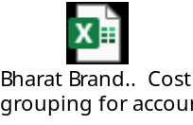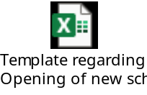

104.6 - CR-334(MID - 0194689)-Linking of AH 7321 & 7331 with Product code 0501.

1. Mapping of AH 7321 and 7331 with product code 0501.
2). Updating of other relevant reports
3) Up-dation of COA
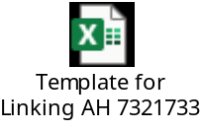

104.7 - CR-332(MID -0193954): Creation of new HOA i.e. 4104, 4105, 4106 and 4629 w.e.f. 01.04.2023.

1). For opening of new HOA w.e.f. 01.04.2023, the detail is as under:--
a) 4104-Differential on account of PSF- OMSS (D) Rice
b) 4105-Differential on account of PSF-Bharat Atta
c) 4106-Differential on account of PSF-Bharat Rice
d) 4629-Sundry Debtors for PSF (Food grains)
2). Updating of other relevant reports
3) Up-dation of COA

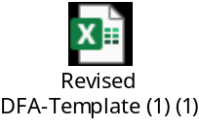

104.8 - CR-323 (MID-0187163)-Deactivation of HOAs- w.r.t. circular no 1215 (Year 2017) of A/cs Div- AH 1691, 1692, 1693 and 1694 etc. (total 21 AH).
A. De-activation of HOAs w.e.f. 31.03.2024.
B. Updation of Chart of Accounts.
C. Updation of other relevant Reports
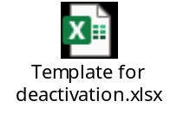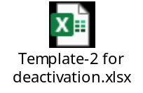

105.1 - CR-340- To update Dependent Unit code of Existing Account Head i. 4629.
A.- To update Dependent Unit code of Existing Account Head i. 4629 - (Sundry Debtors for PSF (Foodgrains).
B. Updation of Chart of Account.
C. Updation of Other Rlevant Reports.
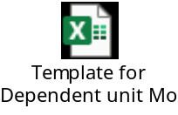

105.2 - CR-331- Addition of new scheme code 3357 and minor category 357.

1. Addition of new scheme code 3357-Plant & Machinery - Modern QC Lab Equipment and minor category 357-Plant & Machinery - Modern QC Lab Equipment.
2.Scheme 3357 to be used in dependent scheme of acct. head 2147, 2247, 2347.
3. Updation of CVR.
4.Updation om other relevant reports.

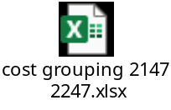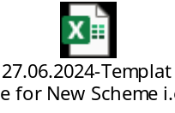

105.3 - CR-339-For creation of new HOA 2914- Deposit with utility service provider (other than Electricity Board) w.e.f. 01.04.2024.

1). To create new HOA 2914- Deposit with utility service provider (other than Electricity Board) w.e.f. 01.04.2024.
2). Updating of other relevant reports
3) Up-dation of COA

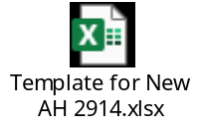

105.4 - CR-344-Linking of Product code 0201 to 0209 with existing HOA 5233 & creation of new HOA 5236- Farmer Welfare Charge w.e.f. 01.04.
1). To create new HOA 2914- HOA 5236- Farmer Welfare Charge w.e.f. 01.04.2024.
2) Linking of Product code 0201 to 0209 with existing HOA 5233- Handling Charges- Loading at Mandi w.e.f. 01.04.2024
2). Updating of other relevant reports
3) Up-dation of COA
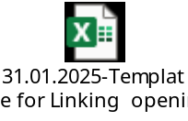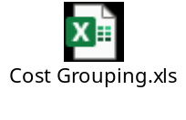

105.5 - CR-345- For Creation of new HOA 4764- Sundry debtors against CPF Trust for Higher Pension w.e.f. 01.04.2024.
1). To create new HOA 4764- Sundry debtors against CPF Trust for Higher Pension w.e.f. 01.04.2024
2). Updating of other relevant reports
3) Up-dation of COA
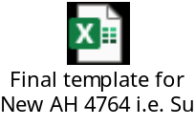

105.6 - CR-346-For Creation of new HSN 71069290 – For transfer of Silver Coins w.e.f. 01.04.2024.
1). To create new HSN 71069290 – For transfer of Silver Coins w.e.f. 01.04.2024. The GST Rate 3% is applicable.
2). Updating of other relevant reports
3) Up-dation of COA


105.7 - CR-347- Creation of new HOA 4107-4109, change in Nomenclature of HOA 4105, 4106 and de-activation of HOA 4104 w.e.f. 01.04.2024.
1). To create new HOA :-
i) 4107- Reimbursement of Transportation cost by Road PSF-Bharat Brand under OMSS(D)
ii) 4108- Reimbursement of Transportation cost by Railway PSF-Bharat Brand under OMSS(D)
iii) 4109-Reimbursement of Transportation cost by Steamer PSF-Bharat Brand under OMSS(D)
2) To Change in Nomenclature of existing HOA:-
i) 4105- Differential on account of Price Difference PSF-Bharat Atta under OMSS(D)
ii) 4106- Differential on account of Price Difference PSF-Bharat Rice under OMSS(D)
3) De-activation of HOA – 4104- Differential on account of PSF-OMSS (D) Rice
The changes will be effective from 01.04.2024.
4). Updating of other relevant reports
5) Up-dation of COA.
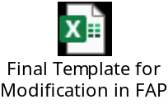

105.8 - CR-333-For opening of new HOA 0945, 1405 and 1406.

1. For opening of new HOA 0945, 1405 and 1406 w.e.f. 01.04.2024, The detail is as under:-
a. 1405-Deposit by Ex-member toward Higher pension Fund.
b. 1406-Deposit by active member/employee toward Higher pension Fund.
c. 0945- Inter office Higher pension Fund (IOHPF).
2. Updation of COA.
3. Updation of other relevant Reports.
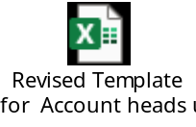

105.9 - CR-343- To create a new HSN/SAC i.e. 999799 - "Other Services".
A. For creation of new HSN/SAC - 999799 - "Other Services".
B. Updation of Chart of Account.
C. Updation of other relevant Reports


106.1 - CR-352- For creation of new HOA 1562- Liability for Contribution to EPS 1995 additional 1.16% increased contribution w.e.f. 01.04.25.
1). To create new HOA 1562- Liability for Contribution to EPS 1995 additional 1.16% increased contribution w.e.f. 01.04.2025.
2). Updating of other relevant reports
3) Up-dation of COA
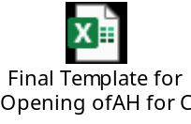

106.2 -CR-348 - For creation of new SAC codes i.e 998221 to 998224.
1. For creation of new SAC codes. The detail is as under:-
i) 998221 - Financial Auditing Services
ii) 998222 - Accounting and Book-Keeping Services
iii) 998223- Payroll Services
iv) 998224 - Other similar services nowhere else classified.
2). Updating of other relevant reports
3) Up-dation of COA.


106.3 -CR-342- Addition of new scheme code 3213 and minor category 213.

1. Addition of New scheme code 3213- “Buildings - Purely Temporary Erections” and Minor category 213- “Buildings - Purely Temporary Erections”.
2. Scheme 3213 to be used in dependent scheme with acct. heads 2125, 2225 and 2325.
3. The combination of asset HOA/minor category i.e. 212 with 2125 is to be discontinued w.e.f. 01.04.2024 (FY 24-25), whereas 212 will continue to be mapped/linked with AH 2124 (i.e. “Buildings - Staff Quarters [Other than RCC Frame Structure]” ).
4. Updation of CVR.
5. Updation of other relevant reports.
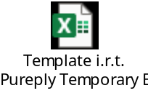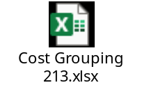

106.4 -CR 355 Addition of new scheme code 3358 and minor category 358.

1. Addition of New scheme code 3358- “Plant & Machinery - AI-Based Automatic Food grain Analyser” and Minor category 358- “Plant & Machinery - AI-Based Automatic Food grain Analyser”
2. Updation of CVR.
3. Updation of other relevant reports.

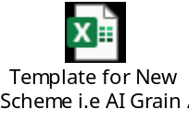

106.5 -CR 356 For creation of new HOA 5522- Ocean Freight – Movement to Lakshadweep w.e.f. 01.04.2025.

1). To create new HOA 5522- Ocean Freight – Movement to Lakshadweep w.e.f. 01.04.2025.
2). Updating of other relevant reports
3) Up-dation of COA

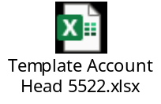

106.6 -CR 357 For creation of new HOA 3161 - Fee for Independent Engineer & Auditor (IE&A) at Silo w.e.f. 01.04.2025.

1). To create new HOA 3161 - Fee for Independent Engineer & Auditor (IE&A) at Silo w.e.f. 01.04.2025.
2). Updating of other relevant reports
3) Updation of COA
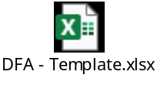

106.7-CR 358 For creation of new HOA 7114, 7124, 7125, 7207, 7208, 7169, 7170, 7178, 7232 and 7233 w.e.f. 01.04.2025.

1 To create new HOA 7114, 7124, 7125, 7207, 7208, 7169, 7170, 7178, 7232 and 7233 w.e.f. 01.04.2025 and modify nomenclature of HOA 7424 from “Goods in Transit Rail/Road” to “Goods in Transit Rail/Road/Container”.
2 Updation of CVR.
3 Updation of other relevant report.
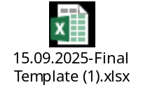

106.8-CR-363- For creation of new Scheme Code 0210 to 0227 and 1210 to 1227 and link same with existing HOA 2819, 4005, 5232, 5233, 5.

1). To create new Scheme Codes 0210 to 0227 and 1210 to 1227 and link same with existing HOA 2819, 4005, 5232, 5233, 5234, 5235, 5236, 5281, 5402, 5403 and 5522
2). Updating of other relevant reports
3) Updation of COA.



106.9-CR-361- For linking of Scheme Code 2301 with HOA- Towel, Soap & Workman's Compensation.

1). To link Scheme Code 2301 with HOA 6105- Towel, Soap & Workman's Compensation
2). Updating of other relevant reports
3) Updation of COA

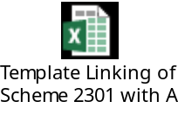

107.1-CR-362-Creation of new scheme code 801, 802, 803 and 804 and linking under existing HOA 3303.

1). Creation of new scheme code 801, 802, 803 and 804 (Parent Scheme code 800) and linking under existing HOA 3303 Taxes-Property.
2). Updating of other relevant reports

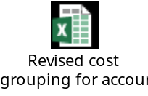

107.2-CR-364-Change in T.B. Group of HOA 6091 and Change in P&L Grouping of HOA 3997, 4551, 4553 & 4557.
1). To Change in T.B. Group of HOA 6091 and Change in P&L Grouping of HOA 3997, 4551, 4553 & 4557.
2). Updating of other relevant reports
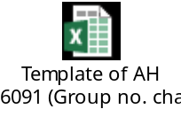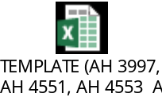

107.3-CR-365- For creation of new HOA 3227-Charges under PMS Model and 3228 -Charges under Non-PMS Model.
1). To create New HOA 3227-Charges under PMS Model and 3228 -Charges under Non-PMS Model w.e.t. 01.04.02025
2). Updating of other relevant reports
3) Updation of COA

